Chapter-6 : Example for Chondrichthyes

Shark

Scoliodon sorrakowah
Phylum: Chordata
Subphylum: Vertebrata Gnatho
Superclass: Gnathostomata
Class: Chondrichthyes
Subclass: Elasmobranchii

Scoliodon is a cartilaginous fish. Hence it is included in the class Chondrichthyes. Scoliodon is commonly called Indian dogfish or shark. In tamil, it is called ‘Chura Meen’. The common species are:
Scoliodon sorrakowah = S.laticaudas
Scoliodon dumerilli
Scoliodon palasorrah
Scoliodon walbeehmi
Scoliodon is a marine fish. It is a fast swimmer. It is carnivorous in habit.
The sexes are separate. Fertilization is internal and development is direct It is viviparous and giving birth to youngones.
Scoliodon is elongated, spindle-shaped and laterally compressed. Both ends are pointed. It reaches a length of about 60 cm. Shark exhibits counter shading, an adaptation. The dorsal and lateral sides are dark grey in colour. The ventral side is white in colour. This helps the shark to escape from the enemies.
When an enemy looks shark from above, the dark grey merges with the dark background of the bottom. When an enemy looks from below, the white underside of the shark merged with the lighted background of the atmosphere.
On either side of the body, a faint line extends from the head to the tail. This line is called lateral line. It marks the presence of lateral line sense organ inside the body.
The skin is rough and the roughness is due to the presence of innumerable backwardly directed spine-like structures called placoid scales.
The body is divisible into three regions, namely head, trunk and tail.
The head is present at the anterior end. It is dorso-ventrally flattened. Anteriorly, it is produced into a pointed snout. The head contains a mouth on the ventral side. It is a crescentic opening. It is bounded by two jaws, namely an upper jaw and a lower jaw. Each jaw has one or two rows of teeth.
Infront of the mouth, two slit-like openings are situated on the ventral side. They are called nostrils. They are used exclusively as an olfactory organ and not as a respiratory organ.
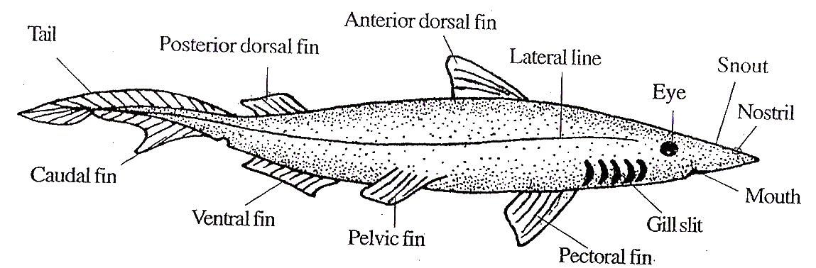

Fig.6.1: Scoliodon (shark) – lateral view.
Two prominent eyes are present on the sides of the head at a place between the mouth and nares.
Each eye is protected by three eyelids, namely an upper eyelid, a lower eyelid and a nictitating membrane or third eyelid. The upper and lower eyelids are immovable.
The nictitating membrane is thin, transparent and movable. It lies along the lower side and can be drawn over the eye to cover it, when required.
The head and snout, on the dorsal side, contain numerous groups of pores called ampullary pores. They are the external openings of ampulla of Lorenzini.
Five pairs of vertical slit-tike openings are present on the sides of the head behind the eyes. These openings are called external gill slits or external branchial apertures. They open into the pharynx.
The trunk extends from the last gill slit to the cloacal aperture. The trunk is laterally compressed. . It contains fins and cloacal aperture.
The trunk has an anterior median dorsal fin, a pair of pectoral fins behind the head and a pair of pelvic fins infront of the tail. The cloacal aperture lies between the pelvic fins.
The tail is the posterior region and it extends behind the cloacal aperture. It constitutes about half of the length of the trunk. It is also laterally compressed like the trunk.
It is slightly bent upwards. Such an upturned tail is called heterocercal tail.
The tail bears three fins, namely a posterior median dorsal fin, a caudal fin and a ventral fin.

Fins
Fins are specialized locomotory organs of fishes. Fins are flap-like outgrowths of the body wall directed backwards and supported by rods and fin rays.
Shark has two types of fins. They are median fins or unpairedfins and pairedfins or lateral fins.
1. Median Fins or Unpaired Fins ; Median fins are located along the median line of the body. They are unpaired and are arranged individually.
Shark has three types of median fms, namely two dorsal fins, a caudal fin and a ventral fin.
One dorsal fin lies along the median line about the middle of the body. It is called anterior dorsal fin or first dorsal fin. It is triangular in shape.
The second dorsalfin lies just infront of the tail. It is called posterior dorsalfin. It is rectangular in shape.
The heterocercal tail is surrounded by a caudal fin. The caudal fin is formed of two lobes, namely a dorsal epichordal lobe and a ventral hypochordal lobe.
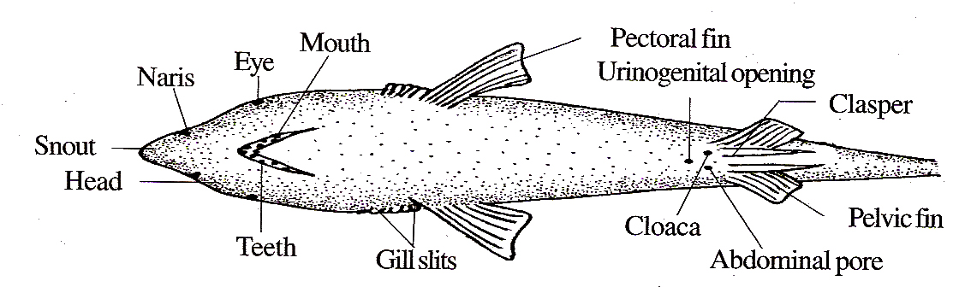

Fig.6.2: Scoliodon – ventral view.
The hypochordal lobe has a notch dividing it into a large anterior part and a small posterior part. In the root of the caudal fin, there is a caudal pit on both the dorsal and ventral sides.
The ventral side has a ventralfin infront of the caudal fin.
2. Paired Fins or Lateral Fins: Paired fins occur in pairs on the lateral sides of the body, especially in the trunk region. As they are present on the lateral sides, they are also called lateral fins.
Shark has two types of lateral fins, namely pectoral fins and pelvic fins. These fins correspond to the fore limbs and hind limbs of higher vertebrates.
The pectoral fms are large and triangular in shape. They are located just behind the gill slits.
The pelvic fins are smaller and are subtriangular. They are located on the ventral side at the junction of the trunk and tail on either side of the cloacal aperture.
In the male, each pelvic fin bears on its inner edge, a rod-like structure called clasper. Each clasper has a groove on its dorsal surface leading into a cavity at its base.
Placoid Scales
The skin of shark contains thousands of spine-like structures called placoid scales. They form the exoskeleton. They are dermal in origin.
Each placoid scale has a basal plate and a spine. The spine is a trident. It is formed of dentine. The dentine is externally coated with enamel. It encloses a cavity called pulp cavity.
It is filled with pulp containing numerous odontoblasts, blood vessels, nerves, etc.
The basal plate is diamond-shaped. It has an opening in the centre to open into the pulp cavity.
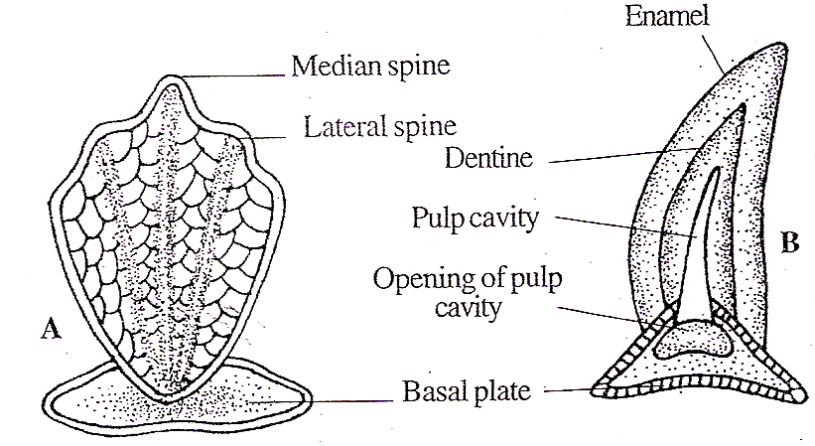

Fig.6.3: Shark- A. Placoid scale (Entire); B. Placoid scale (L.S.).

Digestive System
The digestive system includes the alimentary canal and the digestive glands. Alimentary Canal
The alimentary canal starts with the mouth. The mouth is crescent-shaped and it is located on the ventral side of the head. It is bounded by upper and lower jaws.
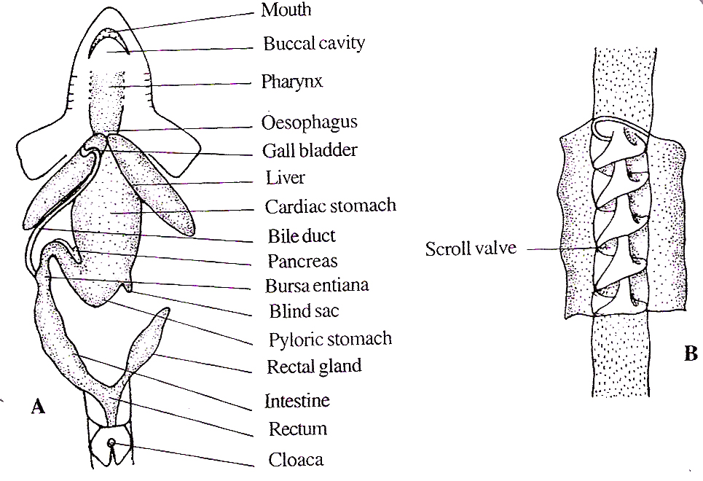
The jaws are provided with one or two rows of teeth. The teeth are homodont and polyphyodont. The teeth are not used for mastication; but for catching and preventing the escape of prey.

Fig.6.4: Shark –A. Digestive system; B. Spiral valve
The mouth leads into the buccal cavity. The buccal cavity contains a tongue. The buccal cavity opens into the pharynx. The pharynx receives the openings of a pair of spiracles and five pairs of gill pouches on the sides. The pharynx is followed by a narrow oesophagus.
The oesophagus opens into the stomach. It is J-shaped. The stomach has two regions, namely an anterior, wide cardiac stomach and a posterior, narrow pyloric stomach. These two are separated by a short blind sac. The distal end of pyloric stomach is slightly dilated to form a sac called bursa entiana.
The stomach leads into the intestine. The intestine is lined with mucous membrane. The mucous membrane is folded to form a scroll valve.
One edge of the scroll valve is attached to the inner wall of the intestine and the other edge is rolled up on itself longitudinally making an anticlockwise spiral of about two and a half folds.
In a cross section, it looks like a watch spring. It has two functions: a. It increases the area of absorption, b. It prevents the rapid flow of food through the intestine. The intestine leads into the rectum which opens into the cloaca. The rectum contains a rectal gland.

Digestive Glands
Shark has two digestive glands, namely the liver and the pancreas.
Liver: Liver is located at the junction of oesophagus and cardiac stomach. The liver is formed of two lobes. The two lobes are united anteriorly and free posteriorly.
The right lobe contains the gall bladder. A bile duct arises from the gall bladder and it opens into the intestine.
The liver has three functions: 1. It secretes bile, 2. It stores glycogen and fat, 3. It destroys worn out RBC.
Pancreas: The pancreas is located in the loop of the stomach. It is bilobed. The pancreatic duct arising from the pancreas opens into the intestine opposite to the bile duct.

Physiology of Digestion
Shark is carnivorous, feeding on fishes, crustaceans, molluscs, etc. The teeth prevent the escape of prey. Digestion starts in the stomach and is completed in the intestine. Absorption occurs in the intestine. The scroll valve helps absorption.

Respiratory System
The respiratory system is formed of five pairs of gill pouches. They are located on the lateral wall of the pharynx. They open into pharynx by an internal branchial aperture and to the outside by the external branchial aperture.
The mucous membrane of gill pouches is produced into a series of leaf-like structures called branchial lamellae. They are highly vascularized.
Each gill pouch has two sets of branchial lamellae; one is on its anterior wall and the other is on its posterior wall
The lamellae of one side of each gill pouch constitute a hemibranch. Two hemibranchs constitute a holobranch.
The gill pouches are separated by interbranchial septa. An interbranchial septum is nothing but a part of the pharyngeal wall located in between the gill pouches.
Each interbranchial septum is supported by a cartilaginous rod called visceral arch. The visceral arches at their inner end bear comblike gill rakers to protect the internal branchial aperture.
The visceral arch lying infront of the first gill pouch is called hyoid arch. The hyoid arch bears only one gill on its posterior surface. Hence it is a hemibranch. The remaining posterior arches are called I, II, III, IV and V branchial arches.
The last branchial arch is without any gills. Hence it is an abranch. The remaining four oranchial arches bear four holobranchs. Hence shark has nine hemibranchs on each side.

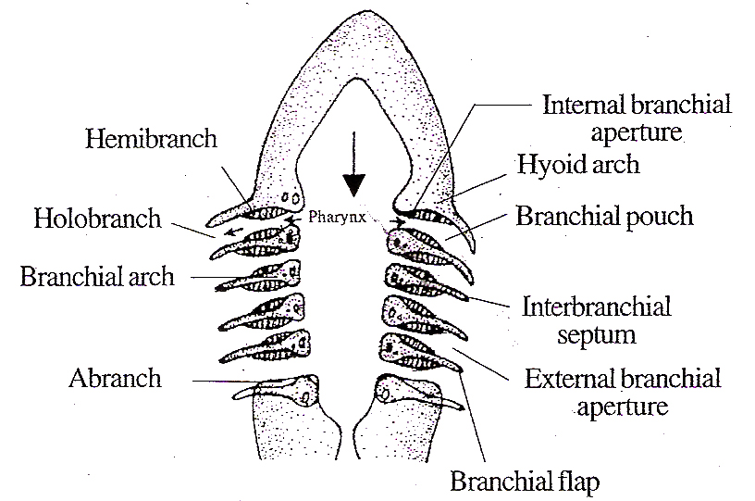

Fig.6.5: Shark- Respiratory system
In shark, the gill lamellae are attached to the entire length of the interhranchial septum; hence the gills are called lamelliform. Between the mandibular arch and the hyoid arch there is a pit in the inner wall of the pharmx. It is called spiracle.
In shark, it has no lamellae and no opening to the exterior. It is a vestigial gill. In other clasmobranchs, it is a functional gill having amellae and an opening to the exterior.

Mechanism of Respiration
The respiration in shark is aquatic. The gills are the respiratory organs. During respiration the mouth is opened and the buccal and pharyngeal cavities are enlarged. Water is draws in through the mouth. The water enters the gill pouches through the internal branchial apertures. The entry of blood particles into the gill pouches is prevented by the gill rakers.
From the gill pouches, the water passes out through the external branchial apertures after washing the branchial lamellae. The O₂ from the water diffuses into the blood and the CO₂ diffuses into the water.

Circulatory System
The circulatory system comprises the heart, blood, arteries and the veins.

Blood
The blood is reddish in colour. It has a liquid component called plasma andcellular components. The cellular components include RBC, WBC, platelets, etc.

Heart
The heart is the muscular puniting' organ of the circulatory system. The heart is located beneath the pharynx. It is a conical muscular organ. It is enclosed in a two layered sac called pericardium. The heart is formed of two chambers, namely an atrium and a ventricle.
Sclerotic coat is the outer covering. It is cartilaginous. Anteriorly it remains as a transparent membrane called cornea. The cornea is covered by a thin membrane called conjunctiva.
The choroid coat is the middle layer. It is formed of blood vessels and pigment cells.
The inner surface of the choroid coat contains a layer of cells having light reflecting guanine crystals. This layer is called tapetum lucidum. They reflect the light back to the retina.
Anteriorly the choroid forms a circular disc called iris. The centre of the iris has a slit called pupil. A lens is located in the pupil.
At the junction of the iris and the choroid there is a nonpigmented, non- vascular thickened area called the ciliary body. The inner surface of the ciliary body is thrown into radiating folds called ciliary processes.
The lens is attached to the ciliary process by a gelatinous suspensory ligament . The lower side of the lens is attached to the ciliary body by a muscle called protractor lentis muscle.
Retina is the innermost layer. The retina contains photosensitive cells called rods, cones are absent Hence fish is colour blind. From the rods nerve fibres arise.
All the nerve fibres converge towards the posterior side of the eyes and come out with the name of optic nerve. The point of the retina from where nerve leaves the eye is called blind spot The blind spot is free from rods; so this area cannot form any image and hence the name.
The eye is protected by three eyelids, namely the upper eyelid, the lower eyelid and the nictitating membrane. The nictitating membrane is a special outgrowth of the anterior region of the lower eyelid. It can cover the eye fully.
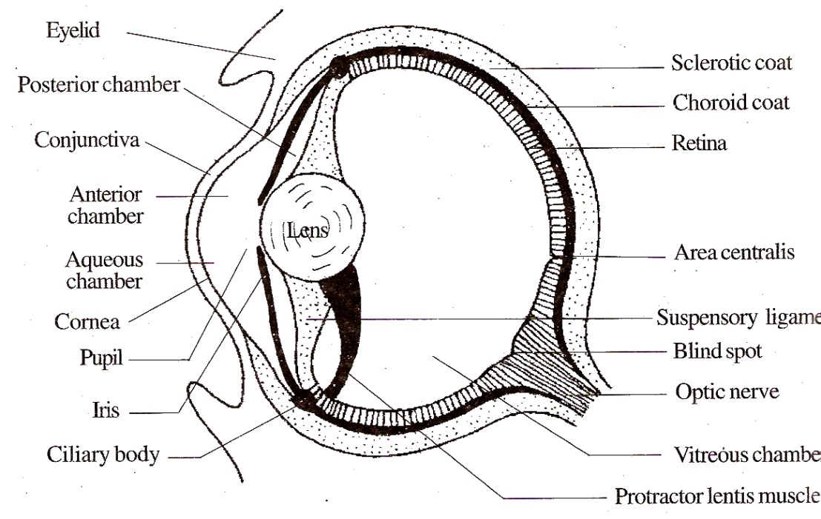
The eye encloses cavities filled with a transparent gelatinous fluid called humour.

Fig.6.6: Shark – Eye
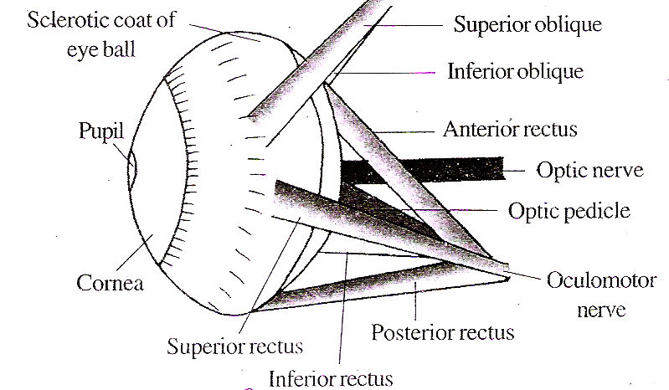

Fig.6.7: Scoliodon- Eye and muscles

(humor). The cavity lying between cornea and iris is called anterior chamber.
The small cavity lying between the lens and the iris is called posterior chamber. These two chambers are filled with a thin watery liquid called aqueous humour. Hence these two chambers are collectively called aqueous chambers.
The large cavity lying between the lens and the retina is called vitreous chamber and it is filled with a jelly like material called vttreous humour.
The eyes are kept in position in the orbit by 6 muscles and an optic pedicle which is cartilaginous.
The eye muscles are the following
- Superior oblique muscle
- Inferior oblique muscle
- Superior rectus muscle
- Inferior rectus muscle
- Anterior rectus muscle
- Posterior rectus muscle
These muscles bring about the movement of eye ball.
The eyes have a monocular vision. The two eyes are independent in vision. They cannot discriminate between colours. They are colour blind. The eyes are adapted for vision in dimlight.

- Ears
Ears are the organs of equilibrium and hearing. The shark has. two ears. The external and the middle ears are absent. Only internal ears are present in the shark.

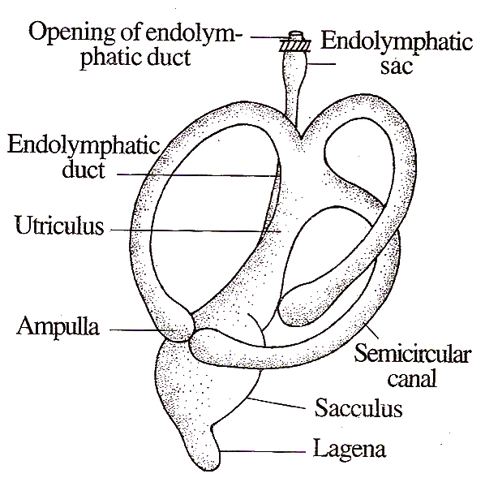

Fig.6.8: Scoliodon – Internal ear
The internal ear is called membranous labyrinth. It is enclosed in a cartilaginous labyrinth. There exists a space in between the membranous labyrinth and the cartilaginous labyrinth. It is called perilymphatic space. The membranous labyrinth is filled with endolymph.
The membranous labyrinth has two chambers, namely a dorsal utriculus and a ventral sacculus. The sacculus gives out a small projection from its ventral side, called lagena.
A small canal arises from the dorsal side of the sacculus called endolymphatic duct. It runs upwards and dilates to form a sac called endolymphatic sac. It opens to the outside on the dorsal side.
The utriculus has three semicircular canals. Both ends of the canal open into the utriculus. One end of each tube becomes dilated to form a sac called ampulla. One duct is horizontal and the other two are vertical in position.
The inner ear is provided with six sensory patches. Of these, three are in the ampullae and they are called cristae. The other three are in utriculus, sacculus and lagena and they are called maculae.

4. Lateral Line Sense Organs (Neuromast Organs)
The lateral line sense organs are rheoreceptors of fishes. They detect the water current. They are in the form of two canals embedded in the dermis, one on each side of the body. They extend from the head to the tail.
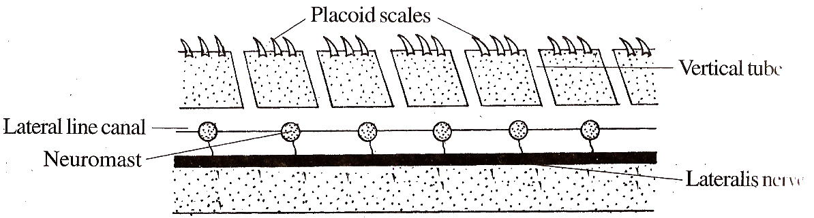

Fig.6.9: L.S. of lateral line.
In the head region, they are highly- branched. Just behind the head, the two lateral canals are joined dorsally by a commissural occipital canal, Then each canal runs forward as the temporal canal. Each temporal canal divides into many branches.
The canals are filled with mucous. They open to the exterior by vertical tubes. The tubes are lined with epithelial cells. There are many mucous gland cells secreting mucous.
There are groups of sensory cells called neuromasts. Each neuromast is made up of a group of sensory receptor cells and supporting cells.
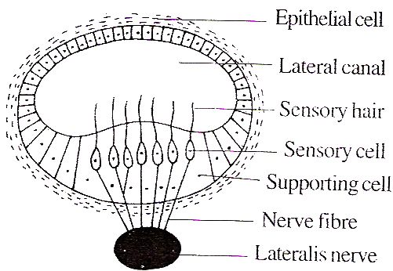
Each sensorycell has a sensory hair at its inner surface and a rieme fibre at its outer surface. The nerve fibres are connected to the lateralis nerve.

Fig.6.10: Lateral line through a neuromast.
The sensory hairs are tipped with a gelatinous substance in the form of a cup called cupula.

Functions
The neuromast organs detect the vibrations in water. This helps the fish to move in darkness and turbid water. It also helps the fish to detect the enemies.
5. Ampuliae of Lorenzini
These are thermoreceptors of shark. They are present in groups in the head. They are embedded in the skin.
Each ampulla of Lorenzini has an elongated tube called tubule filled with mucous. The outer end opens to the exterior by an aperture and the inner end has a dilated ampullary sac.
Each ampullary sac has 8-9 chambers arranged around a central core called centrum. The ampullary sac is lined with two types of cells, namely gland cells and sensory cells. The gland cells secrete mucous. The sensory cells are connected to netye fibres.

Urinogenital System
The urinogenital system includes two systems, namely the excretory system and the reproductive system.

Excretory System
The excretory system includes a pair of kidneys, a pair of ureters and an urinogenital sinus.
The kidney is a mesonephros. It is long and flattened. It extends from the cloaca to the oesophagus. It has two distinct parts, namely a slender anterior part and a thicker posterior part.
In the male, the anterior part is called genital kidney. This part is rudimentary and functionless in the female. The posterior part is called renal kidney. It carries out the excretoty function.
The kidney is formed of thousands of tubules called uriniferous tubules or nephron. One end of each uriniferous tubule is a Malpighian corpuscle. It is formed of a tap-like structure called Bowman’s capsule and a network of capillaries called glomerulus. The other end is connected to a collecting tubule which receives many uriniferous tubules.
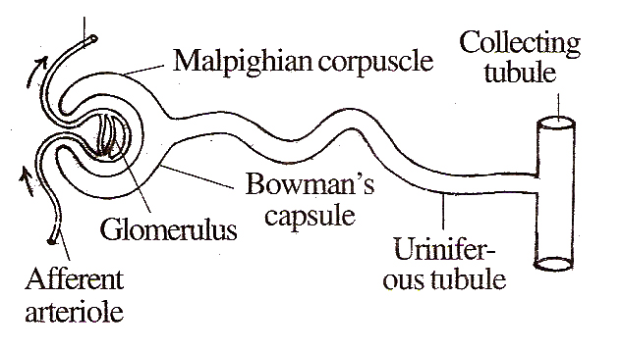

Fig.6.11. A nephron
The collecting tubules open into the ureter. The ureters of the two kidneys open into an urino-genital sinus which intum opens to the cloaca.

Reproductive System
In shark, the sexes are separate. It exhibits sexual dimorphism.
In the male, the inner margins of the pelvic fins bear a pair of copulatory organs called claspers. They are absent from the females.

Male Reproductive System
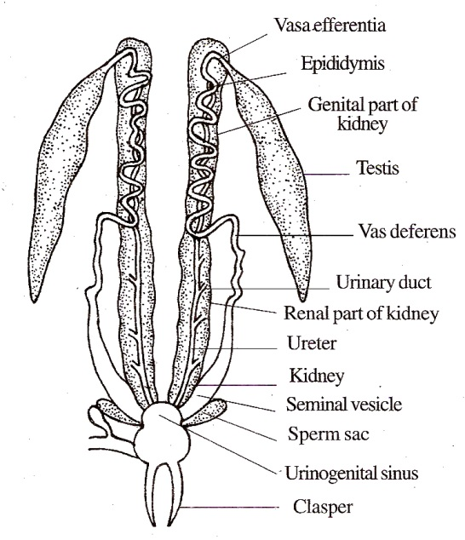
The male has two testes. They are elongated. They are attached to the dorsal body wall by a membrane called mesorchium.

Fig.6.12: Scoliodon – Male urinogeni

From each testis arise several vasa efferentia. The vasa efferentia open into a vas deferens. It remains much coiled in the genital kidney. This is called epididymis. It comes out of the kidney and posteriorly it dilates to form a sac called seminal vesicle.
The seminal vesicles open into the urinogenital sinus which in turn opens into the cloaca. Two sperm sacs of unknown function are attached to the urinogenital sinus.

Female Reproductive System
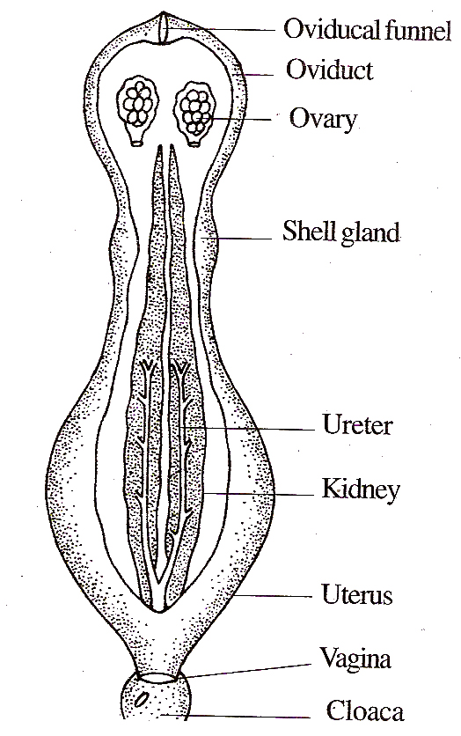
It consists of a pair of ovaries, oviducts, shell glands and uteri. The ovaries are located behind the oesophagus.

Fig.6.13. Scoliodon – Female urino genital systemi

They are attached to the dorsal body wall by a membrane called mesovarium.
The oviducts are long and they open into the body cavity by oviducalfunnels near the oesophagus. Near the middle the oviduct has a sac called shell gland to store spermatozoa.
Posteriorly, the oviduct dilates to form a sac-like uterus. The two uteri join together to form a vagina. The vagina opens into the cloaca.

Copulation and Fertilization
Mature males and females take part in copulation. During copulation, the claspers are introduced into the cloaca of the female.
The sperms are introduced into the vagina. Fertilization is internal and occurs in the oviduct.
Development
In the case of Scoliodon, fertilization is internal. The fertilized egg develops inside the uterus of the mother and the mother gives birth to youngones.
The embryo is nourished by the yolk stored in the egg and the mother gives mainly protection. This type of development is called ovoviviparous.
About 3-7 embryos develop inside the uterus. The yolk of the developing embryo is enclosed in a sac called yolk sac.
The yolk sac gets connected with the gut of the embryo by a tubular yolk stalk. When the yolk is used up, the reduced yolk sac gets attached to the uterine wall of the mother. This tissue connection between the embryo and the uterus is called yolk sac placenta. In the mean time, blood vessels enter the yolk sax by way of the yolk stalk. Now the yolk stalk is called placental cord.
Nutritive materials are transferred through the placental cord. The placental cord sends numerous slender tubular outgrowths called appendicula into the uterine wall to absorb more food.

