Chapter – 7 : Osteichthyes

Lates calcarifer
Phylum : Chordata
Subphylum : Vertebrata
Super class: Pisces
Class : Osteichthyes
Sub class : Actinopterygii
Superorder : Teteostei
Order : Cypriniformes

Lates caicarifer has fins, scales and lateral line sense organs. Hence it is included in the super class Pisces. Its vertebral column is bony in nature. Hence it is included in the class Osteichthyes.
Lates caicarifer is an estuarine fish. It is also found in freshwater streams.It is carnivorous. The sexes are separate. It is oviparous and it lays eggs. Development is direct The body is spindle shaped. The body is covered with ctenoid scales (scales with spines). The body consists of three regions namely the head, trunk and tail.
The head bears & snout, a mouth, a pair of nostrils, a pair of eyes and a pair of oper- cula. The mouth is wide and terminal located at the tip of the head. The mouth is bounded by the jaws, the upper jaw and lower jaw. The jaws bear teeth.
The dorsal side of the head has a pair of nostrils. They do not open into the buccal cavity. So they are not respiratory in function. But they detect smell.
Behind the nostrils, two eyes are located on the lateral sides. Eyelids are absent. But the eyes are protected by a transparent membrane.
Behind the eye there is a bony flap called operculum or gill cover. It encloses a cavity called gill chamber or branchial chamber: The branchial chamber contains 4 gills. The branchial chamber opens to the outside by the branchial aperture. The posterior margin of the operculum is attached with a membrane called branchiostegal membrane.
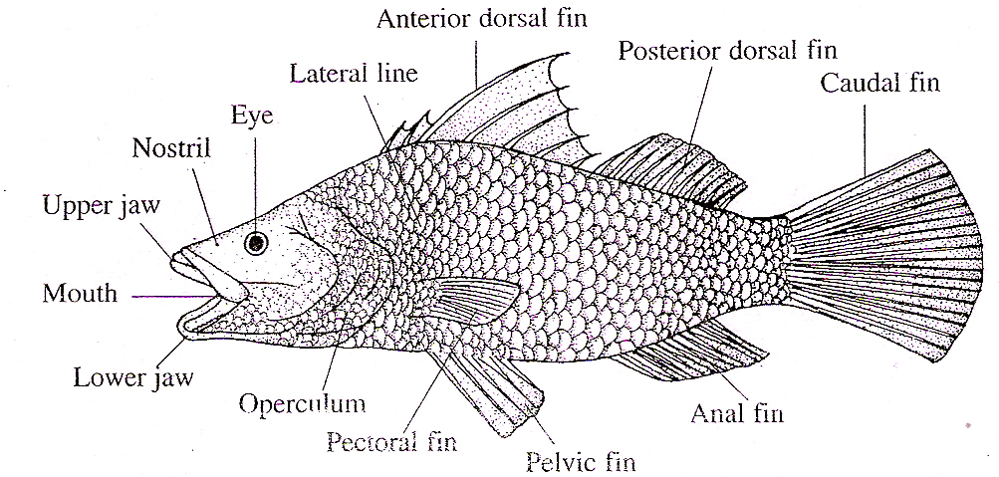

Fig.7.1: Lates calcarifer
The trunk is the main bulk of the body, it is covered by ctenoid scales. They are attached by the anterior side and the posteier side is free. The free end bears spines. The anterior row of scales overlap the posterior row.
The posterior end of the trunk has an opening on the ventral side called vent. The recent receives anus of the gut, genital apernures and urinary aperture.
The trunk bears an anterior dorsal fin, ; pair of pectoral fins and a pair of pelvic fins.
The tail is the posterior part of the body, t has a posterior dorsal fin on the dorsal ide, an anal fin on the ventral side and a audal fin at the posterior end. The vent is situated infront of the anal in. A lateral line is present on each side of the trunk and tail.

Fins
Fins are flap-like outgrowths of the skin directed backwards and supported by rods called fin rays. Lates has two types of fins. They are, Lateral fins (paired fins) and median fins. Lates has 4 types of median fins namely anterior dorsal fin, posterior dorsal fin, anal fin and caudal fin. The anterior dorsal fin is situated maiddorsally in the middle of the trunk. It is tail-like. It is supported by 7 fin rays the third one is the largest. The posterior dorsal fin is situated behind the anterior dorsal fin. The anal fin (ventral fin) is located behind the vent. It is supported by 11 fin rays.
The caudal fin is situated at the posterior end. It is fan-like. It is supported by 19 fin rays. It is made up of a single lobe and such a tail fin is called homocercal.
Lates has two types of paired fins. They are pectoral fins and pelvic fins.
The pectoral fins are located behind the operculum, one on each side. It is supported by 14 fin rays.
The pelvic fins are situated behind and below the pectoral fins. They are rhomboi- dal in shape. Each pelvic fin is supported by 5 fin rays. The fins are used for swimming.

Ctenoid Scales
Ctenoid means comb-like. These scales have teeth. They are present in teleost fishes and some actinopterigians. They are dermal in origin.
In Lates the head, trunk and tail are covered by ctenoid scales. They are oval in shape.They are attached by the anterior end and the posterior end is free. The posterior margin has comb-like teeth called cteni. They are arranged in an overlapping fashion like the tiles on the roof of a house. It is made up of two layers, namely an outer isopedine and inner fibrous layer.
The central part of the scale is called focus. It is the first part to develop. The focus is surrounded by concentric bony ridges called lines of growth (growth rings).Some growth lines are thick and they are called annuli.

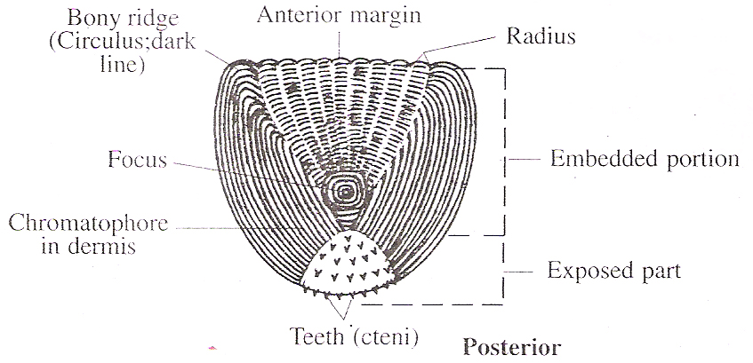

Fig.7.2: Lates – Ctenoid scales
A number of grooves radiate from the centre to the margin. They are called radii or radius.

Body Wall
The body wall is covered by ctenoid scales. The body wall (skin) consists of 4 layers namely epidermis, dermis, muscles and peritoneum.
The epidermis is the outer layer. It is formed of stratified squamous epithelium. The epithelial cells rest on a basement membrane. The epidermis contains mucous glands secreting mucous.
The dermis lies below the epidermis. It is made up of connective tissue. The outer part of the dermis contains pigment cells. Ctenoid scales are embedded in the dermis below the epidermis. Below the dermis, the muscles are metamerically arranged. Each muscle block is called a myotome. The my tomes are shaped. They are separated by connective tissue septa called myocommata.
The inner most layer of the body wall is called peritoneum. It is the coeiomic epithelium. lining the body wall
Coelom
Coelom is the cavity between the body wall and gut. It is lined by coelomic epithelium (peritoneum). The coelome is filled with a fluid called coelomic fluid. The coelomic epithelium lining the body wall is called pericardial peritoneum and the coelomic epithelium lining the gut is called visceral peritoneum. The coelom is divided into two unequal compartments by a vertical partition called septum transversum. The anterior compartment is small and is called pericardial cavity. It encloses the heart The posterior compartment is large and is called perivisceral cavity. It encloses all visceral organs except heart.
The visceral organs are suspended from the dorsal body wall by a membrane called mesentery.

Digestive System
The digestive system consists of alimentary canal and digestive glands. Alimentary Canal. Alimentary canal is the gut It starts from the mouth and ends with the anus. The alimentary canal consists of mouth, buccal, cavity, pharynx, oesophagus, stomach, intestine, rectum and anus.
The mouth is terminal. It is a transverse, wide opening. It is bounded by an upper jaw and a lower jaw. The jaws are provided teeth. The mouth leads into a spacious buccal cavity. The floor of the buccal cavity has a tongue. The tongue is non-muscular\
The buccal cavity leads into the pharynx which is spacious. The wall of the pharynx is perforated by 5 pairs of vertical slit-like openings calledgill-slits. They open into the gill chamber. The wall of the pharynx between the gill slits is supported by gill arches. The pharynx leads into a tubular oesophagus.
The oesophagus leads into the stomach. The opening of oesophagus into the stomach is guarded by sphinter muscles to prevent the entry of water into the stomach.
The stomach is V-shaped. It consists of two regions namely an anterior cardiac stomach and a posterior pyloric stomach. The pyloric stomach leads into the intestine. There is a pyloric constriction at the junction of pyloric stomach and intestine. From the pyloric constriction five finger-like outgrowths called pyloric caeca arise.
The intestine continues as the rectum. The rectum opens to the outside by the anus in the middle of the vent.
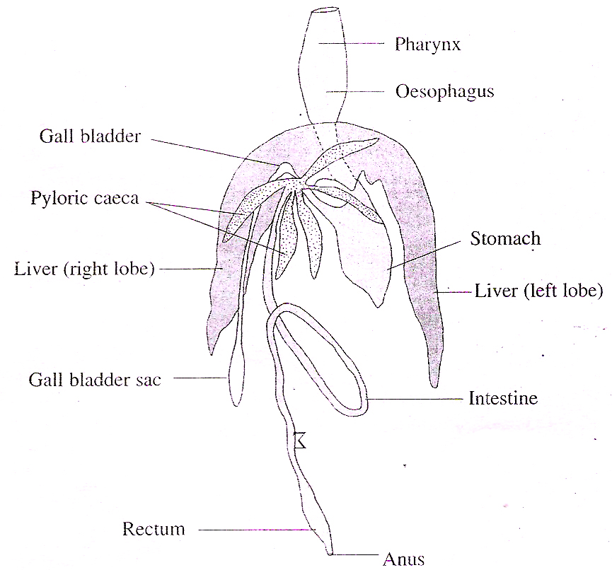

Fig.7.3: Lates – Digestive system

Digestive Glands
The digestive glands include liver and pancreas.
The liver is bilobed and the two lobes are connected by a transverse band.
The left lobe is longer than the right. The liver secretes bile. The bile is carried by hepatic ducts which open into the gall bladder.
The gall bladder is a pear-shaped greenish sac located near the right lobe of the liver. The gall bladder continues backwards as a tube along the right lobe of the liver and behind the liver, it dialates to form a sac. A duct, called bile duct arising from the gall bladder opens into the intestine just behind the junction with the pyloric stomach.
There is no separate pancreas in Lates. The pancreatic gland cells are found diffused among the liver tissues. The secretion of pancreatic gland cells is called pancreatic juice. It mixes with the bile and is earned by the bile duct.
Feeding
Lates is carnivorous. It feeds on the fry of fishes and the larvae of crustaceans. The food organisms enter the buccal cavity through the mouth along the respiratory water current. They enter the pharynx and the mouth is closed. The water is forced out through the gill-slits. The gill rakers present on the gill slits prevent the escape of food organisms through the gill slits. Thus the water is sent into the gill chamber for respiration and the food organisms are retained inside the pharynx.
The food organisms are then passed into the stomach through the oesophagus. In the stomach, they are mixed with bile and pancreatic juice. They digest the food partly.
The partly digested food enters the intestine where the digestion is completed. The distal part of the intestine absorbs the digested food. The unabsorbed wastes are passed into the rectum and then to the outside through the anus.

Air Bladder
Air bladder is a gas filled sac located above the gut. It is present the whole length of the body. It has no connection with the gut and hence called physoclistous air bladder. But in the early stage it remains connected with the oesophagus by a duct called pnematic duct. The air bladder with a pneumatic duct is called physostomous air bladder.The air bladder consists of two chambers called an anterior chamber and a posterior chamber.
The two chambers are interconnected by an opening called ductus communicans. The posterior chamber has a network of capillaries called rete mirabile and a gas gland.
The two together are called red body. The red body is concerned with the secretion of gas into the bladder from the blood. The dorsal side of the posterior chamber has a pocket like structure called oval body. It can closed or opened by sphincter muscles. When the sphincter is open, the oval body absorbs gas from the bladder.
The primary function of air bladder is hydrostasis, i.e. it serves to keep the fish at the same density as the water.

Respiratory System
Lates is a gill breather. Respiration is aquatic.The respiratory organs are 4 pairs of gills. They are located inside two gill chambers (branchial chambers). The gill chambers are located on either side of the pharynx in the head region. Each gill chamber is covered by a flap of skin called operculum. The gill chamber opens to the outside by a crescentic opening called gill aperture in front of the pectoral fin and behind the operculum. The posterior margin of the operculum is attached with a membrane called branchiostegal membrane.
The pharynx has 5 pairs of gill slits on the lateral wail of the pharynx and they open Gill filaments Capillaries into the gill chamber. The wall of the pharynx between the gill slits is called the interbran-chial septum. There are, thus 4 pairs of interbranchial septa. Each inter branchial septum is supported by a branchial arch (gill arch ). The first four pairs of branchial arches support the four pairs of interbranchial septa.
Lates has 4 pairs of gills. Each gili chamber accomodates 4 gills. Each gill is formed of a gill arch and gill filaments. The gill filaments are attached on the anterior and posterior faces of the gill arch in two rows. Thus each gill is a holobranch formed of two hemibranchs. Each hemibranch is a row of gill filaments.
In Lates the interbranchial septa are reduced and the gill filaments hang freely into the gill chamber. This type of gill is called filiform or pectinate.
The inner end of each branchial arch is produced into teeth like processes inside the pharyngeal cavity. They are called gill rakers. They prevent the entry of food materials into the gill chamber.
The gill filaments are covered by thin epithelium with blood capillaries.
An afferent artery supplies deoxygenated blood to the gill. The oxygenated blood is collected by an efferent artery.
Mechanism of Respiration
Lates exhibits gill respiration and aquatic respiration. During breathing, the gill apertures are closed tightly by pressing the opercula against the body. The interbranchial septum swells out, the floor of the buccopharyngeal cavity lowers
- As a result, the buccopharyngeal cavity enlarges.
- The mouth opens.
- Water flows in through the mouth and the buccopharyngeal cavity is filled with water.
- Now the mouth is closed.
- The interbranchial septum contracts; the floor of the buccopharyngeal cavity moves up.
- The opercula lift up and the gill apertures open
- The water from the buccopharyngeal cavity flows over the gills through the gill slits.
- The gills are bathed in water.
- The blood of gill filaments absorb O, and gives out CO,.
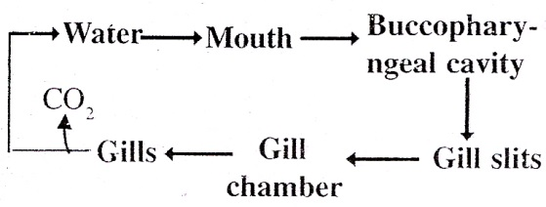
- This process is repeated. This process brings out the regular opening and closing of the mouth and operculum.

Fig.7.4: Respiratory route
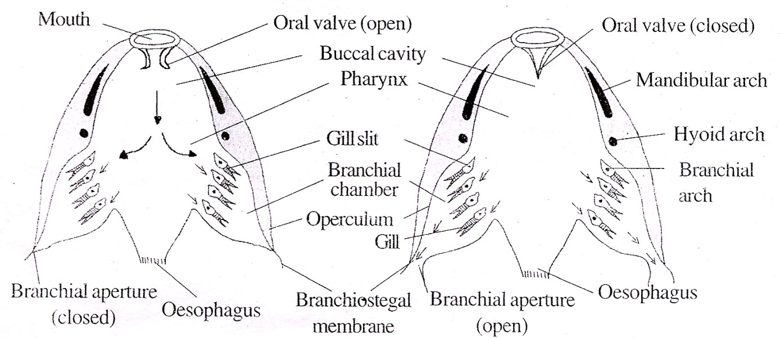

Fig.7.5: Respiratory mechanism

Circulatory System
The circulatory system comprises the blood, heart, arteries and the veins.

Blood
The blood is reddish in colour. It has a liquid component and a cellular component. lie liquid component is called plasma. The cellular components include RBC (Red Blood Corpuscles), WBC (White Blood Corpuscles), platelets, etc.
The blood cells are nucleated. The RBC contains haemoglobin.

Heart
The heart is the muscular pumping organ of the circulatory system.
Fishes have a two chambered heart. It has a venous heart (branchial heart).
The heart is located beneath the pharanx. It is a conical muscular organ. It is inclosed in a two layered sac called peri- cardium. Between the two layers of the pericardium there is a narrow space called pericardial cavity filled with a pericardial fluid. The pericardial fluid protects the heart from shocks and provides free movement to the heart during contraction.

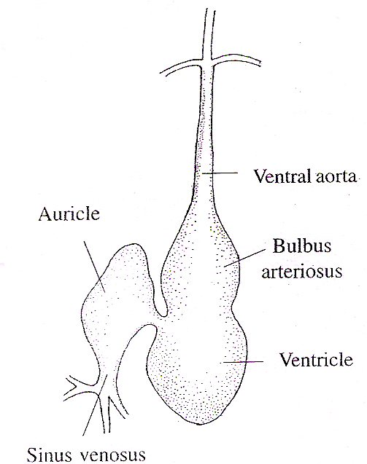

Fig.7.6: Lates Heart
The heart is formed of two chambers, namely an atrium (auricle) and a ventricle. The atrium is oval in shape. It is thin walled. It opens into the ventricle by the auriculo-ventricular aperture guarded by the auriculo-ventricular valve.
The ventricle is thick walled. The inner surface of the ventricle has numerous muscular strands called chordae tendinae. Anteriorly the ventricle leads into a tubular structure called bulb us arteriosus. The opening of the ventricle into the bulbus arteriosus is guarded by valves. The bulbus arteriosus is provided with two transverse rows of semilunar valves. The bulbus continues forwards in the form of a tube called ventral aorta.
The atrium receives blood from a sac called sinus venosus. The sinus venosus is thin walled. It receives venous blood. The sinus venosus opens into-the atrium by the sinu-auricular aperture. It is guarded by the sinu-auricular valves. These valves prevent the flow of blood from the atrium into the sinus venosus.
The heart of Lates contains only deoxygenated blood. Hence it is called venous heart or branchial heart.
As the sinus venosus and bulbus arteriosus are not considered as true chambers, the heart of Lates is called two-chambered heart.
Sense Organs
Lates has the following sense organs: 1. Olfactory sacs, 2. Eyes, 3. Ear, 4. Lateral line sense organs (Neuromast organs )
1. Olfactory Sacs
The Lates has two olfactory sacs located inside the nostrils. They are chemore- ceptors. They feel the sense of smell They open to the exterior by external nostrils.

2. Eyes
The eyes are photoreceptors. Lates has two eyes. They are located on the sides of the head in the orbits. The eye is in the form of a hollow ball called eye ball Cts wall is formed of three coats, namely an outer sclerotic coat, a middle choroid coat and an inner retina.
Sclerotic coat is the outer covering. It is cartilaginous. Anteriorly it remains as a transparent membrane called cornea. The cornea is covered by a thin membrane called conjunctiva. The choroid coat is the middle layer. It is formed of blood vessels and pigment cell between the choroid and the sclerotic coat, there is a silvery reflecting layer called argentea. The choroid coat extends into the eye through region of optic nerve as a vascular body called falciform process. The free end of falciform process becomes attached to the lens by a retractor lentis muscle. The falciform process moves the lens front and back to see near and distant objects. The lens does not change its size.
The inner surface of the choroid coat contains a layer of ceils having light reflecting guanine crystals. This layer is called tapetum lucidum. They reflect the light back to the retina.

Anteriorly it forms a circular disc called iris. The centre of the iris has a slit called Pupil. A lens is located in the pupil. At the fuction of the iris and the choroid lies the liary body.
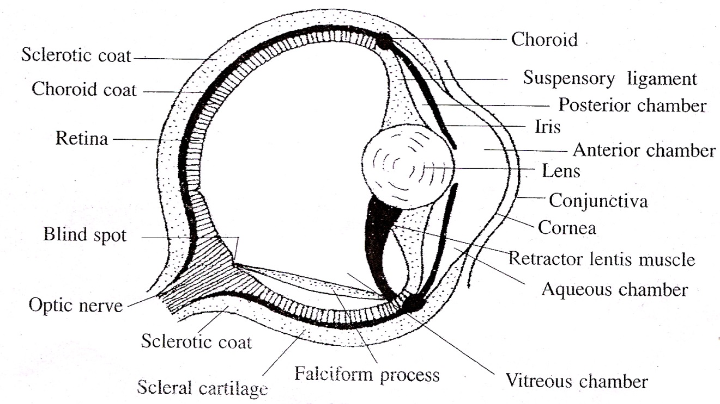

Fig.7.7: Lates - Eye
The inner surface of the ciliary body is crown into redialing folds called ciliary -ocesses.
The lens is attached to the ciliary process by a gelatinous suspensory ligament. The lower side of the lens is attached with the ciliary body by a muscle called retractor lentis muscle.
Retina is the innermost layer. The retina contains photosensitive cells called rods cones are absent. From the rods nerve fibres arise. All the nerve fibres converge towards the posterior side of the eyes and come out with the name of optic nerve. The point of the retina from where nerve leaves the eye is called blind spot.
The eye is protected by three eyelids, namely the upper eyelid, the lower eyelid called the nictitating membrane. The nictitating membrane is a special outgrowth of the anterior region of the lower eyelid. It is cover the eye fully.
The eye encloses cavities filled with ansparent gelatinous fluid called humour lumor. The cavity lying between cornea and iris is called anterior chamber. These two chambers are filled with a thin watery liquid called aqueous humour. Hence these chambers are collectively called aqueous chambers.
The large cavity lying between the lens and the retina is called vitreous chamber and it is filled with a jelly like material called vitreous humour.
The eyes have a monocular vision. The two eyes are independent in vision. They cannot discriminate between colours. The eyes are adapted for vision in dimlight.
3. Ears
Ears are the organs of equilibrium and hearing. The Lates has two ears. The external and the middle ears are absent. Only internal ears are present in the Lates.
The internal ear is called membranous labyrinth, It is enclosed in a cartilaginous labyrinth. There exists a space in between the membranous labyrinth and the cartilaginous labyrinth. It is called perilymphatic space. The membranous labyrinth is filled with endolymph.
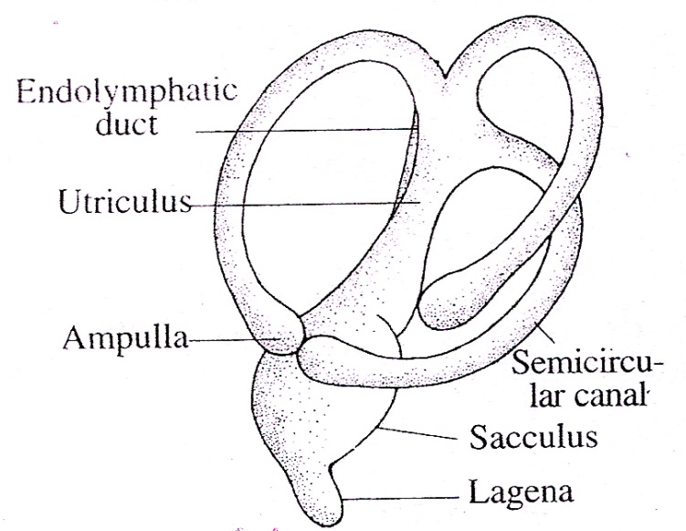

Fig.7.8: Internal ear

The membranous labyrinth has two chambers, namely a dorsal utriculus and a ventral sacculus. The sacculus gives out a small projection from its ventral side, called lagena. A small canal arises from the dorsal side of the sacculus called endolymphatic duct. it runs upwards and dilates to form a sac called endolymphatic sac. It opens to the outside on the dorsal side.
The utriculus has three semicircular canals. Both ends of the canal open into the utriculus. One end of each tube becomes dilated to form a sac called ampulla. One duct is horizontal and the other two are vertical in position.
The inner ear is provided with six sensory patches. Of these, three are in the ampullae and they are called cristae. The other three are in utriculus, sacculus and lagena and they are called maculae.

4. Lateral Line Sense Organs (Neuromast Organs)
The lateral line sense organs are rheoreceptors of fishes. They detect the water current. They are in the form of two canals embedded in the dermis, one on each side of the body. They extend from the head to the tail. In the head region, they are highly branched. Just behind the head, the two lateral canals are joined dorsally by a commissural occipital canal. Then each canal runs forward as the temporal canal. Each temporal canal divides into many branches.
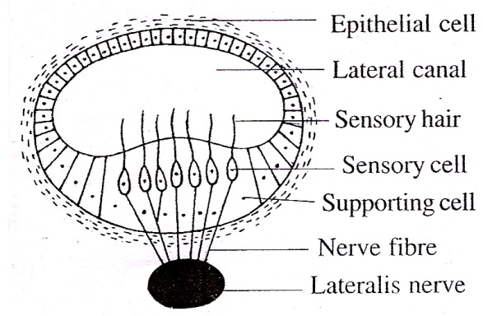

Fig.7.9: Lateral line
The canals are filled with mucous. They open to the exterior by vertical tubes. The tubes are lined with epithelial cells.
There are many mucous gland cells secreting mucous. There are groups of sensory cells called neuromasts. Each neuromast is made up of a group of sensory receptor cells and supporting cells. Each sensory cell has a sensory hair at its inner surface and a nerve fibre at its outer surface. The nerve fibres are connected to the lateralis nerve. The sensory hairs are tipped with a gelatinous substance in the form of a cup called cupula.

Functions
The neuromast organs detect the vibrations in water. This helps the fish to move in darkness and turbid water. It also helps the fish to detect the enemies.
Urinogenitai System
The urinogenitai system includes two systems, namely the excretory system and the reproductive system.

Excretory System
The kidney of Lates is a mesonephros. The excretory system consists of a pair of kidneys, a pair of ureters, urinary duct, urinary bladder and urinary aperture.
Lates has a pair of kidneys. They occupy the entire length of the trunk. The two kidneys remain separate anteriorly but fused posteriorly.
The kidney is formed of thousands of tubules called uriniferous tubules or nephrons. One end of each uriniferous tubule has a Malpighian corpuscle. It is formed of a cup-like structure called Bowman’s capsule and a network of capillaries called glomerulus. The other end is connected to a collecting tubule which receives many uriniferous tubules. The collecting tubules open into the ureter. The two ureters open into an urinary bladder. The urinary bladder opens to the outside by the urinary aperture behind the anus.
The urinary bladder is not homologous to vertebrates. Here it is mesodermal in origin. But in higher vertebrates it is endoder- nml in origin. The ventral surface of the kidney has many openings called nephrostomes. They communicate with the uriniferous tubules internally.
The kidneys do a dual function namely excretion and osmoregulation.
Lates is ammonotelic as it excretes ammonia. The body fluid of Lates is hypertonic, but the surrounding freshwater is hypotonic. Hence water enters the body through, en- dosmosis. The excess water is pumped out by the kidney. The urinary tubules reabsorbsalts from the outgoing urine and hence the urine is very dilute.
Reproductive System
The sexes are separate
Male Reproductive System
Male reproductive system consists of a pair of testes, a pair of vasa deferentia and a pair of male genital apertures. The testes are long. They become large during breeding season. They are formed of seminiferous tubules. They open into a vas deferens. The two vasa deferentia open to the outside on the sides of anus by two male genital apertures.

Female Reproductive System
The female Lates has two ovaries. They are located on either side of the oesophagus. The ovaries are well developed during breeding season. From each ovary arises an oviduct. The two oviducts run backwards and they open to the outside by the female genital apertures (gonopores) on either side of the anus.

Life Cycle
Lates breeds during winter season. The males and females release sperms and eggs into the water. Fertilization is external. The development is direct.
The eggs hatch into hatchlings. The hatchlings develop into fry. The fry develop into fingerlings. The fingerlings grow into adult.

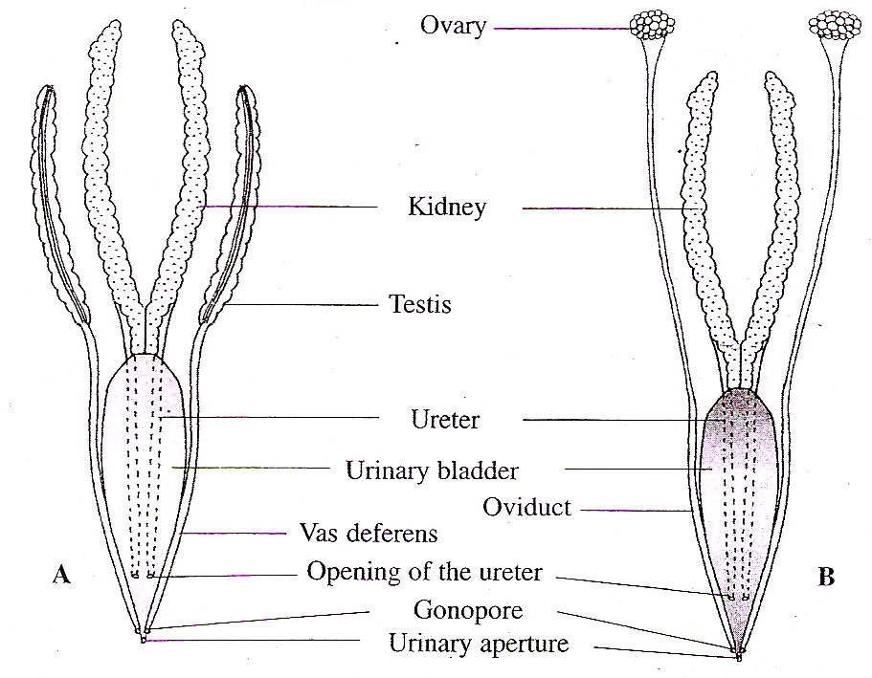

Fig.7.10: Lates- Urinogentital system. A. Male. B. Female

