Chapter – 8 : Amphibia
Amphibia may be defined as ectothermic vertebrates typically living on land and breeding in water; they are having smooth or rough skin rich in glands which keep it moist; if scales are present; they are hidden in the skin .
The term 'Amphibia¹ refers to a double life (Amphi=double; bios=life). The amphibians live both in water and on land.
They are the first group of vertebrates living on land. They came from water. They are not fully adapted for the life on land. A part of their life is carried out in water. So they lead an amphibious life.
They originated from fishes. Structurally, amphibians are intermediate between fishes and reptiles. Eg. Frogs, toads, caecilians, etc.

General Characters
Amphibians possess the following general characters:
1. Amphibians are cold blooded vertebrates with dual life.
- They contain a cranium around the brain. So they are called Craniata.
- They have jaws. Hence they are included in the superclass Gnathostomata.
- They are tetrapods having 4 limbs.
- The embryos do not develop an amnion. Hence they are called an amniota.
- All amphibians are freshwater forms. There are no marine amphibians.
- The skin is moist, glandular and without outer scales.
- The limbs are pentadactylous (having 5 digits).
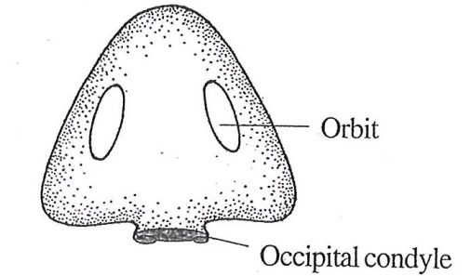
- The skull possesses two occipital condyles

Fig.8.1: Skull of frog showing two occipital condyles
- The heart is 3-chambered consisting of 2 auricles and one ventricle.
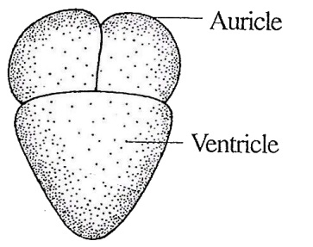

Fig.8.2: Three chambered heart of Amphibia

- Three pairs of aortic arches are present.
- The RBCs are nucleated.
- The respiratory organs include gills, lungs, skin and buccopharynx,
- The kidney is a mesonephros.
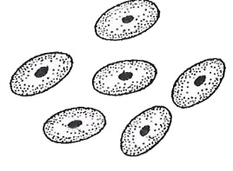
- They contain 10 pairs of cranial nerves.

Fig.8.3:Nucleated RBC of Amphibia
- The ear consists of middle ear and internal ear. External ear is absent. The middle ear contains a single ear bone called columella auris.
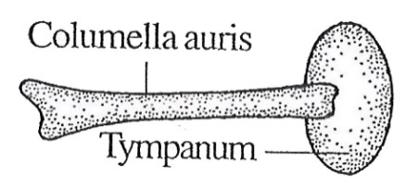

Fig.8.4: Columella auris of Amphibia

- The sexes are separate With sexual dimorphism.
- Amphibians are oviparous i.e. laying eggs.
- Fertilization is external.
- The development is indirect. A tadpole larva is included in the life history.
- Metamorphosis commonly takes place in them.

Classification of Amphibia
Amphibians are cold blooded vertebrates living both in water and land.
Amphibians are Chordates as they develop a notochord in the embryonic stage.
They are vertebrates because they contain a vertebral column.
They have a cranium around the brain. So they are included in the group Craniata.
They have jaws. So they are included in the superclass Gnathostomata.
They do not develop an amnion. So they are included in anamniota. They have 4 limbs. So they are included in the group Tetrapoda.
Class Amphibia is divided into three subclasses, namely:
- Labyrinthodontia - Extinct
- Lepospondyli - Extinct
- Lissamphibia - Extant

Bufo melanostictus (Toad)
Phylum Chordata
Sub phylum Veriebrata
Superclass Gnathostomata
Class Amphibia
Subclass Lissamphibia
Order Amir a
Bufo is the toad. It is an amphibian. It has no tail and hence it is included in the order Anura.
It is more terrestrial than frog. It lives most of the time on moist land. It is nocturnal in habit.
Bufo lives in damp places near ponds and ditches. It leads a dual life living both in water and on land (Amphibia: Amphi-two, bios-life). But it is more terrestrial.
During winter season it goes to winter sleep, hibernation.
It is a cold blooded animal, a poikilotherm. It is carnivorous and nocturnal in habit.
It breeds in water. The development is indirect as the life cycle includes a tadpole larva. The tadpole lives in water only. It undergoes metamorphosis to become the adult. It is grey in colour. But it can change its colour according to the colour of the background.
The body consists of two regions, namely a head and a trunk. The head is triangular in shape and has a semicircular outline. Anteriorly the head is produced into a short snout.
The mouth is located below the snout. The mouth is bounded by an upper jaw and a lower jaw. Two nostrils are present on the dorsal side of the snout.
Two eyes are present on the head. The eye has three eyelids, namely an upper eye lid, a lower eye lid and a nictitating membrane. Behind the eye, the head has a circular membrane called tympanum.
Two elevated ridges are present on the two sides of the head.
In the male, the ventral side of the head has a pouch called vocal sac. Behind the tympanum, the anterior side of the trunk has an elongated gland on each side called parotid gland. These glands act as organs of offense and defense. They secrete a pungent poisonous secretion. When the secretion falls on the eye, it causes irritation. When swallowed, it causes nausea and affects the heart.
The trunk has two pairs of limbs namely. fore limbs and hind limbs. The fore limbs are smaller than the hind limbs.
Bufo has a pair of fore limbs. They are situated at the anterior end of the trunk.
The fore limb consists of three regions, namely a proximal upper arm (brachium), a middle/ore arm (ante-braeilium) and a distal hand (manus).
The hand in turn is divisible into three regions, namely a wrist (carpus), a palm (metacarpus) and the fingers. Bufo has 4 fingers. The first linger, corresponding to our thumb (pollex) is absent.
In the case of male, a cushion-like pad develops on the index finger during the breeding season, it Is called nuptial pad. The nuptial pads help to grip the female during amptexus.
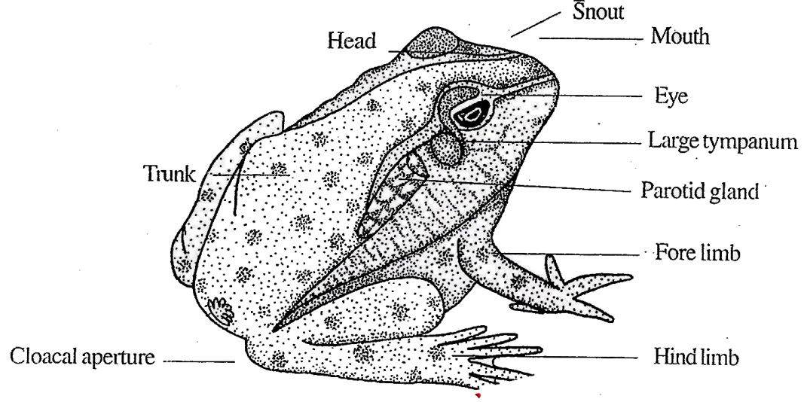

Fig.8.5: Bufo

The Bufo has a pair of hind limbs. They - located at the posterior end of the trunk, e hind limbs are strongly built and are much ger than the fore limbs.
The hind limbs are used for jumping and emming. Each hind limb consists of three ions, namely a proximal thigh (femur), a idle shank (crus) and a distal foot (pes).
The foot in turn is divisible into three ions, namely an ankle (tarsus), an instep tatarsiis) and the toes. A cloacal aperture is present at the serior end of the trunk. The body is covered by skin. The skin is trough and has a large number of warts ng an ugly look to the toad.

Sexual Dimorphism
Sexual dimorphism is a phenomenon where the two sexes are morphologically present. Bufo exhibits sexual dimorphism. The differs from the female in the following characters :
- The male is smaller in size; but the female is larger.
- Males are slim.
- The ventral surface of the abdomen is rough in male; but smooth in female.
- The male has a vocal sac located near the ankle of the jaw on the left side.
- Males croak loudly with the vocal sac.
- The male has a nuptial pad in the index finger (inner finger).
- In the copulating position, the upper Bufo is the male and the lower Bufo is the female.

Skin
The skin of Bufo is moist and slimy. It is naked and without any exoskeleton. It consists of two layers, namely an outer epidermis and an inner dermis.
The epidermis is the outer most layer. It is formed of several layers of epidermal cells. The epidermis is further divided into two layers, namely an outer stratum corneum and an inner stratum germinativum.
The outermost layer of the epidermis is called stratum corneum. It is formed of a single layer of cells. This layer is dead and is shed periodically.
The inner layers of epidermis constitute the stratum germinativum or stratum Malpighii. This layer is formed of columnar cells. New cells are formed from this layer. A basement membrane separates the epidermis from the dermis.
Dermis is the inner layer of the skin. It is differentiated into two layers, namely an outer stratum spongiosum and an inner stratum compactum.
The stratum spongiosum consists of loose network of connective tissue with blood vessels, It contains many mucous glands. The superficial part of this layer contains chromatophores. The stratum compactum is made up of dense connective tissue, smooth muscle fibres, nerves and blood vessels.

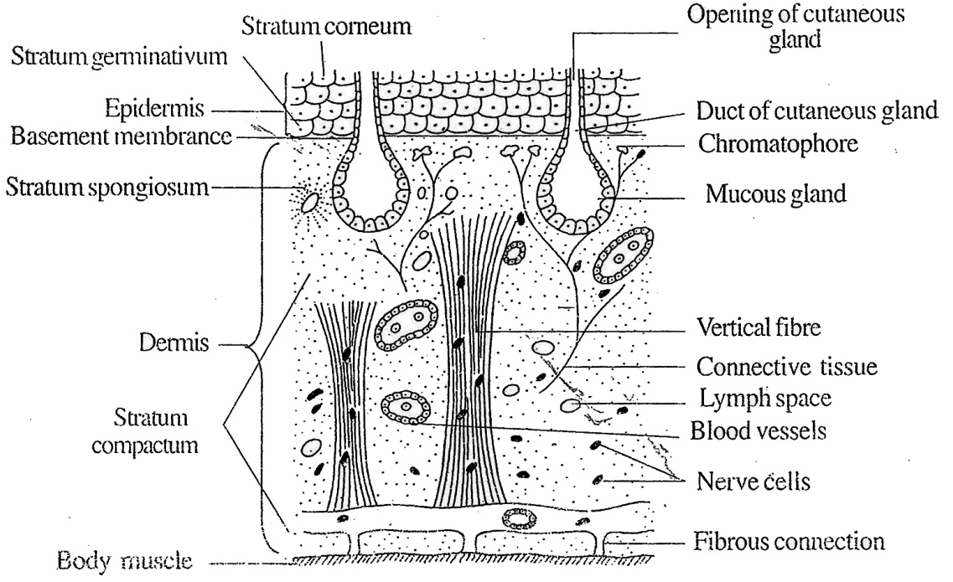

Fig.8.6: Bufo V.S. of the skin

Chromatophores and Colour Changes
Chromatophores are the pigment cells. They are lying scattered in the dermis. There are three types of chromatophores, namely melanophores (with black pigment) lipophores (with red pigments) and guanophores (with crystals of guanine).
The colour of the skin is produced by the combination of pigments and the reflection of light from the guanine crystals. Bufo can change its colour. Change in the colour of the skin is brought about by the movement of pigments in the chromatophores.
When the pigment is dispersed, the skin is dark. When the pigment concentrates, the skin becomes light. This phenomenon helps the Bufo to change its colour according to the colour of the environment.
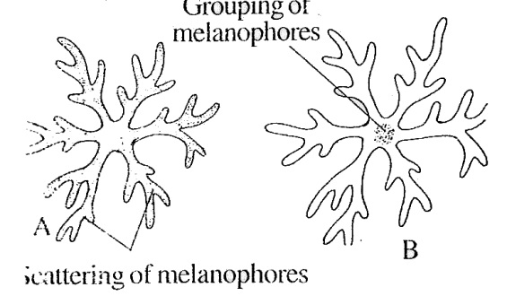

Fig.8.7:Melanophores and colour changes. A. The skin is darker in colour. B. The skin is light in colour
Coelom
The cavity lying between the body wall and the alimentary canal is called coelom. The pericardial cavity is also a part of the coelom.
The coelom is lined by a layer of coelomic pitheliurn called peritoneum. The visceral organs are located inside pelom. They are suspended in the body all by transparent membranes called tesenteries.

Locomotion
Toad moves by three methods, namely alking, jumping and swimming.
Toad walks slowly. During walking tie fore limb is lifted and placed a step rward. Then the second fore limb is lifted id placed a step forward. This is followed y the lifting of one hind limb and placing it step forward. Then the second hind limb . -lifted and placed a step forward. Then le process is repeated.
jumping is the common movement of pad . The hind limbs make a thrust on the round and the toad jumps upward and rward.
Toads swim in water. The webbed hind mbs are used as oars in swimming.

Digestive System
The digestive system consists of alimentary canal and digestive glands. Alimentary Canal. The alimentary canal starts from the mouth and ends in the cloaca. The mouth is a wide opening located at the terminal end of the head. It is bounded by the upper and lower jaws. The teeth are absent in Bufo.
The mouth leads into the buccal cavity. The buccal cavity contains the following strucaires:
Internal nostrils
Eye balls
Eustachian apertures
Opening of vocal sac
Glottis
Tongue

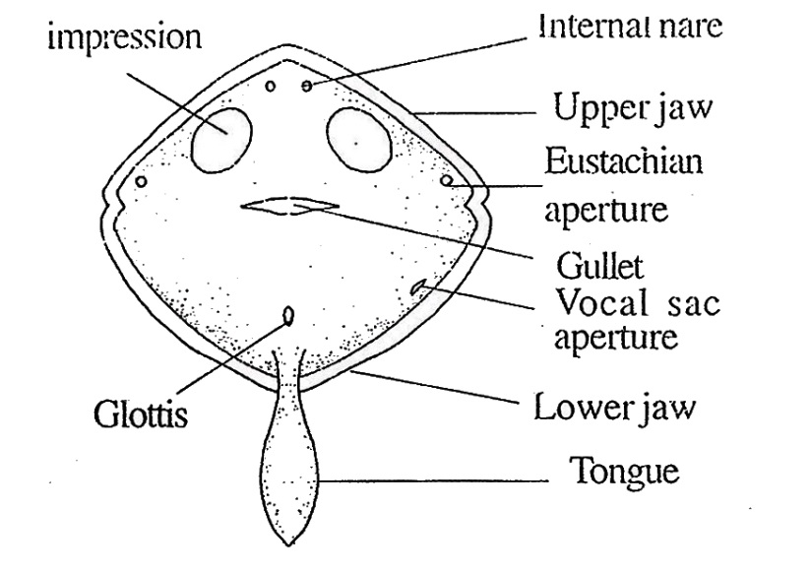

Fig.8.8: Bufo- Buccal cavity
The internal nostrils are a pair of openings located on the roof of the buccal cavity. They serve in respiration.
There are two large oval areas on the roof of the buccal cavity. They are the eye balls. A pair of eustachian apertures lies on the roof of the pharynx almost at the angles of the jaws. They lead into the eustachian tubes.
The eustachian tubes connect the pharynx with the middle ear and help in keeping the air pressure equal on both sides of the tympanic membrane.
In male toad, the opening of vosal sac is present on the floor towards left side. The vocal sac is black pigmented and situated beneath the floor of the mouth cavity.
The tongue is soft and fleshy. It lies on the floor of the buccal cavity. It is attached by its anterior end and it is free at the posterior end. The free end of the tongue is rounded. The tongue can be thrown out and taken back with great rapidity. Behind the tongue there is a slit-like opening called glottis. It opens into the trachea. The posterior end of the buccal cavity is the pharynx. There is no demarcation between the buccal cavity and the pharynx.
The pharynx opens into the oesophagus through a wide opening called gullet
The oesophagus is a short wide tube leading into the stomach.
The stomach is a broad chamber. The stomach is formed of two regions, namely an anterior large chamber called the cardiac stomach and a posterior small chamber called the pyloric stomach. The posterior end of the pyloric stomach contains a valve called pyloric sphincter. The cardiac end of the stomach also has a valve called cardiac sphincter. The stomach is an organ for temporary food storage and digestion.
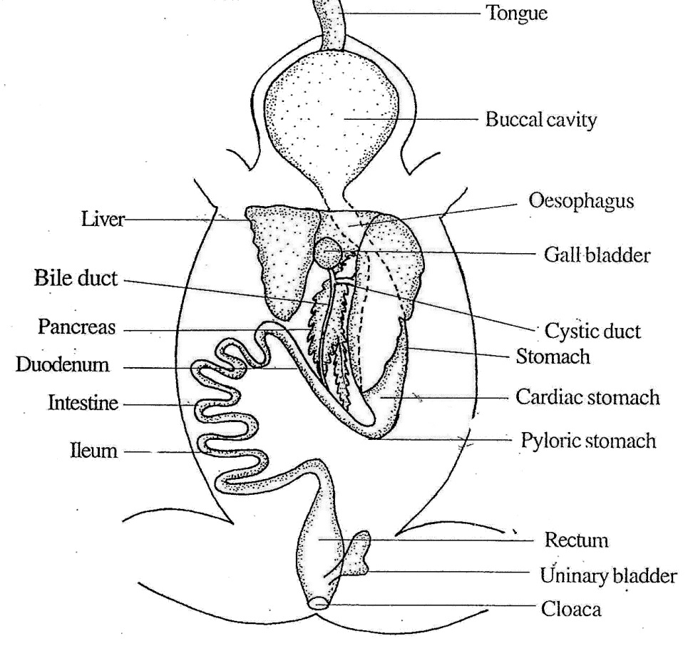

Fig.8.9: Digestive System
The pyloric stomach leads into the intestine. The intestine has two regions, namely an anterior small intestine and a posterior large intestine.
The small intestine is further divided into two regions, namely an anterior duodenum and a posterior ileum. The duodenum runs parallel to the .stomach to form an U-shaped structure. The duodenum receives the hepatopancreatic duct. The ileum is coiled and it is the longest part of the alimentary canal. The ileum leads into the rectum. It is a soft wide tube. It opens into the cloaca.
The cloaca is a common passage for urinogenitai system and alimentary canal. The cloaca opens to the outside by the cloacal aperture.

Digestive Glands
Bufo has the following digestive glands:
- Liver
- Pancreas
- Gastric glands
- Intestinal glands.
- Liver
The liver is bilobed and the left lobe is large. The liver is a large dark red gland. A gall bladder lies between the two lobes.
The liver secretes a greenish liquid called bile. The bile is stored in the gall bladder. The bile is transported to the gall bladder by some hepatic ducts.
From the gall bladder the bile is carried -away by a cystic duct. The cystic duct and some of the hepatic ducts unite together to form a common duct called bile duct. The bile duct passes through the pancreas and receives numerous ducts called pancreatic ducts. Now the bile duct is called hepatic pancreatic duct. It opens into the duodenutm
- Pancreas
Pancreas is an elongated, irregulai cream coloured gland situated between the stomach and the duodenum . Numerous pancreatic ducts arise from the j pancreas. The pancreatic ducts open into the bile duct to form hepatopancreatic duct. opens into the duodenum. The pancreas secretes pancreatic juice.
- Gastric Glands
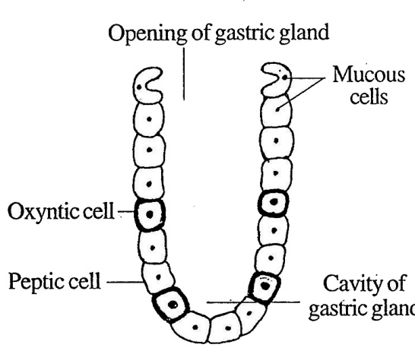
The gastric glands lie in the wall of they stomach. These glands are in the form of tubular structures. There are two types of cells in the gastric glands. They are cubicaipeptic cells secreting an enzymes called pepsin and ovoid oxyntic cells secreting hydrochloric acid. The secretion of the gastric glands is called gastric juice.

Fig.8.10: Bufo- Gastric gland

- Intestinal glands
The intestinal glands lie in the wall of the intestine. They secrete intestinal juice.
Feeding
Bufo is carnivorous animal. It feeds on crustaceans, worms, insects and spiders.
The sticky tongue is used for capturing the insects. On finding the prey, the mouth opens and the sticky tongue is shot out rapidly. The prey adheres to the sticky tongue. Suddenly the tongue is withdrawn and the mouth is closed.
If the prey is large, it is gripped with jaws. The prey is swallowed. The mucous helps in swallowing. Digestion takes place in the stomach, duodenum and ileum. The undigested food is expelled out through the cloacal aperture.
Respiratory System
Bufo exhibits aerial respiration. There are three types of respiration. They are the following:
- Cutaneous respiration
- Buccopharyngeal respiration
- Pulmonary respiration.
- Cutaneous Respiration
It is the skin respiration. The skin is used as the respiratory organ. The skin is kept moist by the mucous secreted by the mucous glands.
The skin is permeable to gases. The skin has abundant blood supply. The oxygen from outside diffuses into blood and the carbon dioxide from the blood diffuses out through the skin. Cutaneous respiration takes place both in the water and on land.
- Buccopharyngeal Respiration
Respiration occurring inside the buccal cavity and the pharynx is called buccopharyngeal respiration. It is a terrestrial respiration where air is used.
The buccal cavity and the pharynx are lined with thin mucous membrane which is moist with mucous, permeable to gases and richly supplied with blood vessels.
The buccopharyngeal cavity communicates to the exterior through a pair of respiratory tracts.
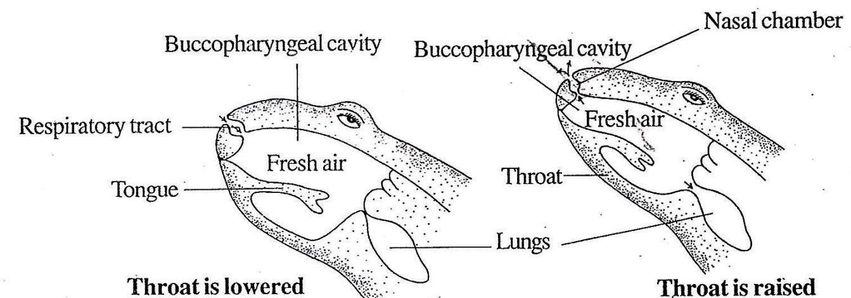

Fig.8.11: Bufo- Mechanism of buccopharyngeal respiration

Each respiratory tract consists of an internal nostril, a nasal chamber and external nostril.
The buccopharyngeal respiration is brought about by the raising and lowering of the throat alternately. Wien the throat is lowered the buccopharyngeal cavity becomes enlarged. This reduces the pressure of air in the buccopharyngeal cavity. Hence fresh air from outside rushes into the buccopharyngeal cavity through the respiratory tracts. Now exchange of gases takes place between the blood of the mucous membrane and the air of the buccopharyngeal cavity.
Now the throat is raised. This increases the pressure of air in the cavity. Hence the air goes out from buccopharyngeal cavity through the respiratory tract. The process is repeated regularly. During buccopharyngeal respiration the external nostrils remain open; the mouth and the glottis are kept closed; and the lungs remain idle.
3. Pulmonary Respiration
In pulmonary respiration, the lungs are used. It is a terrestrial respiration where air is used. The pulmonary respiratory system consists of respiratory tracts and lungs.
There are two respiratory tracts. Each respiratory tract starts from an external nostril. It opens into a nasal chamber. The nasal chamber opens into the buccopharyngeal cavity. The buccopharyngeal cavity leads into a sac called laryngotracheal chamber through a slit-like opening called glottis.

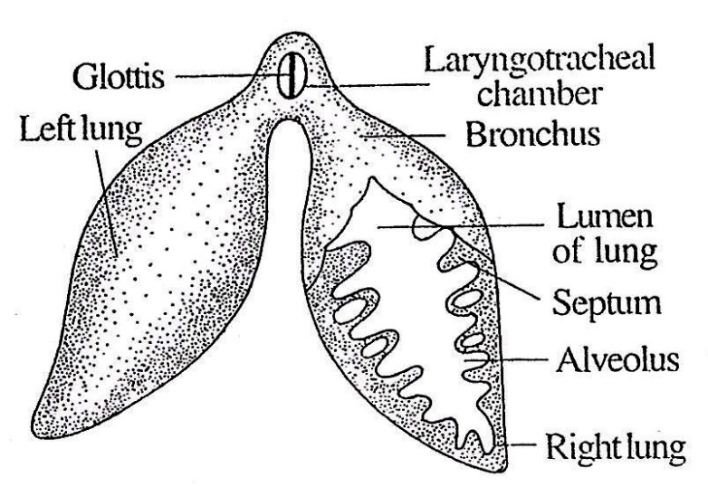
Fig.8.12: Bufo- Lungs
The laryngotracheal chamber opens into the lungs through a pair of short ducts called bronchi. The lungs are thin-walled oval sacs. They lie one on either side of the heart. The walls are elastic and highly vascular. The inner lining of the lungs has a number of ridges called septa. The septa enclose cavities called alveoli.
The alveoli are lined with epithelium rich in blood capillaries.

Mechanism of Respiration
The process of pulmonary respiration consists of three steps. They are,
- Aspiration
- Inspiration
- Expiration.
- Aspiration; The entry of the air into the buccopharyngeal cavity is called aspiration. During this process, the mouth is closed and the external nostrils are kept open. The throat is lowered.
The buccopharyngeal cavity is enlarged. So air from outside enters the buccopharyngeal cavity through the respiratory tracts.
- Inspiration: The passage of air from the buccopharyngeal cavity into the lung is called inspiration. During inspiration the external nostrils are tightly closed. The throat is raised. The cavity of the buccopharyngeal cavity is decreased. So the air is forced through the glottis into the lungs. Oxygen from the air diffuses into the blood of alveoli. From the blood of alveoli carbon dioxide diffuses into the lungs.
- Expiration: The passage of impure air from the lungs to the exterior is called expiration. During expiration the throat is lowered. The volume of the buccopharyngeal cavity increases.
Air from the lungs enters the buccopharyngeal cavity through the glottis. Now the throat raises; the external nostrils open; and the impure air is expelled out.
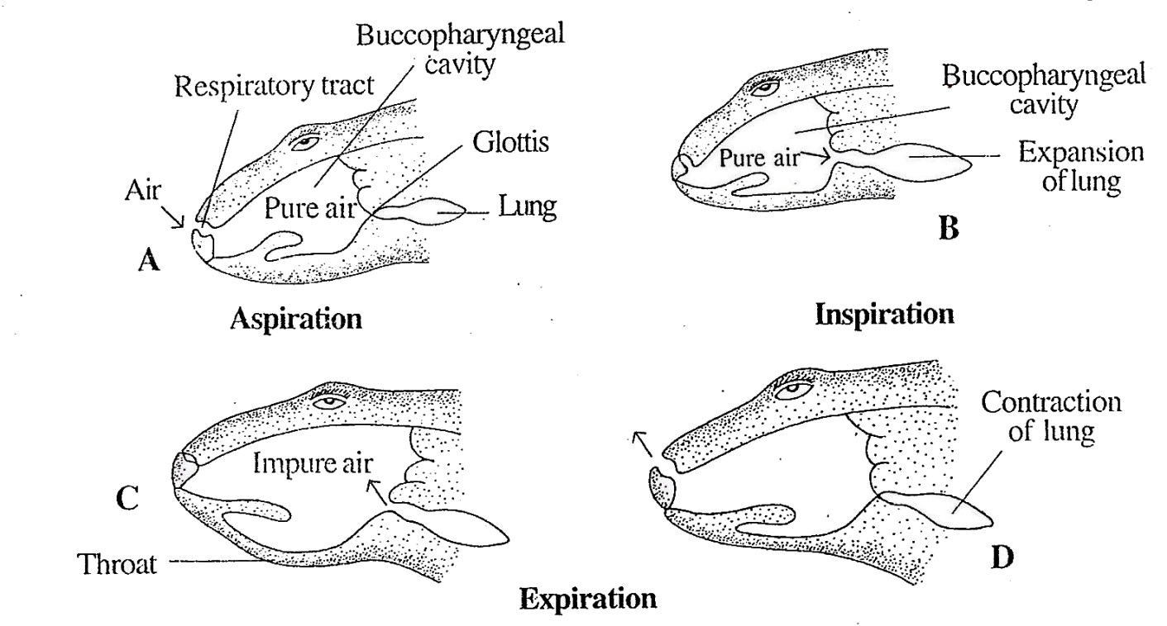

Fig.8.13: Bufo-Mechanism of pulmonary respiration

Sound Producing Organ
The laryngotracheal chamber functions as the sound producing organ. It lies between the glottis and the bronchi. It is in the form of a sac.
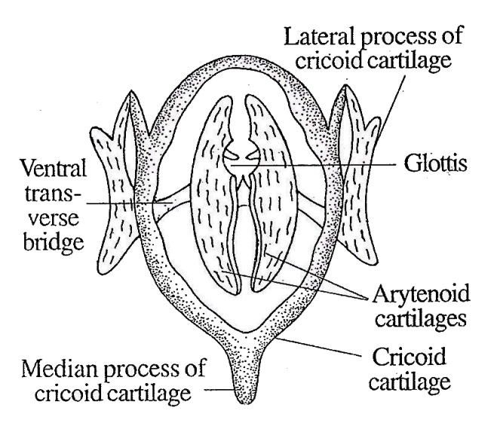

Fig.8.14: Bufo- Sound producing organ
The wall is supported by three cartilages, namely a cricoid cartilage and two arytenoid cartilages.
The cricoid cartilage is in the form of a oval ring. It has a median process at the hind end and two lateral processes.
The two lateral processes are joined by a transverse bridge on the ventral side of the laryngotracheal chamber. The arytenoid cartilages are semilunar in shape. The lining of laryngotracheal chamber is produced into a pair of horizontal folds called the vocal cords. The sound is produced by the vibrations of the vocal cords, when air from the lungs is vigourously forced between them.
The vocal sac of male Bufo functions as resonators to intensify sound. The vocal sac open into the buccopharyngeal cavity.
Air is pumped into them from the lungs and is forced back again, passing between the vocal cords.

Circulatory System
The circulatory system of Bufo is a closed type. It consists of the following components:
- Blood
- Heart
3. Arterial system
4. Venous system.

1.Blood
The blood is a red colour fluid. It consists of plasma and corpuscles.
The plasma is liquid in nature. The corpuscles are the cellular components of the blood. Red blood corpuscles (RBC)
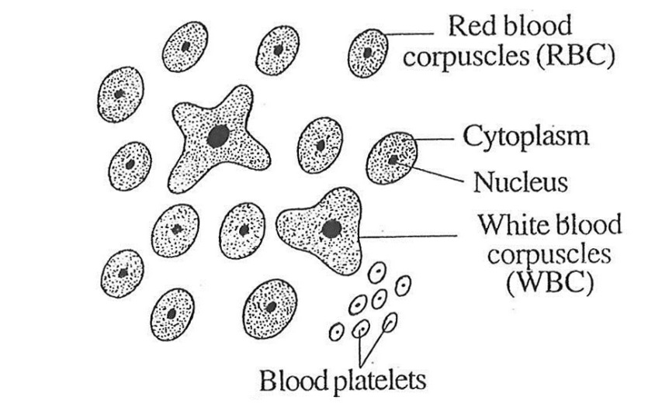

Fig.8.15: Bufo- Blood corpuscles
There are three types of corpuscles, namely RBC, WBC and platelets.
The RBC is nucleated and it is reddish in colour because it contains haemoglobin. The WBC is colourless. It is also nucleated. The platelets are also nucleated.

2.Heart
The heart is a muscular, central pumping . organ of the circulatory system. It is conical in shape. It is enclosed by a transparent, two layered membrane called the pericardium.
The two layers of pericardium are separated by a narrow space called pericardial cavity. This cavity contains a fluid called pericardial fluid.
The pericardium protects the heart from injury. The pericardial fluid protects the heart from shocks and it allows free movement of the heart. The heart of Bufo has three chambers. They are two auricles and one ventricle. But structurally, it consists of four components namely a sinus venosus, two auricles, and a ventricle. The sinus venosus is the receiving chamber of the heart. It is triangular in shape. It receives three veins, namely two precaval veins and one postcaval vein. The sinus venosus opens into the right auricle through sinu-auricular aperture. The auricles are thin walled. They are two in number and are called right auricle and left auricle.
The right auricle is larger than the left. The two auricles are separated by a thin membrane called inter-auricular septum. The sinu-auricular aperture is guarded by two sinu auricular valves. These valves allow the blood to pass from the sinus venosus into the right auricle and it prevents the reverse flow. The left auricle receives blood from the lungs through a common pulmonary vein.
The two auricles open into the ventricle by a opening called auriculo-ventricular aperture. It is guarded by four valves called auriculo-ventricular valves. The free ends of the valves are connected to the inner surface of the ventricle by fine threads called chordae tendineae. The auriculo-ventricular valves give one-way traffic of blood from the auricles to the ventricle.
The ventricle lies posteriorly. It is triangular in shape. It is thick-walled. It is
separated from the auricles by a septum called auriculo-ventricular septum.
The inner surface of the ventricle contains many ridges and depressions. The ridges are cal led columnae cameae and the depressions are called fissures.
The conus arteriosus is a short chamber. It starts from the ventricle on the right side. Its opening into the ventricle is guarded by three semilunar valves. They allow the blood to flow from the ventricle into the conus arteriosus and not in the reverse direction. The conus arteriosus continues forwards as the truncus arteriosus. The cavity of the conus arteriosus is longitudinally divided into two chambers by a spiral valve; the two chambers are cavum pulmocutaneum and the cavum aorticum.
The interior of truncus arteriosus is divided into three vessels by two longitudinal partitions. The three vessels are carotid arch, systemic arch and pulmocutaneous arch.
The free end of the truncus arteriosus bifurcates into two branches.
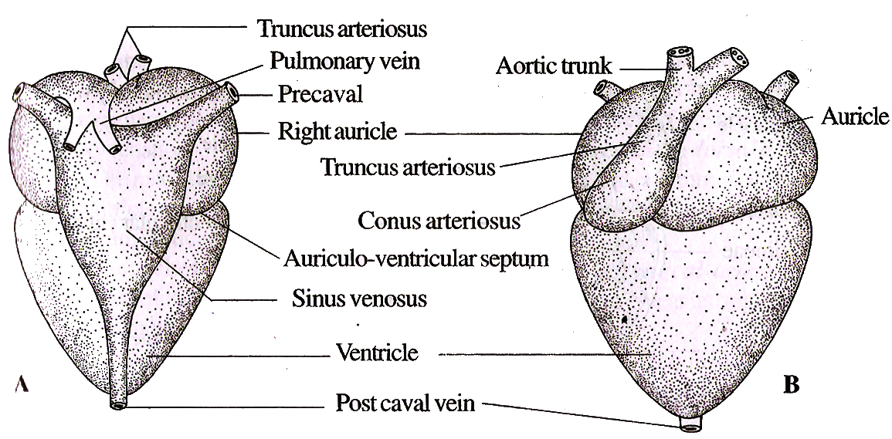

Fig.8.16: Bufo- Heart.A- Dorsal view; B- Ventral view

Working of the Heart
The heart is the pumping station of the circulatory system. It has the inherent ability to contract and relax.
The contraction of the heart is called systole and the relaxation of the heart is called diastole. The systole and diastole constitute a heart beat. The events taking place during heart beat constitute a cardiac cycle.
During heart beat the following events take place:
- The sinus venosus receives deoxygenated blood through the three venacavae.
- Contraction of sinus venosus forces the blood into the right auricle through the sinu- auricular aperture.
- At the same time, the left auricle receives the oxygenated blood from the lungs through the pulmonary veins.
- The auricles contract simultaneously forcing the blood into the ventricle through the auriculo-ventricular apertures.
- The ventricles contract, forcing the blood into the truncus arteriosus.
Sensory Organs
Bufo has five types of sense organs. They are,
- Organs of touch
- Organs of taste
- Organs of smell
- Organs of sight or eyes
- Organs of hearing or ears.
- Organs of Touch
The touch receptors present in the skin are known as cutaneous sense organs. There are two types of touch receptors. They are, nerve endings and corpuscles. These touch receptors are sensitive to a wide range of stimuli, like touch, pressure, temperature, chemicals, humidity and pain,
- Organs of Taste
The taste buds are located on the surface of the tongue. Each taste bud is formed of a group of cells. There are two types of cells in each taste bud. They are supporting cells and neurosensory cells.
The supporting cells form the outer covering and the neurosensory cells occupy the interior of the taste bud. Each neurosensory cell is long and narrow with a taste hair at the free end and nerve fibre at its base. The taste hairs project into a depression called taste pore.
The organs of taste are called the taste buds.
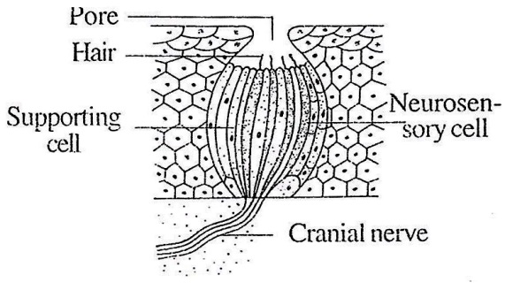
The taste cells are sensitive to the chemicals present in the food.

Fig.8.17: Bufo- Taste bud.

- Organs of Smell
The organ of smell or olfacto-receptor is formed of two nasal chambers. They open out by external nares, and into the buccopharyngeal cavity by internal nares. They are lined by columnar epithelium .The columnar epithelium contains special olfactory cells.
Each olfactory cell is a long, narrow spindle -shaped body having a nucleus in the middle swollen part. Its free end bears fine process called the olfactory hair. Its other end is continued as a fine fibre, which runs in one of the olfactory nerves as a non-medullated nerve fibre. A stream of water is circulated over this olfactory epithelium, when the Bufo is in water.
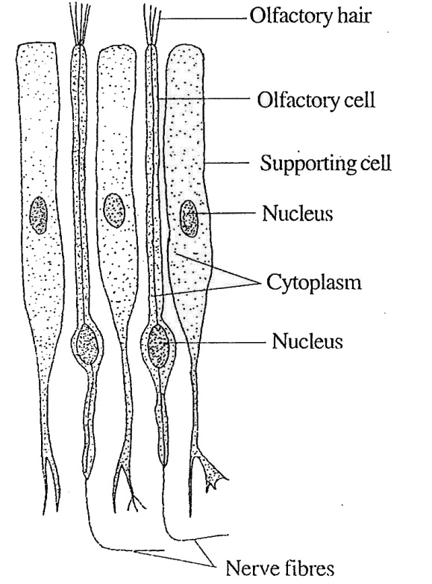

Fig.8.18: Bufo- Olfactory epithelium in olfactory sacs
The olfactory cells convert the chemical stimuli into nerve impulses, which are carried to the brain by the olfactory nerves.
4. Organs of Sight or Eye
The eye is the photoreceptor. Bufo has two eyes. They are located on the dorso- lateral sides of the head in the orbits.
The eye is in the form of a hollow ball. Its wall is formed of three coats, namely an outer sclerotic coat, a middle choroid coat and an inner retina.
Sclerotic coat is the outer covering. It is cartilaginous. Anteriorly it remains as a transparent membrane called cornea. The cornea is covered by a thin membrane called conjunctiva.
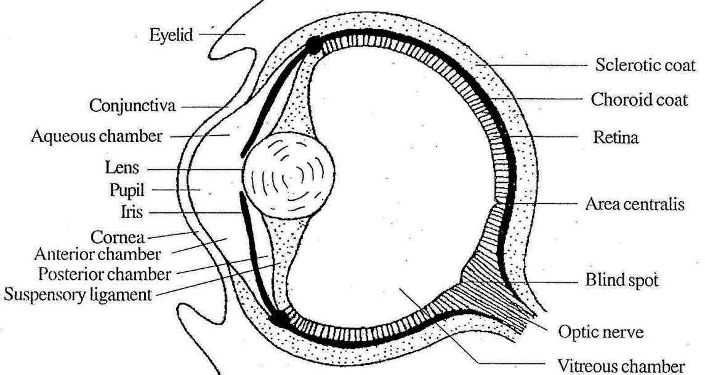
The choroid coat is the middle layer. It consists of blood vessels and pigment cells. Anteriorly it forms a circular disc called iris. The centre of the this has a slit called pupil. A lens is located in the pupil. At the junction of the iris and the choroid lies the ciliary body.

Fig.8.19: Bufo- Eye
Retina is the innermost layer. The retina contains photosensitive cells called rods and cones. From the rods and cones nerve fibres arise. All the nerve fibres converge towards the posterior side of the eyes and come out as optic nerve. The point of the retina from where nerve leaves the eye is called blind spot. The blind spot is free from rods and cones; so this area cannot form any image and hence the name.
The eye is protected by three eyelids, namely the upper eyelid, the lower eyelid and the nictitating membrane. The nictitating membrane is a special outgrowth of the anterior region of the lower eyelid. It can cover the eye fully.
The eye coats enclose cavities filled with a transparent gelatinous fluid called humour (humor). The cavity lying between cornea and iris is called anterior chamber. The small cavity lying between the lens and the iris is called posterior chamber. These two chambers are filled with a watery liquid called aqueous humour. Hence these two chambers are collectively called aqueous chambers.
The large cavity lying between the lens and the retina is called vitreous chamber and it is filled with a jelly like material called vitreous humour.
5. Organs of Hearing or Ear Ear is the organ of hearing. Ln Bufo, the ear consists of middle ear and interned ear. External ear is absent

Middle Ear
Each middle ear consists of a tympanic cavity, a tympanum, a columella auris, a stapedial plate and a fenestra avails.

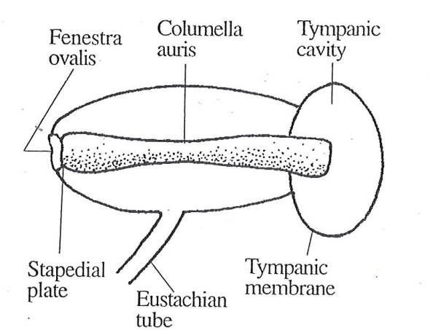

Fig.8.20: Bufo-Middle Ear
The tympanic cavity is present on the side of the head. Its outer surface is marked by a tympanic membrane (tympanum),
The inner end of the tympanic cavity is connected to the inner ear through a opening called fenestra avails. The fenestra ovalis is closed by a round cartilaginous plate called stapedial plate. The tympanic cavity is connected to the buccopharyngeal cavity through an eustachian tube.
A slender ear bone, the columella auris remains inside the tympamic cavity,
The outer end of the columella auris is connected to the tympanic membrane and the inner end is connected to the fenestra ovalis.

Inner Ear
The inner ear is called membranous labyrinth. It is enclosed in a bony labyrinth. The space lying between the bony and membranous labyrinth is filled with a fluid called perilymph. The membranous labyrinth is filled with the endolymph.
The inner ear has two chambers, namely a dorsal tubular utriculus and a ventral sac-like sacculus. The utriculus has three semicircular canals. Two are vertical and one is horizontal. The semi-circular canals open into the utriculus by their both ends. One end becomes dilated to form a sac-like structure called ampulla.
Each ampulla contains a sensory organ called crista. The utriculus and sacculus contain another sensory organ called macula.
A tubular structure arises from the utriculus. It is called endolymphatic duct. It opens beneath the duramater of the brain. The sacculus produces two finger like outgrowths called lagena and pars basilaris. The utriculus produces a small process called of pars neglecta.
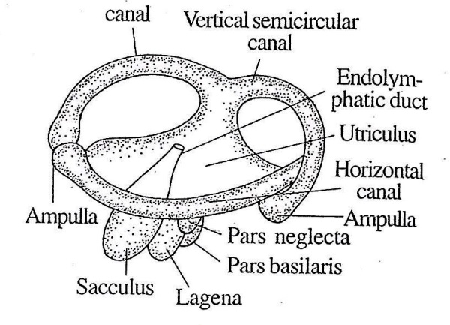

Fig.8.21: Bufo- Ear
The auditory sensory-spots of the ampullae are called cristae and those in the vestibule, the maculae. The cristae and maculae contain flask-like auditory cells supported by columnar supporting cells.
The ear has two functions:
- Hearing
- Maintaining equilibrium.

Urinogenital System
The urinogenital system comprises the excretory and the reproductive organs. The
excretory system is closely associated with the genital system in males but they are separate in females.

Excretory System
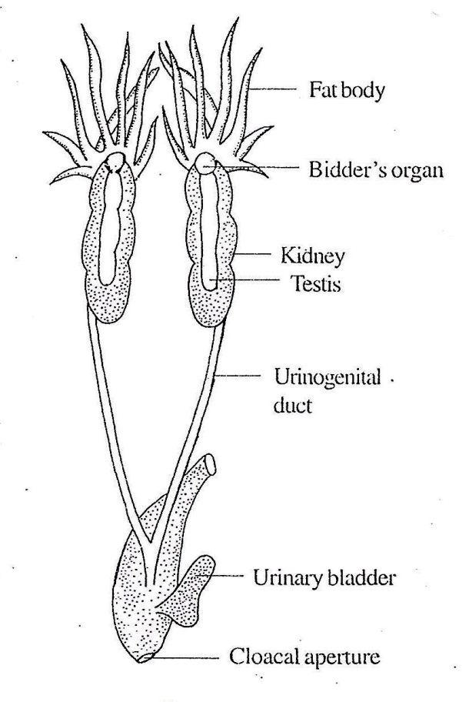
The excretory system consists of a pair of kidneys. The functional kidney of amphibians is mesonephros.

Fig.8.22: Bufo- Male Urinogenital system
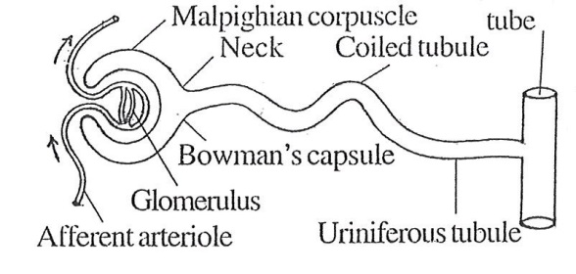

Fig.8.23: Bufo- Anephron

In tadpole larva., pronephros is present; but later it is replaced by the mesonephros in the adult.
The kidney is flat with a convex outer surface. The inner surface is almost straight with two or three notches. From each kidney arises a tube called ureter. The ureter is the mesonephric duct or Wolffian cluct. The ureters run backwards. Posteriorly, the two ureters unite and open into the cloaca by a common opening. The urinary bladder is connected with the cloaca. The urinary bladder is a bilobed thin walled, transparent sac.
In the male the vasa efferentia also open into the ureter. Hence the ureter of male is called urino genital duct
A testis, and a tuft of fat body are attached to each kidney of males.
A kidney is composed of many minute tubules called uriniferous tubules or nephrons. They are the functional units of kidney.
Each nephron is a coiled tubule. One end of the nephron is formed of a cup-like structure called Bowman’s capsule. The cavity of the cup contains a network of capillaries called glomerulus.
The Bowman’s capsule and the glomerulus are together called Malpighian corpuscle. The Malpighian corpuscle leads into a neck which is followed by a coiled tubule. The coiled tubule opens into a large tubule called collecting tube. Each collecting tube receives many uriniferous tubules. The collecting ducts open into the ureter:
The uriniferous tubule of Bufo has no Henle’s loop. The uriniferous tubule receives blood from the renal artery and the renal portal vein. The renal artery divides into small branches called afferent arterioles. They supply blood to the glomerulus. The blood from the glomerulus is taken away by the efferent arteriole. The efferent arteriole divides into capill- aries around the coiled tubule. The branches of the renal portal vein become connected with the capillary network. From the capillary network the blood is taken away by the branches of the renal vein.
The ventral side of the kidney has several ciliated funnel-like openings called nephros- tomes. In the tadpole, the nephrostomes are connected with the nephron. But in the adult they are not connected with the nephron. The function of kidney is to produce urine.

Reproductive System
In the case of Bufo, the sexes are separate.

Male Reproductive System
The male reproductive system consists of a pair of testes, a pair of urinogenital ducts and an urinogenital aperture.
Male Bufo has a pair of testes. They are elongated and attached to the ventral side of the kidney. The testis is formed of many seminiferous tubules. The seminiferous tubules lead into vasa efferentia.
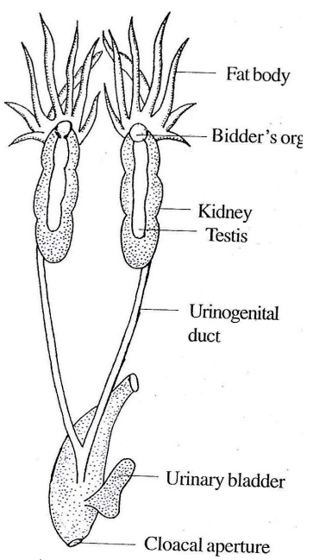
The vasa efferentia enter the kidney and are connected with the collecting ducts through the uniniferous tubules. The collecting ducts open into the ureter As the ureter receives both urine and semen, the ureter is called urinogenital duct . The urinogenital

Fig.8.24: Bufo- Male urinogenital

ducts run backwards, unite together and open into the cloaca through a common aperture called urinogenital aperture.
In front of the testis, there is a rounded lx)dy attached to the anterior end of the kidney called Bidder’s organ. It will develop into ovary, if the testis is removed.

Female Reproductive System
In female Bufo there are two ovaries attached to the kidney by a membrane called tnesovarium. The ovary wall is made of an outer epithelium, inner epithelium and a layer of flat cells or stroma inbetween. The ova develop inside the ovarian follicles.
The oviducts {Mullerian ducts) are long, white, much coiled ducts extending upto the base of the lungs. Anteriorly each oviduct has a funnel- like structure called oviducalfunnel. It opens into the coelom by the ostium.
Posteriorly each oviduct dilates to form a thin walled sac, the ovisac. The inner wall of the oviduct is glandular and secretes the jelly coat of the egg. The oviducts of the two sides unite to form a median duct which opens into the cloaca by a female genital pore.
During the breeding season the ova are released into the body cavity. The ova enter the oviduct through the ostium and get collected in the ovisac. Later they are released into the water through the cloacal aperture.
Life Cycle of Bufo During the breeding season, the males and females aggregate in the pond.
The male grasps the female from the back and eggs and spermatozoa are shed into the surrounding water in close proximity. This form of sexual act is known as amplexus.
Fertilization is external. The sperms make their way through the jelly, penetrate the eggs by their head. A single sperm penetrates an ovum and the zygote is formed.

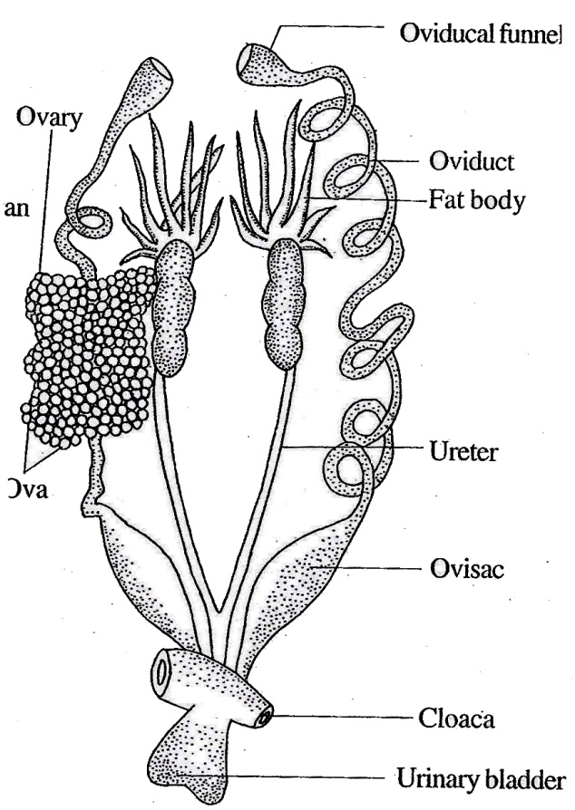

Fig.8.25: Bufo- Female urinogenital

