Mustansiriayh University
Science Collage
Biology Department
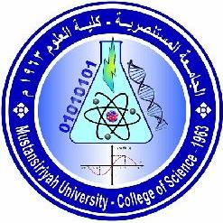

Practical Biochemistry Manual
Stage Two

2018-2019

Prepared By
L . Emad Mahmoud

Teaching Staffer of Material
L .Emad Mahmoud L . Manal Sadeq

