Lab(1)
Introduction
Parasitology : is the study of relationships between parasites and their host , all parasitic organisms are eukaryotes .
Parasites : are living organisms, which depend on a living host for their nourishment and survival .parasites can be classified as: (Ectoparasite inhabit only the body surface of the host without penetrating the tissue e.g. lice, ticks ,) or (Endoparasite which lives within the body of the host e.g. malaria, giardia ). parasites may be simple unicellular protozoa or complex multicellular metazoa.
Host : an organism, which harbors the parasite and provides nourishment and is relatively larger than the parasite .
Definitive host: the organism in which the adult or sexually mature stage of the parasite lives.
Intermediate host : the organism in which the parasite lives during a period of its development only.
Vector: a living carrier that transports a pathogenic organism from an infected to non infected host (e.g. the female Anopheles mosquito that transmits malaria)

Host – parasite relationships :
-Symbiosis: both host and parasite are dependent upon each other, none of them suffers any harm from the association .
-Commensalism: only the parasite derives benefit from association without causing any injury to the host .
-parasitism: the parasite derives benefites and the host is always harmed due to the association.

Transmission of parasites:
1-Food or water contamination (Round worm, Amoeba,Giardia).
2-Vectors (Sand fly Leishmaniasis, Tse tse fly Trypanosomiasis).
3-Sexual contact (Trichomonas).
4-Inhalation of contaminated dust or air (Pinworm,Toxoplasma gondii).
5-Skin penetration (Hook worms, Schistosomes, Strongyloides).

Parasitic damage to host:
1-Trauma (damage to tissues , intestine, liver, eye).
2-Lytic action (activity of enzymes elaborated by organism).
3-Tissue response (localized inflammation , eosinophilia).
4-Blood loss (heavy infection with hookworm may cause anemia).
5-Secondary infections (weakened host susceptible to bacterial infection).

Types of specimens which can be examined for diagnosis of parasites:
1-Natural secretions:
- stool (Entamoeba histolytica ),
- sputum (paragoniumuswestermani ),
- urin (Schistosoma heamatobium).
2-Blood: ( Plasmodium spp.).
3-Vaginal secretions: (Trichomonas vaginalis).
4-Biobsy of liver or spleen: ( Leishmania donovani ).

Detection of parasites :
1-Clinical diagnosis: depends on symptoms
2-Laboratory diagnosis :
a.Microscopic examination
- wet preparation
- perception
- flotation
b. Serological exam
c. Animal inoculation
d. Intra-dermal sensitivity exam
e. Culture method
f. Tap technique
g. X-ray technique

Lab (2)
Kingdom : Protista
Subkingdom : Protozoa
Phylum : Sarcomastigophora
1-Subphylum : Sarcodina
Genus : 1-Entamoeba histolytica (pathogenic ameba)
2-Entamoeba coli (non-pathogenic ameba)
3-Endolimax nana (non-pathogenic ameba)
4-Iodamoeba butschlii (non-pathogenic ameba)
5-Entamoeba gingivalis (non-pathogenic ameba)
1-Entamoeba histolytica
Disease name : Amebic dysentery or Amebiasis
Site of infection : Large intestine
Entamoeba histolytica : pathogenic ameba have two stages Trophozoite (vegetative and diagnostic stage ) and Cyst ( infective and diagnostic stage ) .
Morphology of trophozoite
Trophozoite of E. histolytica is (15-30) micrometer in diameter, has asingle nucleus with a small centrally placed karyosome . The nuclear chromatin is evenly distributed along the periphery of the nucleus . The fine granular endoplasm may contain ingested RBCs
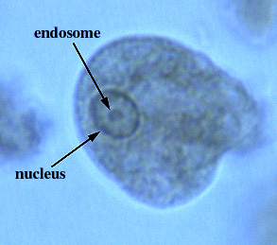
Entamoeba histolytica (trophozoite)
Morphology of cyst
Cyst of E. histolytica is (10-15) micrometer in diameter and contain one to four nuclei . Chromatoid bodies are usually present in young cysts as elongated bars with bluntly rounded ends. Glycogen is usually diffuse, but in young cysts it is often present as a concentrated mass, staining reddish brown with iodine.
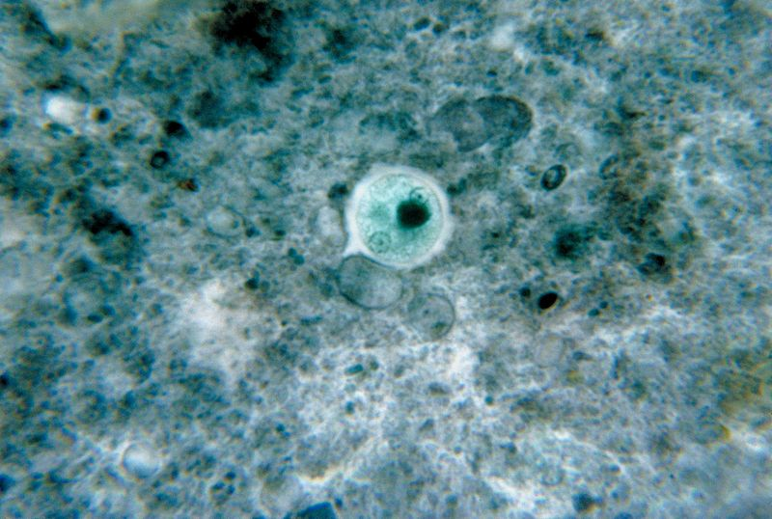
Entamoeba histolytica (cyst)

Life cycle of Entamoeba histolytica :
Infection occurs by ingestion of cysts on focally contaminated food or hands. The cyst is resistant to the gastric environment and passes into small intestine where it decysts. The metacyst divides into four and then eight amoebae which move to the large intestine. The majority of the organisms are passed out of the body with the feces but with chronic infection some amoeba invade the mucosal tissue forming flask-shaped lesions. The organisms encyst for mitosis and are passed through with feces.(there are no intermediate or reservoir host).
Symptoms : including diarrhea with blood and mucus, fever and dehydration.
Laboratory diagnosis:
1-Laboratory diagnosis by finding the characteristic cysts in an iodine stained or formolether concentration method or a permanent stained preparation . Direct microscopy should be done by mixing asmall amount of the specimen in 0.9% sodium chloride solution
2-The tests of indirect fluorescent antibody test (IFAT), or (ELISA) .

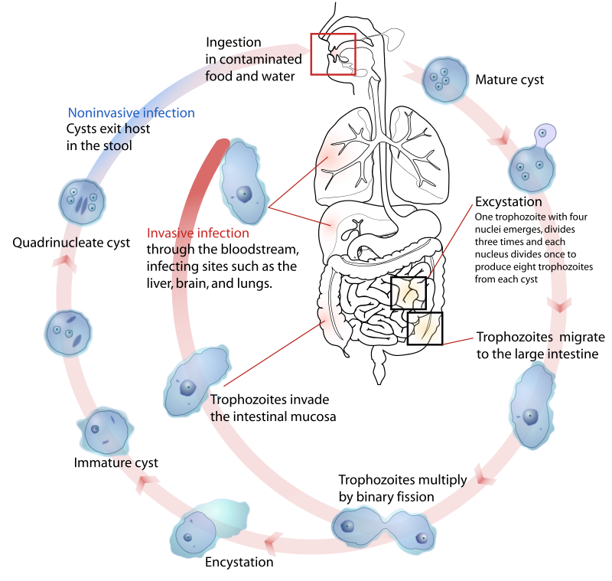
Life cycle of Entamoeba histolytica

2-Entamoeba coli
Entamoeba coli are anon-pathogenic ameba with world wide distribution. Its life cycle is similar to that of E.histolytica but it does not have an invasive stage and does not ingest red blood cells.
Morphology of trophozoite
Trophozoite is larger than of E.histolytica ranging from (15-50) micrometer in diameter .It exhibits blunt pseudopodia with sluggish movement. A permanen tly stained preparation shows a nucleus with a moderately large eccentric karyosome with the chromatin clumped on the nuclear membrane. The cytoplasm appears granular containing vacuoles with ingested bacteria and other food particles.
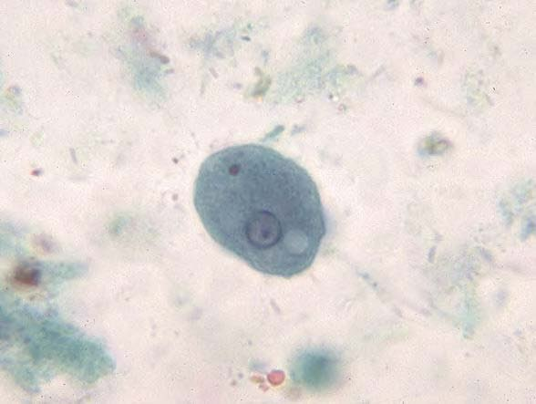
Entamoeba coli (trophozoite)
Morphology of cyst
Cyst of E.coli is (15-30) micrometer in diameter and contain (1-8) nuclei with irregular peripheral chromatin, karyosomes not central. Chromatoid bodies are not frequently seen but when present they are usually splinter-like with pointed ends. Glycogen is usually diffuse but in young cyst is occasionally found as a well-defined mass, which stains reddish brown with iodine.
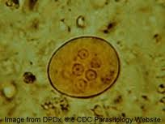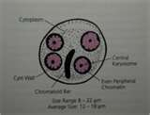
Entamoeba coli (cyst)

3-Endolimax nana
Morphology of trophozoite
Trophozoite of E.nana ranging from (6-12) micrometer in diameter.Motilityis sluggish with blunt hyaline pseudopodia. In a permanently stained preparation, the nucleus exhibits a large karyosome with no peripheral chromatin on the nuclear membrane.

Morphology of cyst
Cyst of E.nana is (6-9) micrometer in diameter. They can be spherical or ovoid in shape and contain (4) pinpoint nuclei, which are highlighted by the addition of iodine. Chromatoid bodies are not found and glycogen is diffuse.
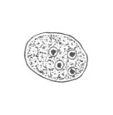

4-Iodamoeba butschlii
Morphology of trophozoite
Trophozoite of Iodamoeba butschlii ranging from (8-20) micrometer in diameter,its actively motile. On a permanently stained fecal smear ,a nucleus with a large karyosome is evident. Chromatoid bodies form striations around the karyosome. The cytoplasm appears granular containing vacuoles with ingested bacteria and debris.
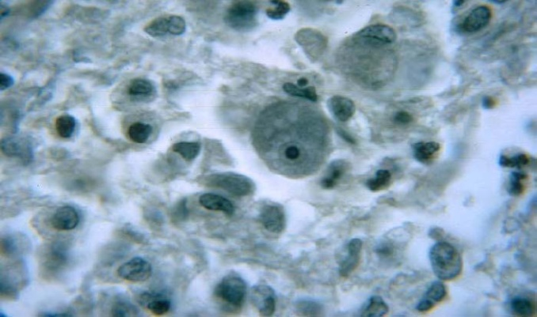
Iodamoeba butschlii (trophozoite)
Morphology of cyst
Cyst of Iodamoeba butschlii is (9-15) micrometer in diameter, and have one nucleus in mature cysts usually eccentrically placed. Chromatoid bodies are not present and glycogen is present as acompact well defined mass staining dark brown with iodine.
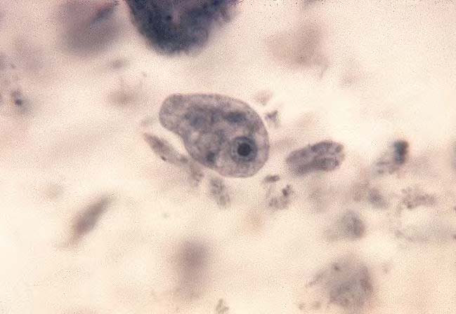
Iodamoeba butschlii (cyst)

5-Entamoeba gingivalis
Entamoeba gingivalis is found in mouth near the base of the teeth. It has only trophozoite.
Morphology of trophozoite
Trophozoite of E. gingivalis ranging from (5-30) micrometer in diameter, contain single small spherical nucleus, contains irregular distributed small masses of chromatin, central or eccentric karyosome. They are several food vacuoles in endoplasm contain largely dark bodies .

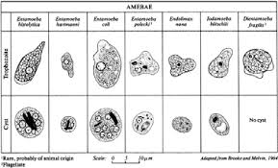
Types of amebae

Lab(3)
Kingdom: Protista
Subkingdom: Protozoa
Phylum: Sarcomastigophora
2-Subphylum: Ciliophora
Class: Ciliata
Order: Euciliata
Genus: Balantidium coli
3- Subphylum: Mastigophora (Flagellates)
Class:Zoomastigophora
Order: Diplomonadida
Genus: Giardia lamblia , Trichomonas vaginalis
Balantidium coli
Disease name: Balantidiasis , Balantidil dysentery
Site of infection: Large intestine, cecum and terminal ileum

Morphology of trophozoite
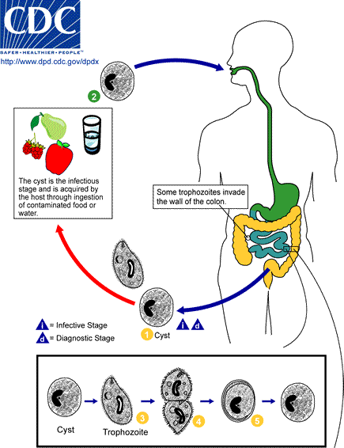

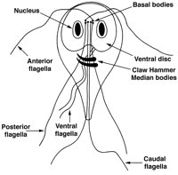
Giardia lambilia trophozoite
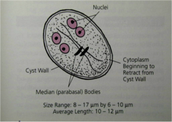
cyst Giardia lambilia
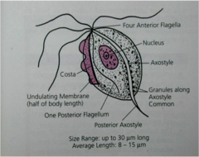
Trichomonas vaginalis trophozoite

Lab (4)
Blood and Tissue flagellates: it include flagellated protozoa that contain
1-flagella 2-nuclues 3-kinetoplast
Morphology of tissue and blood flagelates
1-Amastigote 2-Promastigote 3-Epimastigote 4-Trypomastigote
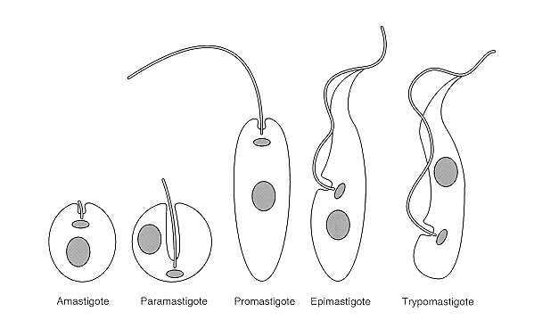

Kingdom: Protista
Subkingdom: Protozoa
Phylum:Sarcomastigophora
Class:Zoomastigophora
Order: Kinetoplastida
Family: Trypanosomatidae
Genus:1-Leishmania spp.
2-Trypanosoma spp.
Leishmania spp.
1-Leishmania tropica
2-Leishmania donovani
3-Leishmania braziliensis
Disease name:
- Leishmania tropica causes Baghdad boil ( cutaneous leshmaniasis).
-Leishmania donovani causes kalazar or black fever (visceral leshmaniasis).
-Leishmania braziliensis causes subcutaneous (mucocutaneous leshmaniasis).
Site of infection:
-Leishmania tropica ( skin )
-Leishmania donovani ( liver, spleen, lymph node, bone marrow )
-Leishmania braziliensis ( mucocutaneous tissue of skin, nose, mouth )
Definitive host : human
Intermediate host (vector) : Phlebotomus female ( sand fly)
Morphology:
Leishmania exist as flagellated extracellular Promastigotes in the sandfly vector and as a flagellar obligate intracellular Amastigotes within mononuclear phagocytes of their vertebrate hosts. The various species are not distinguishable morphologically from one another. When stained with Giemsa stain, amastigotes appear as round or oval bodies ranging from 2-3 micrometer in diameter with a well defind nucleus and kinetoplast, a rod shaped specialized mitochondrial structure. The flagellated Promastigote form is spindle shaped, measuring (10-20) micrometer in length, not including the length of the flagellum. As in the Amastigote form a nucleus and kinetoplast are clearly visible.

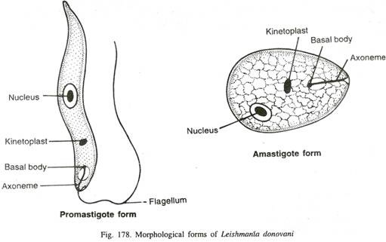

Life cycle:
All forms of infection starts when a female sand fly (Phlebotomus sp.) takes a blood meal from an infected host . Small amounts of blood, lymph and macrophages infected with Leishmania amastigotes are ingested. Once ingested the amastigotes transform to promastigotes in the sandfly, the non-infective promastigotes divide and develop into infective metacyclic promastigotes. These are formed in the midgut of the sandfly and migrate to the proboscis. When the sandfly bites, the extracellular inoculated promastigotes at the site of the bite are Phagocytosed by macrophages. After phagocytosis, transformation to dividing amastigotes occurs within 24 hours. Reproduction at all stages of the lifecycle is believed to occur by binary fission. No sexual stage has been identified.

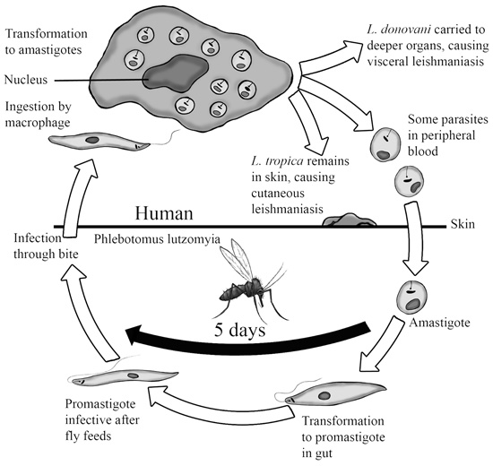

Diagnosis:
1-Direct smear of blood and lymph.
2-Serology.
3-Cuturing in N.N.N.(Nove MacNeal-Nicole).
4-Biobsy from liver,Spleen and bone marrow.

Lab(5)
Trypanosoma spp.
Trypanosomes are hemoflagellates and three species of the genus Trypanosoma are responsible for disease in humans

1-African trypanosomiasis (sleeping sickness)
There are two clinical forms of African trypanosomiasis
A – Trypanosoma brucei gambiense causes ( Gambian trypanosomiasis chronic sleeping sickness).
B- Trypanosoma brucei rhodesiense causes (Rhodesians trypanosomiasis acute sleeping sickness).
Site of infection: blood ,lymph, spleen, liver, cerebrospinal fluid
Vector Tsetse genus: Glossina spp.

The parasite undergo several forms depending on the host
In vertebrate host (human) which is definitive host :trypomastigote
In invertebrate host (insect) which is intermediate host: trypomastigote and epimastigote

Morphology
The parasite is an elongated cell with single nucleus which usually lies near the centre of the cell, single flagellum which appears to arise from a small granule kinetoplast. two forms of trypomastigote can be seen in peripheral blood: one is long slender, 30 μm in length, and is capable of multiplying in the host, the other is stumpy, not dividing, 18 μm in length.
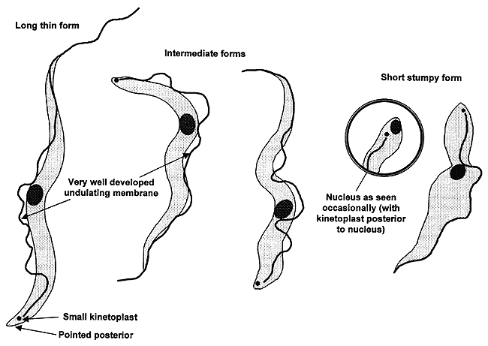
Life Cycle
Transmission from one vertebrate to another is carried out by blood-sucking invertebrates, usually an insect ( vector).Metacyclic (infective) trypomastigotes are inoculated through the skin when a tsetse fly takes a blood meal. The parasites develop into long slender trypomastigotes which multiply at the site of inoculation where ulceration occurs. The trypanosomes continue to develop and then may invade the lymphatic tissues, the heart, various organs and in later stages, the central nervous system. Trypomastigotes are taken up by the tsetse fly (male and female) during a blood meal. The parasites develop in the midgut of the fly where they multiply. 2-3 weeks later the trypomastigotes move to the salivary glands transforming from epimastigotes into metacyclic S-shape (infective) trypomastigotes. These are known as salivarian trypanosomes as they complete their development in the salivary system (anterior portion of the vector).The tsetse fly remains infective for life i.e. about three months.

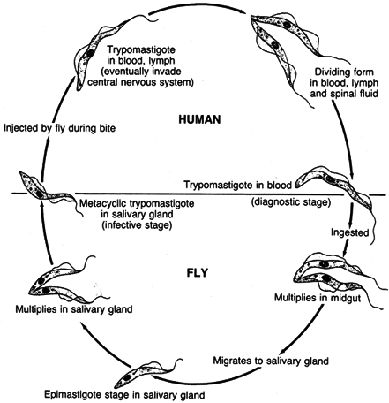

Symptoms:
The early stages of African trypanosomiasis may be asymptomatic and there is a low grade parasitiaemia. This period may last for several weeks to several months. The disease may terminate untreated at this stage or go on to invade the lymph glands. Invasion of the lymph glands is usually accompanied by a high irregular fever with shivering, sweating and an increased pulse rate.Trypanosomes may invade the central nervous system giving symptoms of meningoencephalitis, confusion, apathy, excessive sleeping and incontinence.

Laboratory diagnosis of African Trypanosomiasis is by:
• Examination of blood for the parasites
• Examination of aspirates from enlarged lymph glands for the parasites
• Examination of the CSF for the parasite
• Detection of trypanosomal antibodies in the serum

2-Amarican trypanosomiasis
Trypanosoma cruzi causes ( chagas disease).
Site of infection: muscular muscle, kidneys, thyroid gland, sexual organs
Vector Bug genus: Tritoma

Morphology:
Trypanosoma cruzi has a single form (monomorphic), about 20μm in length, and characteristically curved (C-shape). The kinetoplast is large, considerably larger than the Trypanosoma brucei species.The flagellum is medium in length. Trypanosoma cruzi in man only occurs in the amastigote phase in muscular tissue and cells.

Lifecycle of Trypanosoma cruzi

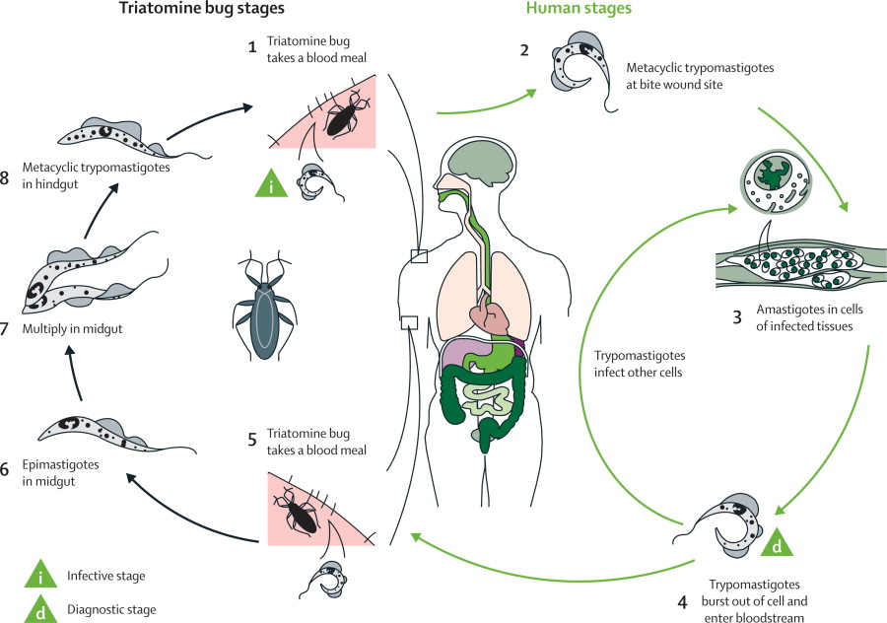

Symptoms:
In an acute infection there may be fever, malaise, increased pulse rate, and enlargement of lymph glands, liver, and possibly spleen .Chronic infection include signs of cardiac muscle damage leading to heart failure.

Laboratory diagnosis of South American trypanosomiasis is by:

• Examination of blood.
• Xenodiagnosis
• Blood culture
• Serology

Lab (6)
Kingdom: Protista
Subkingdom: Protozoa
Phylum: Sarcomastigophora
Class: Ampicomplexa (sporozoa)
Order: Eucoccida
Family: Plasmodidae
Genus: Plasmodium vivax (benigntertian malaria).
Plasmodium malaria (quartian malaria).
Plasmodium ovale (ovale tertian malaria).
Plasmodium falsiparm (malignant tertian malaria).

Disease name: Malaria
Site of infection: Red blood cell and Liver tissue cell

Plasmodium requires two hosts:
-Definitive invertebrate host: (vector Anopheles mosquitoes female).

-Intermediate vertebrate host: (mammals, birds and lizards).

Morphology:

 | P.falciparum | P.malaria | P. vivax | P.ovalae
Trophzoite | ring forms | band form | amoeboid form | compact rings in cells
Schizont | (8 – 36) merozoites. | (6–12) large  merozoites | (16). merozoites | (6-12) merozoites
Microgametocyte | Larger than RBC,  kidney shaped with blunt round ends | Smaller than RBC,round compact | Fills  enlarged RBC, small round or oval,compact with central nucleus | Of the size of RBC  round, compact
Macrogametocyte | more slender and longer than the  male | Round or oval with peripheral nucleus | large round or oval with peripheral nucleus | Round or oval with peripheral nucleus

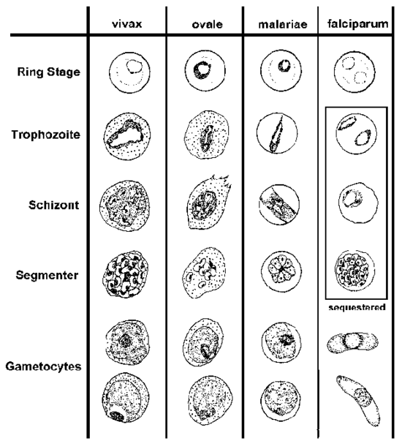
Life cycle:
sexual cycle
occurs in mosquito (9-21 days) ,fusion of micro and macrogametes are infective for mosquito→ zygote→ookinete (~24 houre) →oocyst
Asexual replication (sporogony) → sporozoites released → migrate through hemocoel→ invade salivary glands

Asexual cycle
1-Exoerythrocytic schizogony ( Liver stage)
Sporozoites injected during mosquito feeding→ merozoites(uninucleate asexual stages) invade liver cells .After this initial replication in the liver (exo-erythrocyticschizogony ) the parasites undergo asexual multiplication in the erythrocytes.

2-Erythrocytic schizogony ( Blood stage)
Merozoites infect red blood cells and forms the ring stage in it and transform into trophozoites that mature into schizonts ( multinucleated asexual stages) , which rupture releasing merozoites . Some parasites differentiate into asexual erythrocytic stages (gametocytes) repeated erythrocytic schizogony (48hr) in Pf., Pv., Po.and(72 hr) in Pm.

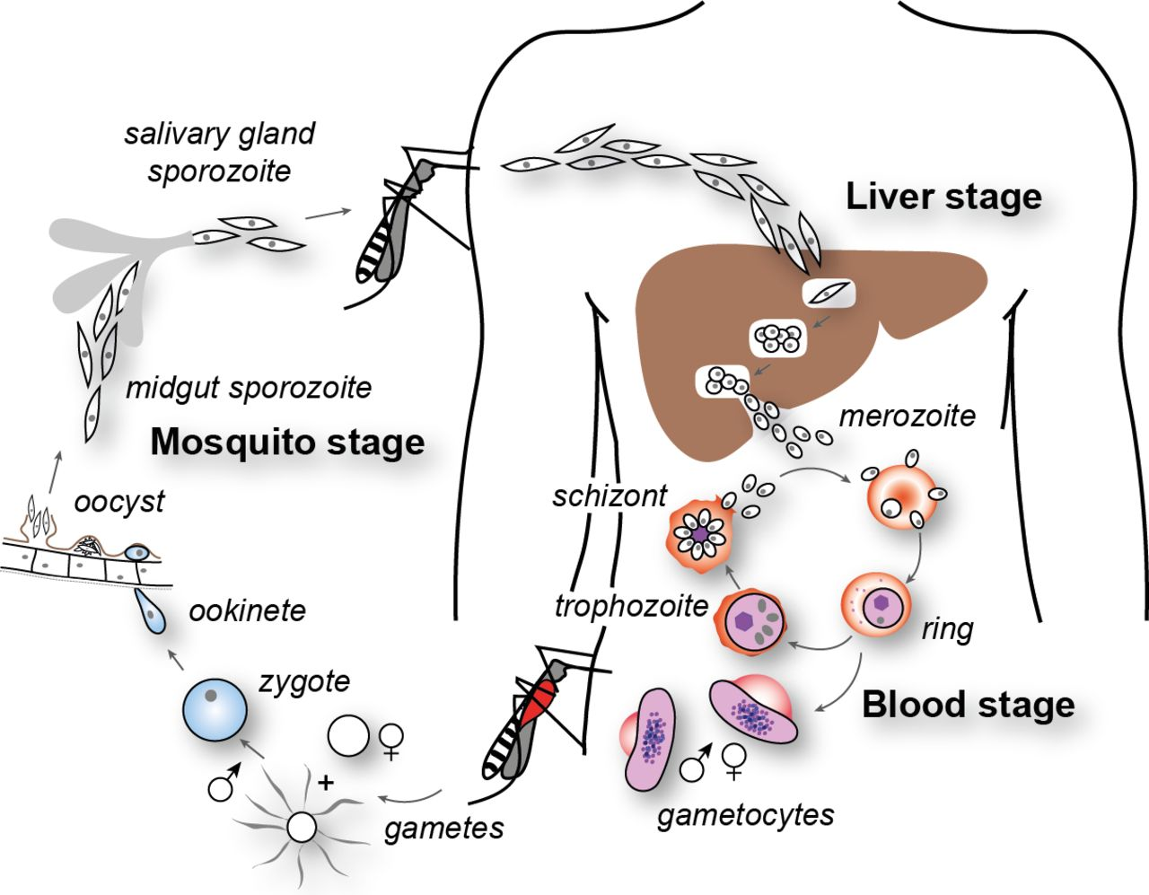

Symptoms:

- Fever: Often irregular. The regular pattern of fever does not occur until the illness has continued for a week or more.
-Anemia: The anemia is hemolytic in type. It is more severe in infections with P. falciparum because in this infection cells of all ages can be invaded.
-Splenomegaly : The spleen enlarges early in the acute attack of malaria.
-Jaundice: Amild jaundice due to hemolysis may occur in malaria.

Diagnosis:

1-Thin blood films stained with Giemsa stain.
2-Antibody test.

Lab (7)
Kingdom: Protista
Subkingdom: Protozoa
Phylum: Sarcomastigophora
Class: Ampicomplexa (sporozoa)
Order: Eucoccidia

Genus:1-Toxoplasma gondii
2- Cryptosporidium parvum
3- Isospora belli

1-Toxoplasma gondii
Disease name :Toxoplasmosis
Site of infection: brain, eye, skeletal muscle, neural tissue
Definitive host: Cats
Morphology:
1-Tachyzoite: pear shaped organisms
2- Bradyzoites
3- Oocysts: contain 4sporozoites (infective stage)

Life cycle:
Infection occur by ingestion of Oocyst from contaminated hands or food, sporozoites released from oocyst in the small intestine penetrate the intestinal mucosa and find their way into macrophages where they divide very rapidly (hence the name tachyzoites) and form a cyst which may occupy the whole cell. The infected cell burst and release the tachyzoites to enter muscle and nerve cells where they are protected from the host immune system and multiply slowly (bradyzoites).these cysts are infectious to carnivores (including man).cats get infected by ingestion of cysts in flesh. Decystation occurs in the small intestine the organisim penetrates the submucosal epithelial cell where they undergo mitosis,resulting micro(male) and macro(female) gametocytes.Fertilized macrogametocytes develop into Oocyst that are discharged into the gut lumen and excreted.
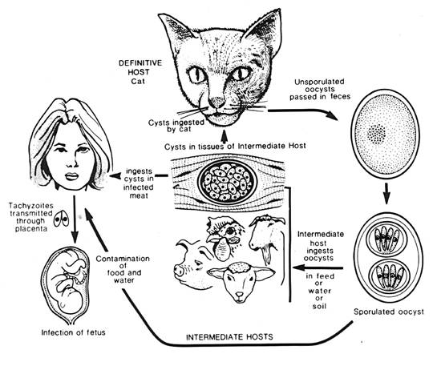
Symptoms
Abortion, Hydrocephalus or Microcephaly , Blindness
Laboratory Diagnosis
1.Serological Techniques
2.Isolation parasites techniques.

3.Direct identification of the parasite from peripheral blood, amniotic fluid or in tissue section.

2-Cryptosporidium parvum
Disease name : Cryptosporidiosis
Site of infection : Epithelial cells of the small intestine
Infective stage :Oocyst

Life cycle

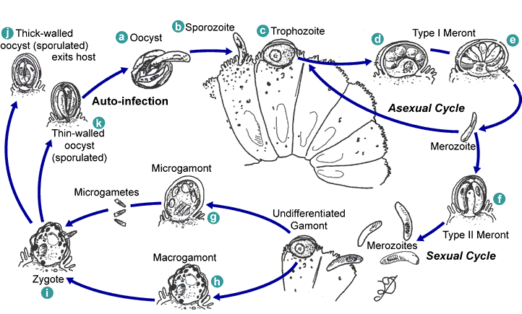

Symptoms
Persistent watery offensive diarrhea accompanied with abdominal pain, nausea, vomiting and anorexia

Diagnosis:
- Demonstration of oocyst in the stool.
- intestinal fluid or small bowel biopsy specimens
- Antigen in stool(ELISA)
-Molecular methods ( PCR. )
-Serological test

3-Isospora belli
Disease name : Isosporiasis
Site of infection : Epithelial cells of the small intestine .
Infective stage : Oocyst

Life Cycle

This organism can be acquired by the ingestion of sporulated oocysts found in contaminated food or water. The oocyst are thin walled ,transparent ,ovoid in shape and much larger than the oocysts of Cryptosporidium parvum . Oocysts of I. belli can survive for years in the environment.

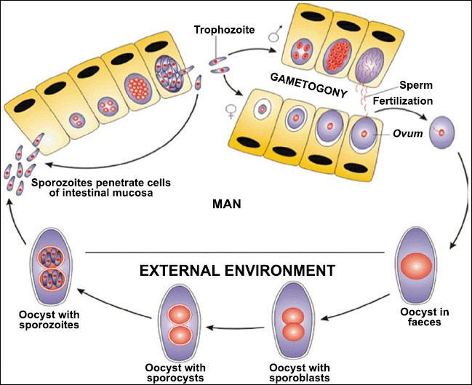

Symptoms

In chronic infections, severe non-bloody diarrhea with cramp-like abdominal pain can last for weeks and result in fat malabsorption and weight loss. Eosinophilia may be present (atypical of other protozoa infections).

Laboratory Diagnosis :.
Oocysts can be detection in stool samples .Alternatively, oocysts can be seen in a fecal smear stained by a modified Ziehl-Neelsen method, where they stain a granular red color against a green background, or by phenolauramine.

