Introduction of algae

Definition phycology
- The word "phyco" is derived from a Greek word "phykos" that means seaweed. Phycology is the study of the cells, structure, function, life cycles, ecology and other properties of algae. It is also called algology. they use the sunlight energy to convert inorganic substance into simple organic compounds ,called photosynthesis
- Algae are thallophytic ;their vegetative body is not organized in root and leafy stems like that of the kormophytes . . many algae are living in solitary cells , colonies ,filaments , or primitive vegetation bodies and do not have a vascular system . in contrast to the phanerogams (plant producing seeds ),

- Following a conception of sub divition of living organisms into five kingdoms (Monera, protoctista, fungi, animalia, and plantae).

- The prokaryotic algae (blue green algae ,cyanobacteria,cyanoprokaryota) are placed in the monera (Eubacteria) and the eukaryotic algae in the protoctista . the algae do not belong to kingdom of plantae . Nevertheless , it is widely accepted (because of the photosynthesis characteristic )to interpret algae as (lower plants)in distinction to the vascular (higher plants).

-The eukaryotic algae posses membrane –bound organelles sush as nuclei, mitochondria and plastids . the prokaryotic cyanobacteria do not exhibit sush organelles:;their DNA and photosynthetic thylakoids lie free in the cytoplasm.

Most algae are posses as primary producers , they use the sunlight energy to convert inorganic substances into simple organic compounds.
- And provide the principal basis of food webs on the Earth . they produce oxygen that is essential for heterotrophic organisems . algae populate a waide range of habitats from soil to water , whether it is cold or warm , alkaline or acidic , hyper or hyposaline .
How to distinguished algae from plants
1-plants show a very high degree of differentiation with root ,leaves, stem and xylem /phloem vascular network
2-reproductives organs are surrounding by a jacket of sterile cells
3-they have a multicellular diploid embryo stage that remains developmentally and nutritionally dependent on the parent's gametophyte for significant period
4-producing tissue that differentiate in a wide variety of shapes.
algae do not have any of these
1-they do not have root and leafy stems.
2- they don’t form true embryo
3- do not have a vascular system .

Distribution and abundance
In the aquatic ecosystems we can find algae as :
-Attachment :Epipelic / on the clay--Epipzamic / on the sand---Epilithic / on the rocks.---Epiphytic / on the plants----Epizoic / on the animals----Endozoic / in the animals body---Endophytic / in the plants body
-Plankton:
Euphytoplankton / all the life cycle is plankton
Tychophytoplankton / some of the life cycle is plankton
According to environments we can subdivided Algae in to :
Halophyts: in region with high salinity.
Thermophyts: in region with high temperature.
Cryptophyts: in the region with low temperature.
In the trrastrial environments we can classified Algae in to :
Lithophyts—Epidaphics—Endodaphics--Casmolithics
Some algae live inside other organisms, and in a general sense these are called endosymbionts. Specifically, endozoic endosymbionts live in protozoa or Hydra, corals,other, larger animals, whereas endophytic endosymbionts live in fungi, plants, or other algae. like lichens. the algae gives to the fungus nutriments from photosynthesis and the fungus gives a surface to the algae , minerals and protection against dehydration
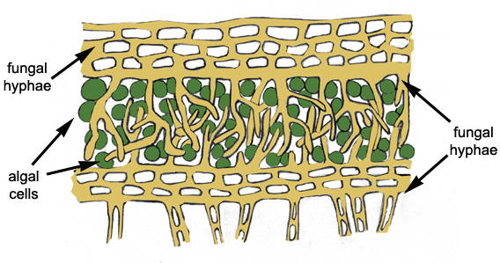
When nutrients are abundant, as in some polluted waters, algal cell numbers can become great enough to produce obvious patches of algae called “blooms” or “red tides,” usually linked to favorable growing conditions, including an abundance of nutrients.
Eutrophication: is a major problem that is associated with algal blooms in lakes. A direct result of human interference, eutrophication is caused by the addition of excess nutrients (runoffs of phosphate and nitrate from chemical fertilizers and sewage disposal) to the water that encourage algae to grow abundantly. As the algae die and sink to the bottom, most of the water's oxygen is consumed in breaking down the decaying plant matter. Fish and other animals that require large amounts of oxygen can no longer survive and are replaced by organisms with lower oxygen demands.
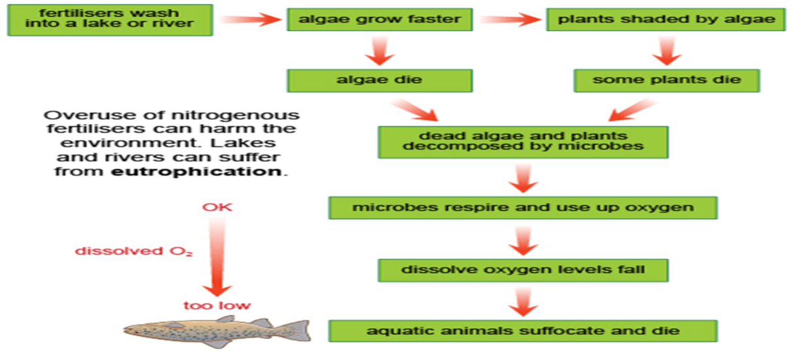

Size range and diversity of structure
The size range of the algae about microscopic cell to large. Many algae consist of only one cell, others have two or more cells, and the largest have millions of cells such as Kelp forest up to 50 m height are the marine equivalent to terrestrial forest; mainly built by brown algae
In large, macroscopic algae, groups of cells are specialized functions, such as anchorage, transport, photosynthesis, and reproduction..
The algae can be divided into several types based on the morphology of their vegetative, or growing, state.
A.Unicellular form: This form exists in most of the algae except Red and brown algae may be unicellular algae motile may be unicellular algae which posses flagella as in algae the Euglena, Chlamydomnas or be Non-motile that not posses flagella such as Chlorella ,Diatoms
B-multicellular form;
a.Colonial form: they are two type some of them non- motial colonial such as Scenedesmus , Pediastrum algae anther motile colonial such as Volvox
b. Filamentous forms
i.Unbranched filaments (e.g., Spirogyra)
ii..branched filaments , (e.g., Chladophora)
3- Parenchymatous forms (tissuelike) , such as the giant kelp, can be very large, measuring many metres in length.such as ulva, Macrocystis
4.Siphoneous forms of algae grow to large sizes without forming distinct cells. Coenocytic algae are essentially unicellular, multinucleated algae in which the protoplasm is not subdivided by cell walls .ex: Vaucheria
5.Some algae have flagella and swim through the water. These flagellates range from single cells, such as Ochromonas, to colonial organisms with thousands of cells, such as Volvox.
6. Coccoid forms, such as Scenedesmus, normally have an exact number of cells per colony, produced by a series of rapid cell divisions when the organism is first formed; once the exact cell number is obtained, the organism grows in size but not in cell number.
7.Capsoid organisms, such as Chrysocapsa, have variable numbers of cells. These cells are found in clusters that increase gradually in cell number and are embedded in transparent gel.
8-Erect thallus forms:such as Nitella ,Chara
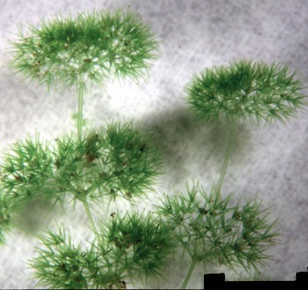 Chara 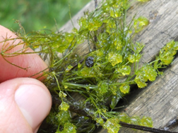 Nitella
BASIS FOR CLASSIFICATION OF ALGAE
The primary classification of algae is based on the following five criteria:
- Photosynthetic apparatus and pigments
- Nature of reserve food
- Nature of cell wall components
- Type, number and attachment of flagella
- Cell structure
Photosynthesis pigments
Algae have various different colour and these to classification of algae
Colour frequency varies of with change in environmental condition and classification depends on chemical analyses of the photosynthesis pigment
They are three photosynthesis pigment in algae :
1)chlorophylles 2)carotenoids 3)biloprotein
1-chlorophylls
Chl. a present in all algae
Chl. b is found in chlorophyta &Euglenophyta
Chl. c is found in Bacillariophyta Cryptophyta and phaeophyta
Chl.d is present only in the Rhodophyta
Chl. e has been identified only in two genera Xanthophyta
2-Crotenoids
B-carotene is present in most algae
∞-carotene is present in some algae
3-Xanthophylls
• lutein, zeaxanthin, violaxanthin, antheraxanthin,and neoxanthin• Siphonein, Siphonoxanthin
Biloprotein is present in only three algal :
1-cyanophyta 2-cryptophyta 3-Rhodophyta
2-Food storage products
Starch ,oils present in chlorophyta ,dinoflagellates
Chrysolaminarin ,oils present in Bacillariophyta and golden algae
Phycocyanin,pycoerythrin found in cyanobacteria
Laminarin ,carbohydrates ,oils found in phaeophyta
Floridean starch,oils found in Rhdophyta
3-Wall composition
Cellulose, Xylens, Mannans , Sulphated polysachccraids, Alginic acids, Protein Silicon dioxide, Calcium carbonate

CLASSIFICATION OF ALGAE PROPOSED BY SMITH
- Smith (1933, 1951, 1955) gave classification of algae on the following basis:
  - Characters of vegetative cells
  - Morphology of motile reproductive cell
  - He divided algae into seven divisions, then classes were included in each division.
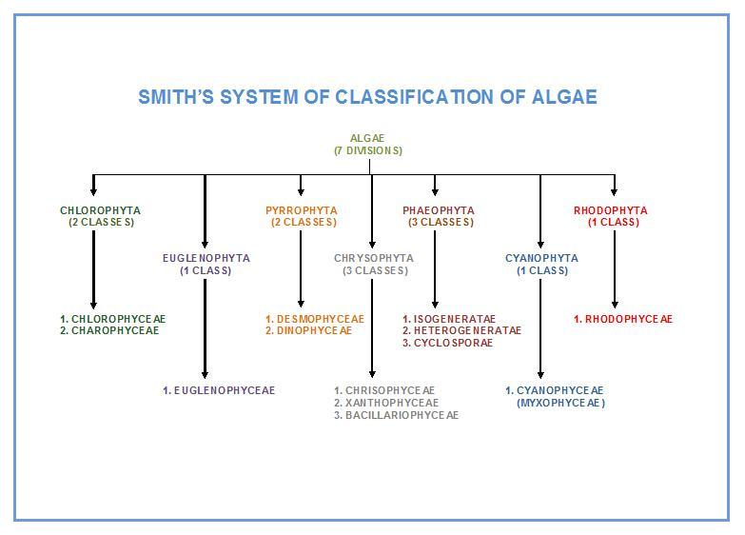
Reproduction in algae
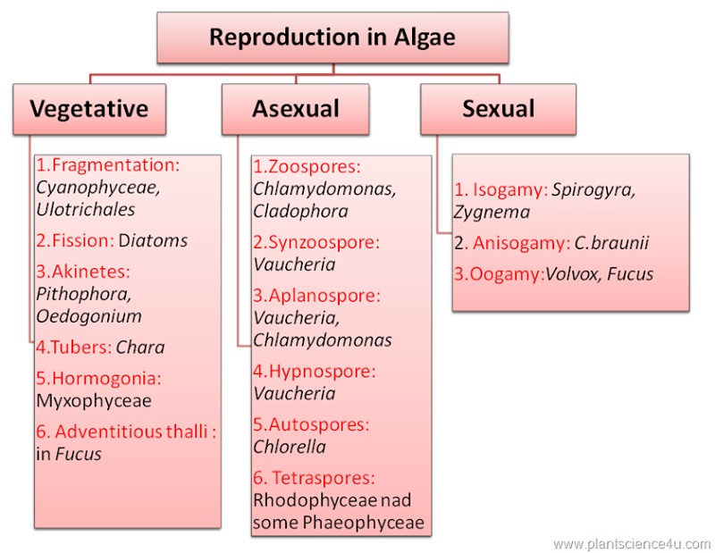

Beneficial Aspects of Algae
- Food for humans
- Food for invertebrates and fishes in mariculture
- Animal feed
- Soil fertilizers and conditioners in agriculture
- Treatment of waste water
- Diatomaceous earth (= diatoms)
- Chalk deposits
- Phycocolloids (agar, carrageenan from red algae; alginates from brown algae)
- Drugs
- Model system for research
- Phycobiliproteins for fluorescence microscopy
Detrimental Aspects of Algae
- Blooms of freshwater algae
- Red tides and marine blooms
- Toxins accumulated in food chains
- Damage to cave paintings, frescoes, and other works of art
- Fouling of ships and other submerged surfaces
- Fouling of the shells of commercially important bivalves

defiant terms:
Isogamy – sexual fusion between flagellated gametes that are similar in size and shape
Anisogamy – sexual fusion between flagellated gametes of distinctly different sizes
Oogamy – sexual fusion between a flagellated gamete (sperm) and non-flagellated gamete (egg)
Sporophyte: diploid, 2n, multicellular 􀃆release spores in alternation of generations
Gametophyte: hapliod, 1n, multicellular 􀃆release gametes in alternation of generations.

