Volcanic activity
Links between climate variability and volcanic activity are clear. As discussed, surface cooling driven by increased amounts of volcanic dust and sulfate aerosols in the stratosphere occurs one to two years after major explosive events. The effects of the eruption of Mt. Pinatubo in the Philippines in June 1991 may be seen in Figure 6 as lower global average temperatures in 1992 and 1993 compared to surrounding years. Regionally the impacts were larger. Surface temperatures over the northern continents were up to 2°C below average in summer 1992 but, owing to impacts on atmospheric circulation patterns, up to 3°C above average in the winters of 1991–1992 and 1992–1993 . As noted earlier, given the short timescale of the forcing, prolonged cooling would require a chain of eruptions events; such a series of events may help to explain the ‘Little Ice Age’. The period 1883–1912 also saw frequent eruptions . Conversely, reduced volcanic activity after 1914 may have contributed in part to the early twentieth-century warming. The surface cooling agents include both the transformation of sulfur dioxide (a gas) into sulfuric acid droplets (a reflective aerosol) and microparticles of dust that absorb solar radiation in the stratosphere (large particles rapidly settle out). Increased acidity in the snow falling on ice sheets can be measured by determining the signal of electrical conductivity in an ice core. This yields records of past eruptions. Global average temperatures the year following a major eruption may be reduced by several tenths of a degree C, but impacts can be much larger at hemispheric and regional scales.

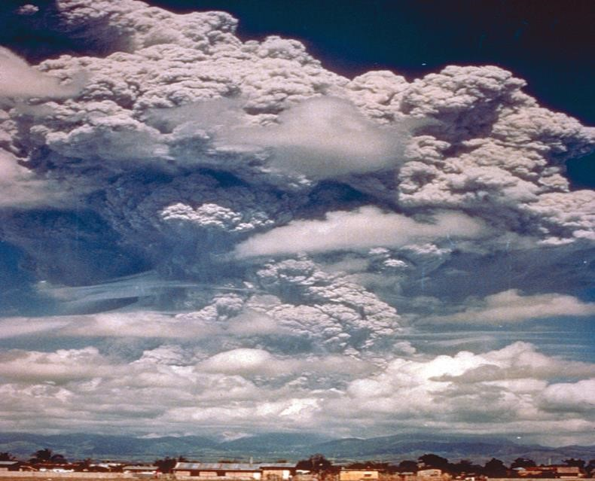

Figure 6 The first major eruption of Mt. Pinatubo on 12 June 1991. Mt. Pinatubo is located on the southwestern part of the island of Luzon in the Philippines. Prior to 1991, it had been dormant for more than 635 years.

Anthropogenic factors
As introduced earlier, the effects of human activities are best viewed in the framework of global radiative forcing, which refers to the amount by which a factor alters the radiation balance at the top of the atmosphere and is expressed in units of W m^{–2}. Figure 7 summarizes the different components of radiative forcing in 2005 relative to 1750. The largest single positive radiative forcing is from the increased concentration of carbon dioxide (about 1.7W m^{–2}). This means that compared to 1750, the increase in carbon dioxide, considered by itself, would lead to a radiation imbalance of this amount. Methane (CH4), nitrous oxide (N2O) and halocarbons together contribute about another 1W m^{–2}. Hence the total radiative forcing from long-lived greenhouse gases (long-lived in that they have a long residence time in the atmosphere) is about 2.2W m^{–2}. Halocarbons is a collective term for the group of partially halogenated organic species, and includes the chlorofluorocarbons (CFCs). Other smaller factors with a positive radiation forcing include tropospheric ozone, black carbon on snow (essentially soot from fossil fuel burning) and solar irradiance (which is of course not associated with human activities).
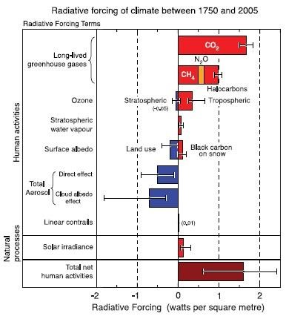
Figure 7 Components of global radiative forcing (Wm–2) for the year 2005, expressed as relative to the year 1750. The error bars indicate uncertainty ranges.

These positive forcings are in part countered by negative forcings due to increased aerosol concentration and increased surface albedo associated with land use, yielding the estimated total forcing due to human activities of about 1.6W m–2. The uncertainty in this value is largely due to uncertainty in the aerosol effects. Because of their highly episodic nature, Figure 7 does not include the effects of volcanic eruptions. While CFCs (one of the halogens) have a positive radiative forcing, the student may be more familiar with the link between CFCs and the destruction of stratospheric ozone. Despite the Montreal Protocol that has helped to control the production and use of CFCs, CFCs are longlived and are still impacting upon the ozone layer. Emissions of H2O and NOx by jet aircraft and by surface emissions of N2O are contributing to the problem. Ozone circulates in the stratosphere from low to high latitudes and thus the occurrence of ozone in polar regions is diagnostic of its global concentration. In October 1984, an area of marked ozone depletion
(termed the ‘ozone hole’) was observed in the lower stratosphere (i.e., 12–24km) centered on, but extending far beyond, the Antarctic continent. Ozone depletion is always greatest in the Antarctic spring, but in that year the ozone concentration was more than 40 percent lower than in October 1977. By 1990, Antarctic ozone concentrations had fallen to about 200 Dobson units in September to October, compared with 400 units in the 1970s. In the extreme years (1993–1995), record minima of 116 DU have been recorded at the South Pole. It has been estimated that, owing to the slowness of the global circulation of CFCs and of their reaction with ozone, even a cut in CFC emissions to the level of that in 1970 would not eliminate the Antarctic ozone hole for at least 50 years. Winter ozone depletion also occurs in the Arctic stratosphere and was well marked in 1996 and 1997, but absent in 1998. Localized mini-holes are fairly common, but extensive holes are rare even in cold stratospheric winters. It seems that whereas the Antarctic vortex is isolated from the midlatitude circulation, the Arctic vortex is more dynamic so that transport of ozone from lower latitudes makes up much of the loss.
Aerosol forcings are both direct and indirect. Together, they have an estimated radiative forcing of about –1.2W m–2. The direct effects relate to how aerosols absorb and scatter both solar and longwave radiation; a variety of aerosol types, including fossil fuel organic carbons, fossil fuel black carbon, biomass burning and mineral dust and sulfate aerosols, exert a significant radiative forcing. The indirect effect relates to how aerosols alter clouds. A key issue is how effectively an aerosol particle can act as a cloud condensation nucleus, which depends on factors such as the chemical composition and size of the aerosol. The indirect aerosol effect includes impacts on cloud albedo (often termed the first indirect effect) and impacts on cloud liquid water, height and lifetime (the second indirect effect). Reducing the high uncertainty in the direct and indirect effects of aerosols is a key focus area of climate research. Regarding land use, the basic issue is that increasing population pressures have led to overgrazing and forest clearance, acting to increase the planet’s surface albedo. While the radiative forcing relative to 1750 is a modest – 0.2Wm^{–2}, human effects on vegetation cover have a long history. Burning of vegetation by Aborigines in Australia has been traced over the last
50,000 years, while significant deforestation began in Eurasia during Neolithic times (about 5000 years ago), as evidenced by the appearance of agricultural species and weeds. Deforestation expanded in these areas between about AD 700 and 1700 as populations slowly grew, but it did not take place in North America until the westward movement of settlement in the eighteenth and nineteenth centuries. During the past half-century extensive deforestation has occurred in the tropical rainforests of Southeast Asia, Africa and South America. Estimates of current tropical deforestation suggest losses of 105km2/year out of a total tropical forest area of 9 × 106km². This annual figure is more than half the total land surface currently under irrigation. Forest destruction causes an increase in albedo of about 10 percent locally, with consequences for surface energy and moisture budgets.

