Lec.7 Biotechnology Dr. Sahira Nsayef
Enzyme Technology
Enzyme technology is the study of industrial enzymes and their uses.
The advantages and disadvantages of using enzymes are directly related to their properties:
Advantages | Disadvantages
They are specific in their action and are therefore less likely to produce unwanted by-products | They are highly sensitive to changes in physical and chemical conditions surrounding them.
They are biodegradable and therefore cause less environmental pollution | They are easily denatured by even a small increase in temperature and are highly susceptible to poisons and changes in pH. Therefore the conditions in which they work must be tightly controlled.
They work in mild conditions, i.e. low temperatures, neutral pH and normal atmospheric pressure, and therefore are energy saving | The enzyme substrate mixture must be uncontaminated with other substances that might affect the reaction.

There are two types of enzymes:
- Intracellular enzymes, which are produced inside the cell.
- Extracellular enzymes, which are produced outside the cell.
Table comparing intra- and extra-cellular enzymes:
Intracellular enzymes | Extracellular enzymes
More difficult to isolate | Easier to isolate
Cells have to be broken apart to release them | No need to break cells – secreted in large amounts into medium surrounding cells
Have to be separated out from cell debris and a mixture of many enzymes and other chemicals | Often secreted on their own or with a few other enzymes
Often stable only in environment inside intact cell | More stable
Purification/downstreaming processing is difficult/expensive | Purification/downstreaming processing is easier/cheaper

Isolating the Enzyme
Pure enzymes are needed for commercial use; therefore microbes must be grown in aseptic conditions, free from contaminants. It is necessary to prevent contamination with other bacteria since:
• There may be competition for nutrients.
• The required enzyme may not be produced as readily.
• The end-product may be contaminated and unsafe.

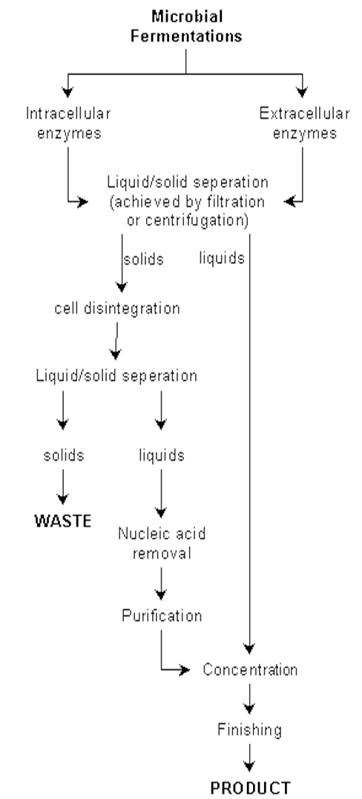
Uses of enzymes
Depending on the applications of enzymes,they are grouped into four broad categories:
1- Therapeutic uses
Enzyme | source | Application
streptokinase | Streptococcus pyogenes | Removal of fibrin clots
L-asparaginase | E.coli | Cancer chemotherapy
L-glutaminase | Achromobacter spp. | Treatmentof leukemia
β-galactosidase | Lactobacilli spp. | Treatment of lactose intolerance
2- Analytical uses
Enzyme | source | Application
Glucose oxidase | Aspergillusniger | Detection of glucose in blood
urease | Jack beans | Measurement of urea in body fluids
3- Manipulative uses.
Enzyme | source | Application
lysozyme | Hen egg white | disrupts mucopeptide of bacterial cell walls
nuclease | bacteria | genetic manipulation
4- Industrial uses.

The industrial use of enzymes (using the whole microbe)
Industry | Microbe
Brewing and baking | Saccharomyces cerevisiae
Vinegar production | Acetobacter
Yoghurt production | Lactobacillus

The industrial use of enzymes (not using the whole microbe)
Enzyme | source | Application
alpha-amylase | Bacillus spp. | Conversion of starch to glucose or dextrans in food industry
proteases | Bacillus spp. | Laundry aid
Glucose isomerase | Streptomyces spp. | Production of high fructose syrups
rennin | bacteria | Cheese making

Improving the Enzyme: Immobilization
Immobilization: The process whereby the movement of enzymes, cells, organelles, etc. in space is completely or severely restricted usually resulting in a water-insoluble form of the enzyme.”
Immobilized enzyme: An enzyme fixed by physical or chemical means to a solid support to confine a reaction of interest to a particular site.
Advantages of enzyme immobilization:
1- Enzyme can be recovered and reused.
2- Immobilized enzymes are usually more stable.
3- Ability to stop the reaction rapidly by removing the enzyme from the reaction solution.
4- Product is not contaminated with the enzyme, no purification required.
5- Easier to separate enzyme and products.
6- Allows development of a multienzyme reaction system.
7- Reduces effluent disposal problems.
Disadvantages of enzyme immobilization:
1- Immobilization may alter shape of enzyme.
2- May alter catalytic ability.
3- Enzyme may become detached.
4- Expensive.

There are four main methods available for immobilizing enzymes:
1) Adsorption
This method is based on the physical adsorption of enzyme protein on the surface of water-insoluble carriers such as glass or alginate beads. The bond between the enzyme and carrier molecule involves electrostaticforces such as vanderwaal forces, ionic bridges and hydrogen bonds.
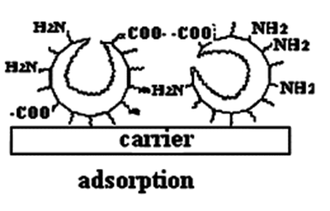
2)Entrapment
In entrapment the enzymes or cells are simply trapped inside the polymer matrix. Polymers like polyacrylamide, collagen, cellulose acetate, calcium alginate or carrageenan etc are used as the matrices.
1. Occlusion within a cross linked gel:
In this entrapment method, a highly cross-linked gel is formed as a result of the polymerization which has a fine "wire mesh" structure.
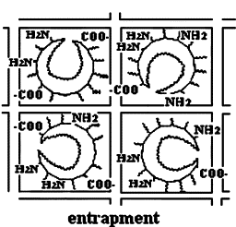
2. Microencapsulation:
This entrapment involves the formation of spherical particle called as “microcapsule” in which a liquid or suspension of biocatalyst is enclosed within a semi permeable polymeric membrane.
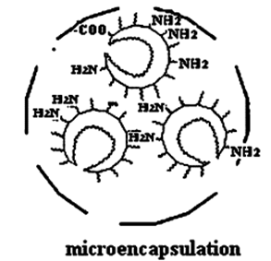
3)Covalent binding
This method involves the formation of covalent interactions between the functional groups present on the support surface and those present on the amino acid residues on the enzyme surface.
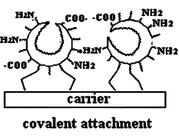
4)Cross linking
This method is based on the formation of covalent bonds between the enzyme molecules leading to three dimensional cross linked aggregates. The most common reagent used for cross-linking is glutaraldehyde.
