***Meteorological statistic***

***for 1st stage postgraduate (Masters)***

Not lecturer

**Assistant. prof. Dr. Asraa Khtan**

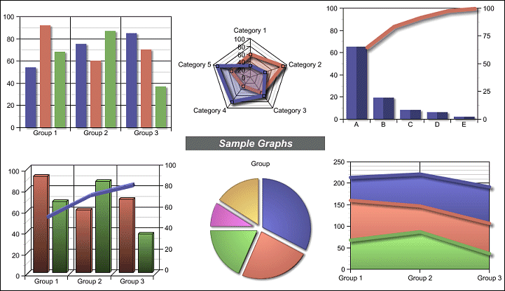

**GENERAL OVERVIEW**

**Statistic**: A branch of mathematics dealing with the collection, classification, presentation and analysis of data. The two major types of statistics are descriptive statistics and inferential statistics.

**Descriptive statistics:** the branch of statistics devoted to the summarization , organization and description of data. It's includes the construction of graphs, charts and tables.Descriptive statistics measures (measures of central tendency, measures of dispersion and variability and percentiles).

**Inferential statistics**: the branch of statistics concerned with using sample data to make an inference about a population of data. It's includes methods like point estimation, interval estimation and hypothesis testing which are all based on probability theory.

There are many applications of statistics in all branches of science meteorological one of them.

**Basic statistical terms**

**Variable**: is any characteristic, number or quantity that can be measured or counted. So variables can be classified as :

**Population** is any specific collection of objects of interest.

**Sample** is any subset or sub collection of the population, including the case that the sample consists of the whole population.

**Data** is the most basic element in statistics consists of observations, variables and data values.

**Types of variables**

There are different ways variables can be described according to the ways they can be studied, measured and presented. So variables can be classified as :

**Qualitative:** the datacollected for categorical variable whereuse wordslike names and labels , example: Baghdad station.

**Quantitative**: the datacollected for a numeric variable where use numbers , example: temperature is 23oc.

**Potential:** use name and numberfor example: temperature of Baghdad station is very high is 50 oc.

**\*\*\*\*\*data in atmospheric science is observation from device like temperature or measurement from equation like evaporation.**

**Data presentation**

After data collection is important to display the in an easy and understandable which appropriate to the size and type of data. There is more than one way.

**a-Tables**

A way to summarize data in different way, frequency tables one of them. for example the table below.

Table of No. of dust storm for three stations

|  |  |
| --- | --- |
| **Stations** | **No. of dust storm** |
| Baghdad | 13 |
| Basra | 10 |
| Mosul | 12 |

**\*\*\*\*\*must put title of table above it**

**b- Diagram**

Representation data by using graphical way .there are many types of diagram like (histogram, line polygon----) .for example the diagram below.



**No. of dust storm for three stations**

**\*\*\*\*\*must put title of diagram down it**

**c- Pie Charts**

Is a circular graph divided into sectors, each sector shows the relative size of each value. we must estimate percent and sector where

**Percent** is divide each value by the total and multiply by 100%

percent = (value/total) *100%

**Sector** is divide each value by the total and multiply by 360

Sector = (value/total) *360

**\*\*\*\*\*\*\*all percent equal 100 and all sector equal 360.**

**example**: if the total amount of precipitation (400mm) for the station Sulaymaniyah (120mm) of them in the form of hail and (60mm) snow and (220mm) rain, use pie chart to show precipitation.

percent = (value/total) *100%



p% hail=(120/400)*100%=30%

p% snow=(60/400)*100%=15%

p% rain=(220/400)*100%=55%

Sector = (value/total) *360

Sector hail=(120/400)*360=108o

Sector snow=(60/400)*360=54o

Sector rain=(220/400)*360=198o

**Frequency Distribution**

The frequency distribution is used to organize data so that their characteristics may be easily and quickly summarized where the actual data organize into numerical **classes** .usually the frequency of values is shown on the vertical axis (Y) and the classes or mid-point is presented on horizontal axis (X).the interval of data over which a class extends is called the **class interval** three kinds of class interval may be used in atmospheric

1. Class interval that is numerical and equal in size.

(10-19),(20-29),(30-39)

2- Class interval that is numerical and unequal in size.

(10-20) , (21-50), (51-100)

3-Class interval that is not numerical but is expressed in word.

(clear), (scattered), ( overcast)

The frequency distribution can be shown with:

**Histogram (bars)**:the frequency of values is shown as a series of vertical bars.

**Frequency polygon** (line): is similar to a histogram except that the vertical position of each data value or class is shown as a point rather than a bar.

**Types of frequency:**

**-Absolute frequency:** used to display the frequency of each value of data.

-**Relative frequency (percentage)**:used to display the frequency percentages of each value of data**.**

**-Cumulative frequency (ogive):** used to know the distribution of meteorological element in terms of "more than" or "less than" a certain value.

**-frequency distribution of vectors (Wind Rose):** display wind direction and speed.