Lec.15: Bioseparation Technique
Gel electrophoresis(Composition)

The matrix:
The matrix used to contain, and then separate the target molecules. In most cases, the gel is a crosslinked polymer whose composition and porosity is chosen based on the specific weight and composition of the target molecules to be analyzed.
When separating proteins ,DNA, RNA, or oligonucleotides, the gel is usually composed of different concentrations of acrylamide and a cross-linker, producing different sized mesh networks of polyacrylamide. When separating larger nucleic acids, the preferred matrix is purified agarose. In both cases, the gel forms a solid, yet porous matrix. Acrylamide, in contrast to polyacrylamide, is a neurotoxin and must be handled using appropriate safety precautions to avoid poisoning. Agarose is composed of long unbranched chains of uncharged carbohydrate without cross links resulting in a gel with large pores allowing for the separation of macromolecules and macromolecular complexes.
Types of gel:
The types of gel most typically used are agarose and polyacrylamide gels;each type of gel is well-suited to different types and sizes of analyte.

Agarose gels:
Agarose gels which are made from the: natural polysaccharide polymers extracted from seaweed have lower resolving power for DNA but have greater range of separation. Agarose gel electrophoresis can be used for the separation of DNA fragments ranging from 50 base pair to several megabases .
Agarose gels do not have a uniform pore size, but are optimal for electrophoresis of proteins that are larger than 200 kDa. . Most modern DNA separation methods now use agarose gels, except for particularly small DNA fragments. Gel electrophoresis of large DNA or RNA is usually done by agarose gel electrophoresis.Agarose gels are typically run horizontally in a submarine mode.
Polyacrylamide gels:
Polyacrylamide gel electrophoresis (PAGE) is used for separating proteins ranging in size from 5 to 2,000 kDa due to the uniform pore size provided by the polyacrylamide gel. Pore size is controlled by modulating the concentrations of acrylamide and bis-acrylamide powder used in creating a gel, also Polyacrylamide gel have very high resolving power for small fragments of DNA (5-500 base pair). Polyacrylamide gels are run in a vertical configuration.
Gel conditions:
Proteins are denatured using sodium dodecyl sulfate, usually as part of the SDS-PAGE process. For full denaturation of proteins, it is also necessary to reduce the covalent disulfide bonds that stabilize their tertiary and quaternary structure, reducing conditions are usually maintained by the addition of β-mercaptoethanol.
Buffers:
Buffers in gel electrophoresis are used to provide ions that carry a current and to maintain the pH at a relatively constant value. These buffers have plenty of ions in them, which is necessary for the passage of electricity through them.
After the electrophoresis is complete, the molecules in the gel can be stained to make them visible. DNA may be visualized using ethidium bromide , fluoresce under ultraviolet light, while protein may be visualised using Coomassie Brilliant Blue dye.
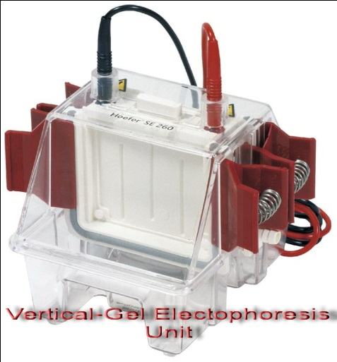

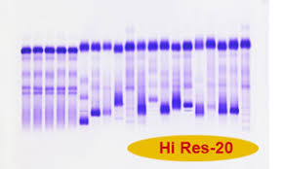

After separation, the gel will then be physically cut, and the protein complexes extracted from each portion separately,each extract may then be analyzed, this can provide a great deal of information about the proteins in a complex.
Applications:
Estimation of the size of DNA molecules following restriction enzyme #
- Analysis of PCR products
- # Separation of restricted genomic DNA.
# Gel electrophoresis is used in forensics, molecular biology, genetics, microbiology and biochemistry.

