2-3 Net effective temperature (NET)
As another example of a heat index suited to local weather conditions and requirements by public, the net effective temperature (NET), routinely monitored by the Hong Kong Observatory can be considered . The NET takes into account the effect of air temperature , wind speed and relative humidity on human beings .For example, heat loss by a human body will be faster under lower temperature, higher wind speed and higher relative humidity conditions in winter and, as such, the feeling of coldness will also be more pronounced.
NET is calculated as follows:
NET = 37 - (37-T)/(0.68 - 0.0014RH + 1/(1.76+1.4v0.75) ) - 0.29T (1-0.01RH)
where T= the air temperature (°C), v = the wind speed (m/s), and RH = the relative humidity (%), and has a higher value when the temperature is higher, but its value will be lower at higher wind speed and relative humidity.

2-4 Wind chill:
Wind chill is the chilling effect of the wind in combination with a low temperature .Humans do not sense the temperature of the air directly .When humans feel that it is cold, they are actually sensing the temperature of their skin .Because the skin temperature is lower when it is windy (humans lose heat from the skin faster than the body can warm it),humans feel that it is colder when there is wind .This sensation is what the wind chill index attempts to quantify.
Each year, in Canada, more than 80 people die from overexposure to the cold, and many more suffer injuries from hypothermia and frostbite. Wind chill can play a major role in such health hazards because it speeds up the rate at which the body loses heat. A recent survey indicated that 82 per cent of Canadians use wind chill information to decide how to dress before going outside in the winter. Many groups and organizations also use the system to regulate their outdoor activities.
The new index is expressed in temperature-like units, the format preferred by most Canadians as determined through public opinion surveys. It must be noted that although the wind chill index is expressed on a temperature scale (the Celsius scale in Canada), it is not a temperature: it only expresses a human sensation. The index likens the way human skin feels to the temperature on a calm day.
For example, if the outside temperature is -10°C and the wind chill is -20, it means that the exposed face will feel as cold as it would on a calm day when the temperature is -20°C.
The equation to determine the new index is the following:
W = 13.12 + 0.6215*T_{air} – 11.37*V10 _{metre} 0.16 + 0.3965* T_{air} * V10 _{metre} 0.16
In addition, specifically, the new wind chill index has the following features:
• It uses wind speed calculated at the average height of the human face (about 1.5 metres) instead of the standard anemometer height of 10 metres. The correction is effected by multiplying the 10-metre value (what is indicated in weather observations) by a factor of 2/3;

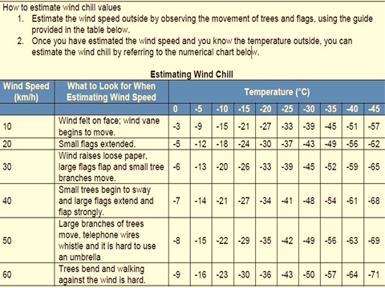

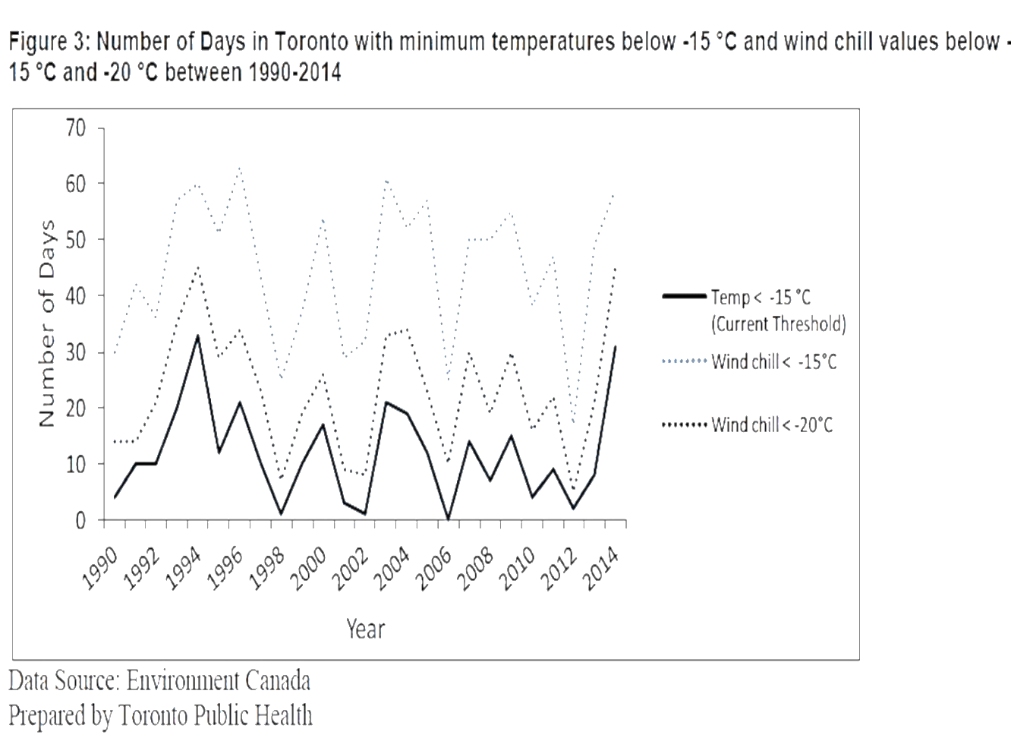
Health Impacts of Cold Weather
chronic health conditions The health impacts of cold weather include:
- cold weather injuries
- impacts on mortality and
- other

Cold Weather Injuries
Cold injuries can be classified as
- hypothermia, freezing injuries,
- and non-freezing injuries.
Effects are relatively immediate for most cold weather injuries.
Hypothermia occurs:
when the body’s core temperature drops below 37 ºC. A body temperature that is too low affects the brain, making the victim unable to think clearly or move well.
This makes hypothermia particularly dangerous because a person may not know it is happening and will not be able to do anything about it.
Hypothermia is characterized by shivering, confusion and loss of muscular control (e.g., difficulty walking), and can progress to a life-threatening condition where shivering stops or the person loses consciousness. Cardiac arrest may occur.

Freezing injuries include:
frostnip and frostbite and occur when body tissues freeze.
Frostnip is the milder of the two and involves freezing of the skin only. Frostbite is more severe and occurs when both the skin and the underlying tissue such as fat, muscle, and bone are frozen.
In cold weather, blood vessels near the skin’s surface constrict in order to protect the body’s core temperature. With long periods of exposure to cold, this can lead to reduced blood flow to extremities such as hands, feet, nose, and ears. These areas are then most likely to be affected by frostnip or frostbite. While frostnip is typically only associated with discomfort, untreated severe frostbite can lead to permanent nerve damage, blisters, and even to infection and loss of limbs. Trench foot is an example of a non-freezing cold injury. Trench foot is often described as a "wet cold disease" and results from prolonged exposure in a damp or wet environment from above the freezing point to about 10 ºC. Injury occurs because wet feet lose heat 25-times faster than dry feet.

