Lect. 4 **Cytogenetics**

**4.2. Numerical chromosome aberrations**

**The numerical anomalies, when one or more chromosomes are in excess or missing, ultimately modify the entire genome size, so they can be considered genome mutations as well.**

**There are three types of numerical chromosome aberrations:**

**1 / euploid**

**2 / aneuploid**

**3 / mixoploid mutations**

**4.2.1. Euploid chromosome mutations**

**In the case of euploidy each chromosome is present in the same number, i.e. in a haploid cell everything is present only once, twice in diploids, three times in triploids and so on. The haploid chromosome number - i.e. typical of the gametes - is n, its exact multiples, that is, 2n, 3n, etc. found in the euploid somatic cells.**

**.**

**Polyploidy means, if we find a multiple of n, either in gametes or in somatic cells. However, mutations only have arisen if the individuals or just the cell have chromosomes in a number different from the species specific (haploid or diploid) set. The multiplication of the chromosome set occurs in the( M) phase of the cell cycle due to the defects of microtubules and / or the abnormal organization of mitotic**

**spindle.**

**In plants, polyploidy is compatible with normal life moreover it is economically quite advantageous, since the multiplication of chromosomes leads not only to the multiplication of genes, but also to the multiplication of their products. Thus the protein content and the crop yield grow, such as banana, wheat etc. In plant cells, the polyploidy found is either the result of that species’ evolution or the result of conscious plant breeding work. For the induction of polyploidy spindle poisons - Colcemid, Colchicine, Vincristine, Vinblastine - alkaloids inhibiting the polymerization of spindle microtubules can also be used. In this case *autopolyploidy* is created, since every chromosome is of the same species.**

**In contrast, hybrids(e.g. wheat) established by crossing of species or related species are *allopolyploids*.**

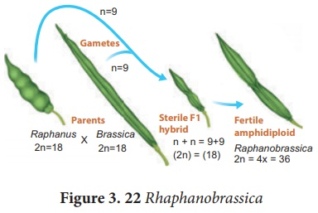

An organism which possesses two or more basic sets of chromosomes derived from two different species is called allopolyploidy. It can be developed by interspecific crosses and fertility is restored by chromosome doubling with colchicine treatment. Allopolyploids are formed between closely related species only. (Figure 3.22) **Example:1 *Raphanobrassica*, G.D. Karpechenko (1927) a Russian geneticist, crossed the radish (*Raphanus sativus*, 2n=18) and cabbage (*Brassica oleracea*, 2n=18) to produce F1 hybrid which was sterile. When he doubled the chromosome of F1 hybrid he got it fertile. He expected this plant to exhibit the root of radish and the leaves like cabbage, which would make the entire plant edible, but the case was vice versa, so he was greatly disappointed.**

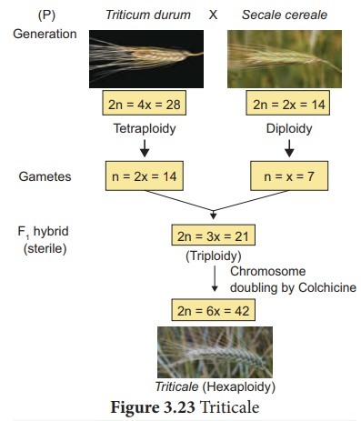

**Unlike plants polyploidy in animals or in humans is lethal, leads to death in utero. With the exception of certain cells/tissues, for example bone marrow megakaryocytes and a part of the regenerating liver cells which are also polyploids. In these cases it is fixed during the millions of years of evolution what type of cell has the multiplication of chromosome number during ontogeny.**

**In 10% of the spontaneously aborted fetuses triploidy occurs. Interestingly, 90% of them is of paternal origin, derived either from fertilization by a diploid sperm or from double fertilization. Only a minority comes from fertilization of a diploid egg.**

***4.2.2. Aneuploid chromosomal aberrations***

**Aneuploidy is a chromosomal abnormality when only a certain chromosome is in excess or missing. If there is only one chromosome instead of the normal two homologues we are talking about *monosomy*, if there are three copies *trisomy* occurs. If a particular chromosome is not found at all in a cell / organism *nullisomy* is present. The latter is lethal both in humans and animals, but in plants is not. Generally speaking, in humans / animals the excess of chromosomes is tolerated better than the chromosomal deficiency. Several somatic and especially sex chromosome aneuploidies - trisomies - occur in live-born, but only one - the X chromosomal monosomy (Turner syndrome) occurs in live-born. The aneupolid mutations are due to *mitotic or meiotic non-disjunctions*, when the sister chromatids or the chromosomes do not separate in the anaphase – because of the abnormality of the kinetochore, the centromere or both. Less frequently (uniparental disomy) a chromatid / chromosome lagging behind the others in the anaphase - *anaphase lag* - do not get to the right pole, and therefore not to the daughter cell. Due to this one of the daughter cells is with an extra chromosome, while there is a deficiency in the other. Of course, from medical point of view meiotic non-disjunctions are more important as these lead to defective gametes, and finally to affected offspring.**

**In the case of *mitotic non-disjunction*, it is crucial, when and in which cell type’s division occurs. The early non-disjunction, eventually involving many cells / tissues leads to severe consequences (mosaicism).**

**The *meiotic non-disjunctions* are grouped according to when they occur – in the first or in the second meiotic division. In the first meiotic non-disjunction, some pairs of homologous chromosomes are not segregated, whereas in the second meiotic non-disjunction - as in**

**mitotic non-disjunctions the sister chromatids are not separated. These have different consequences accordingly.**

**Following *the first meiotic non-disjunction* all four progeny cells - in spermatogenesis**

**the four sperms - will have an abnormal chromosome set – will be aneuploid. Two is with an additional chromosome (n+1); two is without one (n-1). In *the second meiotic non-disjunction only the half of the daughter cells* are affected. They will also be with an extra or an absent chromosome. The fusion of such abnormal gamete with a normal one results in trisomic or monosomic zygote. In the case of trisomie**

**In the case of trisomies there is difference in the origin of the three homologues depending**

**on in which meiotic division the mutation took place. *Trisomies derived from the first meiotic division all three homologues are of different origin (e.g. one is from the maternal grandmother, the other is from the maternal grandfather, and the third is inherited from the father). However, in trisomies from the second meiotic non- disjunction two homologues are identical (e.g. either from the maternal grandmother or from the maternal grandfather) and only the third comes from the other parent, from the father.***

***70% of the human aneuploid chromosome mutations are derived from the first and 30% from of the second meiotic non-disjunction.***

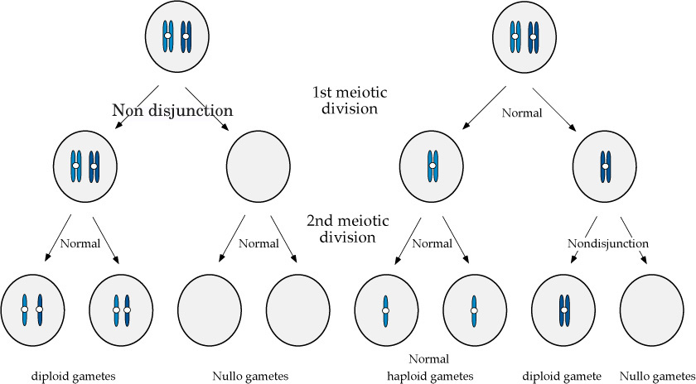

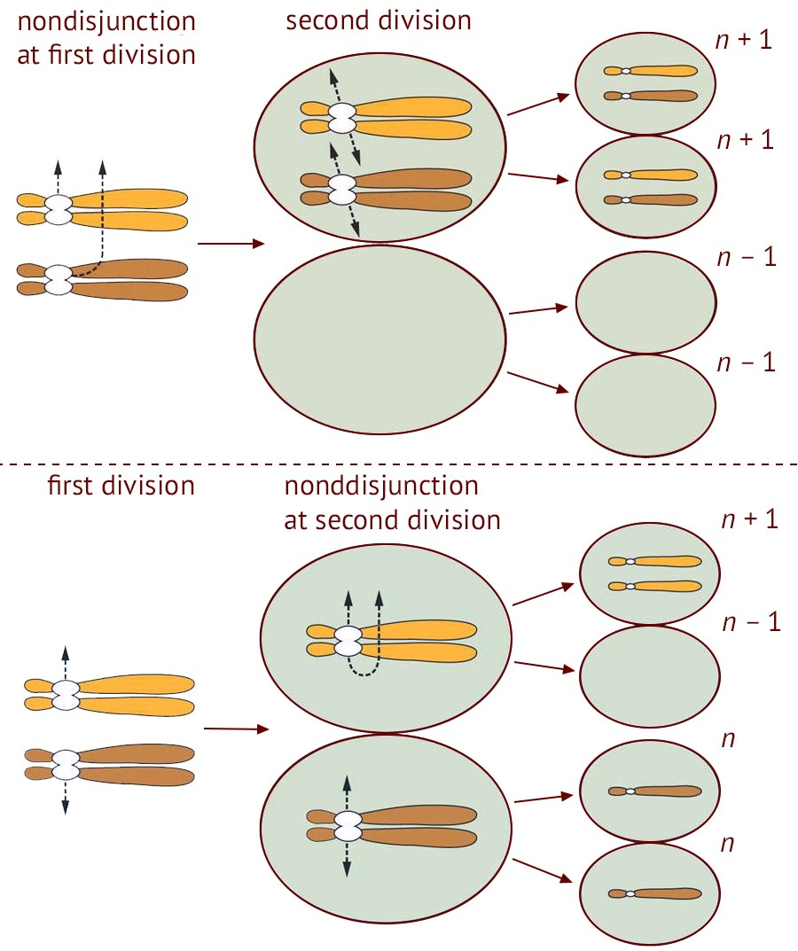

**Figure  Non-disjunction during meiosis results in an abnormal chromosome number**



***Figure 4.7. Rate of meiotic non-disjunctions in function of maternal age***

***So most of the meiotic non-disjunctions occur during the first meiotic division and are of maternal origin. The frequency of maternal non-disjunctions and the aneuploid offspring(like Down syndrome) - increases with maternal age (Figure 4.7). The reason of this lies in the characteristics of female gametogenesis: probably the aging of the synaptonemal complex, which reduces the chance of co-segregation of homologues leads to the formation of gametes with abnormal chromosome number. This is why above a certain maternal age (35-40) prenatal tests are recommended or required, to determine whether a fetus carries a numerical chromosome aberration or not.***

***4.2.3. The most common numerical chromosomal abnormalities***

***All chromosome trisomies except the one of the largest human chromosome (chromosome1) were found in spontaneously aborted fetuses, among live born three autosomal trisomies and some involving sex chromosomes occur (Figure 4.8). Two things are suggested by this:***

***first, the fate of trisomies is strongly dependent on the number and type and function of genes present in the chromosome, on the other hand there is a strong intrauterine selection, so the most severely affected fetuses die in utero. These are confirmed by the fact that in spontaneously aborted fetuses the most common abnormalitiy is the trisomy 16, which although affects a relatively small chromosome, is never found in live born! All the monosomies, with the exception of the X chromosomal monosomy are incompatible with life.***



**Figure 4.8.** Autosomal numerical chromosome aberrations

***4.2.3.1.Trisomy 21***

***Trisomy 21 is the cause of Down syndrome. Although the non-disjunction of chromosome 21 is not the only cause of Down syndrome -a smaller proportion of the cases is due to either centric fusion or translocation - it is the most common type. Despite the fact that trisomy 21 fetuses die in utero the average population frequency of Down syndrome is 1:650, but this value increases dramatically with maternal age, at 45 years of age it is more than1:100!***

***Although today live-born trisomy 21 patients have more or less the same life expectancy than healthy individuals, but the leukemia and some other disease prevalence is higher among them than in the general population. In recent decades, there is a significant change in the***

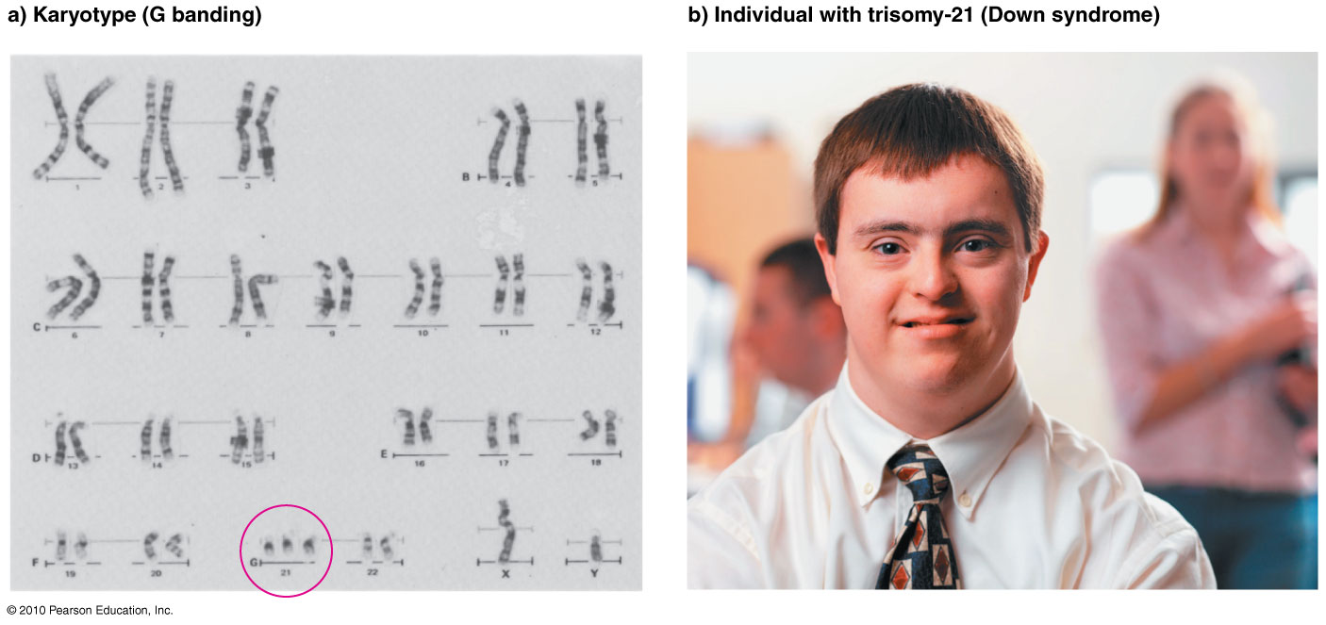

***social status of Down syndromic individuals, whereas before they were excommunicated, teaching them was thought to be impossible, now increasing efforts have been made to facilitate their social integration (e.g. special kindergartens, in many countries they are taught together with healthy children in public school classes, sporting events etc.).***

***4.2.3.2.Trisomy 13***

***Trisomy 13 is the Patau syndrome. Similar to Down syndrome it is most commonly derived from maternal non-disjunction. 65% of such non-disjunctions derived from the first meiotic division. Frequency of birth is 1:12 500 - 1:21 700. Only <5% of these infants survive the first year of life.***

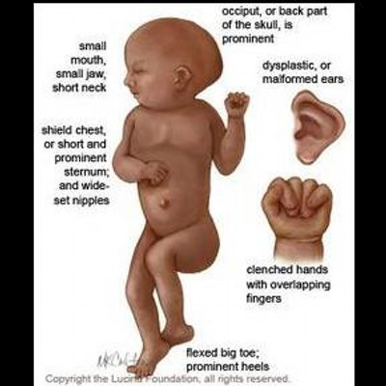

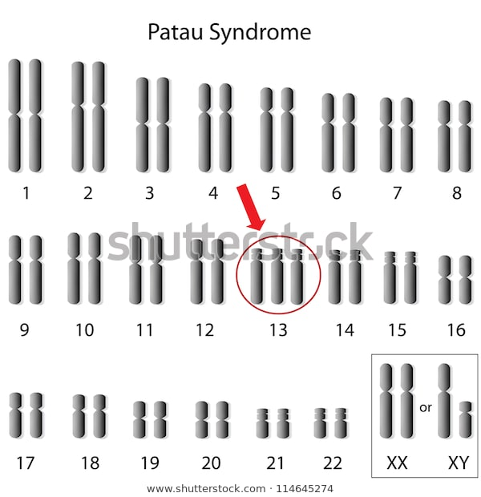

***4.2.3.3. Trisomy 18***

***Trisomy 18 is the Edwards syndrome. It is primarily due to maternal non-disjunction. 95%! of the cases are due to non-disjunction in the first meiotic division. The frequency is1:6000 -1:10000 live-born but the frequency at the time of conception can be much higher, since approx. 95% of the fetuses die within the womb. 30% of the Edwards syndromic abnormal newborns die within one month, > 95% of them die within a year.***

