ECOLOGY
Lecture 7.

THE NITROGEN CYCLE
The nitrogen cycle is the biogeochemical cycle by which nitrogen is converted into multiple chemical forms as it circulates among atmosphere, terrestrial, and marine ecosystems. The conversion of nitrogen can be carried out through both biological and physical processes. Important processes in the nitrogen cycle include three steps:
- Fixation: Nitrogen fixation is an anaerobic (without oxygen) process in which atmospheric nitrogen (N₂)is reduced to NH₃. Bacteria are responsible for this process. Bacteria in terrestrial and aquatic(water) environments participate in this process. These organisms must have a special enzyme known as dinitogenase to be able to this action. These organisms called nitrogen fixers, include:
- The cyanobacteria or blue- green algae of fresh water, marine , and soil environments.
- Certain free living soil bacteria.
- Bacteria associated with the roots of leguminous plants.
- Actinomycetes bacteria associated with the roots of alders Alnus and Several other species of woody plants
- Ammonification: Ammonia is formed in the soil by the decompostion of plants and animals and by the release of animal waste.
- Nitrification: Plants receive the components of the "fixed" nitorgen using nitrates in the soil to provide the nutrients they need. Bacteria such as Nitrosomonas, Nitrococcus, and Nitrobacter participate. Nitrification involves two steps. First, the ammonium ion (NH₄+) is oxidized into NO₂-. Then, this compound is further oxidized into NO₃-. Again, bacteria in the soil participate in both processes.
- Assimilation: Plant roots assimilate Nitrogen mainly in the form of nitrates while animals assimilate their nitrogen by eating the plants.
- Denitrification: This is the reduction of nitrates to gaseous nitrogen. Denitrifying bacteria perform almost the reverse of the nitorgen fixing bacteria
The nitrogen cycle is a cycle within the biosphere which involves the atmosphere, hydrosphere, and lithosphere. The majority of Earth's atmosphere (78%) is atmosphere nitrogen,[16] making it the largest source of nitrogen. However, atmospheric nitrogen has limited availability for biological use, leading to a scarcity of usable nitrogen in many types of ecosystems.
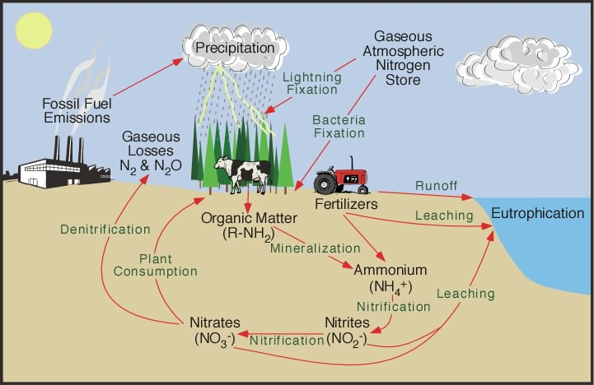

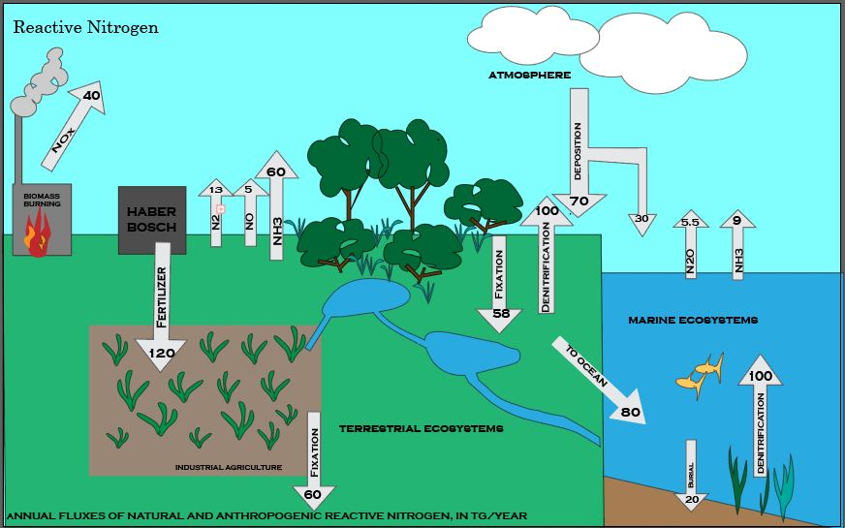

This figure summarizes the global cycling of reactive nitrogen. includes industrial fertilizer production, nitrogen fixed by natural ecosystems, nitrogen fixed by oceans, nitrogen fixed by agricultural crops, NOx emitted by biomass burning, NOx emitted from soil, nitrogen fixed by lightning, NH3 emitted by terrestrial ecosystems, deposition of nitrogen to terrestrial surfaces and oceans, NH3 emitted from oceans, ocean NO2 emissions from the atmosphere, denitrification in oceans, and reactive nitrogen burial in oceans.

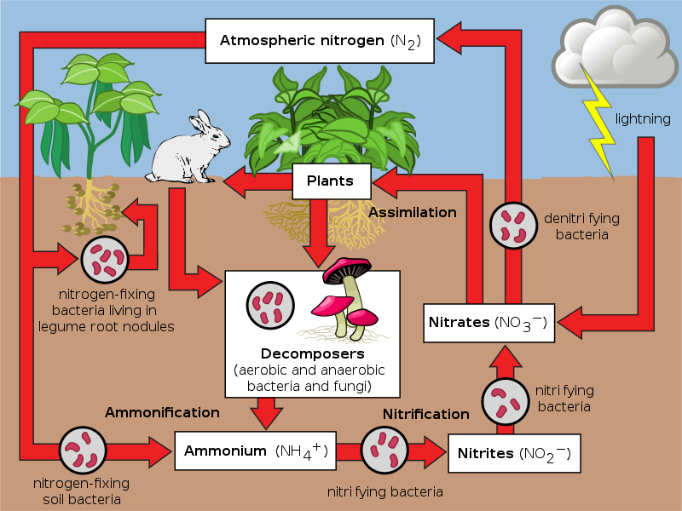
The above schematic representation of the flow of nitrogen through the ecosystem. The importance of bacteria in the cycle is immediately recognized as being a key element in the cycle, providing different forms of nitrogen compounds able to be assimilated by higher organisms.

