ECOLOGY
Lecture 8.

ECOLOGICAL SUCCESSION
Ecological succession is the process of change in the species structure of an ecological community over time. The time scale can be decades (for example, after a wildfire), or even millions of years after a mass extinction.^{[1]}
Succession may be initiated either by formation of new, unoccupied habitat, such as from a lava flow or a severe landslide, or by some form of disturbance of a community, such as from a fire, severe windthrow, or logging. Succession that begins in new habitats, uninfluenced by pre-existing communities is called primary succession, whereas succession that follows disruption of a pre-existing community is called secondary succession.

Basic Types of Succession:

1. Primary succession:
In any of the basic environments viz., terrestrial, fresh water, marine, one type of succession is primary succession which starts from the primitive substratum, where there was no previously any sort of living matter. The first group of organisms establishing there are known as the pioneers, primary colonisers or primary community.

2. Secondary succession:
It starts from previously built up substrata with already existing living matter. The action of any external force, as a sudden change in climatic factors, biotic intervention, fire etc. causes the existing community to disappear. Thus, area becomes devoid of living matter but its substratum, instead of primitive, is built up.

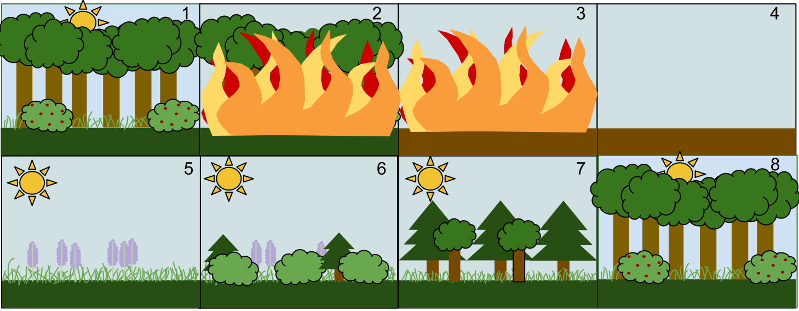

An example of Secondary Succession by stages:
- A stable deciduous forest community.
- A disturbance, such as a fire, starts.
- The fire destroys the vegetation.
- The fire leaves behind empty, but not destroyed soil.
- Grasses and other herbaceous plants grow back first.
- Small bushes and trees begin to colonize the public area.
- Fast-growing evergreen trees and bamboo trees develop to their fullest, while shade-tolerant trees develop in the understory.
- The short-lived and shade-intolerant evergreen trees die as the larger deciduous trees overtop them. The ecosystem is now back to a similar state to where it began.

Mechanism (General Process of Succession):
The whole process of a primary autotrophic succession is actually completed through a number of sequential steps, which follow one another. These steps in sequence are as follows:
- Nudation:
- Migration:
- Ecesis:

Competition and coactions:

Reaction:

Stabilization (climax):

Climax concept
According to classical ecological theory, succession stops when the sere has arrived at an equilibrium or steady state with the physical and biotic environment. Barring major disturbances, it will persist indefinitely. This end point of succession is called climax.

Climax community
The final or stable community in a sere is the climax community or climatic vegetation. It is self-perpetuating and in equilibrium with the physical habitat. There is no net annual accumulation of organic matter in a climax community. The annual production and use of energy is balanced in such a community.

Characteristics
- The vegetation is tolerant of environmental conditions.
- It has a wide diversity of species, a well-drained spatial structure, and complex food chains.
- The climax ecosystem is balanced. There is equilibrium between gross primary production and total respiration, between energy used from sunlight and energy released by decomposition, between uptake of nutrients from the soil and the return of nutrient by litter fall to the soil.
- Individuals in the climax stage are replaced by others of the same kind. Thus the species composition maintains equilibrium.
- It is an index of the climate of the area. The life or growth forms indicate the climatic type.

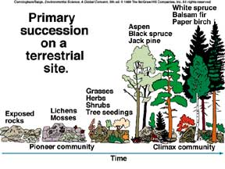

WHICH TYPE OF SUCCESSION? AND WHY?

