Examination Of Indicator Organisms In water:
- Total coliforms or the coliform group:
Indicators are still useful for monitoring the microbial quality of piped water supplies. For this reason, it is important to examine a drinking water source frequently by simple tests. coliform organisms may not always be directly related to the presence of fecal contamination, these microbial indicators of drinking-water quality are easy to detect and enumerate in water, Drinking water must be completely free of these microorganism .
*Characteristics of total coliforms :
-Are members of the Enterobacteriaceae, rod-shaped, Gram-negative ,
non-sporing , aerobic and facultative anaerobic, growth in the presence of bile-salts , lactose fermenting bacteria at 35° - 37°C with the production of acid with gas .
- Including the genera Escherichia, Citrobacter, Klebsiella and Enterobacter.
- Many coliform species occur in the environment in the absence of faecal contamination.
- These are normal intestinal ﬂora of humans and other warm-blooded animals but considered elsewhere as a source of contamination.
*Detection method: Membrane filter (MF) technique, MPN techniques or plate count , Incubation temperature: 37°C time : 24 hours.

The indicators examination of water : has been standardized into three tests. The first, presumptive test, is a screening test to water for the presence of coliform organisms. If the presumptive test is negative, no further testing is performed, and the water source is considered microbiologically safe. If, however, a presumptive test is positive of any tube in the series, the water is considered unsafe and the confirmed test is performed on the tube that appears a positive reaction. The confirmed test is a second screening procedure to select a Gram-negative bacteria by using a selective broth medium. The completed test is performed on a tube that reaffirms gas production in selective medium , re-culture on differentiate media to distinguish between coliform organisms by morphological and physiological properties.
The presumptive test by MPN :
Principle : The test is called presumptive because the reaction observed may sometimes be due to the presence of some other organisms (non-coliforms ). In the presumptive test, measured volumes of water sample added to a series of tubes containing lactose broth . Acid production + Gas production due to ferment of lactose in any one of the tubes is presumptive evidence of the presence of coliforms and needs to be confirm . The most probable number (MPN) of coliforms in 100 ml of the water sample can be estimated by reference to statistical tables (McCrady).
Culture media :
- Lactose broth.
- Lauryl tryptose (lactose) broth.
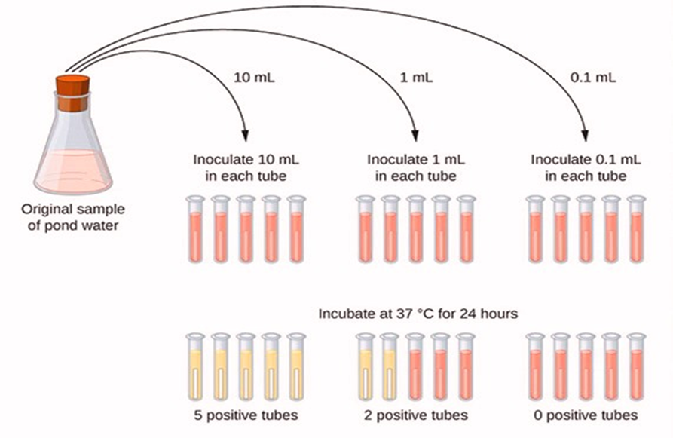

Presumptive test procedure :
1-Collect approximately 100 ml of water to be tested (from pools, streams, ocean, etc.).Record the source and date on the sample to be tested.
2-Aseptically, Prepare three sets of tubes each set of five test tubes containing (Durham tubes) and transfer 10 ml of water sample into tubes containing double strength lactose broth in 1^{st.} row.
- Then transfer 1 ml of sample into tubes in 2 ^{nd.} the row containing a single concentration of lactose broth. Finally, inoculate 3 ^{rd.} row (single concentration) with 0.1 ml of water.

- Incubate all tubes at 37º for 24 h.
- After the incubation period, the broth for gas formation (bubbles in Durham tube ) and acid production ( by the color change of the medium) is what draws attention. Tubes with gas are considered positive.
- Refer to table to get the MPN.

Interpretation of the results:
Gas production means ferment lactose happened with the gas ( positive presumptive test) , but if gas not forming then leave another 24 hours, if gas formation it means a doubtful presumptive test, but if gas were not made after 48 hours, this negative test.

The Confirmed Test :

Principle : the presumption reaction is due to coliform organisms should be conﬁrmed. If any of the tubes inoculated with the water sample produce gas, the water is presumed to be unsafe. However, it is possible that the formation of gas may not be due to the presence of coliforms. In order the confirm the presence of coliforms, it is necessary to inoculate in Macconkey broth from a positive presumptive tube. The Macconkey broth inhibits Gram positive organisms and allows the Gram-negative coliforms to grow.
Culture media used :
- MacConkey broth.
- Brilliant green lactose bile broth.

Confirmed test procedure :

  - by transferring a loopful of culture from a positive tube of the presumptive test (higher dilution) and inoculated into a tube broth with Durham tubes.
  - Incubate tubes 37 C for 48 hours
  - observed for gas production
  - if the gas is formed, it means a positive presumptive test. If no gas is present in any of the Durham tubes, this is a negative presumptive test.

Interpretation of the results :
MacConkey broth or Brilliant green lactose bile broth will inhibit positive bacteria to grow in the sample.

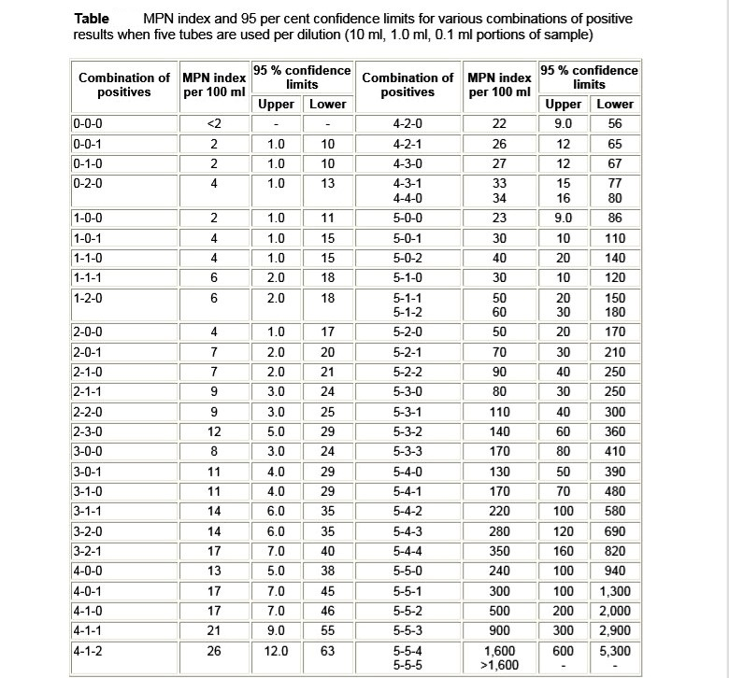
Completed test:
Principle : To identification the coliform organisms in confirm test. This examination do on the samples that gave positive confirmed test. Completed test was carried out by streaking a loopful of broth from a positive tube into eosin methylene blue (EMB) agar plate for pure colonies. The plates were incubated at 37°C for 24-48 h. Colonies developed on EMB agar was further identiﬁed as coliforms fecal coliforms (E. coli) using culture characteristic, morphology, and biochemical test. For fecal coliforms, colonies with green metallic sheen were Gram-stained, and the IMVIC test was carried out to identify the colony as E. coli.

Culture media used : 1) EMB agar. 2) Endo agar.
The procedure :
- Take a loopful from the tube which has given a positive confirmation test and streak on Eosin methylene blue or Endo agar plates then Incubate at 37 C for 24 hours .
- After the end of the incubation period , we observe the coliform bacteria ( ex: E. coli colonies be green metallic sheen on the EMB media or Red metallic sheen at the *Endo agar). From one of these colonies, set up your completed test by inoculating a lactose fermentation tube and a nutrient agar .Incubate them at 37º C.
- After this incubation, check the lactose tube for acid and gas production. If no gas is present, this is a negative completed test.

4. Prepare a Gram stain. If the organism is a non-spore producing Gram negative rod and the lactose broth shows an acid/gas reaction, this is a positive completed test.
*Endo agar: Detection and confirmation of coliforms by differentiate between lactose fermenting and non- lactose fermenting bacteria . the coliform bacteria that ferment lactose appears as dark red color with golden-green metallic sheen.
for example : Escherichia coli; produce red colonies and red surrounding area while non- lactose ferment appear colorless or transparent colonies.
- IMVIC Tests :
Aim: The primary aim of this test was to identify the presence of the test organisms. The identification was further based on the results obtained by the biochemical tests that were performed.
Materials and Methods: Broths for Indole, Methyl red, VP, Citrate slants and Urease tests were performed for the identification of the presence of test organisms.

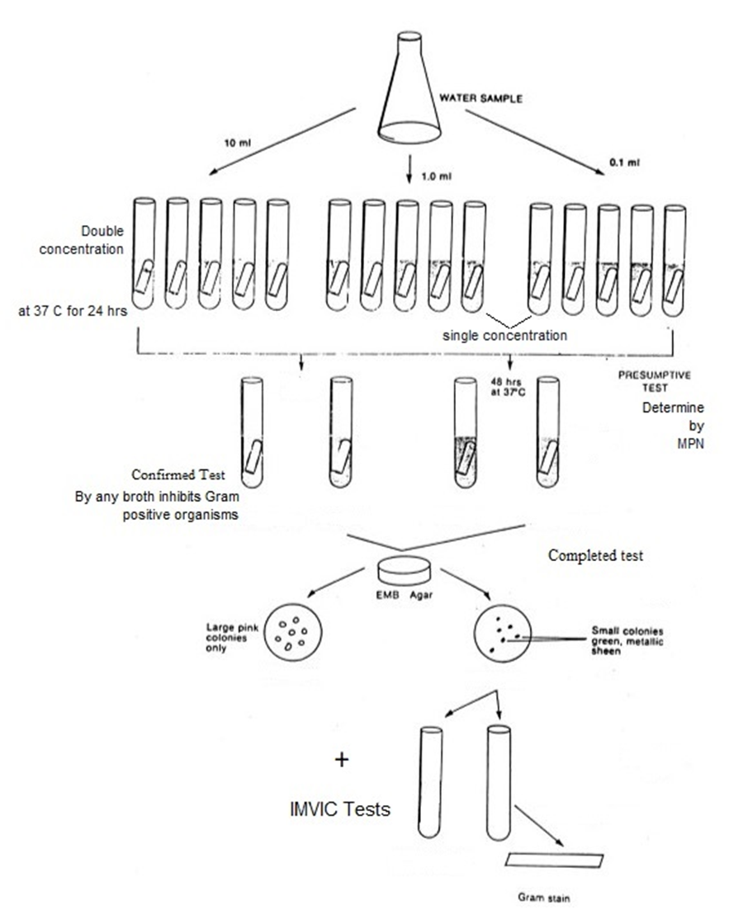

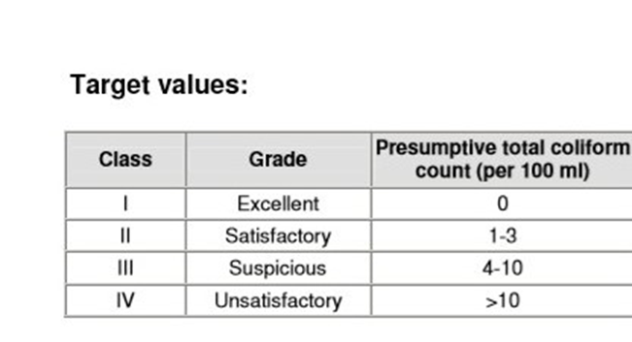

2-Escherichia coli
The coliform including E.coli one of the most important indicators of fecal contamination in the water. The presence of E. coli is considered evidence of fecal new contamination .
*Characteristics of Escherichia coli :
1) it is a small, gram-negative rod
2) it does not contain spores
3) it ferments lactose with the production of acid and gas until 44°C or 44.5°Cº.
4) it produces a green metallic sheen on EMB agar.
- E. coli which is found in large numbers in the feces of all animals, in fresh feces it may attain concentrations of 10⁹ per gram, if E. coli are present, there should be intestinal pathogens do.
Most E. coli are an indicator of fecal contamination since it is not-
normally found in water or soil.
Detection method :
Membrane filtration (MF) method is used to obtain single colonies of E. coli as the easiest than (MPN) by using EMB medium or Endo agar .

Non Faecal Coliform | Faecal Coliform
Live in soli ,aquatic environment and vegetation | Live in the intestine of the warm-blooded animals
Optimal temperature for lactose fermentation is 37C | Optimal temperature for lactose fermentation is 44C
Ex: Citrobacter | Ex: E.coli

On EMB agar : E. coli and Enterobacter. aerogenes can be distinguished from one another by the size and color of the colonies. E. coli colonies are small and have a green metallic sheen, whereas E. aerogenes forms large pinkish colonies.
