**Cytogenetic**

**Lab -1-**

-Cytogenetics is the branch of genetics that correlates the structure,number,and behavior of chromosome with heredity and diseases.

Cytogenetics is the study of the of structure chromosome material.-

-Cytogenetics is the branch of genetics that is concerned wiht the study of the structure,and function of the cell,especially the chromosome.

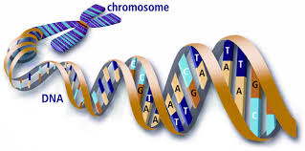

**The chromosomes**

Chromosomes are organized structures of DNA and proteins found in

cell. They are thread-like structures located inside the nucleus of animal and plant cells. Each chromosome is made of protein and a single molecule of deoxyribonucleic acid (DNA). Chromosomes are passed from parents to offspring.The term chromosome comes from the Greek words for color (chroma) and body (soma). Scientists gave this name to chromosomes because they are cell structures, or bodies, that are strongly stained by some colorful dyes used in research.

Chromosomes play an important role that ensures DNA is copied and distributed accurately in the process of cell divition .chromosome are made up of DNA segments.carry all the information that help a cell grows ,survive and reproduce .DNA segments specific patterns are called genes.

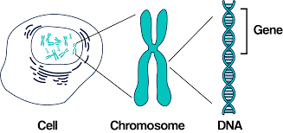

Chromosomes are found in cells in the form of pairs,in human cells 23 pair ( where 22 pair of them are autosome and a pair of sexy represented by X and Y chromosomes).

Chromosomes are not visible in the cell’s nucleus—not even under a microscope—when the cell is not dividing. However, the DNA that makes up chromosomes becomes more tightly packed during cell division and is then visible under a microscope. Most of what researchers know about chromosomes was learned by observing chromosomes during cell division.

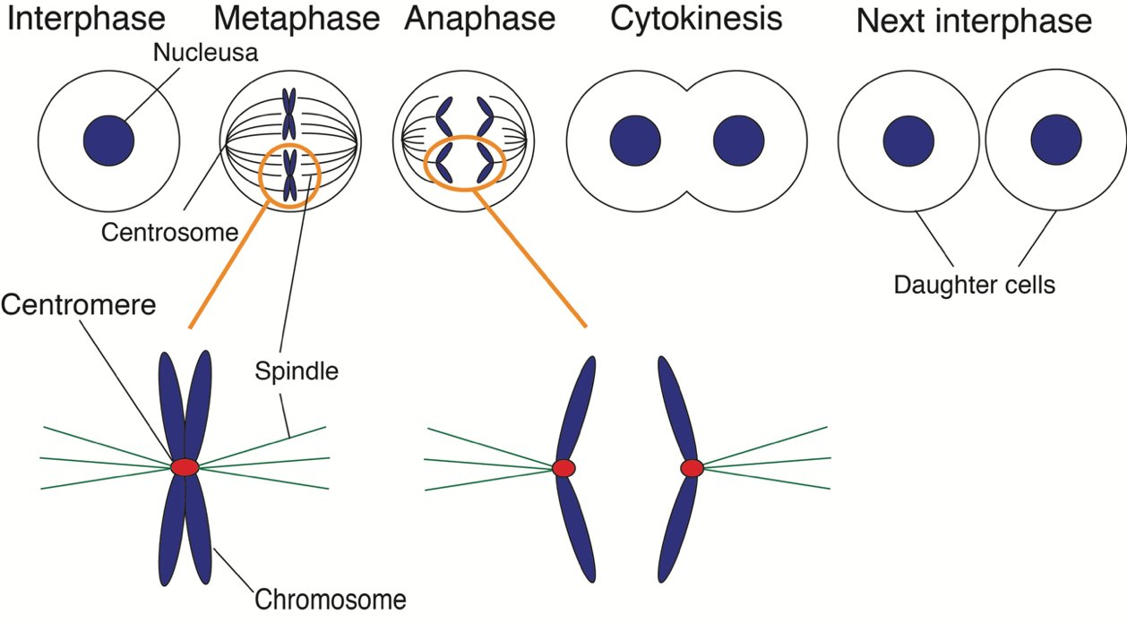

The chromosome of nearly all eukaryotic life forme contain two important structures centromere and telomeres.

Each chromosome has a constriction point called the centromere, which divides the chromosome into two sections, or “arms.” The short arm of the chromosome is labeled the “p arm.” The long arm of the chromosome is labeled the “q arm.” The location of the centromere on each chromosome gives the chromosome its characteristic shape, and can be used to help describe the location of specific genes.

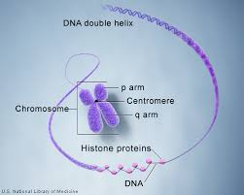

**Depending on the centromere site the chromosome devided to:**

**1- Metacentric** chromosome **–** centromere is in middle, meaning p and q arms are often equal length.   
**2-Submetacentric** chromosome **–** centromere off-centre, leading to shorter p arm relative to q arm .  
**3-Acrocentric** chromosome **–** centromere severely off-set from centre, leading to much shorter p arm.  
**4-Telocentric** chromosome **–** centromere found at end of chromosome, meaning no p arm exists .

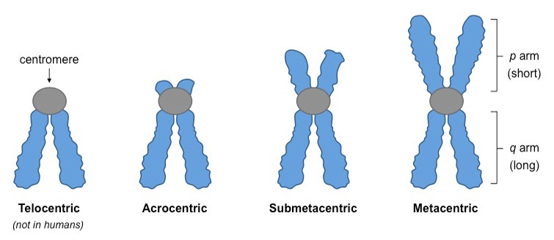

Telomeres are specialized sequences of DNA that are found at the tips of chromosome. Telomeres serve as akind of cap that prevents the end of chromosome from attaching to the end of other chromosomes. Scientists suspect that telomeres may influence the activity of nearby gene and may play arole in determining the life span of acell.

Depending on these divisions,it is possible to devided the chromosomes during metaphase in to seven groups (A-G) under the naming(Karyotype):

A(1to 3),B(4 and 5),C(6 to 12), D(13 to 15),E (16 TO 18), f(19 AND 20),AND G(21,22 )and the sex chromosome(23) .

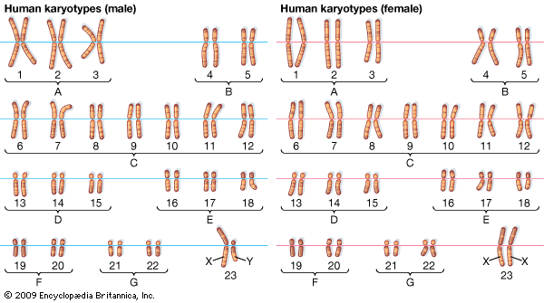

**Lab – 2 -**

While chromosome mutations may be formed during both mitosis and meiosis, those may occur in meiosis, lead to defective gamete formation, and to the birth of affected offspring. Thus their medical significance is greater than that of mitotic chromosome aberrations.

From the point of mitotic chromosomal abnormalities it is also important when during development and in what kind of cell they are formed. Mutations occurred during the early cleavage divisions may have serious consequences for the divisions may have serious consequences for the entire organism, while aberrations occurred in a continuously proliferating cell type (e.g. epithelial cells) in adulthood may have negligible role. However, certain chromosomal mutations may have a role in the formation and subsequent rapid proliferation of tumor cells. Two chromosomal regions have special importance in the formation of chromosome aberrations(centromeres and telomeres)

**-STUDYING HUMAN CHROMOSOMES**

■ Mitotic chromosomes are fairly easy to study because they can be observed in any cell undergoing mitosis.

■ Meiotic chromosomes are much more difficult to study because they can be observed only in ovarian or testicular samples. In the female, meiosis is especially difficult because meiosis occurs during fetal development. In the male, meiotic chromosomes can be studied only in a testicular biopsy of an adult male.

■ Any tissue that can be grown in culture can be used for karyotype analysis, but only certain tissue samples are suitable for some kinds of studies. For example, chorionic villi or amniocytes from amniotic fluid are used for prenatal studies; bone marrow is usually the most appropriate tissue for leukemia studies; skin or placenta is used for miscarriage studies; and blood for patients with dysmorphic features, unexplained mental retardation, or any other suspected genetic conditions.

■ Whatever the tissue used, the cells must be grown in tissue culture for some period of time until optimal growth occurs. Blood cells must have a mitogen added to the culture media to stimulate the mitosis of lympocytes, but other tissues can be grown without such stimulation.

■ Once a tissue has reached its optimal time for a harvest, colchicine (Colcemid) is added to the media, which arrests the cells in metaphase.

■ The cells are then concentrated, treated with a hypotonic solution, which aids in the spreading of the chromosomes, and finally fixed with an acetic acid/methanol solution.

■ The cell preparation is then dropped onto microscope slides and stained by a variety of methods (see below).

■ It is often preferable to use prometaphase chromosomes in cytogenetic analysis as they are less condensed and therefore show more detail. In cytogenetic analysis, separated prometaphase or metaphase chromosomes are identified and photographed or digitized.

■ The chromosomes in the photograph of the metaphase are then cut out and arranged in a standard pattern called the karyotype, or in the case of

digital images, arranged into a karyotype with the assistance of a computer.

**Lab – 3 -**

Basic Cytogenetics Laboratory Procedures

The study of chromosomes using traditional cytogenetic techniques requires cells that are actively dividing Chromosomes are individually distinguishable under the light microscope only during cell division and are best examined during metaphase.

Specimens that contain spontaneously proliferating cells

include :

• bone marrow

• lymph nodes

• solid tumors tissue biopsies

• amniotic fluids

• Chorionic villi

Specimen Collection and Handling

• Peripheral Blood Specimens

Peripheral blood samples should be collected in sterile syringes or vacuum tubes containing preservative-free *sodium* heparin for best results, blood samples should be set up within 24 h of collection Temperature extremes must be avoided if samples are transported or

stored. Specimens should be kept at room *temperature* or refrigerated above 4°C until they can be processed a repeat sample should be requested if these requirements are not met (e.g., the sample is received clotted, on ice, more than 24 h old)

* Bone marrow aspirates

• should be collected in sterile syringes or vacuum tubes containing preservative-free *sodium* heparin

• transported at room temperature

• The first few milliliters of the bone marrow tap contain the highest proportion of cells are the best sample for the cytogenetics laboratory. Bone marrow specimens should be processed immediately upon receipt to avoid cell death.

* Amniotic Fluid Specimens

• can be performed from as early as 10 weeks of gestation until term

• 15 to 30 milliliter of amniotic fluid should be obtained under sterile

conditions and collected in a sterile container approved for cell

• Samples should be transported at room temperature. Temperature

extremes and long transport times should be avoided the

amniocentesis procedure has an inherent, albeit small, risk of

miscarriage and should not be repeated unless absolutely necessary

Solid Tissue Biopsies:

• Solid tissue sources include

• skin biopsies

• chorionic villi

• products of conception

• lymph node and solid tumor biopsies

• tissue from stillbirths

Products of conception and stillbirths (and in most cases, tumor biopsies) are one-of-a-kind specimens that cannot be recollected, and repeat collection of chorionic villi increases the risk of miscarriage, although subsequent amniocentesis is an option here. Microbial contamination is a common problem for many types of solid tissue samples

**Culture Initiation**

1-Growth Media

• AmnioMAX™, Chang Medium or Amniochrome for amniocytes

• giant cell tumor-conditioned medium for malignancies

• PANDIS for breast tumors while others are appropriate for a broad

spectrum of cell types (e.g., RPMI 1640, MEM)

• All culture media are balanced salt solutions with a variety of

additives including salts, glucose, and a buffering system to

maintain the proper pH.

• Phenol red is often used as a pH indicator in many media.

If the medium becomes too acidic, it will turn yellow, while medium that is too basic becomes pink or purple.

2- L -Glutamine

l -Glutamine is an amino acid essential for cell growth.

l -Glutamine is unstable and breaks down on storage to d -glutamine, a form that cannot be used by cells. l -Glutamine must therefore be stored frozen to retain its stability, and it is optimal to add it to the culture medium just prior to use. There are some commercially available complete media that contain l -glutamine.

3-Serum

• Serum is essential for good cell growth.

• Too little does not allow for maximum cell growth, but too much can have a detrimental effect.

• Fetal bovine serum (FBS) is preferred; culture medium is generally

supplemented with 10–30% FBS.

4- Antibiotics

• Microbial inhibitors are added to culture media to retard the growth

of microorganisms Penicillin/streptomycin, kanamycin, and

gentamicin are bacterial inhibitors commonly used in tissue culture

• Mitotic Stimulants (Mitogens)

5-• Some cells, particularly mature lymphocytes, do not spontaneously

undergo cell division and must be stimulated to divide by the

addition of an appropriate mitogen to the cell culture.

• Phytohemagglutinin (PHA) is an extract of red kidney beans

that stimulates division primarily of T-lymphocytes

• For routine peripheral blood cultures, 72 h is usually optimal





**Lab -4-**

Chromosome banding:

- A band is defined as that part of a chromosome which is clearly distinguishable from its adjacent segments by appearing darker or brighter with one or more banding techniques. The chromosomes are visualized as consisting of a continuous series of bright and dark bands.

-Chromosome banding is developed based on the presence of heterochromatin and euchromatin.

-Heterochromatin is darkly staind whereas euchromatin is lightly staind during chromosome

- There are a few types of Chromosomes banding : G bandig, C bandig, Q bandig, R bandig , T banding

-Aunique banding pattern is used to identify each chromosome and to diagnosis Chromosomal aberration.

-Chromosome breakage ,loss ,duplication or inverted segment

* . 