Lab six:.
Gel Electrophoresis:
What is Gel Electrophoresis?
Gel electrophoresis is a widely used technique for the analysis of nucleic acids and proteins. Agarose gel electrophoresis is routinely used for the preparation and analysis of DNA.
Gel electrophoresis separates molecules on the basis of their charge and size. The charged macromolecules migrate across a span of gel because they are placed in an electrical field. The gel acts as a sieve to retard the passage of molecules according to their size and shape.
DNA is Polyanionic in natural PH , The Phosphate groups (PO₄³⁻ group) on the backbone of the DNA molecule readily give up their H⁺ ions, therefore nucleic acids are negatively charged in most buffer systems, DNA molecules will migrate away from the negative electrode (cathode), and migrate towards the positive electrode (anode).
How does electrophoresis work? The gel is made from agarose, DNA is a negative molecules, Molecules sort based on: Charge, Size, shape.
Gels can be made from substances such as agarose or polyacrylamide:
  - Agarose – a complex sugar chain from red seaweed, composed of sugar Galactose and its derivatives and associated with each other hydrogen bonds to form a complex network, agarose material are subject to disruption and discontinuity when the transfer is not good so you must move cautiously. It is commonly used in foods (ice cream, whipped cream, and jellies) and many biological mediums. It has a large pore size good for separating large molecules quickly.
  - Polyacrylamide – chain of acrylic acid molecules. It is often used to make plastics and rubber. It has a small pore size good for separating small molecules slowly and is used for separating fragments of less than about 500 bp. *Polyacrylamide is a neurotoxin!.
  - By using gels with different concentrations of agarose, one can resolve different sizes of DNA fragments. Higher concentrations of agarose facility separation of small DNAs, while low agarose concentrations allow resolution of larger DNAs.
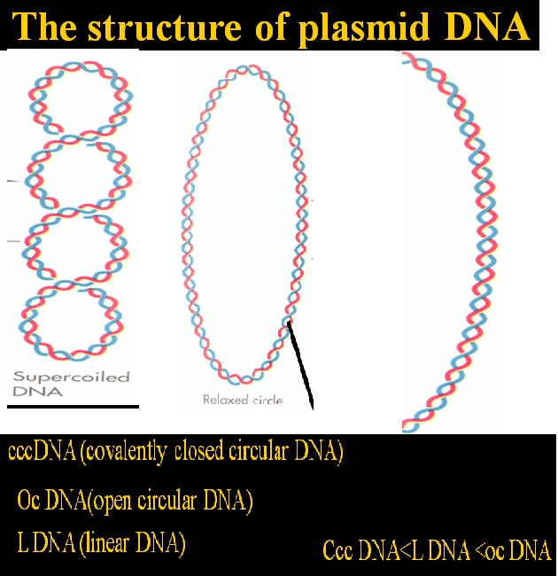

The materials used in electrophoresis:.
- Buffer TBE or TAE (or TPE).
- Agarose
- Loading buffer (6X):
0.25% Bromophenol blue
0.25% xylole
40% sucrose

- Fluoresces dye : Ethedium bromide or other dye.

Several additional factors have important effects on mobility of DNA fragments in agarose gels:
1. Agarose Concentration
2. Voltage
3. Electrophoresis Buffer
4. Effects of Ethidium Bromide.
Using different concentrations gels resolve different sizes of DNA fragments
  - Higher concentrations of agarose for small DNA.
  - Low agarose concentrations allow resolution of larger DNA.
As voltage applied, for best resolution of fragments larger than about 2 kb is attained by applying no more than 5 volts per cm to gel. The cm value is distance between two electrodes, not the length of the gel.
Several different buffers have been recommended for electrophoresis of DNA: TAE (Tris-acetate-EDTA) and TBE (Tris-borate-EDTA) and TPE (Tris-phosphate-EDTA). DNA fragments will migrate at somewhat different rates in these two buffers due to differences in ionic strength. Buffers not only establish a pH, but provide ions to support conductivity
  - If you mistakenly use water instead of buffer, there will be essentially no migration of DNA in the gel
  - If you use concentrated buffer (e.g. a 10X stock solution), enough heat may be generated in gel to melt it.
Ethidium bromide is a fluorescent dye that intercalates between bases of nucleic acids and allows very convenient detection of DNA fragments in gels, and use in final cons. 0.5 μg \mL . Because ethidium is a DNA intercalating agent, it is a powerful mutagen. Incorporation of ethidium in the DNA of living organisms (i.e. you and us) can cause (unwanted) mutations.
Gel stains: Nucleic acids are colorless, Must be stained, DNA stains:
    - Ethidium bromide (EtBr)…orange when mixed with DNA under UV light.
    - Methylene blue…dark blue…not as sensitive as EtBr viewed with white light.
    - Silver Stain
    - SYBR green (is) more expensive.
Components (of) Gel Electrophoresis (system):.
- Power supply
- Cell
- Tray or gel bed
- Comb
- Ultraviolet cabinet

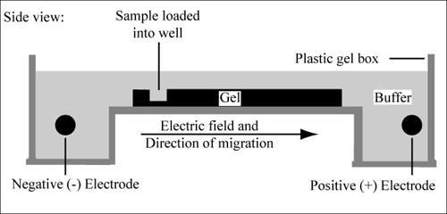

Procedure :.
- An agarose gel is prepared in cons. 1% by dissolve agarose powder in a buffer solution TBE (1X), and add 0.5 μg \mL EtBr .
- Seal the edges of the tray and put in the combs. Place the tray on a level surface, allow the agarose solution to cool slightly (~60ºC) and then carefully pour the melted agarose solution into the tray. Avoid air bubbles.
- Each of the gel combs should be submerged in the melted agarose solution.
- When cooled, the agarose forming a flexible gel. It should appear lighter in color when completely cooled (30-45 minutes). Carefully remove the combs and tape.
- The agarose gel is placed in an electrophoresis tray. Add enough electrophoresis buffer to cover the gel to a depth of at least 1 mm. Make sure each well is filled with buffer.
- Sample Preparation: Mix the samples of DNA with the loading buffer by adding (3-5 μl) of 6X sample loading buffer to (7μl) of DNA sample. This allows the samples to be seen when loading onto the gel, and increases the density of the samples, causing them to sink into the gel wells.
- Carefully place the pipette tip over a well and gently expel the sample. The sample should Place into the well. Be careful not to puncture يثقب the gel with the pipette tip. Inclusion of a DNA ladder (DNA of known sizes) on the gel makes it easy to determine the sizes of unknown DNA.
- Place the cover on the electrophoresis chamber. Connect the electrical leads to the power supply. Be sure the leads are attached correctly - DNA migrates from cathode (black) toward the anode (red). When the power is turned on, bubbles should form on the electrodes in the electrophoresis chamber.
- After the current is applied, make sure the Gel is running in the correct direction. Bromophenol blue will run in the same direction as the DNA.
- After completing of the limited time, Place gel on trans illuminator and each lane shows separation of components from original mixture as one or more distinct bands, one band per component, bands observed can be compared to those of known sizes to determine their size according to the marker.
- Fragment size determination is typically done by comparison to commercially available DNA ladders containing linear DNA fragments of known length.

DNA Ladder consists of known DNA sizes used to determine the size of an unknown DNA sample. The DNA ladder usually contains regularly spaced sized samples which when run on an agarose gel looks like a "ladder".

H.W.
1- Name two common DNA stains that are used to visualize DNA on agarose gels ??
2- Agarose gels can be used to study what size of DNA fragments?
- What is agarose?

