Lab Four :.
Chromosomal DNA extraction from bacteria:
The bacterial cell Lacks to the presence of distinct chromosomes, the nucleolus and the nuclear membrane as it is in eukaryotic cells. Occupies the nuclear material DNA and also called Nucleoid locations close to the center of the cell and is usually connected plasma membrane in an area called mesosome which appear under the microscope in an area with higher density of protoplasm which surrounding it, and represent genetic material or so-called Genome, which consists of a single circular chromosome length of about 1 mm, has no loose end and its associated with all genes so be super coiled molecule.
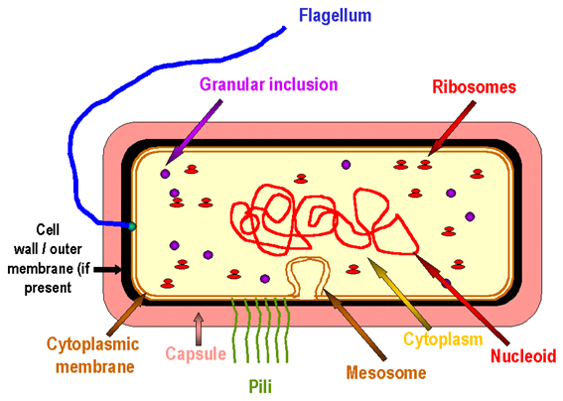

The procedure:.
- Grow bacteria in 3-4 ml of brain heart infusion broth for overnight at 37C°.
- Centrifuge 1-1.5mL of bacterial culture in Eppendrof tube for 5min and remove the supernatant
- Suspend sediment by 1.5mL of the lysis buffer consisting of:
400Mm Tris-Hcl, 60Mm EDTA, 150mM NaCl, 1% SDS PH = 8.
And leave the mixture at room temperature for 10min to analyze the cell walls.
- Add 150 μl of potassium acetate solution consisting of:.
5M potassium acetate 60mL
Glacial acetic acid 11.5mL
D.W. 28.5mL
- Shake the tubes by vortex 10sec.
- Centrifuge for 1min\10000xg.
- Transfer the upper aqueous phase to another tube and add a similar size of a mixture phenol: chloroform (1:5) at pH = 8 and shake well the contents of the tube.
- Centrifuge for 1min\10000xg.
- Transfer supernatant to another tube and add a similar volume of Isopropanol and shake well
- Centrifuge for 2min\10000xg, and neglect the supernatant.
- Wash the sediment by 1 mL of alcohol Ethanol 70% .
- Centrifuge for 1min\10000xg, neglect the supernatant and placed in an inverted on filter paper to dry completely.
- Dissolve the sediment by )10-20 μl ( from TE buffer and keep freezing (-20C°) .

Briefly, steps to DNA Extraction:
- Break the cells to open and expose the DNA.
- Remove membrane lipids by adding detergent.
- Precipitate DNA with an alcohol — usually ethanol or Isopropanol. Since DNA is insoluble in these alcohols, it will aggregate together, giving a pellet upon centrifugation. This step also removes alcohol-soluble salt.

Extraction DNA by rapid boiling:
- Grow bacteria overnight at 37C°,on Brain heart infusion agar .
- Suspend few colonies of bacteria in 1 mL distilled water on Eppendrof tube, and shake well by vortex.
- Boil in a water bath for (10 min) and centrifuge directly , for 13000 rpm/ 5min.
- separate the supernatant and put in another clean Eppendrof tube and then centrifuge tubes quickly (6000) rpm/ 2min, remove the supernatant and melts the pellet with a solution of the TE buffer.

Benefits of additives:.
- TE buffer:
*** Disrupting the bacterial cell walls to contain EDTA, which works on:
* Helps to capture ions Mg⁺⁺ & Ca⁺⁺ from the cellular walls which provide stability of the cell wall.
* Stop the effectiveness of enzymes Nuclease such DNase (destroys the DNA).
* helps disengagement nuclear protein complex.
*** dissolving the DNA sample.
- Sarkosyl or SDS: Ionic detergent works:.
* Denaturation proteins which acting on breaking peptide bonds and thus disengagement amino acids.
* Remove the fat which found in cell walls.
- : Chloroform :Phenol
* Denaturation proteins.
* Eliminates the remaining phenol atoms in the DNA preparations (as phenol effect the solubility the DNA in water).
* Inhibit the effectiveness of the enzyme RNase.
- Isopropanol: precipitation DNA.
- Ethanol 70%: used to wash the DNA sample which helps to reduce dry sediment by alcohol .

