Lab -4-
shapes and functions of the cells
Cells are the building blocks of life – all living organisms are made up of them. Textbooks often show a single ‘typical’ example of a plant cell or an animal cell, but in reality, the shapes of cells can vary widely. Animal cells in particular come in all kinds of shapes and sizes. Plant cell shapes tend to be quite similar to each other because of their rigid cell wall.
We can learn a lot about what a cell does by looking at its shape and size, and microscopes are the ideal tool for this.

*Shaped for the task
Cells have different shapes because they do different things. Each cell type has its own role to play in helping our bodies to work properly, and their shapes help them carry out these roles effectively. The following cell types all have unusual shapes that are important for their function.
- The muscle cells have a special structure which represented by the actin and myosin filament that perform special function (muscular contraction).
- The fatty connective tissues have a large space in the cytoplasm which permit a formation of large fat drop in it and these cells perform special function (storage fatty energy and thermal barrier)
- The nervous cells in the brain and nervous system, they have astral shape due to presence of branches which called dendrites, Their job is to carry electrical messages all the way from the brain to the rest of the body and back (almost like electrical wire).
- The photoreceptor cells (rods and cones) are cells in the eye that detect light.
- The immune cells are cells that respond when the body is infected (by a bacterium, for instance). To do their job, they need to be able to change shape. For instance, lymphocytes may need to move through body tissue to get to the site of infection, so they change their shape to squeeze past tightly packed tissue cells. Some immune cells (such as neutrophils) engulf bacteria and viruses, so they need to change their shape to ‘swallow’ them.
- The red blood cells have a disk shape with concave edges, and have hemoglobin molecule that attach with O₂ and CO₂ molecules, this concave edges contribute to the transfer and carry these molecules between lung and other body system.

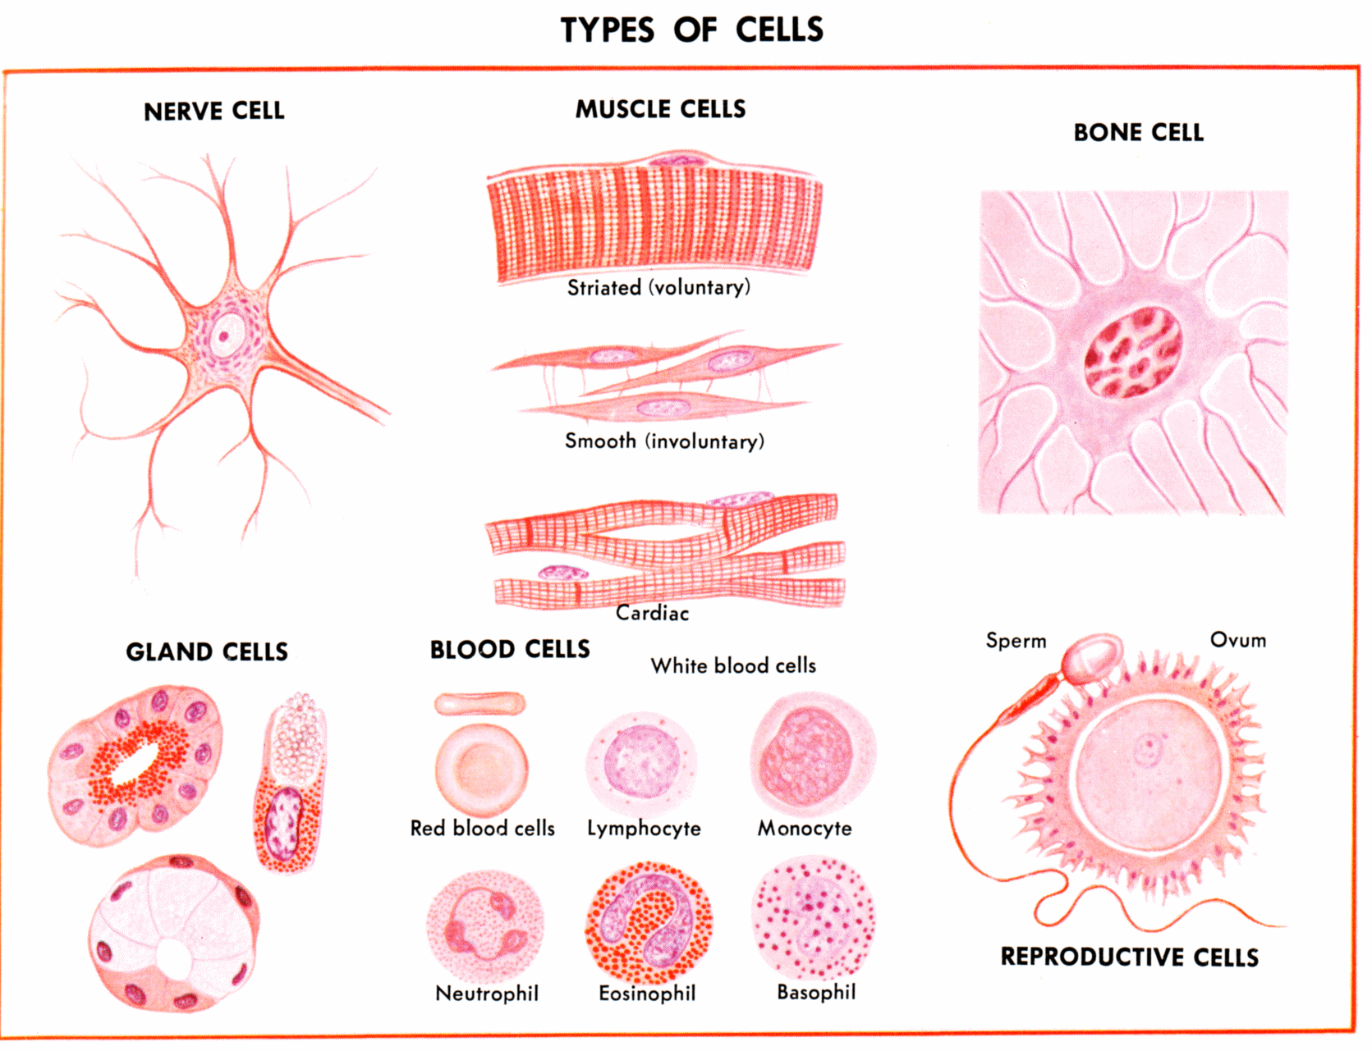

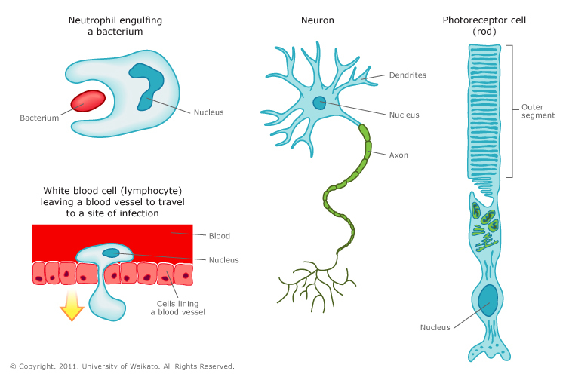
*The Shapes of the cells*
*Site of the cells
The special functions of the cells determined by the site of the cells (organs and tissue) ex: skin epithelial cells are found on the external surface of the body because their function is the protection and excretion (sweating), while the same type of the cells found in the lining of the small intestine because their function is absorption of the digestive food.
The cells in the multicellular organisms carried out to differential process or cellular specify. In this process, each group of the cells are specialist to build special tissues to enter in organ build, according to this, the cells modified the shape to obtain new types of the cells that have special function.
*Factors that modifying the shape of the cell
The shape of the cells can be modified according to many factors:
1-Enternal factors: include all the factors that are related to age of the cells, wall shape, rigidity, shape of cellular membrane, viscosity of cytoplasm and function.
2-External factors: include surface tension, viscosity of the media, and mechanical action of the cells.

**What are the factors that help cells to perform different functions ?
Genes: are segments of deoxyribonucleic acid (DNA) which found in separated shape along the chromosomes in the nucleus. , each gene is code for synthesis of specific protein that is participating to give these properties.
Proteins are very important to perform different function ex: enzymes, hormones and growth factors. Proteins are composed of long chain of amino acid, and there are (20) known amino acid regulate in chains with different length and arrangement to give different proteins with different function. In addition to specialist body cells, there are non-specific cells called stem cells which responsible for the regeneration of body cells.
*Size of the cells
Cells are varying in their sizes, some of them are large ex: bird egg, while others are very small and cannot see with naked eye, ex: human cells. Some of the cells have approximately constant size according to constant volume law and these differences due to the weight and number of the cells and not to the volume of the cell itself, ex: hepatic cell for human, rat, and horse. Also the age of the cells varies between one and the other ex: red blood cells in human body live for four months, while the skin cells live for some days only.
Practical part:
A-show slides and picture of the following:
1-Nervous cell (Astrocyte shape).
2- Smooth muscles (spindle shape).
3-skeletal muscles (cylindrical shape).
4- Cardiac muscles (cylindrical shape).
5-smear of blood to see human red blood cells (disk, concave)
6-forg red blood cell (ovoid shape).

