LAB-6-

Separation of Photosynthesis pigment by chromatographic paper

Chromatography: Is one of the methods of separation and diagnosis of organic compounds. The word chromatography means separation of colored compounds Where simple chromatography technique was used to separate natural colored outputs of plants.
- Chromatography divided into two types:
1-Plate Chromatography
2-column chromatography.
- Plate Chromatography divided to:
1-paper Chromatography.
2- Thin layer chromatography(TCL).
In this lab, we will use the paper Chromatography for separating pigments of colored chloroplast of Spinach or Chard leaf to identify and separate the pigments in plants. On this basis we will talk about the paper Chromatography.

Paper Chromatography
In this type of Chromatography the pigments are separated using two phases:
A-Mobile phase: A liquid substance represented by organic solvents Such as the use of saturated Butanol alcohol , acetyl acetone saturated with water , methanol alcohol with hydrochloric acid or ethyl methyl keton. In this experiment we used the ethanol 70% .
B-Stationary phase: mostly be a solution that are carried on paper cellulose fibers, Hence the name paper Chromatography. In this experiment, the solution that carried on filter paper fiber is supernatant that extracted from Spinach or Chard leaf juice.
In paper chromatography organic compounds are diagnosed by knowing the value of Retention factor ( R_{ƒ}) for unknown compound and compared with the (R_{ƒ}) for the standard compound (known), If they are matching, the unknown compound was identical to the standard compound. Photosynthesis occurred in special structures in plants called chloroplast that contain photosynthesis pigments which necessary for absorption photosynthesis pigments . In this process, the light energy which absorbed from plant pigments was transformed into chemical energy, and by this it can made organic materials from non- organic compound ex: CO2, H2O from chloroplast. In this way, photosynthesis process was essential process for product materials with high chemical energy from low chemical energy.
CO2 $+$H2O (CH2O)n $+$O2
The experiment of paper chromatography by using radioactive materials showed that there are many material of carbohydrate that made from photosynthesis process (triglyceride, tetra, penta, hexa), , where these sugars in form of phosphate and its one of final metabolic products of photosynthesis.
Presence | pigments of photosynthesis
Chlorophyll a | all plants
Chlorophyll b | Higher plant and green algae
Chlorophyll c | diatoms and brown algae
Beta-carotene | some plants
Xanthophylls | some plants
Phycotyanin | blue green and red algae
Facoxanthol | diatoms and brown algae
Phycoerthrine | Red algae, green blue algae

The experiment of extraction and separation of pigments photosynthesis
We take some of green leaves such as Spinach or Chard leaf and crushed well in ceramic mortar with addition of organic solvent acetone or alcohol 70%, then filtered by using gauze, put the streaming in centrifuge for 10-15 min, this lead to get deposit in the bottom of tube and supernatant (the supernatant neglects).Take chromatography paper or filter paper, the filter papers cut into longitudinal strips, draw by a pencil one point off 1 cm of edge of the paper. Then, by capillary tube takes one drop of the deposit and put it on pre-selected point, repeat the process three times for the purpose of increasing concentration, then, put it in special bakers that contain quantity of ethanol, then put the strip in way which attached with ethanol and leave it for a period of time. Notice that ethanol begin arise and carries with it pigments and separated depending on the molecular weight of the pigments and the degree of solubility in solvent and then applied the following equation:

R_{ƒ}= distance the solute moves (pigments ) / distance the solvent moves (ethanol)

R_{ƒ} (retention factor) is a measure of the speed of the liquid movement to be diagnosed compounds relative to the front of the mobile phase as shown in figure (1) .

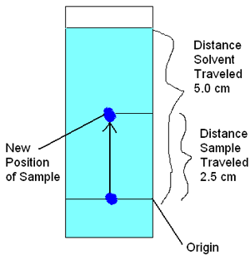
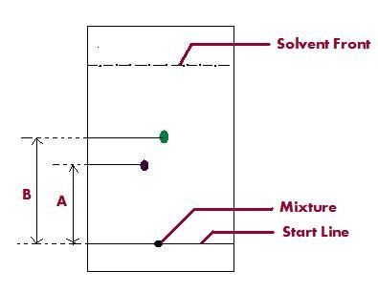
Fig (1) The Organic Compound Movement (pigments) in Paper Chromatography

