LAB -7-

The Chromosomes
Is a concentric duple filament. The term chromosome is derived from the Greek words "chroma" or color and "some" or body and is so named because chromosomes have the ability to be stained with dyes. Each chromosome consist of two chromatid associated with each other by centromere. Depending on the centromere location, the chromosomes divided in to seven groups ( from A to G ) this is called karyotype.
The chromosome consists of a number of genes that have special sites on chromosomes. Chromosomes can be studied in metaphase in mitosis because during this phase of the division the chromosomes can be seen clearly as well as the composition study and the possibility of classification in to groups.
Chromosomes are found in cells in the form of pairs, in human cells 23 pair ( where 22 pair of them are autosome and a pair of sexy represented by X and Y chromosomes) .

Chromosomes forms
Each chromosome has a constriction point called the centromere, which divides the chromosome into two sections, or “arms” The short arm of the chromosome is labeled the “p arm” The long arm of the chromosome is labeled the “q arm” The location of the centromere on each chromosome gives the chromosome its characteristic shape, and can be used to help describe the location of specific genes.
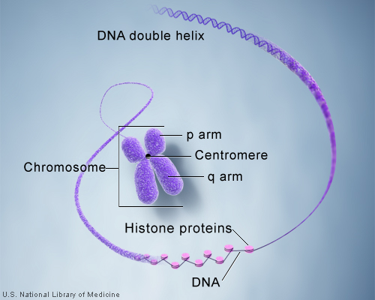

depending on the centromere site the chromosomes devided to :-
- Metacentric chromosomes : the centromere in the center and the arms are often equal lengths.
- Submetacentric chromosomes : The centromere is located between the midpoint and the end of the chromosome.
- Acrocentric chromosomes : the centromere is very close to the end of the chromosome.
- Telocentric chromosomes : the centromere be at the end of the chromosome.
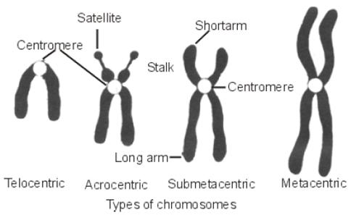
depending on these divisions, it is possible to divide the chromosomes during metaphase in to seven groups ( A-G ) under the naming ( karyotype ):
A : includes the chromosomes number 1, 2, 3.
B : includes the chromosomes number 4, 5.
C : includes the chromosomes number 6,7,8,9,10,11,12.
D : includes the chromosomes number 13,14,15.
E : includes the chromosomes number 16,17,18.
F : includes the chromosomes number 19,20.
G : includes the chromosomes number 21,22, and the sex chromosome (23) as shown in figure (1).
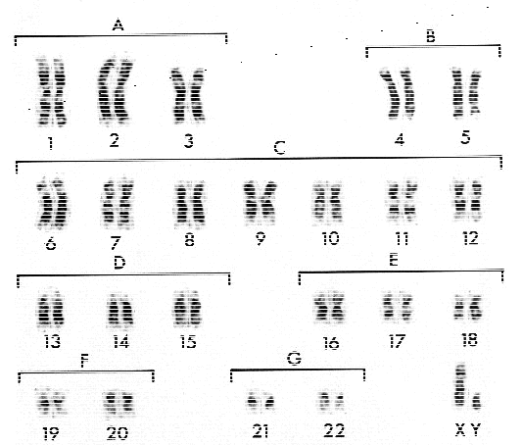
Figure (1)
Either the way of the division of the chromosomes into groups in humans are illustrated in figure (2).
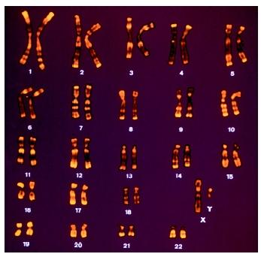
Figure (2)

The sex chromatin or (barr body)
Is a small condensed mass of the inactivated X-chromosome usually located just inside the nuclear membrane of the inter phase nucleus; Bar bodies can be easily found in the oral mucosa. cells that contain this chromatin called ( chromatin positive ) and that do not contain it called ( chromatin negative ). The number of sex chromatin bodies per nucleus is one less than the number of X-chromosomes; normal males and females with Turner syndrome (XO) have none (sex chromatin negative), normal females and males with Klinefelter syndrome (XXY) have one, and XXX-females have two. According to the equation :

Barr bodies = (n-1) where: n = the number of X chromosome

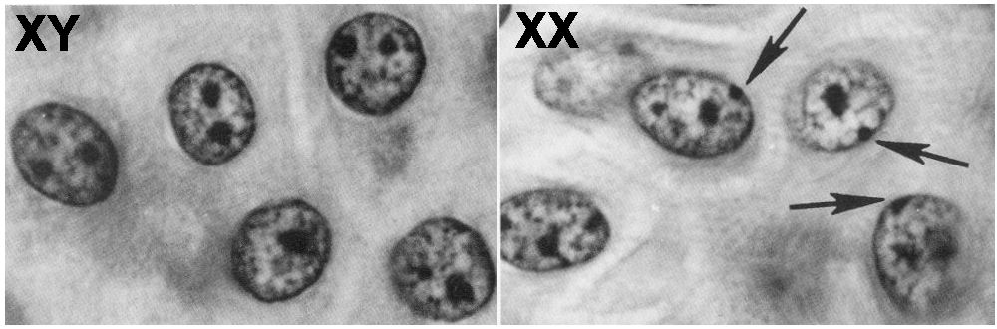
Figure (3) The Sex-Chromatin

The MITOTIC INDEX
Is a guide used to assess the effect of genetic poison of the cells mutagens that were physical or chemical Which often negatively affect the division or ( It is defined as the ratio between the number of cells in mitosis and the total number of cells ).

The mitotic index % = number of division cells / total number of cells Χ 100

For example, UV and X-ray suppress the building of DNA and causing a delay in the mitosis. The mitotic index influenced when treated cells with chemicals such as toxic drugs like (Methotrexate (MTX)) ( Mitomycin-c (MMC)) which cause a significant reduction in mitotic index of the bone marrow cells for humans and mice, this reduction increases with the increasing the dose of the mutagenic drug.

