Lab -7-
cell Division
- All cells are derived from per-existing cells (cell Theory).
-Cell division is the process by which cells produce new cells.
-Cell division differs in prokaryotes (bacteria) from eukaryotes (protests, fungi, 9plants and animals).
-Some tissues must be repaired often such as the lining of gut, white blood cells, and skin cells with a short lifespan.
-Other cells do not divide at all after birth such as muscle and nerve.

*Reasons for Cell division
- Cell growth
- Repair and replacement of damaged tissue parts.
- Reproduction of the species-

*Cell Cycle
-The cell cycle is the sequence of event that takes place in cells. It lead to cell division and replication (duplication).
-The cell cycle includes 2 main parts interphase, and cell division.
-Cell division includes mitosis (nuclear division) and cytokinesis (division of the cytoplasm).
-Interphase is the longest part of a cells life cycle and is called the "resting stage" because the cell isn’t dividing.
-Cells grow,develop, & carry on all their normal metabolic functions during interphase.
-Interphase consists of 3 parts –G1, S & G2 phases.
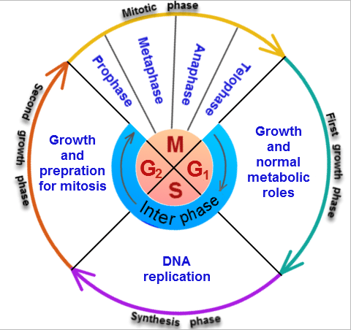
*cell cycle*
*Interphase
-G1 or 1st growth phase occurs after a cell has undergone cell division.
- Cells mature & increase in size by making more cytoplasm & organelles while carrying normal metabolic activities in G1.
- S or synthesis phase follows G1and the genetic material of the cell (DNA) is copied or replicated.
-G2 or 2nd growth phase occurs after S phase and the cell makes all the structures needed to divide.

- Mitosis
*Stages of Mitosis
-Division of the nucleus or mitosis occurs first.
- Mitosis is an asexual method of reproduction.
- Mitosis consists of 4 stages: 1) Prophase, 2) Metaphase, 3) anaphase, 4) Telophase.

1) Prophase
- Chromosomes become visible when the condense into sister chromatids.
- Sister chromatids attach to each other by the centromere.
- Centrioles in animal cells move to opposite ends of cell.
- Spindle forms from centriole (animals) or microtubules (plants).
- Kinetochore fibers of spindle attach to centromere.
- Polar fibers of spindle extend across cell from pole to pole.
- Nuclear membrane dissolves.
- Nucleolus disintegrates.
2) Metaphase
-chromosomes line up in center or equator of the cell attached to kinetochore fibers of the spindle.
3)Anaphase
- kinetochore fibers attached to the centromere pull the sister chromatids apart.
- chromosomes move toward opposite ends of cell.
4)Telophase
- Nuclear membrane forms at each end of the cell around the chromosomes.
- Nucleolus reform.
- Chromosomes become less tightly coiled & appear as chromatin again.
- Cytokinesis begins.

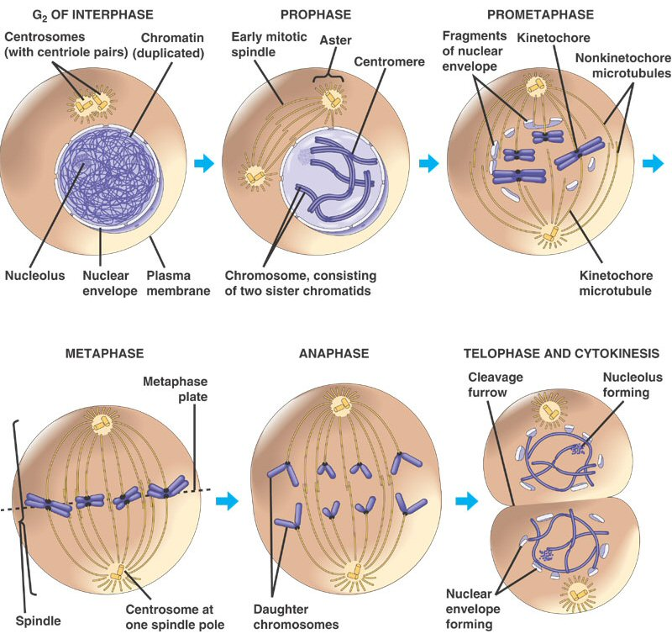
*Stages of mitosis division*

*Cytokinesis
- Cytoplasm of the cell and its organelles separate into 2 new daughter cells.
- In animals, a groove called the cleavage furrow forms pinching the parent cell in two.
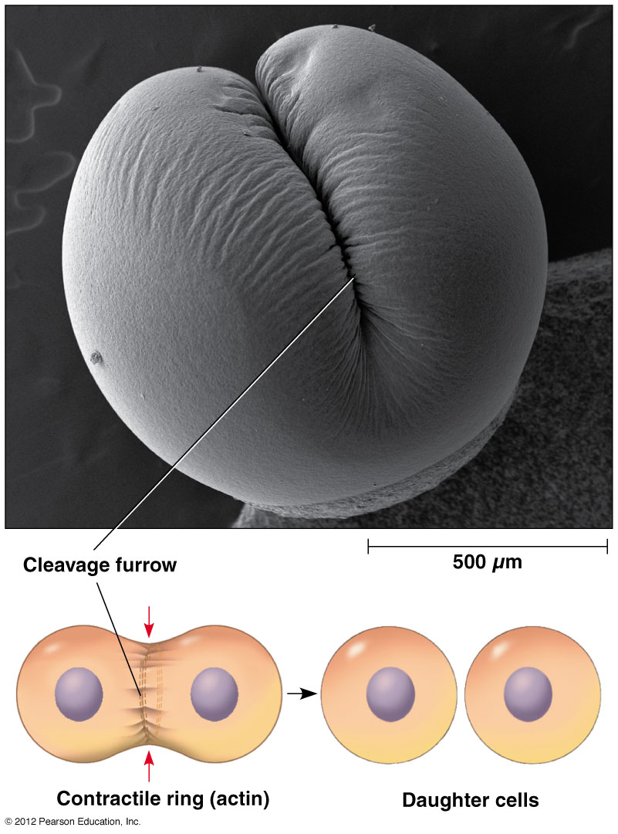
*Cytokinesis in animals (cleavage furrow)*

- - in plant, a cell plate forms down the middle of the cell where the new cell wall will be.
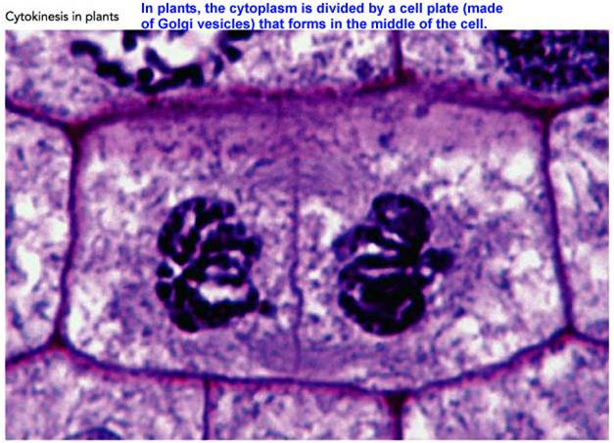
*Cytokinesis in plants*

