College of Science Al-Mustanseryea University Dep.: Biology
Academic year: 2015-2016 Subject: Plant Physiology Class: Fourth Grade
By: Dr. Alaa Jabar & Dr. Rana Azeez
Lecture: 2
***Water movement:
One objective of plant physiology is to understand the dynamic of water as it flows into and out of cells or from the soil, through the plant, into the atmosphere.
Movement of substances from one region to another is commonly referred to as translocation. Mechanisms for translocation may be classified as either active or passive, depending on whether metabolic energy is expended in the process. It is sometimes difficult to distinguish between active and passive transport, but the translocation of water is clearly a passive process. Although in the past many scientists argued for an active component, the evidence indicates that water movement in plants may be indirectly dependent upon on expenditure of metabolic energy. Passive movement of most substances can be accounted for by one of two physical processes:
Either bulk flow or diffusion. In the case of water, a special case of diffusion known as osmosis must also be taken into account.
**Diffusion:
Diffusion is the net movement of molecules from an area of greater concentration to an area of lesser concentration. Diffusion by random movement continues until the distribution of molecules becomes even throughout the solution. The rate of diffusion depends on:
- The size of the molecules (larger molecules move slower).
- The temperature of the solution (higher temperature cause faster movement).
- The solubility of the molecules in the solvent (molecules that do not dissolve do not diffuse).
Diffusion is a significant factor in the uptake and distribution of water, gases, and solutes throughout the plant. In particular, diffusion is an important factor in the supply of carbon dioxide for photosynthesis as well as the loss of water vapor from leaves.
**Osmosis is the diffusion of water across a selectively permeable membrane:
The diffusion of water through a selectively permeable membrane has a special name osmosis. To appreciate the importance of osmosis, consider a membrane that is permeable to water but impermeable to glucose. When such a membrane separates two halves of a container, each having a different concentration of glucose, water diffuses by osmosis into the side having the higher glucose concentration and the lower water concentration. The net movement of water stops either when both sides of the container have the same concentration of glucose and water or when the force of gravity equals the force of water movement, whichever occurs first. Note that the side that began with a higher concentration of glucose increases in volume. This relative increase in volume can contribute to the movement of water and solute through a plant.

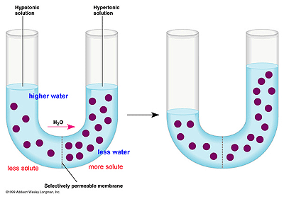
Osmosis is demonstrated by the movement of water through a selectively permeable membrane in a U-tube.

This example of osmosis hints at another feature of the process. Immediately before osmosis begins, the dilute solution in the tube on the left side of the membrane has a higher water and lower glucose concentration compared to the lower water but higher glucose concentration on the right side of the membrane. The concentration difference means water on the left side has a greater potential to move across the membrane. Its movement, however, can be prevented if a piston is placed on the right side with just enough pressure to keep the volume constant. A pressure gauge on the piston measures the force required to maintain a constant volume. This pressure, which is called osmotic pressure, is a measure of the ability of osmosis to do work in a system, such as moving water through a plant.

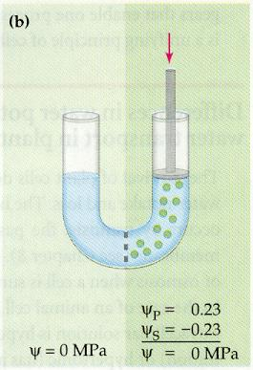
Higher water potential in the left-hand solution causes water to move into the right-hand solution. the amount of pressure that is necessary to maintain constant volume on the right equals the force of water movement across the membrane.

Most plants and indeed plants cells are surrounded by an environment with a lower concentration of solute and higher concentration of water. This difference in solute concentrations results in water entering a plant, which usually has a lower water potential than the surroundings. The cells and the plant absorb as much water as they can hold. Remember that the outward pressure of the cell membrane against the cell walls is called turgor pressure because it keeps the cells turgid.
Turgor pressure is vital to plants in many ways. During growth, cell expansion is caused by turgor pressure on cell walls that have become relaxed. Turgor pressure also keeps herbaceous (nonwoody) plants upright, supports the fleshy stalks and leaves of trees and shrubs. Changes in turgor pressure also cause movements in plants, such as the opening and closing of stomata and the curling of grass leaves. Cells lose turgor when they are placed in a dry environment or high-salt solution. The continued loss of turgor causes the cell membrane and protoplast to shrink away from the cell wall. Dryness causes most loss of turgor in plants.
Osmotically induced shrinkage of the cytoplasm is called plasmolysis. This phenomenon occurs in crop and garden plants when salt accumulates in the soil from extensive use of hard ( i.e., mineral-rich) water. It also occurs when people apply too much fertilizer, causing a high concentration of salt outside the plant. As a result, water exits the plant via osmosis and diffuses to a region of lesser water concentration (i.e., water potential) compared to inside the plant. The loss of turgor in these plants causes their leaves and stems to wilt. Key to turgor pressure is the cellular import and export of molecules other than water. This occur via membrane transport.

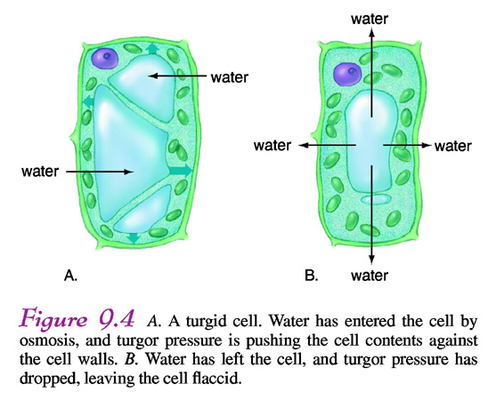

**Water potential can be used to predict the flow of water through a plant:
Like solutes, water also has potential energy to flow to where it is less concentrated. The potential energy of water has a special name: water potential. Water tends to move down a water-potential gradient that is, from a region of high water potential to a region of low water potential. By general agreement, the water potential of pure water is zero.
This means that the water potential of a solution has a negative value because the water is less concentrated than in pure water.
Three key points: 1- the water potential of pure water is zero.
2- water flows down a water potential gradient, toward the more negative water potential.
3 – the addition of solutes to a solution lowers the water potential.
**Water potential is the sum of its component potentials:
Water potential may also be defined as the sum of its component potentials:
Ψ= Ψ_{P}+ Ψ_{S}
The symbol Ψ_{P} represents the pressure potential. It is identical to P and represents the hydrostatic pressure in excess of ambient atmospheric pressure. The term Ψ_{S} represents the osmotic potential. Note the change in sign (osmotic pressure π = - Ψ_{S} ). As pointed earlier, osmotic potential is equal to osmotic pressure but carries a negative sign. Osmotic potential is also called solute potential because it is the contribution due to dissolved solute. The term osmotic(or solute) potential is preferred over osmotic pressure because it is more properly a property of the solution.
We can see from the equation that the hydrostatic pressure and osmotic potential are the principal factors contributing to water potential. A third component, the matric potential (M), is often included in the equation for water potential. Matric potential is a result of the adsorption of water to solid surfaces. It is particularly important in the early stages of water uptake by seeds (called imbibition) and when considering water held in soils. There is also a matric component in cells, but its contribution to water potential is relatively small compared with solute component. It is also difficult to distinguish the matric component from osmotic potential.

