College of Science Al-Mustanseryea University Dep.: Biology
Academic year: 2015-2016 Subject: Plant Physiology Class: Fourth Grade
By: Dr. Alaa Jabar & Dr. Rana Azeez
Lecture: 3
**Absorption of water**
Mechanism of absorption of water:
In higher plants water is absorbed through root hairs which are in contact with soil water and from a root hair zone a little behind the root tips. When roots elongate, the older hairs die and new root hairs are developed so that they are in contact with fresh supplies of water in the soil.
Mechanism of water absorption is of two types:
- Active absorption of water. In this process the root cells play active role in the absorption of water and metabolic energy released through respiration is consumed.
Active absorption may be of two kinds:
A/ Osmotic absorption i.e., when water is absorbed from the soil into the xylem of the roots according to the osmotic gradient.
B/ Non-osmotic absorption i.e., when water is absorbed against the osmotic gradient.

- Passive absorption of water. It is mainly due to transpiration, the root cells do not play active role and remain passive.

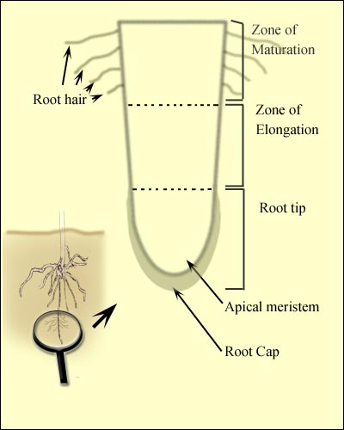
Root tip structure
***Active osmotic absorption of water:
First step in the osmotic absorption of water is the Imbibition of soil water by the hydrophilic cell walls of root hairs. Osmotic Pressure(O.P.) of the cell sap of root hairs is usually than the O.P. of the soil water. There for the diffusion pressure deficit(D.P.D.) in the root hairs become higher and water from the cell walls enters into them through plasma-membrane by osmotic diffusion. When water enters into xylem from pericycle, a pressure is developed in the xylem of roots which can raise the water to a certain height in the xylem. This pressure is called as root pressure.

***Active non-osmotic absorption of water:
Sometimes, it has been observed that absorption of water takes place even when the O.P. of the soil water is higher than the O.P. of cell-sap. This type of absorption which is non-osmotic and against the osmotic gradient requires the expenditure of metabolic energy probably through respiration. Following evidences support this view:
1-the factors which inhibit respiration also decrease water absorption.
2-poisons which retard metabolic activities of the root cells also retard water absorption.
3-auxins (growth hormones) which increases metabolic activities of the cells stimulate absorption of water.

**Passive absorption of water:
Passive absorption of water takes place when rate of transpiration is usually high. Rapid evaporation of water from the leaves during transpiration creates a tension in water in the xylem of the leaves. This tension is transmitted to water in xylem of roots through the xylem of stem and the water raises upward to reach the transpiring surface . As a result, soil water enters into the cortical cells through root hairs to reach the xylem of roots to maintain the supply of water. The force for this entry of water is created in leaves due to rapid transpiration and hence, the root cells remain passive during this process.

**External factors affecting absorption of water:
1-Available soil water:
Sufficient amount of water should be present in the soil in such form which can easily be absorbed by the plants. Usually the plants absorb capillary water i.e., water present in films in between soil particles. Other forms of water in the soil e.g., hygroscopic water, combined water, gravitational water etc. are not easily available to plants.

2-Concentration of the soil solution:
Increased con., of soil solution (due to the presence of more salts in the soil) results in higher osmotic pressure. If the O.P. of soil solution will become higher than the O.P. of cell sap in root cells, the water absorption particularly the osmotic absorption of water will be in alkaline soils and marshes.

3-Soil air:
Absorption of water is retarded in poorly aerated soils because in such soils deficiency of O₂ and consequently the accumulation of CO₂ will retard the metabolic activities of the roots like respiration. This also inhibit rapid growth and elongation of the roots so that they are deprived of the fresh supply of water in the soil. Water logged soils are poorly aerated and hence, are physically dry. They are not good for absorption of water.

4-soil temperature:
Increase in soil temperature up to about 30C favors water absorption. At higher temperature water absorption is decreased .At low temp., also water absorption decrease so much so that at about 0C it is almost checked. This is probably because at low temp. :
1/ the viscosity of water and protoplasm is increased .
2/permeability of cell membranes is decreased.
3/metabolic activities of root cells are decreased.
4/growth and elongation of roots are checked.

***Absorption of mineral and salts:
Previously, it was thought that the absorption of mineral salts from the soil took place along with the absorption of water but it is now well established that the mineral salt absorption and water absorption are two different processes.
Mineral salts are absorbed from the soil solution in the form of ions. They are chiefly absorbed through the meristematic regions of the roots near the tip. However, some mineral salts may also be absorbed at other locations on the root surface or over the entire root surface including zone of elongation and root hairs that depends upon the high availability of such minerals around them and/or strong tissue demand at such locations. Some mineral salts can also be absorbed by leaves of the plants during foliar application of chemical fertilizers on them.
Plasma membrane of the root cells is not permeable to all ions. It is selectively permeable. All the ions of the same salt are not absorbed at equal rate but there is unequal absorption of ions.
The further process of the absorption of mineral salts may be of two types:
1/ Passive and 2/ Active.

A/Passive absorption of mineral salts:
First step in the absorption of mineral salts is the process of Ion-Exchange which does not require metabolically energy but greatly facilitates mineral salt absorption.
Ion-Exchange: The ions adsorb on the surface of the walls or membranes of root cells may be exchanged with the ions of same sign from external solution. For example, the cation K+ of the external soil solution may be exchanged with H+ ion adsorbed on the surface of the root cells. Similarly, an anion may be exchanged with OH- ion. There are two theories regarding the mechanism of ion exchange:
1-Contact Exchange theory
According to this theory, the ions adsorbed on the surface of root cells and clay particles (or clay micelles) are not held tightly but oscillate within small volume of space. If the roots and clay particles are in close contact with each other, the oscillation volume of ions adsorbed cm root –surface may overlap the oscillation volume of ions adsorbed on clay particles, and the ions adsorbed on clay particle may be exchanged with the ions adsorbed on root-surface directly without first being dissolved in soil solution.
2-Carbonic Add Exchange theory
According to this theory, the CO₂ released during respiration of root cells combines with water to form carbonic acid (H₂CO₃). Carbonic acid dissociates into H+ and an anion HCO₃ in soil solution. These H+ ions may be exchanged for cations adsorbed on clay particles.

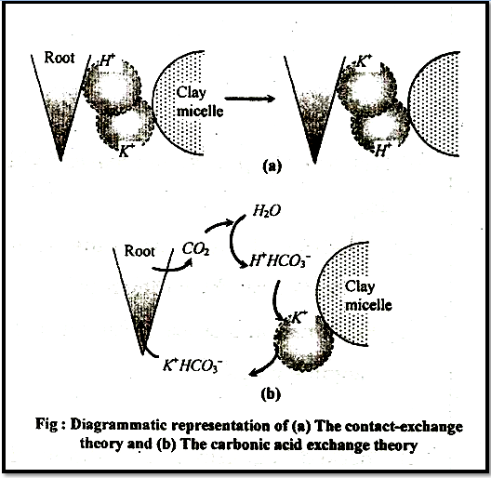

**Donnan’s Equiliberium:
The accumulation of ions inside the cells without involving expenditure of the met energy can be explained to some extent by Donnan’s equilibrium theory. (also known as the Donnan effect, Donnan law, Donnan equilibrium, or Gibbs-Donnan equilibrium).
According to this theory, there are certain pre-existing ions inside the cell which cannot diffuse outside through membrane. Such ions are called as in diffusible or fixed ions which may be in the form of charged carboxyl(-COO⁻ ) and amino (-NH₄⁺) groups of proteins or charged groups of other macromolecules in the cell. However, the membrane is permeable to both anions and cations of the outer solution.
Suppose, there are certain fixed anions in the cell which is in contact with the outer solution containing anions and cations. Normally equal number of anions and cations would have diffused into the cell through an electrical potential to balance each other, but to balance the fixed anions more cations will diffuse into the cell. This equilibrium is known as Donnan’s equilibrium. In this particular case, there would be an accumulation of cations inside the cell if however, there are fixed cations inside the cell, the Donnan’s equilibrium will result in the accumulation of anions inside the cell.
When the concentration of mineral salts is higher in the outer solution than in the cell sap of the root cells, the mineral salts are absorbed according to the concentration gradient by simple process of diffusion. This is called as passive absorption because it does not require expenditure of metabolic energy. It is known that during passive absorption, the mineral salts may diffuse through cell membranes directly through lipid bi-layer.

B/ Active absorption of mineral salts:
This cannot be explained by simple diffusion or Donnan’s equilibrium and has ledpeople to believe that absorption and accumulation of mineral salts against the concentration gradient is an active process which involves the expenditure of metabolic energy through respiration following evidences favor this view:
1-the factors like low temp., deficiency of O₂, metabolic inhibitors etc. which inhibit metabolic activities like respiration in plants inhibit accumulation of ions.
2-rate of respiration is increased when a plant is transferred from water to salt solution (salt respiration) .
It has often been observed that the cell sap in plants accumulates large-quantities of mineral salts ions against the concentration gradient. For example in alga Nitetta the cell accumulated K⁺ and phosphate ions to such an extent that their concentrations were hundreds times greater than in the pond water in which the plant was growing. The mineral salts move mainly through membrane ion-selective protein channels or transmembrane carrier proteins, carrier on channel mediated passive transport of mineral salts across the membrane is also called as facilitated diffusion.

