College of Science Al-Mustanseryea University Dep.: Biology
Academic year: 2015-2016 Subject: Plant Physiology Class: Fourth Grade
By: Dr. Alaa Jabar & Dr. Rana Azeez
Lecture: 4
Respiration
Introduction:
It is known that large amount of photosynthetic products (carbohydrates) is utilized in respiration to produce energy and organic compounds which utilize in growth and development of plant. During respiration some of the energy produced liberated as a heat, while most of energy is utilized in synthesis of high energy compounds to be used to accelerate of chemical reaction within the cells to synthesize the importance biological molecules such as proteins, lipids, carbohydrates, hormones, flowers, and fruit formation.
The energy compounds:
There are types of reactions;
1-Excergonic reaction: it is a reaction that produces energy after completing.
2-Entergonic reaction: it is a reaction that require energy for completing.
The energy produced from the excergonic reaction are stored in chemical compound called energy compound like ATP, GTP, TTP, UTP.
***Respiration:
Respiration can be defined as oxidation process of carbohydrate resulting in energy and chemical compounds utilized in biosynthesis of important biological molecules such as proteins, lipids, and chlorophylls.
The respiration process includes a series of chemical reactions. The storage carbohydrates should be hydrolyzed to glucose which is the first compound oxidize the hydrogen atoms to form H₂O.
The process of respiration is divided into two stages:
1-The first step which conducted in the absence of O₂ and called Glycolysis.
2-The second stage which require O₂ to complete and called Krebs cycle.
***Glycolysis:
It is a series of metabolic reaction started with glucose, and ended with lacted compounds. When the process ends with ethyl alcohol and CO₂ it is called fermentation. The production of lactate or alcohol (fermentation) is restricted to microorganisms, while in higher plants the process ends with production of pyruvate which is the last compound produced before lactate.
The glycolysis process is also called Embden-Meyerhof-Parnas pathway (EMP), to appreciate the scientific efforts of these scientists in discovering the metabolic pathway and their enzymes in this process. The process is located in cytoplasm and does not required O₂. The process consist of two stages:
1-which include transfer of glucose to fructose 1,6 diphosphate.

Glucose G-6-P Fructose-6-P F-1,6diphosphate
ATP
ADP
ATP
ADP

2- Splitting of 1,6 fructose diphosphate into 3C copmpound namely dihydroxy aceton phosphate and glycer aldehyde 1,3 phosphate.
The two compounds above are in equilibrium state and each one can convert to another as needed by the cell.
***Importance of glycolysis:
1-it is necessary step for oxidation of carbohydrates.
2-produce the reduced compound NADH +H⁺.
3-Produce ATP.

***Biosynthesis of Acetyl CoA:
When O₂ is sufficient, oxidation decarboxylation of pyruvate take place forming acetyl CoA and NADH+H⁺ as in the equation:
Pyruvate + CoA +NAD⁺ Acetyl CoA + NADH⁺ +H
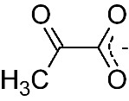
Pyruvate structure

This reaction required the following :
1-Thymine pyrophosphate (TPP).
2-Mg⁺
3-CoA
4-Lipoic acid
5-NAD

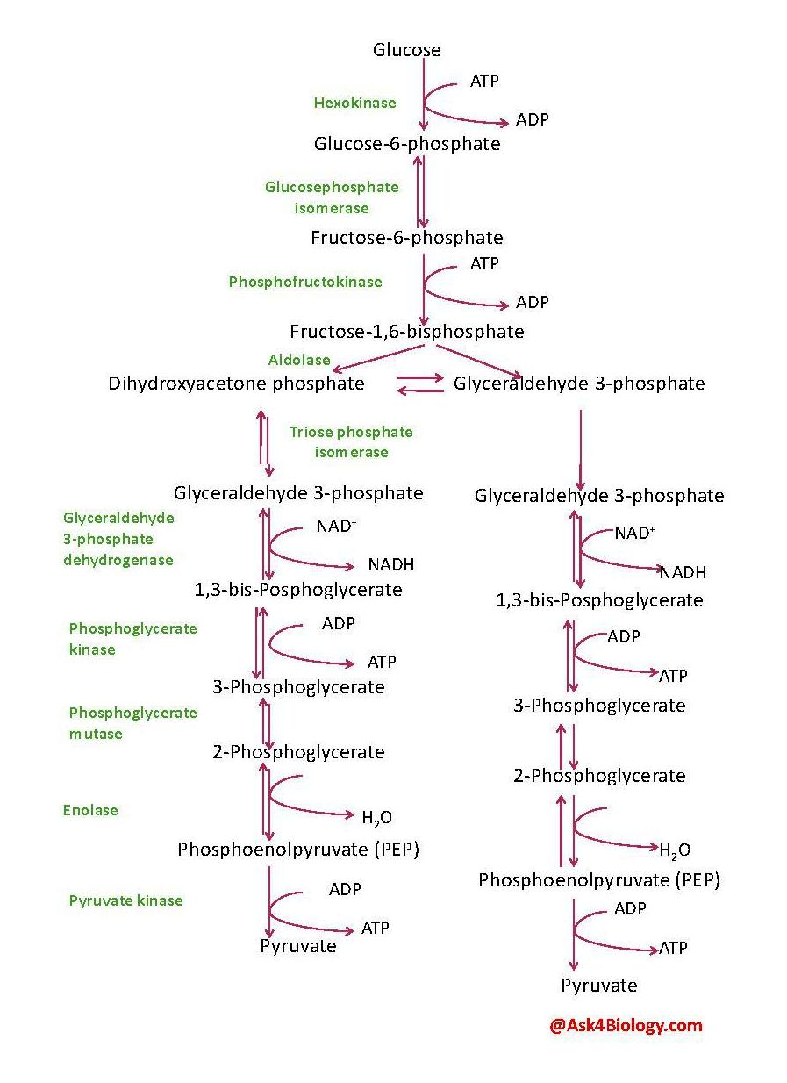
Glycolysis

**Krebs cycle:
It is also called citric acid cycle or Tricarboxylic acid cycle (TCA), it is a cycle since the first compound of the cycle (oxalo acetate OAA) is resynthesized again in the cycle. The cycle is started by the reaction of Acetyl CoA with OAA to form citrate. The citrate convert to cis-aconitate by dehydration reaction. This cis-aconitateis unstable compounds and convert immediately to isocitrate by hydration reaction. And then this cycle continuous to produce malate which converted to OAA forming NADH+H⁺, in the presence of malate dehydrogenase and NAD, thus regeneration of OAA completes the cycle.
Significance of Krebs cycle:
1-production of the reduced forms( NADH+H⁺ and FADH₂).
2-Production of the energy products GTP.
3-The compounds of krebs cycle is involved in the synthesis of important biological molecules such as cytochromes, phytochromes, proteins, vitamins and nucleic acids.

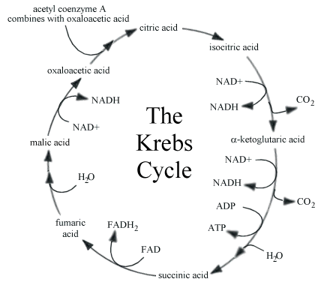

**Electron transport system (ETS) and phosphorylation:
The system is located in mitochondria, and consists of :
1-CoQ, NAD, and FAD carriers.
2-cytochromes a, a3, b, and c.
The system start carrying pairs of electrons and H⁺ from the reactions in krebs cycle to NAD, FAD, and CoQ. Then the pairs of electros were received by cytochromes b, c, a , a3, and combined to O₂ to produce H₂O.
The energy released from the electrons stores in inorganic phosphate bond during the formation of ATP, the NADH+H⁺ goes through the ETS releases 3ATP while the FADH₂ releases only 2ATP.
The production of ATP by electron transport system is called oxidation phosphorylation.

**Respiration quotient ( RQ):
(moles or weight) of CO₂ evolved
RQ=
( moles or weight) of O₂ consumed

? What is the importance of RQ:
To determine the type of stored food in seed or fruit consumed during respiration.
1-In seed which are rich with CHO, the respiration equation would equals (one), that means the stored food is CHO.
2-In oily or fatty seeds the equation would equal less than (one), that means the stored food is oil or fatty acid.
3- In seeds or fruit rich with organic acid the equation would equal more than (one), that means the stored food is protein.

***Factors affecting respiration:
1-Temperature: The temp. has a significant effect on enzyme activity of all enzymes including photosynthesis enzymes. Maximum respiration rate occurred between 35-40 C⁰. The effect of temp. on respiration rate increased with increasing temp.

2-O₂ concentration: under low O₂ concentration, more CO₂ liberated from the plant due to increase of glycolysis rate. But when O₂ increased less CO₂ liberated due to increase of aerobic respiration.

3-CO₂ concentration : Increased CO₂ concentration decrease the O₂ uptake by the stomata this leads to decrease the respiration rate .

4-Photosynthesis: Increasing the photosynthesis causes increase in the respiration rate due to increase in the amount of respiration substrate (sugar).

