The objectives of this lecture are:
- Physics of semiconductors.
- Conductors, Insulators and Semiconductors.
- Solar Photovoltaic systems.
- Semiconductor Types.
- p-n junction.
- principles of solar cells.

References:
- Solar Engineering of Thermal Processes by Duffie & Beckman, John Wiley & Sons, 1991
- Principles of Solar Engineering, Goswami, Kreith and Kreider, Taylor & Francis, 2000.
- Solar Energy Fundamentals, Technology, and Systems
Klaus Jäger Olin do Isabella Arno H.M. Smets René A .C .M. M .van Swaaij Miro Zeman
Copyright Delft University of Technology, 2014 This copy is provided for free,
- Solar PV and Wind Energy Conversion Systems
Springer International Publishing AG Switzerland is part of Springer Science +Business Media (www.springer.com)
- Available from Source:
- http://www.uwsp.edu/geo/faculty/ritter/geog101/textbook/energy/nature_of_electromagnetic_radiation.html .
- http://www.physicalgeography.net

Note: see the properties of silicon and germanium.

3- Physics of semiconductors:

Besides the positively charged protons and the uncharged neutrons inside the nucleus an atom is composed of the negatively charged electrons that assume discrete energy levels (such as "shells" or "orbitals") around the nucleus.
- There is a limited number of electrons that can occupy a certain energy level; according to the so-called Pauli exclusion principle any possible energy level may only be occupied by a maximum of two electrons.
- These two electrons are only allowed if they again differ from each other by their "spin" (i.e. self-angular momentum).
According to the Bohr atomic model, in an isolated atom the energy of any of its electrons is decided by the orbit in which it revolves. But when the atoms come together to form a solid, they are close to each other. So, the outer orbits of electrons from neighboring atoms would come very close or could even overlap. This would make the nature of electron motion in a solid very different from that in an isolated atom. Inside the crystal each electron has a unique position and no two electrons see exactly the same pattern of surrounding charges.
Because Of this, each electron will have a different energy level. These different energy levels with continuous energy variation form what are called energy bands. The energy band which includes the energy levels of the valence electrons is called the valence band. The energy band above the valence band is called the conduction band. With no external energy, all the valence electrons will reside in the valence band. If the lowest level in the conduction band happens to be lower than the highest level of the valence band, the electrons from the valence band can easily move into the conduction band.
Normally the conduction band is empty. But when it overlaps on the valence band electrons can move freely into it. This is the case with metallic conductors. If there is some gap between the conduction band and the valence band, electrons in the valence band all remain bound and no free electrons are available in the conduction band. This makes the material an insulator. But some of the electrons from the valence band may gain external energy to cross the gap between the conduction band and the valence band. Then these electrons will move into the conduction band. At the same time, they will create vacant energy levels in the valence band where other valence electrons can move. Thus, the process creates the possibility of conduction due to electrons in conduction band as well as due to vacancies in the valence band.

Let us consider what happens in the case of Si or Ge crystal containing N atoms.
For Si, the outermost orbit is the third orbit (n = 3), while for Ge it is the fourth orbit (n = 4). The number of electrons in the outermost orbit is 4 (2s and 2p electrons). Hence, the total number of outer electrons in the crystal is 4N. The maximum possible number of electrons in the outer orbit is 8 (2s + 6p electrons). So, for the 4N valence electrons there are 8N available energy states. These 8N discrete energy levels can either form a continuous band or they may be grouped in different bands depending upon the distance between the atoms in the crystal. At the distance between the atoms in the crystal lattices of Si and Ge, the energy band of these 8N states is split apart into two which are separated by an energy gap E_{g} (Fig.3.1). The lower band which is completely occupied by the 4N valence electrons at temperature of absolute zero is the valence band. The other band consisting of 4N energy states, called the conduction band, is completely empty at absolute zero.

Consider that the Si or Ge crystal contains N atoms. Electrons of each atom will have discrete energies in different orbits. The electron energy will be same if all the atoms are isolated, i.e., separated from each other by a large distance. However, in a crystal, the atoms are close to each other (2 to 3 Å) and therefore the electrons interact with each other and also with the neighboring atomic cores. The overlap (or interaction) will be more felt by the electrons in the outermost orbit, while the inner orbit or core electron energies may remain unaffected. Therefore, for understanding electron energies in Si or Ge crystal, we need to consider the changes in the energies of the electrons in the outermost orbit only.

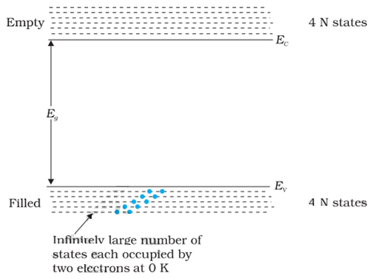
Fig.3.1 The energy band positions in a semiconductor at 0 K. The upper band, called the conduction band, consists of infinitely large number of closely spaced energy states. The lower band, called the valence band, consists of closely spaced completely filled energy states.
3-1 Conductors, Insulators and Semiconductors
The lowest energy level in the conduction band is shown as E_{C} and highest energy level in the valence band is shown as E_{V}. Above E_{C} and below E_{V} there are a large number of closely spaced energy levels, as shown in Fig. 3.1. The gap between the top of the valence band and bottom of the conduction band is called the energy band gap (Energy gap E_{g}). It may be large, small, or zero, depending upon the material. These different situations, are depicted in Fig. 3.2 and discussed below:

Case I: Conductors
This refers to a situation, as shown in Fig.3.2(a). One can have a metal either when the conduction band is partially filled and the balanced band is partially empty or when the conduction and valance bands overlap. When there is overlap electrons from valence band can easily move into the conduction band. This situation makes a large number of electrons available for electrical conduction. When the valence band is partially empty, electrons from its lower level can move to higher level making conduction possible. Therefore, the resistance of such materials is low or the conductivity is high.

Case II: Insulators
In this case, as shown in Fig. 3.2(b), a large band gap Eg exists (Eg > 3 eV). There are no electrons in the conduction band, and therefore no electrical conduction is possible. Note that the energy gap is so large that electrons cannot be excited from the valence band to the conduction band by thermal excitation. This is the case of insulators.
Case III: Semiconductors
This situation is shown in Fig. 3.2(c). Here a finite but small band gap (Eg < 3 eV) exists. Because of the small band gap, at room temperature some electrons from valence band can acquire enough energy to cross the energy gap and enter the conduction band. These electrons (though small in numbers) can move in the conduction band. Hence, the resistance of semiconductors is not as high as that of the insulators. In this section we have made a broad classification of metals, conductors and semiconductors.

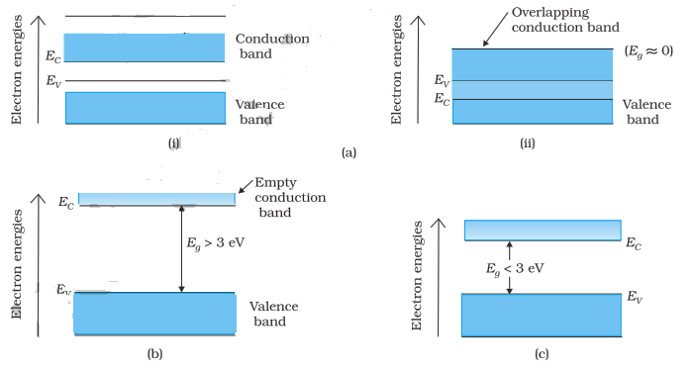
Fig.3.2 Difference between energy bands of (a) metals, (b) insulators and (c) semiconductors.

3-2 Solar Photovoltaic systems:
3-2-1 Intrinsic Semiconductor
We shall take the most common case of Ge and Si whose lattice structure is shown in Fig.3.3. These structures are called the diamond-like structures. Each atom is surrounded by four nearest neighbours. We know that Si and Ge have four valence electrons. In its crystalline structure, every Si or Ge atom tends to share one of its four valence electrons with each of its four nearest neighbour atoms, and also to take share of one electron from each such neighbour. These shared electron pairs are referred to as forming a covalent bond or simply a valence bond. The two shared electrons can be assumed to shuttle back-and forth between the associated atoms holding them together strongly.

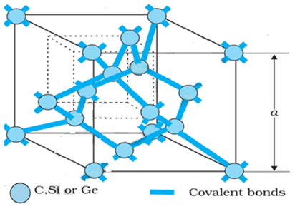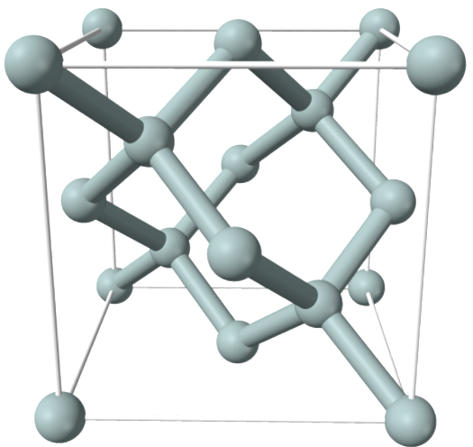

Fig.3.3 Three-dimensional diamond-like crystal structure for Carbon, Silicon or Germanium with respective lattice spacing a equal to 3.56, 5.43 and 5.66 Å

Figure 3.4 schematically shows the 2-dimensional representation of Si or Ge structure shown in Fig. 3.3 which overemphasises the covalent bond. It shows an picture in which no bonds are broken (all bonds are intact). Such a situation arises
at low temperatures. As the temperature increases, more thermal energy becomes available to these electrons and some of these electrons may break–away (becoming free electrons contributing to conduction).
The thermal energy effectively ionizes only a few atoms in the crystalline lattice and creates a vacancy in the bond as shown in Fig. 3.5(a). The neighborhoods, from which the free electron (with charge –q) has come out leaves a vacancy with an effective charge (+q). This vacancy with the effective positive electronic charge is called a hole. The hole behaves as an apparent free particle with effective positive charge. In intrinsic semiconductors, the number of free electrons, n_{e} is equal to the number of holes, n_{h}.
That is: n_{e} = n_{h} = n_{i}. --------1
Here: n_{i} is called intrinsic carrier concentration. Semiconductors possess the unique property in which, apart from electrons, the holes also move.

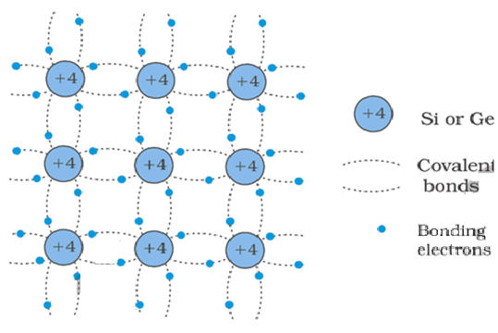
Fig.3.4 Schematic two-dimensional representation of Si or Ge structure showing covalent bonds at low temperature (all bonds intact). +4 symbol indicates inner cores of Si or Ge

Suppose there is a hole at site 1 as shown in Fig. 3.5(a). The movement of holes can be visualized as shown in Fig. 3.5(b). An electron from the covalent bond at site 2 may jump to the vacant site 1 (hole). Thus, after such a jump, the hole is at site 2 and the site 1 has now an electron. Therefore, apparently, the hole has moved from site 1 to site 2.
Note that the electron originally set free Fig. 3.5(a) is not involved in this process of hole motion. The free electron moves completely independently as conduction electron and gives rise to an electron current, I_{e} under an applied electric field.
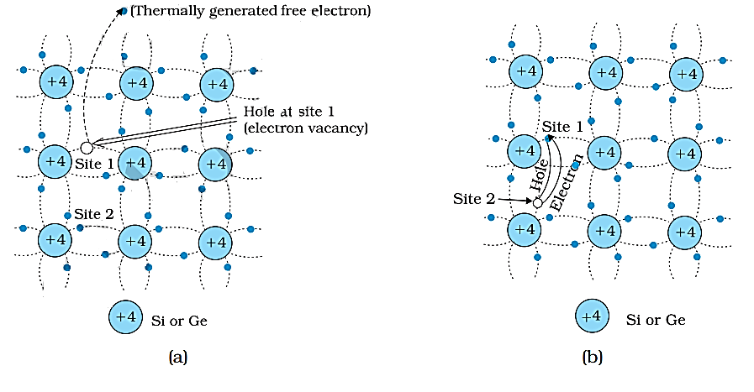

Fig. 3.5 (a) Schematic model of generation of hole at site 1 and conduction electron due to thermal energy at moderate temperatures. (b) Simplified representation of possible thermal motion of a hole. The electron from the lower left-hand covalent bond (site 2) goes to the earlier hole site1, leaving a hole at its site indicating an apparent movement of the hole from site 1 to site 2.

Remember that the motion of hole is only a convenient way of describing the actual motion of bound electrons, whenever there is an empty bond anywhere in the crystal. Under the action of an electric field, these holes move towards negative potential giving the hole current, I_{h}. The total current I is thus the sum of the electron current I_{e} and the hole current I_{h}.
I = I_{e} + I_{h -----------2}
It may be noted that apart from the process of generation of conduction electrons and holes, a simultaneous process of recombination occurs in which the electrons recombine with the holes. At equilibrium, the rate of generation is equal to the rate of recombination of charge carriers. The recombination occurs due to an electron colliding with a hole.
An intrinsic semiconductor will behave like an insulator at T = 0 K as shown in Fig. 3.6(a). It is the thermal energy at higher temperatures (T > 0K), which excites some electrons from the valence band to the conduction band. These thermally excited electrons at T > 0 K, partially occupy the conduction band. Therefore, the energy-band diagram of an intrinsic semiconductor will be as shown in Fig. 3.6(b). Here, some electrons are shown in the conduction band. These have come from the valence band leaving equal number of holes there.
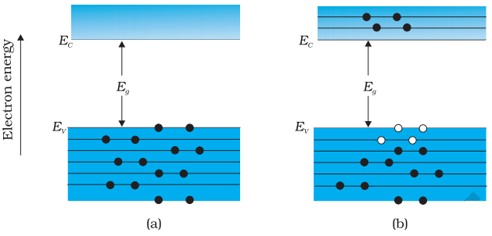
Fig. 3.6 (a) An intrinsic semiconductor at T = 0 K behaves like insulator (b)At T > 0 K, four thermally generated electron-hole pairs.
The filled circle () represent electrons and empty fields ()represent holes

3-2-2 Extrinsic Semiconductor.
The conductivity of an intrinsic semiconductor depends on its temperature, but at room temperature its conductivity is very low. As such, no important electronic devices can be developed using these semiconductors. Hence there is a necessity of improving their conductivity. This can be done by making use of impurities. When a small amount, say, a few parts per million (ppm), of a suitable impurity is added to the pure semiconductor, the conductivity of the semiconductor is increased manifold. Such materials are known as extrinsic semiconductors or impurity semiconductors. The deliberate addition of a desirable impurity is called doping and the impurity atoms are called dopants. Such a material is also called a doped semiconductor. The dopant has to be such that it does not distort the original pure semiconductor lattice. It occupies only a very few of the original semiconductor atom sites in the crystal. A necessary condition to attain this is that the sizes of the dopant and the semiconductor atoms should be nearly the same. There are two types of dopants used in doping the tetravalent Si or Ge:
- Pentavalent (valency 5); like Arsenic (As), Antimony (Sb), Phosphorous (P), etc.
- Trivalent (valency 3); like Indium (In), Boron (B), Aluminum (Al), etc.

We shall now discuss how the doping changes the number of charge carriers (and hence the conductivity) of semiconductors. Si or Ge belongs to the 4th group in the Periodic Table and, therefore, we choose the dopant element from nearby 5th or 3rd group, expecting and taking care that the size of the dopant atom is nearly the same as that of Si or Ge. Interestingly, the pentavalent and trivalent dopants in Si or Ge give two entirely different types of semiconductors as discussed below.

3-3 n-type semiconductor.
Suppose we dope Si or Ge with a pentavalent element as shown in Fig. 3.7. When an atom of +5 valency element occupies the position of an atom in the crystal lattice of Si, four of its electron’s bonds with the four silicon neighbours while the fifth remains very weakly bound to its parent atom. This is because the four electrons participating in bonding are seen as part of the effective core of the atom by the fifth electron. As a result, the ionisation energy required to set this electron free is very small and even at room temperature it will be free to move in the lattice of the semiconductor.

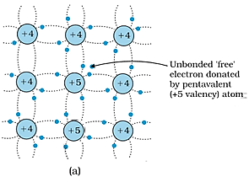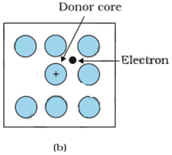
Fig. 3.7 (a) Pentavalent donor atom (As, Sb, P, etc.) doped for tetravalent Si or Ge giving n-type semiconductor, and (b) Commonly used schematic representation of n-type material which shows only the fixed cores of the substituent donors with one additional effective positive charge and its associated extra electron.

For example, the energy required is ~ 0.01 eV for germanium, and 0.05 eV for silicon, to separate this electron from its atom. This is in contrast to the energy required to jump the forbidden band (about 0.72 eV for germanium and about 1.1 eV for silicon) at room temperature in the intrinsic semiconductor. Thus, the pentavalent dopant is donating one extra electron for conduction and hence is known as donor impurity. The number of electrons made available for conduction by dopant atoms depend strongly upon the doping level and is independent of any increase in ambient temperature. On the other hand, the number of free electrons (with an equal number of holes) generated by Si atoms, increases weakly with temperature.
In a doped semiconductor the total number of conduction electrons n_{e} is due to the electrons contributed by donors and those generated intrinsically, while the total number of holes n_{h} is only due to the holes from the intrinsic source. But the rate of recombination of holes would increase due to the increase in the number of electrons. As a result, the number of holes would get reduced further. Thus, with proper level of doping the number of conduction electrons can be made much larger than the number of holes. Hence in an extrinsic semiconductor doped with pentavalent impurity, electrons become the majority carriers and holes the minority carriers. These semiconductors are, therefore, known as n-type semiconductors.
For n-type semiconductors, we have: n_{e} >> n_{h}. ------------ 3

3-4 p-type semiconductor

This is obtained when Si or Ge is doped with a trivalent impurity like Al, B, In, etc. The dopant has one valence electron less than Si or Ge and, therefore, this atom can form covalent bonds with neighbouring three Si atoms but does not have any electron to offer to the fourth Si atom. So, the bond between the fourth neighbour and the trivalent atom has a vacancy or hole as shown in Fig.3.8. Since the neighbouring Si atom in the lattice wants an electron in place of a hole, an electron in the outer orbit of an atom in the neighbourhood may jump to fill this vacancy, leaving a vacancy or hole at its own site. Thus, the hole is available for conduction.
Note that, the trivalent foreign atom becomes effectively negatively charged when it shares fourth electron with neighbouring Si atom. Therefore, the dopant atom of p-type material can be treated as core of one negative charge along with its associated hole as shown in Fig. 3.8(b). It is obvious that one acceptor atom gives one hole. These holes are in addition to the intrinsically generated holes while the source of conduction electrons is only intrinsic generation. Thus, for such a material, the holes are the majority carriers and electrons are minority carriers. Therefore, extrinsic semiconductors doped with trivalent impurity are called p-type semiconductors. For p-type semiconductors, the recombination process will reduce the number (n_{i}) of intrinsically generated electrons to n_{e}. We have, for p-type semiconductors: n_{h} >> n_{e}. --------------4

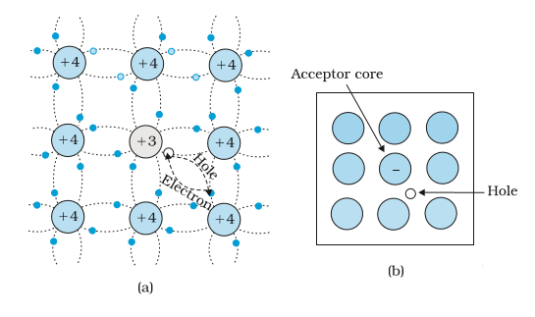
Fig. 3.8 (a) Trivalent acceptor atom (In, Al, B etc.) doped in tetravalent Si or Ge lattice giving p-type semiconductor. (b) Commonly used schematic representation of p-type material which shows only the fixed core of the substituent acceptor with one effective additional negative charge and its associated hole.

The semiconductors energy band structure is affected by doping. In the case of extrinsic semiconductors, additional energy states due to donor impurities (E_{D}) and acceptor impurities (E_{A}) also exist. In the energy band diagram of n-type Si semiconductor, the donor energy level (E_{D}) is slightly below the bottom E_{C} of the conduction band and electrons from this level move into the conduction band with very small supply of energy. At room temperature, most of the donor atoms get ionised but very few (~10^{–12}) atoms of Si get ionised. So, the conduction band will have most electrons coming from the donor impurities, as shown in Fig. 3.9(a).

Similarly, for p-type semiconductor, the acceptor energy level E_{A} is slightly above the top (E_{V}) of the valence band as shown in Fig. 3.9(b). With very small supply of energy an electron from the valence band can jump to the level (E_{A})and ionise the acceptor negatively. (Alternately, we can also say that with very small supply of energy the hole from level (E_{A}) sinks down into the valence band. Electrons rise up and holes fall down when they gain external energy). At room temperature, most of the acceptor atoms get ionised leaving holes in the valence band. Thus, at room temperature the density of holes in the valence band is predominantly due to impurity in the extrinsic semiconductor. The electron and hole concentration in a semiconductor in thermal equilibrium is given by:
n_{e} n_{h} = n_{i}² -------- 5

Though, the above description is grossly approximate and hypothetical, it helps in understanding the difference between metals, insulators and semiconductors (extrinsic and intrinsic) in a simple manner. The difference in the resistivity of C, Si and Ge depends upon the energy gap between their conduction and valence bands. For C (diamond), Si and Ge, the energy gaps are 5.4 eV, 1.1 eV and 0.7 eV, respectively. Sn (Tin) also is a group four element but it is a metal because the energy gap in its case is 0 eV.

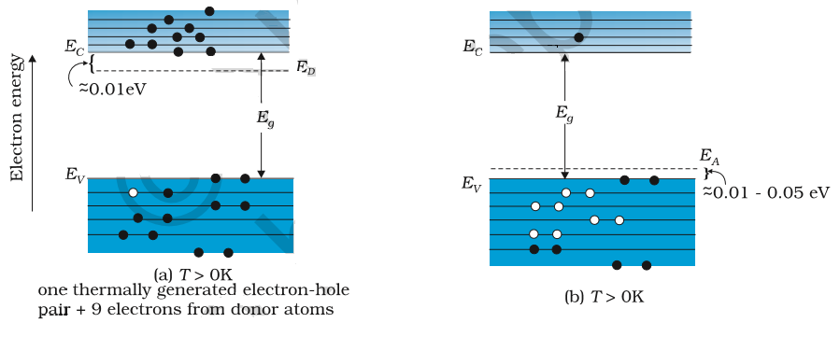
Fig.3.9 Energy bands of (a) n-type semiconductor at T > 0K,
(b) p-type semiconductor at T > 0K.

3-5 p-n junction formation:
A p-n junction is the basic building block of many semiconductor devices like diodes, transistor, etc. A clear understanding of the junction behavior is important to analysis the working of other semiconductor devices. We will now try to understand how a junction is formed and how the junction behaves under the influence of external applied voltage (also called bias).
Consider a thin p-type silicon (p-Si) semiconductor wafer. By adding precisely, a small quantity of pentavalent impurity, part of the p-Si wafer can be converted into n-Si. The wafer now contains p-region and n-region and a metallurgical junction between p-, and n- region. Two important processes occur during the formation of a p-n junction: diffusion and drift. We know that in an n-type semiconductor, the concentration of electrons (number of electrons per unit volume) is more compared to the concentration of holes. Similarly, in a p-type semiconductor, the concentration of holes is more than the concentration of electrons. During the formation of p-n junction, and due to the concentration gradient across p-, and n- sides, holes diffuse from p-side to n-side (p → n) and electrons diffuse from n-side to p-side (n → p). This motion of charge carries gives rise to diffusion current across the junction. When an electron diffuses from n → p, it leaves behind an ionised donor on n-side. This ionised donor (positive charge) is immobile as it is bonded to the surrounding atoms. As the electrons continue to diffuse from n → p, a layer of positive charge (or positive space-charge region) on n-side of the junction is developed.
Similarly, when a hole diffuses from p → n due to the concentration gradient, it leaves behind an ionized acceptor (negative charge) which is immobile. As the holes continue to diffuse, a layer of negative charge (or negative space-charge region) on the p-side of the junction is developed. This space-charge region on either side of the junction together is known as depletion region as the electrons and holes taking part in the initial movement across the junction depleted the region of its free charges (Fig. 3.10). The thickness of depletion region is of the order of 0.1 of a μm. Due to the positive space-charge region on n-side of the junction and negative space charge region on p-side of the junction, an electric field directed from positive charge towards negative charge develops. Due to this field, an electron on p-side of the junction moves to n-side and a hole on n-side of the junction moves to p-side. The motion of charge carriers due to the electric field is called drift. Thus, a drift current, which is opposite in direction to the diffusion current (Fig. 3.10) starts.
Initially, diffusion current is large and drift current is small. As the diffusion process continues, the space-charge regions on either side of the junction extend, thus increasing the electric field strength and hence drift current. until the diffusion current equals the drift current.
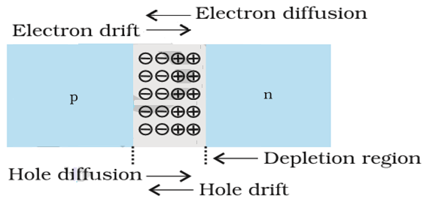
Fig.3.10 p-n junction formation process

This process continues Thus, p-n junction is formed. In a p-n junction under equilibrium there is no net current. The loss of electrons from the n-region and the gain of electron by the p-region causes a difference of potential across the junction of the two regions. The polarity of this potential is such as to oppose further flow of carriers so that a condition of equilibrium exists. Fig. 3.11 shows the p-n junction at equilibrium and the potential across the junction. The n-material has lost electrons, and p material has acquired electrons. The n material is thus positive relative to the p material. Since this potential tends to prevent the movement of electron from the n region into the p region, it is often called a barrier potential.

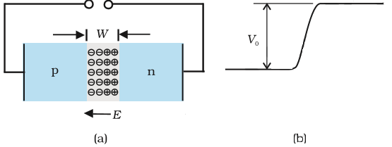
Fig.3.11 (a) Diode under equilibrium (V = 0), (b) Barrier potential under no bias.

3-6 Basics of solar cells
Solar cells can be manufactured from different semiconductor materials and their combinations. The voltage generated by a solar cell depends on the intensity of solar radiation and the cell surface area receiving the radiations. The maximum achievable power is about 100 W/m2 of solar cell surface area. The main types of solar cells are monocrystalline silicon cells, poly crystalline silicon cells, amorphous silicon cells, gallium arsenide (GaAs), and Copper indium dieseline (CID) cells.
At present, silicon solar cells occupy 60% of the world market. Basic types of silicon solar cells are: (1) Mono crystalline silicon solar cells, (2) poly crystalline silicon solar cells, and (3) thin film or Amorphous silicon solar cells.
- Mono crystalline silicon solar cells: A silicon solar cell of size 10cm×10cm produces a voltage of 0.5V and power output of 1 W at a solar radiation intensity of 1000 W/m2. The solar cells are formed into modulus by enclosing in an air tight casing with a transparent cover of synthetic glass. This modulus possesses high efficiency between 15 and 18% and are used in medium and large size plants.
- Poly crystalline silicon solar cells: The higher efficiency of solar module is 12 to 14%.
- Thin-film solar cells: The crystalline solar cells are labor and energy intensive in manufacturing. The thin film cells are produced from amorphous silicon. It has the capacity to absorb more solar radiation due to irregular atom arrangement. The efficiency is 5 to 8%. These are very cheap to manufacture.

Cell efficiency is defined as the ratio of electric power output of the cell, module, or array to the power content of sunlight over its total exposed area. The maximum theoretical efficiency of solar cells is around 47 percent.

3-7 Advantages of photovoltaic solar energy conversion
- Very long life.
- Highly reliable.
- Low maintenance cost.
- Absence of moving parts.
- No environmental pollution.
- Can function unattended for long time.
- Solar energy is free and no fuel required.
- Can be started easily as no starting time is involved.
- Direct conversion of light to electricity at room temperature.

Two major types of PV systems are available in the marketplace today:
flat plate and concentrators. As the most prevalent type of PV systems, flat plate systems build the PV modules on a rigid and flat surface to capture sunlight. Concentrator systems use lenses to concentrate sunlight on the PV cells and increase the cell power output.
Comparing the two systems,
flat plate systems are typically less complicated but employ a larger number of cells while the concentrator systems use smaller areas of cells but require more sophisticated and expensive tracking systems. Unable to focus diffuse sunlight, concentrator systems do not work under cloudy conditions. Types of PV cell materials are crystalline and thin films, which vary from each other in terms of light absorption efficiency, energy conversion efficiency, manufacturing technology and cost of production.

3-8 Solar cell Techniques.
The most useful way of harnessing solar energy is by directly converting it into DC electricity by means of solar photovoltaic cells. Energy conversion devices which are used to convert sun light to electricity by the use of photo-voltaic effect are called solar cells. A photovoltaic (PV) cell converts sunlight into electricity, which is the physical process known as photoelectric effect. Light, which shines on a PV cell, may be reflected, absorbed, or passed through; however, only absorbed light generates electricity. The energy of absorbed light is transferred to electrons in the atoms of the PV cell.

A solar cell is basically a p-n junction which generates emf when solar radiation falls on the p-n junction. It works on the same principle (photovoltaic effect) except that
no external bias is applied and the junction area is kept much larger for solar radiation to be incident because we are interested in more power. A simple p-n junction solar cell is shown in Fig. 3.12. A p-Si wafer of about 300 µm is taken over which a thin layer (~0.3 µm) of n-Si is grown on one-side by diffusion process. The other side of p-Si is coated with a metal (back contact). On the top of n-Si layer, metal finger electrode (or metallic grid) is deposited. This acts as a front contact. The metallic grid occupies only a very small fraction of the cell area (<15%) so that light can be incident on the cell from the top.
The generation of emf by a solar cell, when light falls on, it is due to the following three basic processes: generation, separation and collection.
(i) generation of e-h pairs due to light (with hν > Eg) close to the junction
(ii) separation of electrons and holes due to electric field of the depletion region. Electrons are swept to n-side and holes to p-side;
(iii) the electrons reaching the n-side are collected by the front contact and holes reaching p-side are collected by the back contact. Thus p-side becomes positive and n-side becomes negative giving rise to photovoltage.
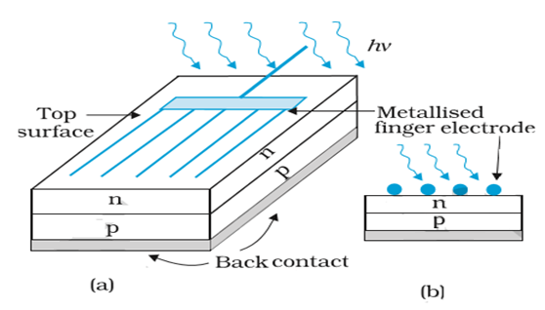
Fig.3.12 (a) Typical p-n junction solar cell; (b) Cross-sectional view.

When an external load is connected as shown in the Fig. 3.13(a) a photocurrent I_{L} flows through the load. A typical I-V characteristic of a solar cell is shown in the Fig. 3.13(b). Note that the I – V characteristics of solar cell is drawn in the fourth quadrant of the coordinate axes. This is because a solar cell does not draw current but supplies the same to the load.
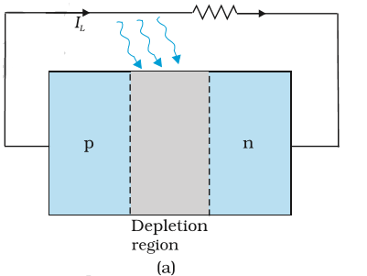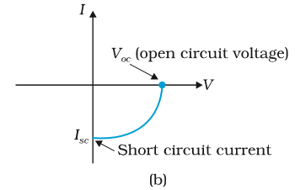
Fig. 3.13 (a) A typical illuminated p-n junction solar cell; (b) I-V characteristics of a solar cell.

Semiconductors with band gap close to 1.5 eV are ideal materials for solar cell fabrication. Solar cells are made with semiconductors like Si (Eg = 1.1 eV), GaAs (Gallium arsenide) (Eg = 1.43 eV), CdTe (Telluride Cadmium) (Eg = 1.45 eV), CuInSe₂ (Copper indium gallium (di)selenide (CIGS) (E = 1.04 eV), etc.

3-10 Criteria for Select Solar Cell fabrication materials
The important criteria for the selection of a material for solar cell fabrication are:
- cost
- band gap (~1.0 to 1.8 eV).
- electrical conductivity.
- high optical absorption (~104 cm–1).
- availability of the raw material.
Note that sunlight is not always required for a solar cell. Any light with photon energies greater than the bandgap will do. Solar cells are used to power electronic devices in satellites and space vehicles and also as power supply to some calculators. Production of low-cost photovoltaic cells for large scale solar energy is a topic for research.

