The purpose of this lesson
- Distribution of Wind Speed.
- Basic Concepts of Wind Energy.
- Estimation of Wind Energy Potential.
- Introduce the concept of useful power for wind energy
- Understand physical quantities and characterizing the wind energy.
- Estimate the average energy available at one particular site.

References:
- WIND ENERGY EXPLAINED Theory, Design and Application Second Edition J. F. Man well and J. G. McGowan
Department of Mechanical and Industrial Engineering, University of Massachusetts, USA
A. L. Rogers DNV – Global Energy Concepts, Washington, USA
- Fundamentals of wind energy: Wei Tong Koll morgen Corporation, Virginia, USA www.witpress.com, ISSN 1755-8336 (on-line) WIT Transactions on State of the Art in Science and Engineering, Vol 44, © 2010 WIT Press doi:10.2495/978-1-84564- / 205-1 01.
- Wind Power Fundamentals Alex Kalmikov and Katherine Dykes With contributions from: Kathy Araujo PhD Candidates, MIT Mechanical Engineering, Engineering Systems and Urban Planning
- file:///D:/references%20renewble/wind/Wind%20Power%20Fundamentals.
- More information about this: at http://www.springer.com/series/8059.
- Wind energy engineering. New York: McGraw-Hill, Jain, P. (2011).
- Fundamental of Aerodynamics, John D. Anderson, Jr., McGraw-Hill, 2001.
- www.ewea.orgEuropean Wind Energy Association.
- wwwindea.org World Wind Energy Association.
- www.awea.orgAmerican Wind Energy Association.
4-Wind Energy
4-1 Introduction to Wind Energy
4-1-1 Historical Development
- Wind has been used by people for over 3000 years for grinding grain, sailboats, and pumping water Windmills were an important part of life for many communities beginning around 1200 BC.
- Wind was first used for electricity generation in the late 19thcentury.
- The Babylonian emperor Hammurabi planned to use wind power for his ambitious irrigation project during seventeenth century B.C.
- The wind wheel of the Greek engineer Heron of Alexandria in the 1st century AD is the earliest known instance of using a wind driven wheel to power a machine.
- By the 13th century, grain grinding mills were popular in most of Europe.
- French adopted this technology by 1105 A.D. and the English by 1191 A.D
- The era of wind electric generators began close to 1900’s.
- The first modern wind turbine, specifically designed for electricity generation, was constructed in Denmark in 1890.
- The first utility-scale system was installed in Russia in 1931.
- A significant development in large-scale systems was the 1250 kW turbine fabricated by Palmer C. Putman.
4-1-2 wind types
Planetary circulations:
– Jet stream – Trade winds – Polar jets
• Geostrophic winds • Thermal winds • Gradient winds
– topographic winds: • Katabatic • Anabatic winds
– downslope wind storms: • Bora • Foehn • Chinook
• Sea Breeze • Land Breeze
• Downdrafts •Convective storms
• Hurricanes • Typhoons • Tornadoes
• Gusts • Dust devils •Microbursts
• Nocturnal Jets
• Atmospheric Waves.

4-1-3 WORLD DISTRIBUTION OF WIND
The basic driving force of air movement is a difference in air pressure between two regions. This air pressure is described by several physical laws. One of these is Boyle’s law, which states that the product of pressure and volume of a gas at a constant temperature must be a constant, or p1V1 = p2V2. Ever since the days of sailing ships, it has been recognized that some areas of the earth’s surface have higher wind speeds than others.
Terms like doldrums, horse latitudes, and trade winds are well established in literature. A very general picture of prevailing winds over the surface of the earth is shown in Fig.4-1. In some large areas or at some seasons, the actual pattern differs strongly from this idealized picture. These variations are due primarily to the irregular heating of the earth’s surface in both time and position. The equatorial calms or doldrums are due to a belt of low pressure which surrounds the earth in the equatorial zone as a result of the average overheating of the earth in this region. The warm air here rises in a strong convection flow. Unless prominent land features change the weather patterns, regions near the equator will not be very good for wind power applications Ideally, there are two belts of high pressure and relatively light winds which occur symmetrically around the equator at 30º N and 30º S latitude. These are called the subtropical calms or subtropical highs or horse latitudes.

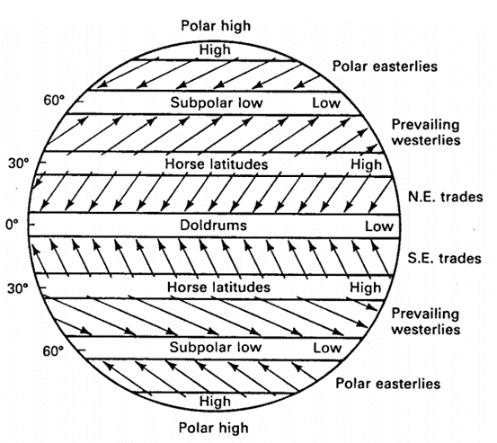
Figure 4-1: Ideal terrestrial pressure and wind systems
There are then two more belts of low pressure which occur at perhaps 60º S latitude and 60o N latitude, the subpolar lows. Finally, the polar regions tend to be high pressure areas more than low pressure. The intensities and locations of these highs may vary widely, with the center of the high only rarely located at the geographic pole. The combination of these high- and low-pressure areas with the Coriolis force produces the prevailing winds shown in Fig. 4-1

4-2 Wind generation:
Wind results from the movement of air due to atmospheric pressure gradients. Wind ﬂows from regions of higher pressure to regions of lower pressure. The larger the atmospheric pressure gradient, the higher the wind speed and thus, the greater the wind power that can be captured from the wind by means of wind energy-converting machinery. The generation and movement of wind are complicated due to a number of factors. Among them, the most important factors are uneven solar heating, the Coriolis effect due to the earth’s self-rotation, and local geographical conditions.

4-2-1Uneven solar heating
Among all factors affecting the wind generation, the uneven solar radiation on the earth’s surface is the most important and critical one. The unevenness of the solar radiation can be attributed to four reasons.

First, the earth is a sphere revolving around the sun in the same plane as its equator. Because the surface of the earth is perpendicular to the path of the sunrays at the equator but parallel to the sunrays at the poles, the equator receives the greatest amount of energy per unit area, with energy dropping off toward the poles. Due to the spatial uneven heating on the earth, it forms a temperature gradient from the equator to the poles and a pressure gradient from the poles to the equator Thus, hot air with lower air density at the equator rises up to the high atmosphere and moves towards the poles and cold air with higher density ﬂows from the poles towards the equator along the earth’s surface. Without considering the earth’s self-rotation and the rotation-induced Coriolis force, the air circulation at each hemisphere forms a single cell, deﬁned as the meridional circulation.
Second, the earth’s self-rotating axis has a tilt of about 23.5° with respect to its ecliptic plane. It is the tilt of the earth’s axis during the revolution around the sun that results in cyclic uneven heating, causing the yearly cycle of seasonal weather changes.
Third, the earth’s surface is covered with different types of materials such as vegetation, rock, sand, water, ice and snow, etc. Each of these materials has different reﬂecting and absorbing rates to solar radiation, leading to high temperature on some areas (e.g. deserts) and low temperature on others (e.g. iced lakes), even at the same latitudes.
fourth reason for uneven heating of solar radiation is, due to the earth’s topographic surface. There are a large number of mountains, valleys, hills, etc. on the earth, resulting in different solar radiation on the sunny and shady sides.
4-2-2 Coriolis force:
The earth’s self-rotation is another important factor to affect wind direction and speed. The Coriolis force, which is generated from the earth's self-rotation, deﬂects the direction of atmospheric movements. In the north atmosphere wind is deﬂected to the right and in the south atmosphere to the left. The Coriolis force depends on the earth’s latitude; it is zero at the equator. Why? and reaches maximum values at the poles. In addition, the amount of deﬂection on wind also depends on the wind speed; slowly blowing wind is deﬂected only a small amount, while stronger wind deﬂected more. In large-scale atmospheric movements, the combination of the pressure gradient due to the uneven solar radiation and the Coriolis force due to the earth’s self- rotation causes the single meridional cell to break up into three convectional cells in each hemisphere: the Hadley cell, the Ferrel cell, and the Polar cell (F ig.4-2). Each cell has its own characteristic circulation pattern In the Northern Hemisphere, the Hadley cell circulation lies between the equator and north latitude 30°, dominating tropical and sub-tropical climates. The hot air rises at the equator and ﬂows toward the North Pole in the upper atmosphere. This moving air is deﬂected by Coriolis force to create the northeast Trade winds. At approximately north latitude 30°, Coriolis force becomes so strong to balance the pressure gradient force. As a result, the winds are defected to the west. The air accumulated at the upper atmosphere forms the subtropical high-pressure belt and thus sinks back to the earth’s surface, splitting into two components: one returns to the equator to close the loop of the Hadley cell; another moves along the earth’s surface toward North Pole to form the Ferrel Cell circulation, which lies between north latitude 30° and 60°. The air circulates toward the North Pole along the earth’s surface until it collides with the cold air ﬂowing from the North Pole at approximately north latitude 60°. Under the inﬂuence of Coriolis force, the moving air in this zone is deﬂected to produce westerlies. The Polar cell circulation lies between the North Pole and north latitude 60°.The cold air sinks down at the North Pole and ﬂows along the earth’s surface toward the equator. Near north latitude 60°, the Coriolis effect becomes signiﬁcant to force the airﬂow to southwest.
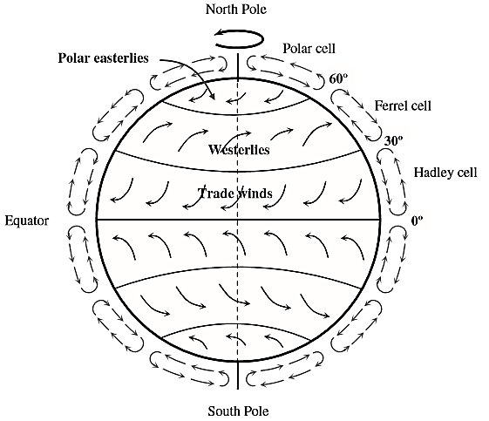
Fig.4-2 Idealized atmospheric circulations
4-2-3 Local geography
The roughness on the earth’s surface is a result of both natural geography and manmade structures. Frictional drag and obstructions near the earth’s surface generally retard with wind speed and induce a phenomenon known as wind shear. The rate at which wind speed increases with height varies on the basis of local conditions of the topography, terrain, and climate, with the greatest rates of increases observed over the roughest terrain. A reliable approximation is that wind speed increases about 10% with each doubling of height. In addition, some special geographic structures can strongly enhance the wind intensity. For instance, wind that blows through mountain passes can form mountain jets with high speeds.
4-3 What Is Wind Energy?
Wind Energy:
is a converted form of solar energy. It is simply air in motion which It is caused by the uneven heating of the atmosphere and Earth's surface, by the sun. Because the Earth's surface is made of very different types of land such as, mountains, valleys and water, which is absorbs the sun's heat at different rates. So, Wind technically comes from the sun as a byproduct of differences in temperature. Wind is a renewable energy source because the wind will blow as long as the sun shines. Wind energy can be either converted into electrical energy by power converting using wind turbines or directly used for pumping water, sailing ships, or grinding gain. wind energy represents a mainstream energy source of new power generation and an important player in the world's energy market. As a leading energy technology, wind power’s technical maturity and speed of deployment is acknowledged, along with the fact that there is no practical upper limit to the percentage of wind that can be integrated into the electricity system.
Only 2% Of solar input, (i.e., 3.6 × 10 ⁹ MW) is converted into wind energy and about 35% of wind energy is dissipated within 1000 m of the earth’s surface. Therefore, the available wind power that can be converted into other forms of energy is approximately 1.26 × 10 ⁹ MW. Because this value represents 20 times the rate of the present global energy consumption, wind energy in principle could meet entire energy needs of the world. compared with traditional energy sources, wind energy has a number of beneﬁts and advantages. Unlike fossil fuels that emit harmful gases and nuclear power that generates radioactive wastes, wind power is a clean and environmentally friendly energy source. As an inexhaustible and free energy source, it is available and plentiful in most regions of the earth. In addition, more extensive use of wind power would help reduce the demands for fossil fuels, which may run out sometime in this century, according to their present consumptions. Furthermore, the cost per kWh of wind power is much lower than that of solar power
4-4-Fundamental Equation of Wind Power:
Kinetic energy exists whenever an object of a given mass is in motion with a translational or rotational speed. When air is in motion, the kinetic energy in moving air can be determined as:
K_{E} = $\frac{1}{2}$ m u² -------------------------------4-1
Where, (m) is the mass and (u) is the mean wind speed over a suitable time period. The mass (m) from which energy is extracted is the mass contained in the volume of air that will flow through the rotor. For a Horizontal Axis Wind Turbine (HAWT), the volume of air is cylindrical, as shown in the fig.4-3. The wind power can be obtained by differentiating the kinetic energy in wind with respect to time,
i.e. P_{w} = $\frac{ⅆk_{E}}{ⅆt}=$ $\frac{1}{2}$ ṁ u² --------------------4-2
However, only a small portion of wind power can be converted into electrical power. When wind passes through a wind turbine and drives blades to rotate, the corresponding wind mass ﬂowrate is:
ṁ = ρ A u ----------------------------------4-3
where ρ is the air density and A is the swept area of blades, as shown in Fig.4-3. Substituting (4-3) into (4-2), the available power in wind P_{w} can be expressed as:
P_{w} = $\frac{1}{2}$ ρ A u³ -------------------------------4-4
An examination of equation (4-4) reveals that in order to obtain a higher wind power, it requires a higher wind speed, a longer length of blades for gaining a larger swept area, and a higher air density. Because the wind power output is proportional to the cubic power of the mean wind speed, a small variation in wind speed can result in a large change in wind power.

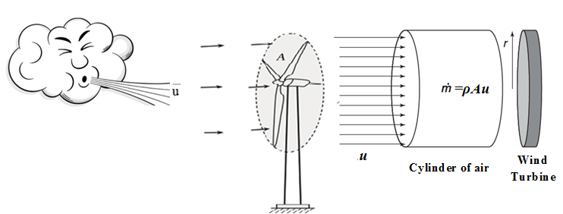
Fig.4-3: Swept area of wind turbine blades
4- 4-1 Blade swept area:
As shown in Fig. 4-3, the blade swept area can be calculated from the formula:
$A=π$ [(l +r)² – r²] = $πl$ [(l +2r) ------4-5
where l is the length of wind blades and r is the radius of the hub. Thus, by doubling the length of wind blades, the swept area can be increased by the factor up to 4. When l$≫2r$ ,$A≫πl$².

4-5 Wind Power Density (WPD)
Wind power density is a comprehensive index in evaluating the wind resource at a particular site. It is the available wind power in airflow through a perpendicular cross-sectional unit area in a unit time period.
In eq. 4-4 if we divide P_{w} by the cross-sectional area (A) of the parcel, then we get the expression:
$\frac{P_{w}}{A}$ = $\frac{1}{2}$ ρ u³ -----------------------------4-6
Note, two important things about this expression: one is that the power is proportional to the cube of the wind speed. The other is that by dividing power by the area, we have an expression on the right that is independent of the size of a wind turbines rotor. In other words, P_{w}/A only depends on (1) the density of the air and (2) the wind speed. In fact, there is no dependence on size, efficiency or other characteristics of wind turbines when determining P_{w} /A.
The term for the quotient Pw/A is called the "Wind Power Density" (WPD) and has units of watts/m².
(WPD) = $\frac{1}{2}$ ρ u³ ----------------------4-6*
Note: that the expression (4-6) for WPD is a simplification because we made the tacit assumption that the wind blew with speed (u) all the time. In reality, varying winds mean we must work a little harder to find the true WPD. To get the most accurate estimate for Wind Power Density, one must actually perform a summation using data taken over time, as follows
_{n}
WPD = 0.5 1/n Σ (ρ_{j} u³_{j}) -------------4-7
_{j=1}
where n: is the number of wind speed readings and ρ_{j} and u_{j} are the j^{th} (1st, 2nd, 3rd, etc.) readings of the air density and wind speed.
Since air density ρ and wind speed u will change with every data reading, the most accurate result would entail a calculation for every data interval. For example, to calculate the best possible value for WPD for a weather station location for a year, one would need to perform calculations for ρ and u for 105,120 data intervals! (288 observations per day times 365 days per year). Clearly this must involve running computer programs.
Fortunately, there are two ways to get reasonable estimates for WPD without doing all the calculations described above.

Method 1.
The best way to approximate WPD uses the results of a wind speed frequency distribution (this is like a histogram - a sample table of wind speed frequency occurrence). Using such distribution information, the following summation can be applied:
_{n}
WPD = 0.5 Σ [ ρ (median u³ in class j) (frequency of occurrence in class j)] -----4-8
_{j=1}
If one uses a value for air density that does not change over time, then air density can come out of the expression to give:
_{n}
WPD = 0.5 ρ Σ [(median u³ in class j) (frequency of occurrence in class j)] -------4-9
_{j=1}
Method 2. we will focus on a simpler method by which you can estimate the WPD in your area of interest. If one makes an assumption about how wind speeds are distributed in the wind speed frequency diagram, one can approximate WPD with the following:
WPD = 0.5 K ρ (mean wind speed)³ -----------------------4-10
Where, K = a value determined by the shape of the distribution pattern that the wind speeds follow.
For example, some wind speed frequency patterns follow a "Rayleigh" distribution, which looks like the figure to the right. For some wind speed distributions, K will have the value 1.91. Inserting that into the expression above gives:
WPD = 0.955 ρ (mean wind speed)³ ------------------------4-11
Now, all that is needed is knowledge of your nearest weather station's mean wind speed and your elevation (to use method 2. for estimating air density) and you can find a reasonable estimate for WPD in your area.
4-6 Determining "Wind Classes"
Areas are often described by their "wind class" ranking, rather than their range of Wind Power Densities or mean wind speeds. Below is a table that shows the ranges of WPD and associated classes, at 10 meters height above ground (a typical wind speed measurement height and small turbine height) and at 50 meters (the industry standard level for WPD determinations for large wind turbines). Note that it also gives the ranges of mean wind speed for each class.

Table 1. classes of wind power density at two standard wind measurement
10 m and 50 m heights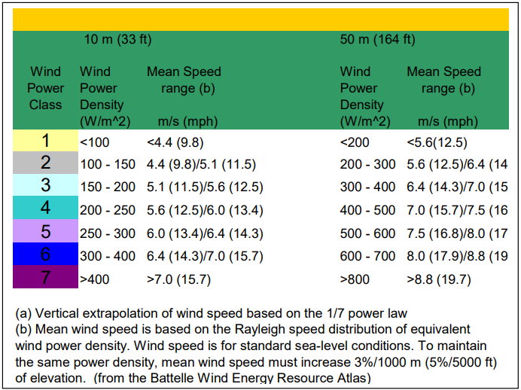

Exercises
- Imagine that you have just 2 readings of wind speed: 5 m/s and 15 m/s. Calculate the WPD over the interval of these readings (assume ρ = 1.0 kg/m3 to make the math easier).
- Calculate the mean of the two readings given in exercise 1, plug that value into expression (4-6), and compare to your answer above to see the error in WPD that would result.
- Let's say you are interested in buying and installing a small wind turbine, and that you live near the station (CHEY). But first you want to get some idea of the WPD (at 10 meters). Given that CHEY's elevation is 692 m. and its long term mean wind speed (at 10 meters) is 5.8 m/s, estimate the WPD in that area (assume a Rayleigh distribution for the winds, with K=1.91). What wind class does this represent?
- For a wind turbine with rotor diameter 43 meters (a typical size for a 600-kW turbine), calculate the volume and mass of a 1-meter thick parcel of air passing through the plane of the turbine blades (for this exercise, assume a value for the air density of 1.225 kg/m³).
- Assume there is a wind blowing with a constant velocity V of 10.0 m/s through the blades of the turbine described in no. 1. What is the wind power density? (again, assume ρ = 1.225 kg/m³)
- A smaller wind turbine which produces about 50kW has a blade rotor radius of 7 m. (14 m. diameter). Calculate WPD for this wind turbine, assuming the same conditions as given in Exercises 4 and 5.

