Lec.8 Bioseparation Technique
Gel electrophoresis
Gel electrophoresis is a technique used to separate and analysis ofmacromolecules(DNA, RNA and proteins) and their fragments based on their size and charge. It is used to separate proteins by charge and/or molecular weight and to separate a mixed population of DNA and RNA fragments by length, to estimate the size of DNA and RNA fragments. Macromolecules are separated by applying an electric field to move the negatively charged molecules through a matrix ,shorter molecules move faster and migrate farther than longer ones because shorter molecules migrate more easily through the pores of the matrix, this phenomenon is called sieving. Proteins are separated by charge in matrix because the pores of the gel are too large to sieve proteins, gel electrophoresis can also be used for separation of nanoparticles. Electrophoresis involves running a current through a gel (matrix) containing the molecules of interest,based on their size and charge, the molecules will travel through the gel in different directions or at different speeds, allowing them to be separated from one another.
Gel electrophoresis uses a gel sieving medium during electrophoresis, the movement of a charged particle in an electrical field, gels suppress the thermal convection caused by application of the electric field, and can also act as a sieving medium, retarding the passage of molecules. DNA gel electrophoresis is usually performed for analytical purposes, often after amplification of DNA via polymerase chain reaction (PCR), and may be used as a preparative technique prior to use of other methods such as mass spectrometry, PCR, cloning, DNA sequencing.
Protein Electrophoresis:
Sodium Dodecyl Sulphate Polyacrylamide Gel Electrophoresis (SDS-PAGE) separate proteins, typically, gels made from polyacrylamide are used to separate proteins on the basis their different sizes (Molecular Weight). Usually, the proteins are first treated with heat and a chemical called Sodium Dodecyl Sulphate (SDS) in order to unravel the protein. SDS is a detergent that gives all the proteins the same overall negative charge so that when an electric current is applied to the gel, separation is only due to the Molecular Weight of the protein. This technique is called SDS-PAGE (SDS-Polyacrylamide gel electrophoresis).Small protein molecules move more quickly through the gel than larger proteins, resulting in a series of ‘bands’,each band contains a protein of a particular Molecular Weight,these can be compared with standards of known sizes, the first lane contains markers of known Molecular Weights,large molecular proteins are at the top of the gel and small proteins are at the bottom. This technique might be used for many purposes, including purifying a particular protein, for example to isolate an enzyme for the food industry.
SDS-PAGE separates proteins according to molecular weight,proteins load with the anionic detergent SDS; due to presence of SDS; the hydrogen bonds and folding of the tertiary and secondary structures are disrupted anddisulfide bonds between cysteine residues in proteins can be cleaved by a β-mercaptoethanol. Since the fractions are uniformly negatively charged, they all migrate in one direction, towards the anode. The separation is based on one physio-chemical parameter (M.Wt.);it is an easy method for molecular weight determination.
In simple terms, electrophoresis is a process which enables the sorting of molecules based on molecular weight by charge. Using an electric field, molecules can be made to move through a gel made of agarose or polyacrylamide. The electric field consists of a negative charge at one end which pushes the molecules through the gel, and a positive charge at the other end that pulls the molecules through the gel. The molecules being sorted are dispensed into a well in the gel material. The gel is placed in an electrophoresis chamber, which is then connected to a power supply. When the electric current is applied, the larger molecules move more slowly through the gel while the smaller molecules move faster,the different sized molecules form distinct bands on the gel. Molecules that have different charges and therefore will attract the molecules according to their charges being the opposite, molecules that are positively charged will migrate towards the cathode which is negatively charged,if the molecules are negatively charged they will migrate towards the positively charged anode. If several samples have been loaded into adjacent wells in the gel, they will run parallel in individual lanes. Depending on the number of different molecules, each lane shows separation of the components from the original mixture as one or more distinct bands. Electrophoresis is performed in buffer solutions to reduce pH changes due to the electric field, which is important because the charge of DNA and RNA depends on pH. Proteins therefore, are usually denatured in the presence of a detergent such as sodium dodecyl sulfate (SDS) that coats the proteins with a negative charge, so that the resulting denatured proteins have an overall negative charge, and all the proteins have a similar charge. The rate at which the resulting SDS coated proteins migrate in the gel is relative only to its size and not its charge.
The matrix:
The matrix used to contain, and then separate the target molecules. In most cases, the gel is a crosslinked polymer whose composition and porosity is chosen based on the specific weight and composition of the target molecules to be analyzed. When separating proteins ,DNA, RNA, or oligonucleotides, the gel is usually composed of different concentrations of acrylamide and a cross-linker, producing different sized mesh networks of polyacrylamide. When separating larger nucleic acids, the preferred matrix is purified agarose. In both cases, the gel forms a solid, yet porous matrix. Acrylamide, in contrast to polyacrylamide, is a neurotoxin and must be handled using appropriate safety precautions to avoid poisoning. Agarose is composed of long unbranched chains of uncharged carbohydrate without cross links resulting in a gel with large pores allowing for the separation of macromolecules and macromolecular complexes.
Types of gel:
The types of gel most typically used are agarose and polyacrylamide gels;each type of gel is well-suited to different types and sizes of analyte.
Agarose gels:
Agarose gels which are made from the natural polysaccharide polymers extracted from seaweed have lower resolving power for DNA but have greater range of separation, Agarose gel electrophoresis can be used for the separation of DNA fragments ranging from 50 base pair to several megabases . Agarose gels do not have a uniform pore size, but are optimal for electrophoresis of proteins that are larger than 200 kDa. . Most modern DNA separation methods now use agarose gels, except for particularly small DNA fragments. Gel electrophoresis of large DNA or RNA is usually done by agarose gel electrophoresis.Agarose gels are typically run horizontally in a submarine mode.
Polyacrylamide gels:
Polyacrylamide gel electrophoresis (PAGE) is used for separating proteins ranging in size from 5 to 2,000 kDa due to the uniform pore size provided by the polyacrylamide gel. Pore size is controlled by modulating the concentrations of acrylamide and bis-acrylamide powder used in creating a gel, also Polyacrylamide gel have very high resolving power for small fragments of DNA (5-500 base pair). Polyacrylamide gels are run in a vertical configuration.

Gel conditions:
Proteins are denatured using sodium dodecyl sulfate, usually as part of the SDS-PAGE process. For full denaturation of proteins, it is also necessary to reduce the covalent disulfide bonds that stabilize their tertiary and quaternary structure, reducing conditions are usually maintained by the addition of β-mercaptoethanol.
Buffers:
Buffers in gel electrophoresis are used to provide ions that carry a current and to maintain the pH at a relatively constant value. These buffers have plenty of ions in them, which is necessary for the passage of electricity through them.
After the electrophoresis is complete, the molecules in the gel can be stained to make them visible. DNA may be visualized using ethidium bromide , fluoresce under ultraviolet light, while protein may be visualised using Coomassie Brilliant Blue dye.
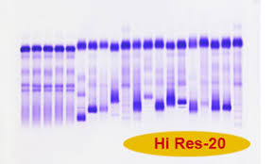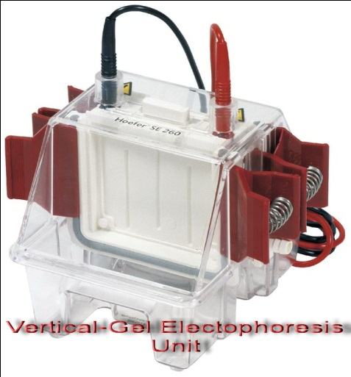
After separation, the gel will then be physically cut, and the protein complexes extracted from each portion separately,each extract may then be analyzed, this can provide a great deal of information about the proteins in a complex.
Applications:
- Estimation of the size of DNA molecules following restriction enzyme #
- Analysis of PCR products. #
# Separation of restricted genomic DNA.
# Gel electrophoresis is used in forensics, molecular biology, genetics, microbiology and biochemistry.

