5- Aviation Weather Hazards
1- Wind Shear and Its Impact on Flight
For business aircraft operators, wind shear has the potential to cause flight turbulence and sudden increases/decreases in both ground and air speed, as well as other associated violent air movements. It’s always best to talk with your aviation meteorologist to confirm the potential impact of any expected wind shear for your trip.
1. Importance of wind shear
Wind shear is important as it can affect the safety of your flight. In the upper atmosphere, the main concern is turbulence, while at lower altitudes – particularly during landing/takeoff – the primary consideration is the avoidance of accidents caused by increases in wind shear.
2. Defining wind shear
Wind shear: A variation in wind speed and direction or both. Over a relatively short distance in the atmosphere is also known, as "wind gradient." Wind shear refers to variations in wind over either horizontal or vertical distances or both. Turbulence may also be associated with wind shear, and this is an additional hazard.
4. Where this occurs:
Wind shear conditions can occur at low or high altitudes – anywhere there is wind. Horizontal wind shear is most frequently experienced, when: crossing fronts or flying near mountainous areas. Vertical wind shear can be experienced anywhere from the surface to upper Flight Levels (FLs) – particularly with associated thunderstorm conditions. The most dangerous conditions are when flying at lower levels, due to proximity of the surface and potential for accidents. At higher altitudes, the negative effects of wind shear are mostly related to turbulence.
5. Measuring wind shear
Wind shear is always measured in knots, with the values being either positive or negative. Increases in wind shear value are positive numbers, while decreases are noted as negative values. When operating in the upper atmosphere, wind shear value is almost always positive. Closer to the surface, you may experience negative wind shear values.
TURBULENCE AND WINDSHEAR
- Wind shear can be defined as: ‘layers or columns of air, flowing with different velocities (i.e., speed and/or direction) to adjacent layers or columns’. Wind shear is a major hazard for aviation especially when operating at low levels.
- Even when flying within a layer with a laminar flow and the flight is smooth and uneventful, the sudden crossing of the boundaries between different laminar streams will accelerate the aircraft to a greater or lesser degree.
- Depending on the flight direction relative to the velocity changes, shear may be felt as turbulence, but also as a sudden tail or head wind with respective consequences
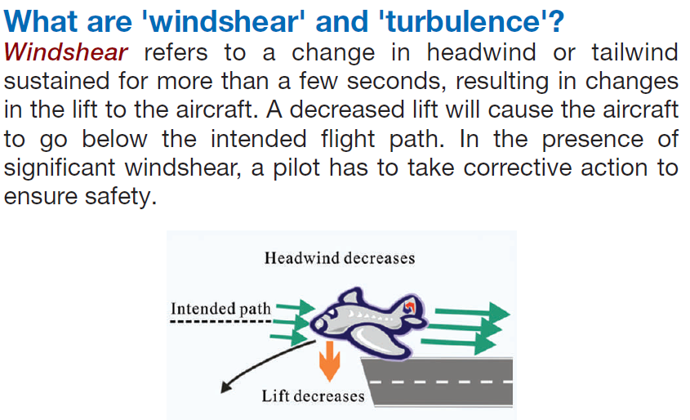

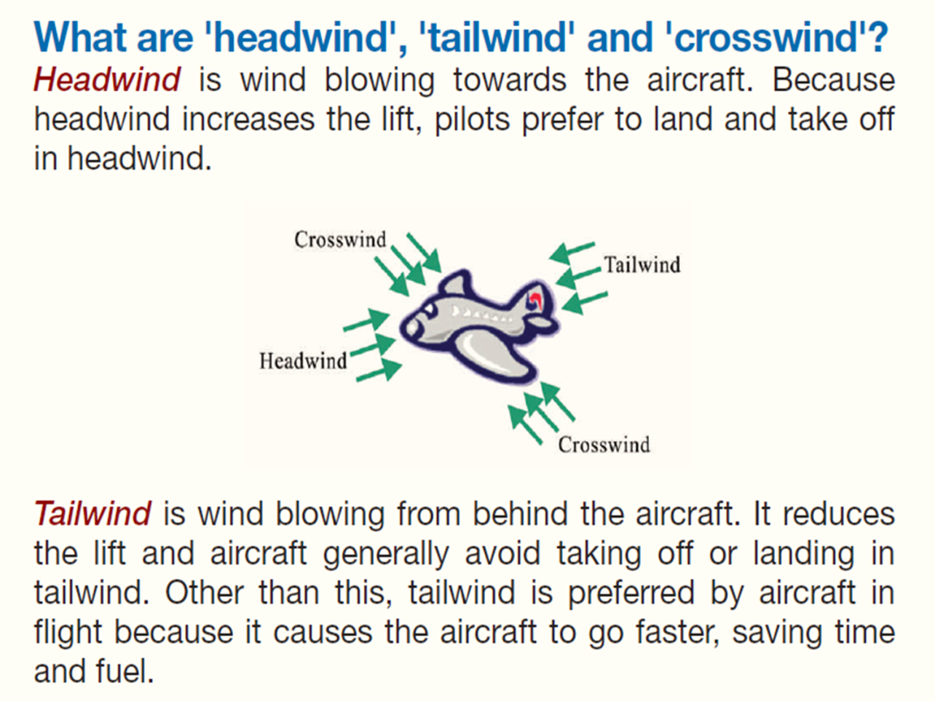

Crosswind
Is the wind blowing from the side of the aircraft. Large changes in crosswind during landing might cause an aircraft to deviate from the runway centerline.
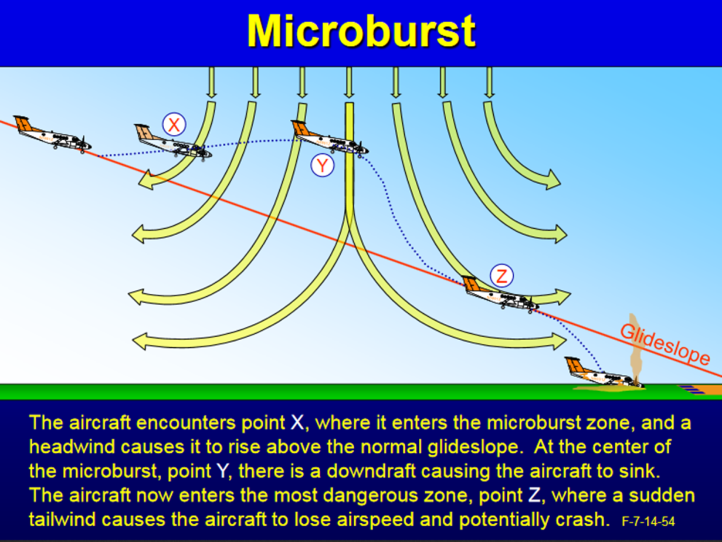
The Relationship Between Wind Shear and Turbulence:
Turbulence is the direct result of wind shear.
The stronger the shear the greater the tendency for the laminar flow of the air to break down into eddies resulting in turbulence. However, not all shear zones are turbulent, so the absence of turbulence does not infer that there is no shear.

