1- Weight and Lift
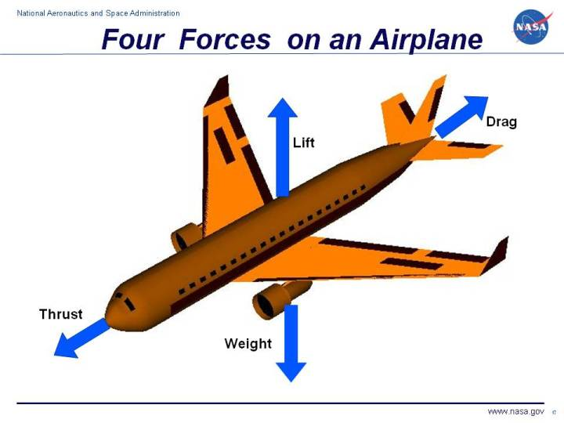
A force may be thought of as a push or pull in a specific direction. A force is a vector quantity so a force has both a magnitude and a direction. When describing forces, we have to specify both the magnitude and the direction. This slide shows the forces that act on an airplane in flight.
1-Weight
Weight is a force that is always directed toward the center of the earth. The magnitude of the weight depends on the mass of all the airplane parts, plus the amount of fuel, plus any payload on board (people, baggage, freight, etc.). The weight is distributed throughout the airplane. But we can often think of it as collected and acting through a single point called the center of gravity. In flight, the airplane rotates about the center of gravity.
Flying encompasses two major problems; overcoming the weight of an object by some opposing force, and controlling the object in flight. Both of these problems are related to the object's weight and the location of the center of gravity. During a flight, an airplane's weight constantly changes as the aircraft consumes fuel. The distribution of the weight and the center of gravity also changes. So the pilot must constantly adjust the controls to keep the airplane balanced, or trimmed. The dream remains that, if we could really understand gravity, we could create anti-gravity devices which would revolutionize travel through the sky. Unfortunately, anti-gravity devices only exist in science fiction.

Weight is the force generated by the gravitational attraction of the earth on the airplane. We are more familiar with weight than with the other forces acting on an airplane, because each of us have our own weight which we can measure every morning on the bathroom scale. We know when one thing is heavy and when another thing is light. But weight, the gravitational force, is fundamentally different from the aerodynamic forces, lift and drag . Aerodynamic forces are mechanical forces and the airplane has to be in physical contact with the air, which generates the force. The gravitational force is a field force; the source of the force does not have to be in physical contact with the object to generate a pull on the object.
Newton developed his theory of gravitation when he was only 23 years old and published the theories with his laws of motion some years later. The gravitational force between two objects depends on the mass of the objects and the inverse of the square of the distance between the objects. Larger objects create greater forces and the farther apart the objects are the weaker the attraction. Newton was able to express the relationship in a single weight equation.
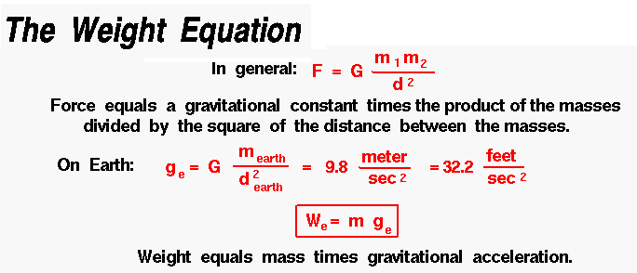
2-Lift
To overcome the weight force, airplanes generate an opposing force called lift. Lift is generated by the motion of the airplane through the air and is an aerodynamic force. "Aero" stands for the air, and "dynamic" denotes motion. Lift is directed perpendicular to the flight direction. The magnitude of the lift depends on several factors including the shape, size, and velocity of the aircraft. As with weight, each part of the aircraft contributes to the aircraft lift force. Most of the lift is generated by the wings. Aircraft lift acts through a single point called the center of pressure. The center of pressure is defined just like the center of gravity, but using the pressure distribution around the body instead of the weight distribution.
Lift is the force that directly opposes the weight of an airplane and holds the airplane in the air. Lift is generated by every part of the airplane, but most of the lift on a normal airliner is generated by the wings. Lift is a mechanical aerodynamic force produced by the motion of the airplane through the air. Because lift is a force, it is a vector quantity, having both a magnitude and a direction associated with it. Lift acts through the center of pressure of the object and is directed perpendicular to the flow direction. There are several factors , which affect the magnitude of lift.
HOW IS LIFT GENERATED? Lift occurs when a moving flow of gas is turned by a solid object. The flow is turned in one direction, and the lift is generated in the opposite direction, according to Newton's Third Law of action and reaction. Because air is a gas and the molecules are free to move about, any solid surface can deflect a flow. For an aircraft wing, both the upper and lower surfaces contribute to the flow turning. Neglecting the upper surface's part in turning the flow leads to an incorrect theory of lift.
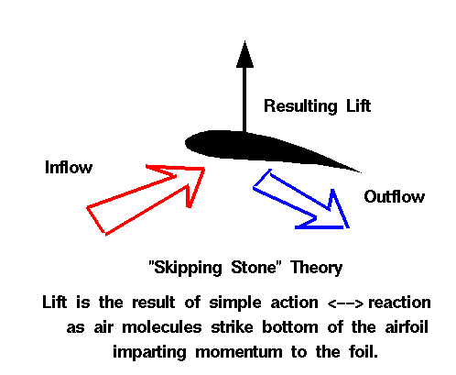
NO FLUID, NO LIFT
Lift is a mechanical force. It is generated by the interaction and contact of a solid body with a fluid (liquid or gas). It is not generated by a force field, in the sense of a gravitational field ,or an electromagnetic field, where one object can affect another object without being in physical contact. For lift to be generated, the solid body must be in contact with the fluid: no fluid, no lift. The Space Shuttle does not stay in space because of lift from its wings but because of orbital mechanics related to its speed. Space is nearly a vacuum. Without air, there is no lift generated by the wings.

NO MOTION, NO LIFT
Lift is generated by the difference in velocity between the solid object and the fluid. There must be motion between the object and the fluid: no motion, no lift. It makes no difference whether the object moves through a static fluid, or the fluid moves past a static solid object. Lift acts perpendicular to the motion. Drag acts in the direction opposed to the motion.
Q1) A- what are the forces affecting the plane, explain in detail one of them?
Q2) A- how is lift generated? With theories?
Q3)What Factors affecting lift? Explain one of them.

