2- lift Equation
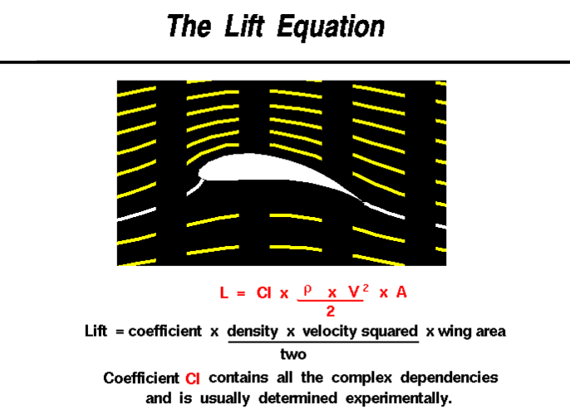
Lift depends on the density of the air, the square of the velocity, the air's viscosity and compressibility, the surface area over which the air flows, the shape of the body, and the body's inclination to the flow . In general, the dependence on body shape, inclination, air viscosity, and compressibility is very complex.
One way to deal with complex dependencies is to characterize the dependence by a single variable. For lift, this variable is called the lift coefficient, designated "Cl." This allows us to collect all the effects, simple and complex, into a single equation. The lift equation states that lift L is equal to the lift coefficient Cl times the density ρ times half of the velocity V squared times the wing area A.
L = Cl x A x 0.5 x ρ x V ²
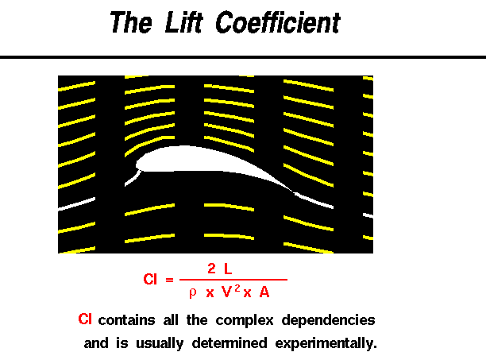
The lift coefficient is a number that aerodynamicists use to model all of the complex dependencies of shape, inclination, and some flow conditions on lift. This equation is simply a rearrangement of the lift equation where we solve for the lift coefficient in terms of the other variables. The lift coefficient Cl is equal to the lift L divided by the quantity: density ρ times half the velocity V squared times the wing area A.
Cl = L / (A x 0 .5 x ρ x V ²)
The quantity one half the density times the velocity squared is called the dynamic pressure q. So
Cl = L / (q x A)
The lift coefficient then expresses the ratio of the lift force to the force produced by the dynamic pressure times the area.
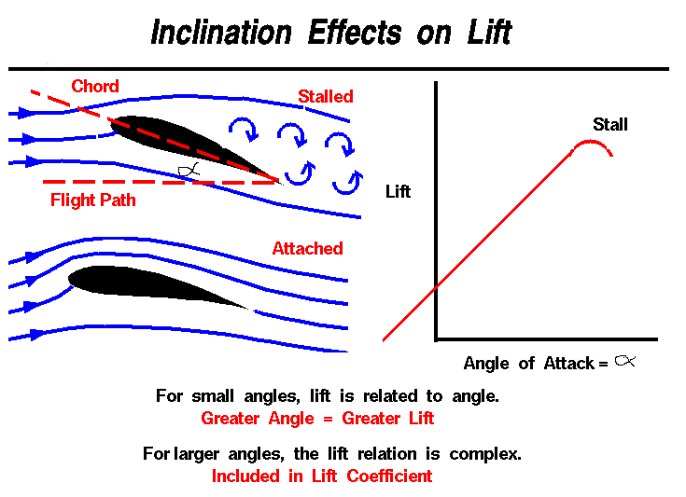

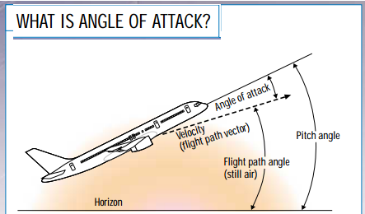

As a wing moves through the air, the wing is inclined to the flight direction at some angle. The angle between the chord line and the flight direction called the angle of attack and has a large effect on the lift generated by a wing. When an airplane takes off, the pilot applies as much thrust as possible to make the airplane roll along the runway. However, just before lifting off, the pilot "rotates" the aircraft. The nose of the airplane rises, increasing the angle of attack and producing the increased lift needed for takeoff.
The magnitude of the lift generated by an object depends on the shape of the object, and how it moves through the air. For thin airfoils, the lift is directly proportional to the angle of attack for small angles (within +/- 10 degrees). For higher angles, however, the dependence is quite complex.
As an object moves through the air, air molecules stick to the surface. This creates a layer of air near the surface called a boundary layer that, in effect, changes the shape of the object. The flow turning reacts to the edge of the boundary layer just as it would to the physical surface of the object. To make things more confusing, the boundary layer may lift off or "separate" from the body and create an effective shape much different from the physical shape. The separation of the boundary layer explains why aircraft wings will abruptly lose lift at high angles to the flow. This condition called a wing stall.
The distribution of lift around the aircraft is important for solving the control problem. Aerodynamic surfaces used to control the aircraft in roll, pitch, and yaw.
WHAT FACTORS AFFECTING LIFT?
The size and shape of the wing, the angle at which it meets the oncoming air, the speed at which it moves through the air, even the density of the air, all affect the amount of lift a wing creates. Let us begin with the shape of a wing intended for subsonic flight.
WHY DOES A WING HAVE A ROUNDED FRONT?
Air divides smoothly around a wing’s rounded leading edge, and flows neatly off its tapered trailing edge. You might think a sharp leading edge would be better. However, air cannot turn a sharp corner, so tilting a sharp wing even slightly would disrupt the smooth airflow over the wing. This would cause a loss of lift and increase drag. A rounded leading edge divides the airflow smoothly, even as the wing tilted up or down.
WHY DOES A WING HAVE A SHARP REAR EDGE?
If the trailing edge rounded, the higher-pressure air flowing along the lower side would try to follow the rounded surface and spill upward into the lower-pressure air above the wing. A sharp trailing edge prevents this upward spill, because air cannot make a sharp turn. Instead, the air flowing off the top and bottom surfaces rejoins smoothly.
HOW DOES TILTING A WING AFFECT THE AIR FLOWING OVER IT?
Tilting the wing upward increases lift—to a point. If you tilt it too much, the airflow pulls away from the upper surface, and the smooth flow turns turbulent. The wing suddenly loses lift, a condition known as a stall. You can reestablish a smooth airflow by tilting the wing back to a more level position.
Q) Why dose awing have around front and sharp rear edge

