Lab // 7
Mammalia

Phylum: Chordate
Subphylum: Vertebrata
Superclass: Tetrapoda
Class: Mammalia
Subclass: Eutheria
Order: Lagomorpha
Genus: Rabbits

Rabbits are small mammals found in several parts of the world. Skin is covered thickly with hairs. The body is divided into head, neck, trunk and tail. Trunk is further divided into thorax and abdomen. Hind limbs and fore limbs are present in the trunk. The fore limb has5 clawed fingers and the hind limb has 4 fingers with claws. In between upper lip and nostrils hair like vibrissae are present. The upper lip has a gap and the teeth can be seen from this gap. He has large eyes that are located on the sides and upper part of the head, enabling each eye to see more than one half of a circle. Together, they can see in every direction. The nose of the rabbit is relatively small, but the sense of smell is quite good. Rabbit ears are long can be moved to any direction. Hearing is a the most vital sense within the rabbit anatomy The shape of a rabbits ears allow them to pick up sounds over 2 miles away.
The rabbit has taste buds situated in the mouth and pharynx.
Female has 2-5 pairs of nipples of mammary glands are present in ventral thorax, no nipples in the male. Urethra opens to the floor of the genital tract.

Digestive system
The first part of a rabbit's digestive system is the mouth. The mouth is terminal and relatively small , bounded by two movable lips. The rabbit uses its lips to grab food and pass it back to the teeth to cut and crush the plant material.
***Mouth leads into a large cavity called Bucco - pharyngeal cavity. There is a partition or barrier separating buccal cavity and nasal cavity, it is called palate. **The anterior half of the palate is called hard palate, while the posterior half is smooth and fleshy and is called soft palate.
**Tongue is situated on the floor of the mouth. It is a muscular organ and helps mixing the food with saliva. There are three kinds of papillae, which are small projections, on which taste-buds are situated.
** The teeth of the rabbit are very well adapted to its normal foods. The teeth consist of two pairs of incisors (or cutting 'teeth) on the upper jaw and one pair on the lower. In mouth several kinds of mucus and salivary glands are present, these are:
- *Sub orbital gland: situated below the eye.
- *Parotids are at the base of external ears.
- *Sub lingual glands are situated under the tongue.
- *Submaxillary glands lie on the inner side of the angles of lower jaws.
Esophagus
Once food is swallowed, it passes through the esophagus. It is a long, narrow straight muscular tube that transfers food from the mouth to the stomach. The opening of the oesophagus into the stomach is provided with a valve called cardiac valve.
Stomach
It is a large, curved sac lying behind the diaphragm. The stomach of the rabbit consists of two parts. 1-The larger left part called cardiac and the smaller right part is called pyloric. Once food is in the stomach, it begins to be broken down through hydrolytic and enzymatic digestion.
Small intestine
*The passes into the small intestine from the stomach is regulated by the pyloric sphincter.
*The small intestine is the place where the majority of digestion and absorption of nutrients occurs.
* The small intestine can be divided into three sections –1- duodenum,2- jejunum, and 3-ileum.
*In duodenum a variety of enzymes are secreted into the small intestine to break down the food.
* Bile is carried into the duodenum by a large bile duct, which is formed by gallbladder from the liver.
* Pancreas also produce an alkaline secretion called pancreatic juice whicn is poured into the duodenum by the pancreatic duct.
** The jejunum is the middle section of the small intestine. Many nutrients, are absorbed here.
The last section is the ileum. The internal lining of the ileum is raised into numerous finger like projections called villi, which increase the absorptive surface.
Cecum
***The cecum is a blind sac located at the junction of the small and large intestines. The cecum may be the most important part of the digestive system of the rabbit. Visible on the external surface is a spiral constriction around the caecum. This is related to the folding of the mucosa internally. There is an appendix at its distal end containing lymphoid tissue.

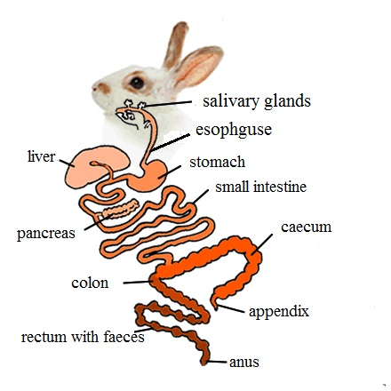
Large intestine
It proceeds from the caecum and consists of two parts: a proximal colon, which is a wide tube. Second part is distal, narrow rectum, long having beaded appearance due to the presence of faeces and opens to the outside through the anus.
Anus
It is situated on the underside of the tail and is provided with a sphincter muscle.

Respiratory system
The respiratory organs in rabbit are a pair of lungs. The respiratory system starts with a pair of external nostrils present at the anterior end of the snout. The nostrils open into nasal passage that is situated above the buccal cavity.
The nasal passage is separated from the buccal cavity by a palate. The nasal passage opens posteriorly into the pharynx by internal nostrils. The pharynx in rabbit has two openings namely the gullet and the glottis.
The gullet leads into oesophagus while the glottis leads into the trachea. The glottis is guarded by a cartilaginous flap like structure called Epiglottis. The epiglottis prevents the entry of food into trachea by closing the glottis. The anterior part of trachea consists of larynx or voice box. The larynx opens into trachea that runs along the length of neck, ventral to the oesophagus. The trachea enters into the thoracic cavity and divided into two branches called Bronchi. Each bronchus enters into the lung of its side. The bronchus is further divided into small branches called bronchioles within the lung. Each bronchiole divides into number of alveolar ducts. The alveolar ducts closed to form air sacs which contain many alveoli. The alveoli are highly vascularised with blood capillaries.
The lungs in rabbit are spongy pinkish bags, lying in thoracic cavity. The left lung consists of two lobes; the right lung consists of four lobes. Inside each lung the bronchiole ends in a cluster of air sacs or alveoli. Gaseous exchange occurs within the alveoli.
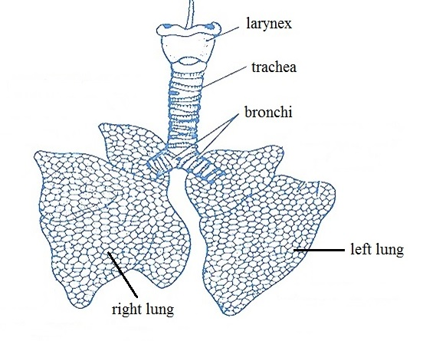

Excretory system
The kidneys are two dark red bodies present on either side of vertebral column. The kidney of the right side is placed slightly anterior than the left kidney. Each kidney is bean-shaped with a median notch or groove called hilus on the inner side. An elongated ureter originates from the hilus that runs posterioly and opens into urinary bladder. The urinary bladder in female rabbit opens into urinogenital canal which opens out by vulva. The urinary bladder in male opens into urethra present in penis. The urinogenital canal both in male and female transmits the germ cells and urine Rabbit urine always contains a certain amount of sediments. This is absolutely normal, the system of rabbits works this way to excrete the too much of calcium in their body.
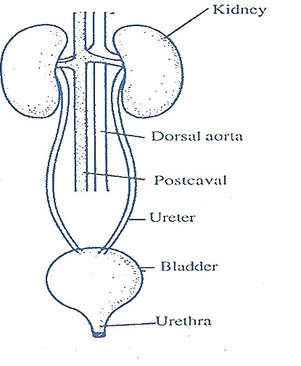

Reproductive system
The male reproductive system consists of paired of testes, testes are small, ovoid bodies. Each testes lies in a special thin-walled sac outside the abdominal cavity, called the scrotum. The epididymis is an irregular, narrow and highly convoluted tubule of great length. It forms a compact ridge - like mass all along the inner surface of the testis. The basal end of epididymis leads into a yellowish-white, straight, and muscular tube, the sperm duct or vas deferens. It runs forward along the inner side of the scrotal sac, to enter the abdominal cavity.
It loops ventrally under the ureter and opens dorsally into urethra immediately in front of the opening of the ureter. The neck of the urinary bladder and the vasa deferentia open into a thick-walled muscular duct, the urethra. Urethra is the common passage for both urine and semen and called the urinogenital duct. It traverses and opens at the tip of the penis as the male urinogenital opening.

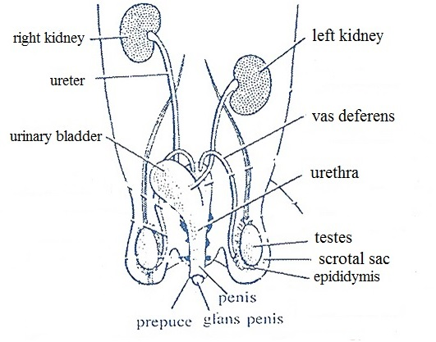
The female reproductive organs include a pair of ovaries, a pair of oviducts, a pair of uteri, vagina. The two ovaries are small, whitish, oval bodies. They are found behind the kidneys, each ovary attached to the dorsal abdominal wall by a double fold of peritoneum called mesovarium. From the surface of ovaries project several small, rounded, semitransparent projections, called ovarian or Graafian follicles, each containing a developing ovum. Each oviduct opens anteriorly, close to the ovary of its side, by a wide
funnel called fallopian or oviducal funnel. The opening of funnel is provided with many cilia to receive the minute ova released from the ovary.
Funnel leads into the upper part of oviduct. It is a short, narrow, coiled and internally ciliated duct called fallopian tube. Ova pass through this tube by ciliary action and fertilization also occurs here. The fallopian tube is followed by a much wider, longer convoluted, thick walled muscular tube the uterus. Fertilized ova get fixed on the uterine wall to develop into embryos. The uterus of both the sides meet into a long wide, median duct, the vagina, lying behind the urinary bladder. It opens posteriorly into the neck of bladder to join the urethra forming a short narrow common urinogenital canal It runs backwards ventral to the rectum and opens out by a slit-like opening, the vulva.
