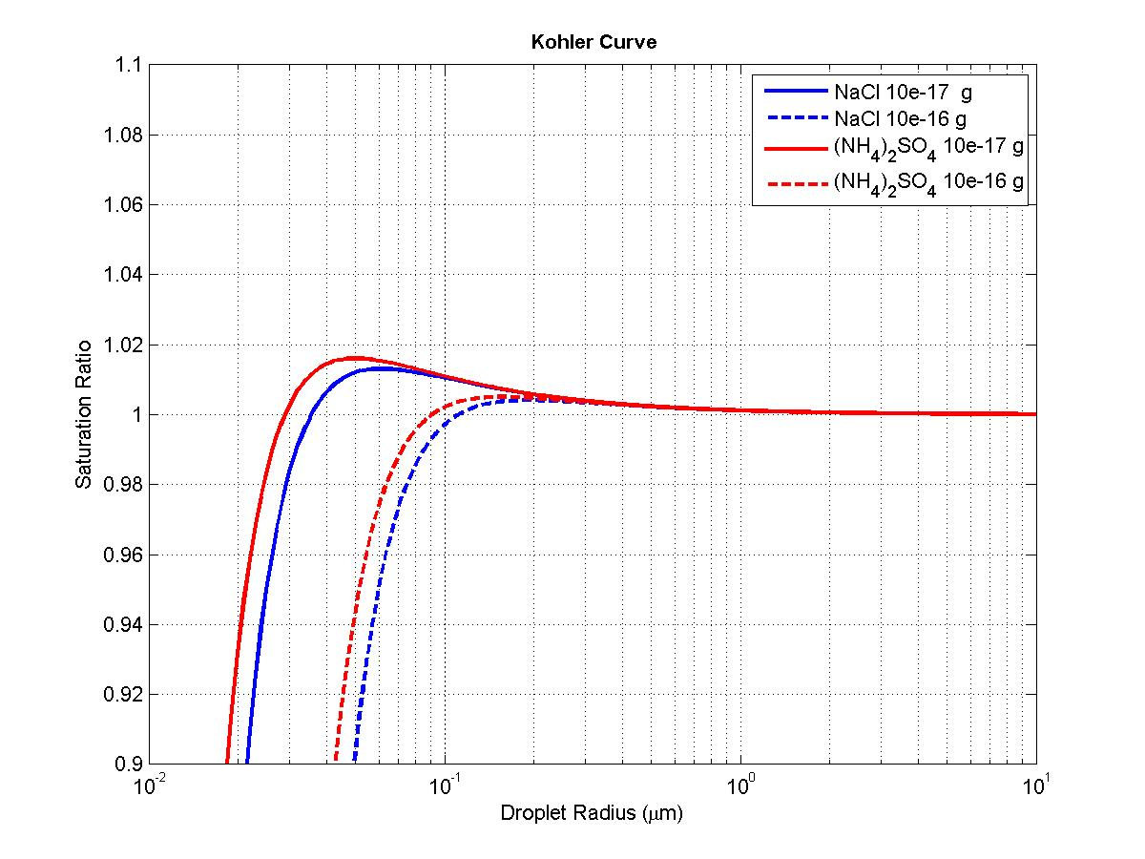

Solute | Mass (g) | C. Radius (um) | C. SS
NaCl | 1.00E-17 | 0.0609 | 1.013
NaCl | 1.00E-16 | 0.1926 | 1.0041
NH4)2(SO4) | 1.00E-17 | 0.0496 | 1.016
NH4)2(SO4) | 1.00E-16 | 0.1569 | 1.0051

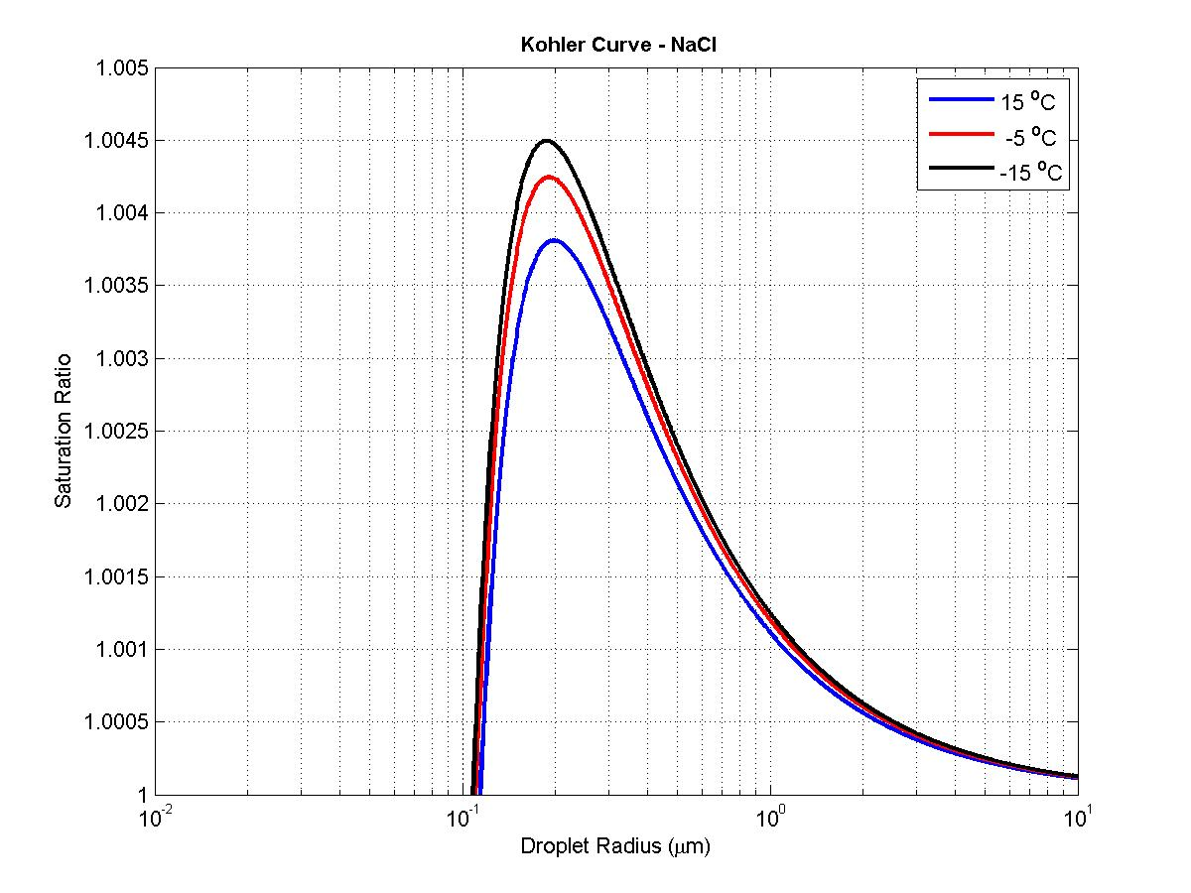

Solute | Temp (C) | C. Radius (um) | C. SS
NaCl | 15 | 0.1978 | 1.0038
NaCl | -5 | 0.1908 | 1.0042
NaCl | -15 | 0.1872 | 1.0045

