Plant genetic engineering Lab (seven) : Gene Sequencing

DNA sequencing is the process of determining the precise order of nucleotides within a DNA molecule. It includes any method or technology that is used to determine the order of the four bases—adenine, guanine, cytosine, and thymine—in a strand of DNA.

Methods of sequencing

1- Maxam-Gilbert chemical cleavage method: DNA is labelled and then chemically cleaved in a sequence-dependent manner. This method is not easily scaled and is rather tedious

2- Sanger dideoxy (primer extension/chain-termination) method: most popular protocol for sequencing, very adaptable, scalable to large sequencing projects, The chain terminator method is more efficient and uses fewer toxic chemicals and lower amount of radioactivity than the method of Maxam and Gilbert

For Sanger dideoxy sequencing you need:

1- Single stranded DNA template

2- A primer for DNA synthesis

3- DNA polymerase

4- radioactively or fluorescently labelled (containing radioactive phosphorus for labelling) Deoxynucleotide triphosphates (dATP, dGTP, dCTP, dTTP). And dideoxynucleotide triphosphates, lacks a hydroxyl group at 3 carbon (ddATP, ddGTP, ddCTP, or ddTTP) figure(1).

1

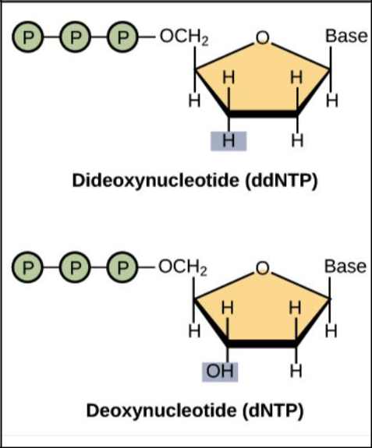

Figure(1) the difference in structure between (dNTP) &(ddNTP)

DNA polymerases that uses in sequencing should be characterized with:

1- Should be highly processive, and incorporate ddNTPs efficiently

2- Should lack exonuclease activity

3- Thermostability required for “cycle sequencing”

Sanger DNA Sequencing method:

Procedure:

1-Firstly, the DNA to be sequenced has to be amplified

2-heat is then used to denaturate the DNA to produce a complementary strand and the template strand for DNA sequencing

3-a primer is then annealed to 5 prime end of template DNA

4-the primed DNA is then dispersed equally among four reaction vessels

5-next, DNA polymerase and four dNTPs are added to all four reaction vessels,

6-only one type of special nucleotide(ddNTPs) is added to each reaction vessel

7-the polymerase attaches the dNTPs to the template strand at the primer normally until the ddNTPs is base paired

2

8-once the ddNTPs is base paired, the sequence is determinated because the ddNTPs lacks a hydroxyl group at 3 carbon (3’-OH ) required for the formation of a phosphodiester bond between two nucleotides

9-as a result of chain termination, DNA fragments of different lengths are formed across all the reaction vessels

10- The newly synthesized and labelled DNA fragments are separated by size by gel electrophoresis on a denaturing polyacrylamide-urea gel with each of the four reactions run in one of the four individual lanes (lanes A, T, G, C). (poly acryl amide gel is used rather than agarose because of its high resolving power and can separate DNA strands that differ in length by 1 base pair

11- the sequence is read from the bottom of the plate. figure(3)
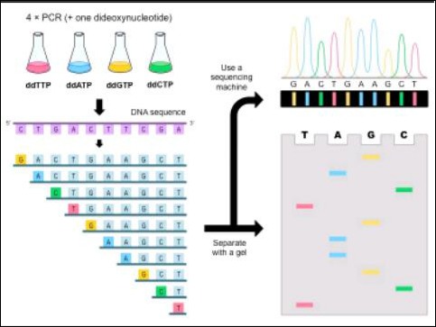

Figure(2): Sanger dideoxy sequencing--basic method

3

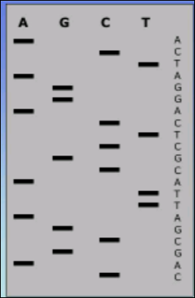

Figure(3): reading of DNA sequencing

4

