**Introduction to Nanotechnology Dr.Neihaya Heikmat**

**What is nanotechnology ?**

“Nano” – From the Greek word “dwarf”, and means 10-9, or one-billionth of a meter.

1 nm = 1/1000 μm = 1/1000000 mm= 1/1000000000 m.

**Nanotechnology** is Field of science whose theme is the control and manipulation of matter on an atomic and molecular scale to create novel structures, devices and systems. It's about creating and using these devices and systems that have novel and better properties and functions because of their small sizes.





* **Nanostructures**—objects with nanometer scale features—are not new and they were not first created by man.
* Individual nanostructures involve: clusters, nanoparticles, nanocrystals, quantum dots, nanowires, nanotubes
* The chemical and physical properties of nano materials can significantly differ from those of the atomic-molecular or the bulk materials of the same chemical composition.
* In general, most agree that three things are important:
* 1. Small size, measured in 100s of nanometers or less
* 2. Unique properties because of the small size

3. Control the structure and composition on the nm scale in order to control the properties



**Natural Nanomaterials**

* Nanoscale materials are found in nature. Naturally occuring nanomaterials exist all around us, such as in smoke from fire, volcanic ash, and sea spray, etc.
* Hemoglobin, the oxygen-transporting protein found in red blood cells, is 5.5 nanometers in diameter.
* The structure viruses (capsid), the wax crystals covering a lotus leaf, spider-mite silk, the "spatulae" on the bottom of gecko feet, some butterfly wing scales, and even our own bone matrix are all natural organic nanomaterials.
* 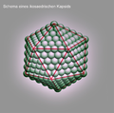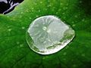
* **Gecko's foot Lotus effect Viral** [**capsid**](https://en.wikipedia.org/wiki/Capsid)
* Studies of adhesive force under both hydrophobic and hydrophilic conditions indicate the gecko’s ability to stick to and climb smooth surfaces is due to (relatively weak) van der Waals intermolecular interactions.
* Nanofabricated, synthetic setae show similar adhesive forces.
* 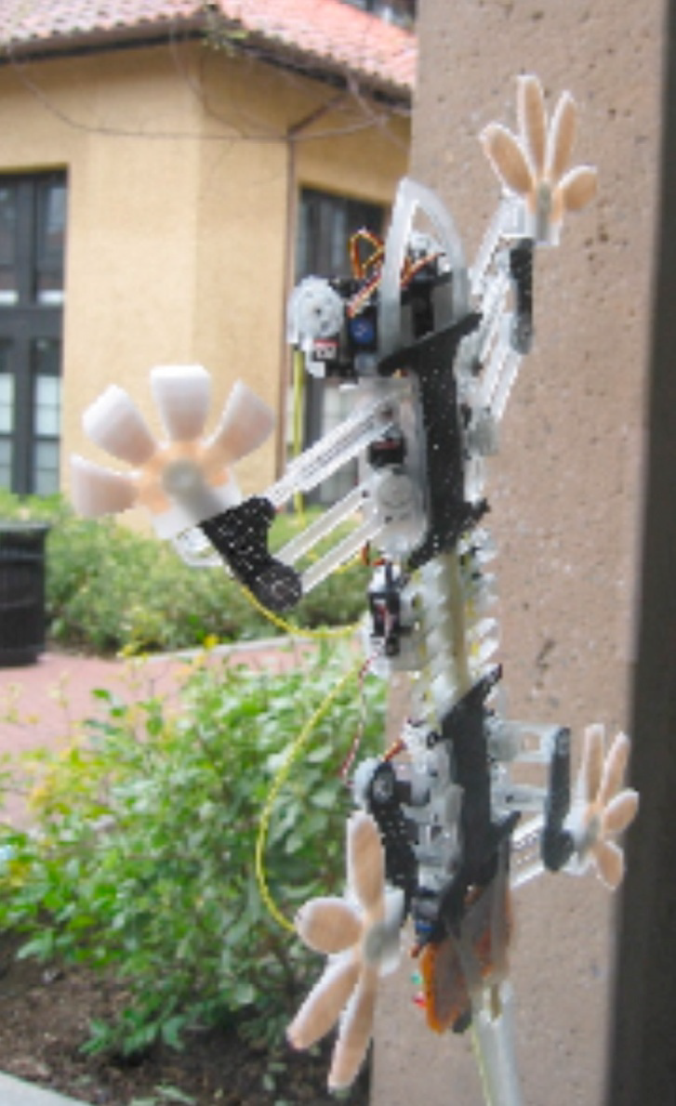 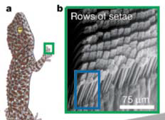

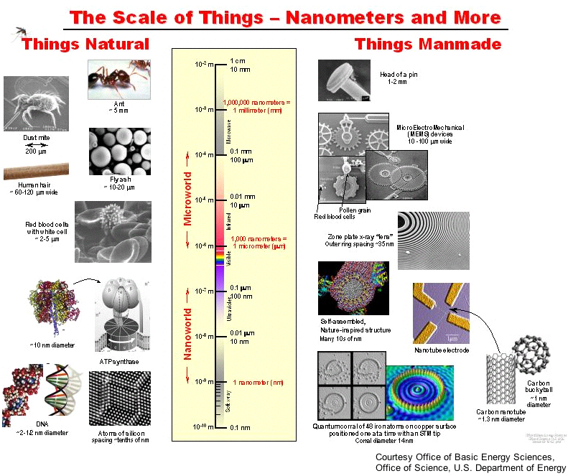

**Why might properties of materials/structuresbe different at the nanoscale?**

* Two of the reasons:

1.Ratio of surface area-to-volume of structure increases (make them more weakly bonded and more reactive).

2. Quantum mechanical effects are important (resulting in changes in electronic and optical properties)

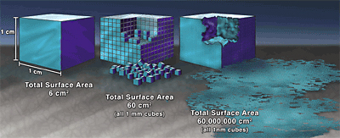

**Why is Small Good?**

**-**Faster

- Lighter

- Can get into small spaces

- Cheaper

- More energy efficient

- Different properties for very small structures

-High packing density. Etc.

**Feynman vision**

* The concept of nanotechnology is attributed to Nobel Prize winner Richard Feynman, who gave a very famous, visionary speech in 1959 (published in 1960) during one of his lectures, saying: “The principles of physics, as far as I can see, do not speak against the possibility of maneuvering things atom by atom”.
* At the time, Feynman’s words were received as pure science fiction. Today, we have instruments that allow precisely what Feynman had predicted: creating structures by moving atoms individually.
* **K. Eric Drexler - 1981**
* Development of the ability to design protein molecules will open a path to the fabrication of devices to complex atomic specifications

**Gold as a nanoparticle**

* Properties of gold nanoparticles are different from its bulk form because bulk gold is yellow solid and it is inert in nature, while gold nanoparticles are red solution and are reported to be anti-oxidant.
* Inter particle interactions and assembly of gold nanoparticles networks play key role in the determination of properties of these nanoparticles.
* Gold nanoparticles exhibit various sizes ranging from 1 nm to 8 μm and they also exhibit different shapes such as spherical, octahedral, irregular shape, tetrahedral, nanotriangles, nanoprisms, hexagonal platelets and nanorods .
* gold is an inert element, meaning it does not react with many chemicals, whereas at the nanoscale.



**Nano structures generations**

**First Generation: passive nanostructures** in coatings, nanoparticles, bulk materials (nanostructured metals, polymers, ceramics): **~ 2001 –**

**Second Generation: active nanostructures** such as transistors, amplifiers, adaptive structures: **~ 2005 –**

**Third Generation: 3D nanosystems** with heterogeneous nanocomponents and various assembling techniques **~ 2010-**

**Fourth Generation: molecular nanosystems** with heterogeneous molecules, based on biomimetics and new design **~ 2020 (?)**

**Terms in Nanotechnology**

**Nanoparticle**: particle with two or more dimensions at the nanoscale.

**Nanoscale: having one or more dimensions of the order of 100** [**nm**](http://ec.europa.eu/health/opinions2/glossary/mno/nanometre.htm) **or less.**

**A bulk material:** material should have constant physical properties regardless of its size.

* **Nanoscience -** refers to the world as it works on the atomic or molecular scale, from one to several hundred nanometers, its pertain to the synthesis, characterization, and utilization of nanostructured materials in the nanometer range.
* **Nanobiotechnology-“**the branch of engineering that deals with things smaller than 100 nanometers”
* [**Green nanotechnology**](https://en.wikipedia.org/wiki/Green_nanotechnology): It refers to the use of the products of nanotechnology to enhance sustainability.
* **Agglomerate:** Collection of weakly bound particles or mixtures where the resulting external surface area is similar to the sum of the surface areas of the individual components.

The forces are weak forces, for example van der Waals forces.

* **Aggregate:** Particle comprising strongly bonded where the resulting external surface area may be significantly smaller than the sum of calculated surface areas of the individual components.

The forces are strong forces, for example covalent bonds.

**Risks of nanomaterial**

**Health Risks**

• Ultrafine particles can catalyze chemical reactions in the body.

• Carbon nanotubes can cause infections of lungs.

• They could easily cross the blood-brain barrier, a membrane that protects the brain from harmful chemicals in the bloodstream.

* **Environmental Risks**

Air, water, and soil pollutions.

**Lab safety**

**Personal Protective Equipment (PPE):**

Wear gloves, lab coats, safety goggles, long pants, closed-toe shoes, and face shields, as appropriate dependent on the nature of the materials and procedure.

***Selection of Nanomaterials:***

Whenever possible, handle nonmaterial in solutions or attached to substrates to minimize airborne release.

**Safety Equipment:**

Know the location and proper use of emergency equipment, such as safety showers, fire extinguishers, and fire alarms.

* **Cleaning:**
* Wet wipe and or HEPA-vacuum work surfaces regularly.
* **Labeling :**
  + - Store in a well-sealed container, preferable one that can be opened with minimal agitation of the contents.
    - Label all chemical containers with the identity of the contents (avoid abbreviations/ acronyms); include term "nano" in descriptor .
    - Use cautious judgment when leaving operations unattended.
* **Transporting:**
* Use sealed, double-contained container when transporting nonmaterial inside or outside of the building.
* **Buddy System:**
* Avoid working alone in the laboratory when performing high-risk operations.

**References**

1- Nanotechnologies, Principles, Applications, Implications and Hands-on Activities .2013

2-An Introduction to Nanoscience and Nanotechnology. 2008

**3-**NANO: The Essentials Understanding Nanoscience and Nanotechnology. 2007