5-1 TOPOGRAPHICAL EFFECTS

In large bodies of water, the thermal inertia of the water causes a slower temperature change than the nearby land. For example, along an ocean coastline and during periods of high solar input, the daytime air temperature over the ocean is lower than over the land. The relative warm air over the land rises and replaced by cooler ocean air. The system is usually limited to altitudes of several hundred meters, which of course, is where pollutants are emitted. The breeze develops during the day and strongest in midafternoon. At night the opposite may occur, although, usually not with such large velocities. At night the ocean is relatively warm and the breeze is from the cooler land the warmer ocean. The on-shore breeze is most likely in the summer months, while the off-shore land breeze more likely occur in winter months. A second common wind system caused by topographical effect is the mountain - valley wind. In this case the air tends to flow down the valley at night Valleys are cooler at higher elevation and the driving force for the airflow result from the differential cooling. Similarly, cool air drains off the mountain at night and flows in to the valley. During the day light hours an opposite flow may occur as the heated air adjacent to the sun warmed ground begins to rise and flow both up the valley and up the mountain slopes. However, thermal turbulence may mask the daytime up- slope flow so that it is not as strong as the nighttime down - slope flow. Both the sea breeze and the mountain valley wind are important in meteorology of air pollution. Large power stations are often located on ocean costs or adjacent to large lakes. In this case the stack effluent will tend to drift over the land during the day and may be subjected to fumigation.
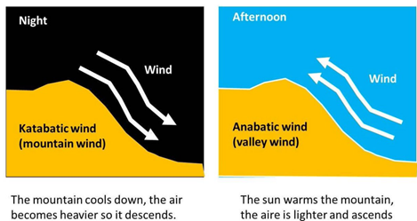

5-2 Wind velocity and Turbulence
The wind velocity profile is influenced by the surface roughness and time of the day. During the day, solar heating causes Thermal Turbulence or eddies set up convective currents so that turbulent mixing is increased. This results in a flatter velocity profile in the day than that at night.
The second type of turbulence is the Mechanical Turbulence, which is produced by shearing stress generated by air movement over the earth’s surface. The greater the surface roughness, the greater the turbulence. The mean wind speed variation with altitude is the planetary boundary layer can be represented by a simple empirical power.
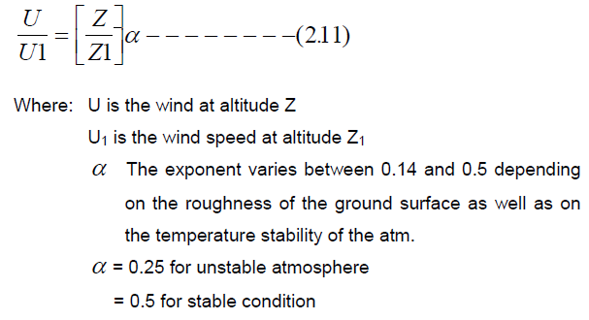
Table 2.1: Wind velocity in different Topography
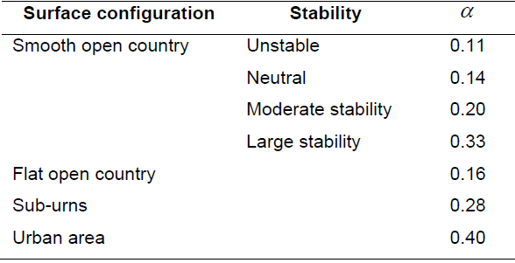
Atmospheric Turbulence is characterized by different sizes of eddies. These eddies are primarily responsible for diluting and transporting the pollutants injected in to the atmosphere. If the size of the eddies is larger than the size of the plume or a puff, then the plume or the puff will be transported downwind by the eddy with little dilution. Molecular diffusion will ultimately dissipate the plume or the puff. If the eddy is smaller than the plume or the puff, the plume or the puff will be dispersing uniformly as the eddy entrains fresh air at its boundary.
5-3 Plume behavior
The behavior of a plume emitted from an elevated source such as a tall stack depends on the degree of unstability of the atmosphere and the prevailing wind turbulence.
5-3-1 Classification of plume behavior and Dispersion
1-Fanning
In the stable atmosphere case (producing a fanning plume). Occurs when the plume is dispersed in the presence of very light winds, there is horizontal dispersion at a right angle to the wind due to turbulence and diffusion. In the vertical, dispersion is suppressed by the stability of the atmosphere, so pollution does not spread toward the ground. This results in very low pollution concentrations at the ground.
For high stacks, fanning is considered a favorable meteorological condition because the plume does not contribute to ground pollution.

2-Looping
In unstable air, the plume will whip up and down as the atmosphere mixes around (whenever an air parcel goes up, there must be air going down someplace else to maintain continuity, and the plume follows these air currents). This gives the plume the appearance that it is looping around.
It occurs under super adiabatic conditions, with light to moderate wind speeds on a hot summer afternoon when large scale thermal eddies are present. The eddies carry portion of a plume to the ground level for short time periods, causing momentary high surface concentration of pollutants near the stack. Thus, the plume moves about vertically in a spastic fashion and the exhaust gases disperse rapidly.
3-Fumigation
An inversion aloft will trap pollutants underneath it, since the stable inversion prevents vertical dispersion. Pollution released underneath the inversion layer will fumigate the mixed layer. Note that if the smokestack was high enough to release the pollution within the inversion layer, the plume would fan because the plume occurs within stable air.
Here, a stable layer of air lies a short distance, above the release point of the plume, and the unstable air layer lies below the plume. This unstable layer of air, causes the pollutant to mix down - wind toward the ground in large lumps, but fortunately, this condition is usually of short duration lasting for about 30 minutes Fumigation is favored by clear skies and light winds, and it is more common in the summer seasons.
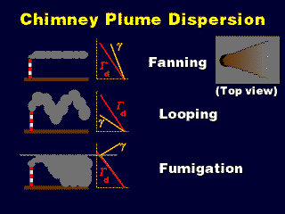

4-Conning
In the neutral atmosphere case, the horizontal dispersion at a right angle to the wind is due to turbulence and diffusion, which occurs at the same rate as the vertical dispersion, which is not being opposed nor encouraged by the stability (or lack of it) in the atmosphere. So, the plume spreads equally in the vertical and horizontal as it propagates downstream, forming a coning plume.
It occurs under cloudy sky both during day and night, when the lapse rate is essentially neutral. The plume shape is vertically symmetrical about the plume line and the major part of the pollutant concentration is carried down -wind fairly far before reaching the ground level.

5- Lofting
In the lofting case, pollution dilutes upward. This produces much lower pollution concentrations at the ground at a distance downstream than the straight stable case (fanning plume), because molecular diffusion and some turbulence allow smoke to reach the ground eventually, and the fanning plume does not have the upward dispersion that the lofting plume has.
The condition for lofting plume is the inverse of those for fumigation, when the pollutants are emitted above the inverse layer, they are dispersed vigorously on the upward direction since the top of the inversion layer acts as a barrier to the movement of the pollutants towards the ground.
6-Trapping:
Occurs when the plume effluent is caught between two inversion layers. The diffusion of the effluent is severely restricted to the unstable layer between the two unstable layers
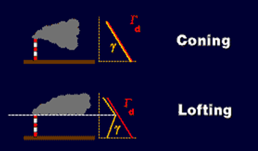
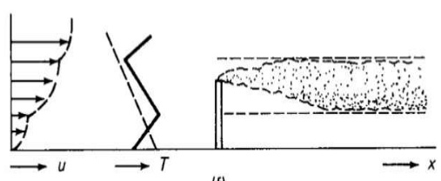

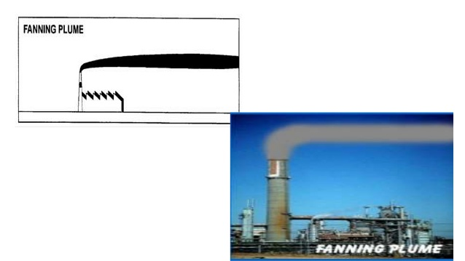
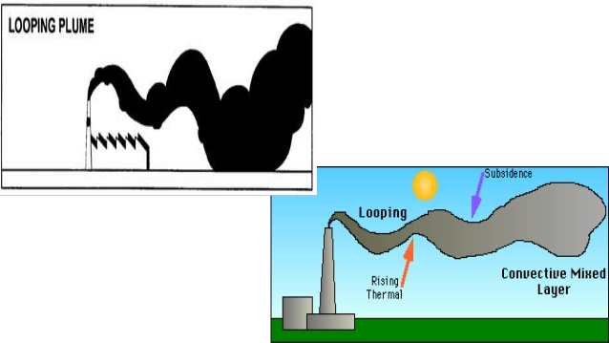
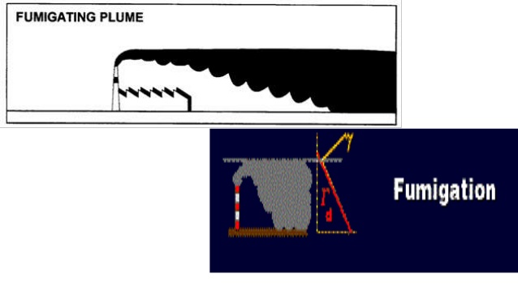
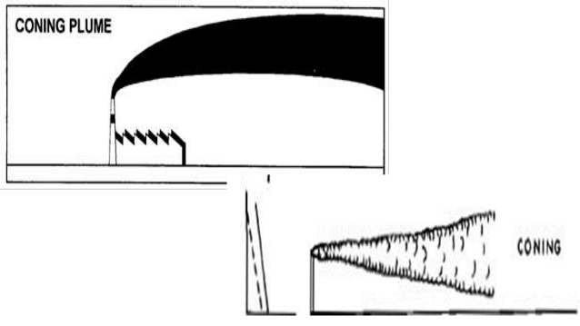
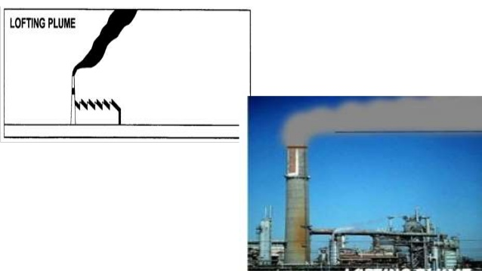

5-4 Enhancing Dispersion
5-4-1 Enhancing Dispersion: Flow Obstructions
- Turbulent wake behind a building helps mix pollutants to the ground that might not have been there normally, in a stable atmosphere.
- Downwash is especially bad when there are pollution sources on the top of the building.
- It is important to get the pollution emitted high enough above the building so that it does not get caught in the downwash and get carried down to the ground.

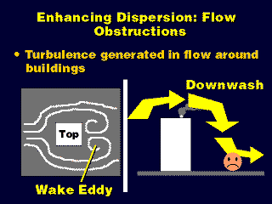

5-4-2 Enhancing Dispersion with Smokestacks
Pollution emitted from a taller stack has to travel a longer distance to get to the ground, so it will become more dilute.
Also, it may be possible for taller stacks to get above low-level inversions....
