**Medical Entomology**: is a branch of entomology which deals with arthropods which affect the health and well being of man and vertebrate animals. In other words, medical entomology is the medical science directly concerned with vectors that affect human and animal health.

-The process of transfer of pathogens by insects Divided in to:-

**1-Mechanical disease transmission:**

disease agents are carried from one host to another by arthropods simply mechanically carried by the body parts (example wings, hairs,feces, vomitus, etc). In this type of disease transmission no change takes place in the number, form or developmental stages of the organism, but simply deposited in the body, food or drink of the host.

**2-Biological disease transmission:**

the agent will exhibit changes in form and or number of developmental stages in the arthropod before entry to the host. This includes: Propagative, cyclodevelopmental and cyclopropagative.

**. propagative:**

In propagative type of disease transmission only the number of pathogens increases and the developmental stage remain constant. The diseases plague and typhus are good examples of propagative type of

disease transmission

• **Cyclo-developmental:**

In this type of disease transmission, only the developmental stage (form) of the disease pathogen is changed (small to big, immature to matured stage,etc.), while the number of the pathogenic organism remains constant. Example Filariasis

**• Cyclo-propagative:**

This type of disease transmission is a combination of both propagative and cyclo-developmental; whereby the disease pathogen undertakes a change both in number and developmental form (stage). Example Malaria.

**Lab:-2**

**Order: Diptera**

**Sub order: Nematocera**

**Family: Culicidae**

**Sub family : Anophelinae**

**Sub family : Culicinae**

**Life Cycle:**

Mosquitoes undergo complete metamorphosis with four stages. The female mosquito lays her eggs on the surface of fresh or standing water; some species lay eggs on damp soil prone to inundation. Larvae hatch and live in the water, most using a siphon to breathe at the surface. Within one to two weeks, the larvae pupate. Pupae cannot feed, but can be active while floating on the water's surface. Adults emerge, usually in just a few days, and sit on the surface until they are dry and ready to fly. Adult females live two weeks to two months; adult males may only live a week.

**Egg**:-

Egg of anophilinae has floats but culicinae no floats

Egg in *anopheles* laid singly and has floats ,

Egg in *Aedes* laid singly and no floats ,

Egg in *Culex* laid in clump "rafts" and no floats

[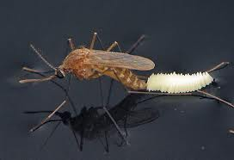](http://www.google.iq/imgres?imgurl=http://entnemdept.ufl.edu/creatures/aquatic/southern_house_mosquito06.jpg&imgrefurl=http://entnemdept.ufl.edu/creatures/aquatic/southern_house_mosquito.htm&h=342&w=500&tbnid=s0rI37biZk-qOM:&zoom=1&docid=UtIj_9hXg40r9M&hl=ar&ei=hDAlVJnBAYOjygPEjYLgCQ&tbm=isch&ved=0CC4QMygTMBM&iact=rc&uact=3&dur=702&page=2&start=17&ndsp=22)

**Larva:-**

The culicine larva has a breathing tube (siphon) which it also uses to hang down from the water surface, whereas the anopheline larva has no siphon and rests parallel to and immediately below the surface. Larvae breathe through [spiracles](http://en.wikipedia.org/wiki/Spiracle) located on their eighth abdominal segments

A larva hatches from the egg after one or two days and generally floats parallel under the water surface, since it needs to breathe air. It feeds by taking up food from the water. When disturbed, the larva quickly swims towards the bottom, but it soon needs to return to the surface to breathe. There are four larval stages or *instars.* The small larva emerging from the egg is called the first instar. After one or two days it sheds its skin and becomes the second instar, followed by the third and fourth instars at further intervals of about two days each. The larva remains in the fourth instar stage for three or four more days before changing into a pupa. The total time spent in the larval stage is generally eight to ten days at normal tropical water temperatures. At lower temperatures, the larval stages take longer to develop

The mosquito larva has a well-developed head with mouth brushes used for feeding, a large [thorax](http://en.wikipedia.org/wiki/Thorax_(insect_anatomy)) with no legs, and a segmented [abdomen](http://en.wikipedia.org/wiki/Abdomen).

[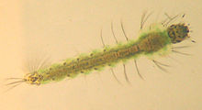](http://en.wikipedia.org/wiki/File:Anopheles_larve.jpg)

[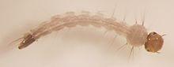](http://en.wikipedia.org/wiki/File:Aedes_aegypti_larva.jpg)

[*Aedes*](http://en.wikipedia.org/wiki/Aedes) aegypti larva

**[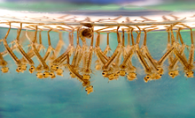](http://en.wikipedia.org/wiki/File:Culex_sp_larvae.png)**

[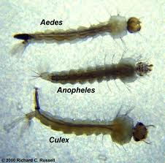](http://www.google.iq/imgres?imgurl=http://www.phsource.us/images/entomology/various_larvae.jpg&imgrefurl=http://www.phsource.us/PH/ME/Insecta/Diptera/Culicidae/mosquitoes.htm&h=409&w=416&tbnid=g_ZEGHCq0QFnRM:&zoom=1&docid=0KLQL2cE84uVAM&ei=rFQ0VNGDDcK_ygP5xoLIAw&tbm=isch&ved=0CCwQMygOMA4&iact=rc&uact=3&dur=3799&page=2&start=11&ndsp=19)

**Pupa:-**

Pupae of both anophelines and culicines are comma-shaped. It stays under the surface and swims down when disturbed, but it does not feed. The pupal stage lasts for two to three days, after which the skin of the pupa splits. Then the adult mosquito emerges and rests temporarily on the water's surface until it is able to fly.

The breathing trumpet of the anopheline pupa is short and has a wide opening, whereas that of the culicinae pupa is long and slender with a narrow opening. However, it is difficult to distinguish anophelinae from culicine pupae in the field.

. The head and thorax are merged into a [cephalothorax](http://en.wikipedia.org/wiki/Cephalothorax), with the abdomen curving around underneath. The pupa can swim actively by flipping its abdomen, and it is commonly called a "tumbler" because of its swimming action. As with the larva, the pupa of most species must come to the surface frequently to breathe, which they do through a pair of respiratory trumpets on their cephalothoraces. However, pupae do not feed during this stage; typically they pass their time hanging from the surface of the water by their respiratory trumpets.



**Adult**:-

With live mosquitoes, you can distinguish between adult anopheline and culicine mosquitoes by observing their resting postures. Anophelines rest at an angle between 50o and 90o to the surface, whereas culicines rest more or less parallel to the surface.

The head also has an elongated, forward-projecting, "stinger-like" [proboscis](http://en.wikipedia.org/wiki/Proboscis) used for feeding, and two sensory palps. The maxillary palps of the males are longer than their proboscises, whereas the females’ maxillary palps are much shorter. In typical bloodsucking species, the female has an elongated proboscis.

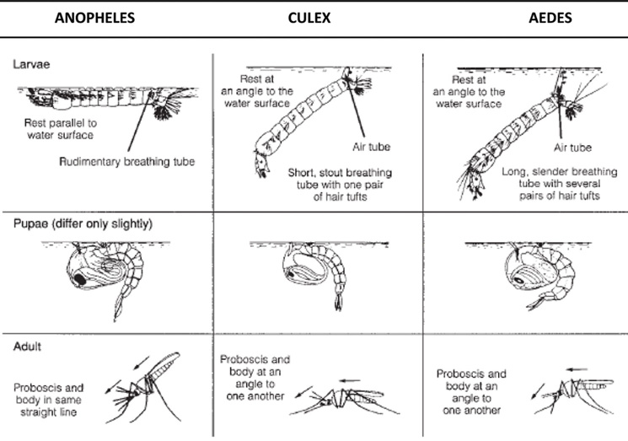

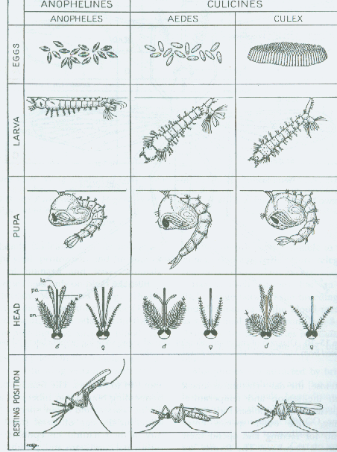

**Stage Culicinae Anophelinae**

**Eggs**  Laid singly, possess floats Laid singly or in egg rafts or

masses. Never possess floats

**Larvae** Never have a siphon. Lie All larvae have a short or

parallel to water surface. long siphon. Subtend an

Have abdominal palmate angle from the water surface

hairs and tergal plates No palmate hairs or

tergal plates .

**Pupae** Breathing trumpets short andBreathing trumpets short or

broad apically. Short peg-likelong, opening not broad

**Adults (both sexes)**

Rest at an angle to any surface. Rest with body more or less parallel

to the surface

**Females pilose**

**antennae**

Palps about as long as proboscis Palps much shorter than proboscis

**Males plumose**

**antennae**

Palps about as long as proboscis Palps about as long as proboscis

and swollen at ends but never swollen at ends; palps

may be hairy

**Lab: 3**

**Order : Diptera**

**Sub order :Nematocera**

**Family : Simuliidae**

**Genus : Simulium**

**LIFE CYCLE**

The length of the life cycle varies with the species and environmental conditions. In temperate regions species may have one generation a year, while continuous breeding occurs in tropical species. The larval stage of *S. damnosum* can be completed in as little as 6 days, and the life cycle from egg to adult can be completed in less than 2 weeks.

**Eggs**:-  
The eggs are commonly laid in batches of 200-300, in a range of 30 to 800, on objects in or near running water or directly onto water or on the surface.

Eggs are 100 to 400 µm long and ovoid - triangular in shape. Their surface is comparatively smooth, lacking the patterned surface found in the eggs of *Culicoides* and culicids, and are covered with a gelatinous substance. Eggs may be laid in skeins like a string of beads, or in untidy masses. Freshly laid eggs are creamy-white, changing to dark brown or black within 24h.

**Larva** :-

brown, gray, or black with light brown head; body cylindrical, somewhat club-shaped; head with prominent pair of mouth brushes, cephalic (labral) fans used for filtering food from the water

posterior part of the abdomen are broader than the anterior segments of the abdomen.. The larva has a single anterior proleg, surmounted by a circlet of hooks and the The larva can change its location by drifting downstream on a silken thread, or by looping over the substrate surface using the posterior circlet and the hooks on the anterior proleg to retain a hold on secreted silk.

The mature last instar larva, recognised by the presence of a dark "gill spot" through which the developing gills of the pupa may be seen, on the lateral side of the thorax, is actually a pharate pupa within the larval skin (i.e. midway between loosening the larval skin and casting it off), and may move to a different site before pupating. In most species the pharate pupa spins a cocoon in which it pupates. This is usually slipper-shaped with the closed end directed upstream and the open end downstream .This alignment prevents the cocoon being torn off the substrate by the current. Construction of the cocoon takes about an hour and then the larval skin is shed.

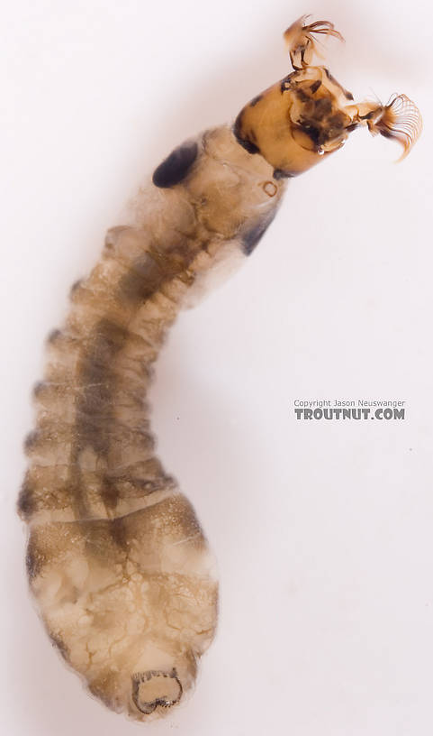

[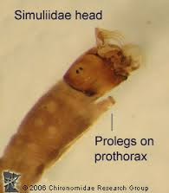](http://www.google.iq/url?sa=i&rct=j&q=&esrc=s&source=images&cd=&cad=rja&uact=8&ved=&url=http://midge.cfans.umn.edu/vsmivp/diptera/simuliidae/&ei=d_VLVO7CM4TjO7LPgcgK&psig=AFQjCNGOjLa0m8MdEYUQUjKocBTZhj7EMQ&ust=1414350584176617)

1. [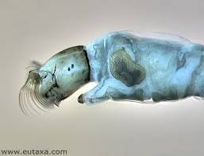](http://www.google.iq/url?sa=i&rct=j&q=&esrc=s&source=images&cd=&cad=rja&uact=8&ved=0CAcQjRw&url=http://www.eutaxa.com/S%20image%20r3b3.htm&ei=lidRVNuzA6au7gaYhICACw&psig=AFQjCNEbkhb1CHxodkoFjUdh_2vt-mQTdg&ust=1414690888896200)

Cephalic fan

Pro leg

Gill spot

**Pupa:-**   
The head and thorax of the pupa are combined into a single cephalothorax, and there is a segmented abdomen .The latter bears spines and hooks which engage with the threads of the cocoon and retain the pupa in place. Thecephalothorax bears a pair of elongate, branched pupal gills, which trail downstream of the cocoon. However, in some species the gills are short and barely extend beyond the lip of the cocoon. The gills are homologous with the respiratory horns of the Culicidae and Ceratopogonidae, but they do not have open spiracles. The tubular branches of the gill bear vertical struts which support a very thin, outer, minutely perforated, trilaminate epicuticle and an inner fine meshwork. The enclosed air-filled space around the struts functions as a plastron. The shapes of the cocoon and gills are important characters in the identification of species.

The pupa, which does not feed, becomes progressively darker as the adult develops within. At emergence, the pupal skin splits, and the adult floats up to the surface in a bubble of air and immediately takes flight, or the newly emerged adult crawls up some emergent object to reach the air.

1. [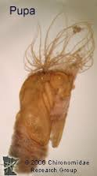](http://www.google.iq/url?sa=i&rct=j&q=&esrc=s&source=images&cd=&cad=rja&uact=8&ved=0CAcQjRw&url=http://midge.cfans.umn.edu/vsmivp/diptera/simuliidae/&ei=pPpLVM-FL8G5OPPjgdAE&psig=AFQjCNGOjLa0m8MdEYUQUjKocBTZhj7EMQ&ust=1414350584176617)

**Adult**

black to various shades of gray or yellow; thorax shiny, strongly convex, giving a humpbacked, gnat-like appearance; wings clear, broad, without hairs or scales; heavy veins near anterior wing margin, weak veins posteriorly; small head with large round eyes and short 11-segmented antennae; ocelli lacking

the female is dichoptic In the male the eyes are much larger and touch above the antennae (holoptic),