6-1 Tall and Short Smoke Stacks
- With a tall enough smokestack, pollution is emitted within the inversion aloft, forming a fanning plume that does not pollute the area near the smokestack. If it's not tall enough, it will fumigate the countryside.
- Switching the layers so that the inversion is at the ground, we need the smokestack tall enough to be above the ground inversion, so that a lofting plume is formed. Architects will need to know the average depth of the nocturnal radiation inversion in order to know how tall to build the smokestack.
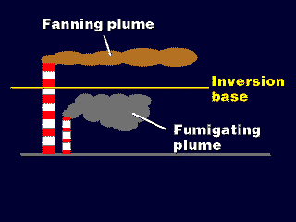

6-2 Exit Velocity
The faster the smoke gushes out, the more momentum it has, and the higher it will fly before it levels out and disperses toward the ground.
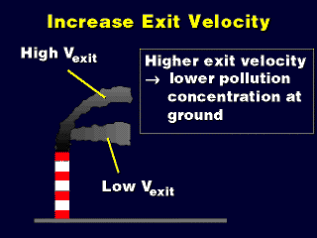

6-3 Methods for Increasing Exit Velocity
- Narrowing the smokestack's opening forces, the smoke out as a faster streaming, narrower jet.
- Backpressure from the smaller opening may reduce the efficiency of the flow of smoke out of the chimney, however, partially offsetting the increasing in plume momentum.

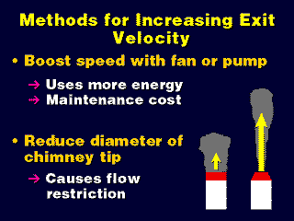
6-4 Exit Temperature
- The higher the temperature, the greater the positive buoyancy in smoke streaming out of the smokestack.
- The smoke has to rise higher before it has adiabatically cooled to a neutral buoyancy temperature
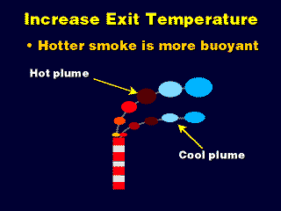
6-5 Methods for Increasing Exit Temperature
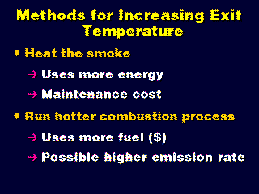
unstable layers.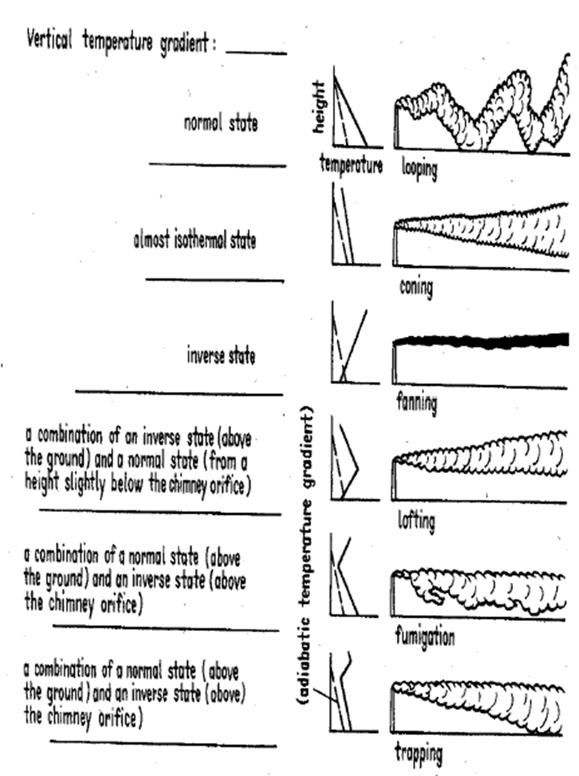

6-6 Atmospheric cleansing processes

- Dispersion: Lessening the concentration of pollutants by wind currents.
- Gravitational Settling: particulates (larger than 20 µm) are settled due to gravitation force.
- Flocculation: The formation of small flocs of particles when larger one’s act as receptors of smaller ones. The flocs would be settled down.
- Natural Absorption: Particulates or gasses are collected in rain or mist, then settle-out with moisture (washout). It takes place below cloud level.
- Rain out: Within clouds, sub-micron particulates serve as condensation nuclei around which drops of water may form.
- Adsorption: In the friction layer of the atmosphere, gases, liquid, and solid contaminants are attracted to a surface (electro statically), where they are concentrated.
Note: What is Adsorption?
The phenomenon of adhesion of the molecules of a substance on the surface of a liquid or solid is adsorption.
6-7 Air quality modeling
- Physical: utilizing advances techniques such as wind tunnels, to result high precision but it is complex and expensive.
- Statistical: requires huge amount of data to build a model with a good level of precision. Also, it requires the use of advanced calculation technology.
- Empirical: same as (2).
- Numerical: requires the solution of the equations for conservation of mass, energy and momentum in three dimensions. It results good level of precision but it needs the use of expensive computerized systems.
- Gaussian: more widely used due to its simplicity. It is far from being exact because it is built on some simple assumptions; these are:
  - There is no variation in wind speed and direction between the source and target.
  - All effluent remains in the atmosphere (no deposition or chemical conversion). Any plume impacting on the ground is totally reflected.
  - Dispersion does not occur in the downwind direction.
  - Emission rates are assumed constant and continuous
6-8 PLUME DISPERSION
Dispersion is the process by which contaminants move through the air and a plume spreads over a large area, thus reducing the concentration of pollutants it contains. The plume spreads both horizontally and vertically. If it is gaseous, the motion of the molecules follows the low of gaseous diffusion. The most commonly used model for the dispersion of gaseous air pollutants is the Gaussian, developed by Pasquill, in which gases dispersed in the atmosphere are assumed to exhibit idea gas behavior.
6-7 The Gaussian plume model
The present tendency is to interpret dispersion data in terms of the Gaussian model. The standard deviations are related to the eddy diffusivities.
6-7-1Gaussian Model
For a description of pollutant dispersion in the atmosphere, we use in several cases models which assume that the pollutant concentration after their release from the source, have a canonical distribution (Gaussian distribution) as examined in the previous paragraphs. These models called Gaussian models. The Gaussian models extensively used since they describe realistically, based on comparison with field data, the pollutant dispersion at a local level for a stationary atmosphere. In a Cartesian orthogonal coordination system with origin at the bottom of the point source, with direction xx0 the wind direction, yy0 the direction vertical to the wind direction at the surface and zz0 the vertical one, the concentration of pollutants at the position (x, y, z) can be described from the equation (Seinfeld and Pandis 2006):
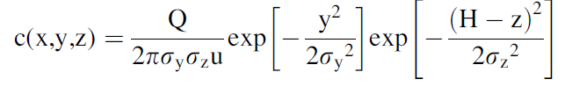
Where:
Q= the, effluent rate, emission rate expressed in mg/s [kg/s], [m³/s]
C (x, y, z) = concentration of pollutant at target point (x, y, z) [kg/m³], ppm or ppb.
σ_{y}, σ_{z}= diffusion coefficients (horizontal and vertical, respectively) [m].
H= effective height of the source [m].
U= wind speed at the height of the source [m/s].
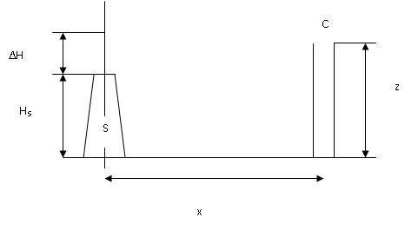
The conditions which have to obtain in order to apply a Gaussian model to give realistic results are the following:
- The pollutant emissions are continuous or at least the emissions occur for a time interval which is larger than the travel time of the pollutant from the source to the receptor point which the concentration has to be derived.
- The pollutants are not reacting chemically in the atmosphere since the Gaussian model is not including chemical reactions.
- At the wind direction the transport process is dominant to the turbulent dispersion.
- The aerosol diameter to be smaller than 20 mm in order for their residence time in the atmosphere to be larger than the time intervals which are studied with the Gaussian models.
- The atmosphere, to be in a stationary condition in relation to the meteorological parameters, for the time interval of transport from the pollution source to the receptors. This condition, is satisfied in most cases. For example, if there is transport of pollutants to distances smaller than 10 km and the wind velocity is 5 m/s, then the transport time is close to 35 minutes and for these time intervals the meteorological conditions are usually stable.
With the Gaussian model are calculated average pollutant concentrations at several points around the emission source. There is a difference in the pollutant concentration distribution between average and instant values. The average concentration has a Gaussian distribution at the cross direction and to a lesser extent in the vertical direction. The question which arises is how large the time interval has to be at which the average concentration values have to be obtained in order for the average concentrations to have a canonical distribution. In the majority of cases average values of hourly concentrations are calculated. However, there are indications that the Gaussian distribution is observed also in cases where the average values are calculated for time intervals of tens of minutes. From the equation which describes the Gaussian plume it can be seen that the model cannot be applied in case the wind velocity tends to zero. In cases of very low wind velocity, it is set equal to 0.5 or 1 m/s based on the model being used.
6-8Limitations of the Gaussian Model
- Conditions of Intense Instability:
When there are very unstable conditions in the atmosphere the air flux inside the boundary layer is turbulent and upward and downward air movements are present. This has as a result the pollutants emitted from a source to be transported quickly to the upper layers of the boundary layer or close to the surface. The upward movements have higher velocity than the downward transport and cover smaller area. Therefore, the pollutants have higher probability to be located in a downward air movement with a final result the main axis of the plume to move to the surface. In total, the plume moves to the surface or to the base of the boundary layer. This fact, is not considered in the Gaussian model and requires caution in application of the models in very unstable conditions.
- Emissions Close to the Surface:
When the emissions occur close to the surface, then difficulties arise in the application of Gaussian models due to the variation of wind velocity and the turbulence structure. More precisely the wind velocity close to the surface changes to logarithmic versus height and is difficult to use a characteristic velocity for the whole boundary layer. Furthermore, the turbulent flux is not homogeneous in the vertical direction and deviates from the Gaussian distribution. The cross-sectional distribution of emissions close to the surface continues to be canonical.

