Applications of Immunology
Ass. Dr. Ekhlass N.
L.Dr. Mohanad A.K.
Lac. 7
Polyclonal antibodies & Monoclonal antibodies
Serum
Serum is a clear, yellowish colored fluid which is part of the blood. It does not contain white or red blood cells or a clotting factor. It is the blood plasma without the fibrinogens. Serum includes all proteins not used in blood clotting (coagulation) and all the electrolytes, antibodies, antigens, hormones, and any extra substances such as drugs and microorganisms).
Immune Sera
Serum that contains antibodies. It is obtained from an animal that has been immunized either by ANTIGEN injection or infection with microorganisms containing the antigen.
Antisera
Antiserum (plural: antisera) is blood serum containing polyclonal antibodies and is used to pass on passive immunity to many diseases. For example, passive antibody transfusion from a previous human survivor (convalescent serum) used to be the only known effective treatment for Ebola infection (but with little success rate).
Antisera are widely used in diagnostic virology laboratories. The most common use of antiserum in humans is as antitoxin
How it works?
Antibodies in the antiserum bind the infectious agent or antigen. The immune system then recognizes foreign agents bound to antibodies and triggers a more robust immune response. The use of antiserum is particularly effective against pathogens which are capable of evading the immune system in the unstimulated state but which are not robust enough to evade the stimulated immune system. The existence of antibodies to the agent therefore depends on an initial "lucky survivor" whose immune system by chance discovered a counteragent to the pathogen, or a "host species" which carries the pathogen, but does not suffer from its effects. Further stocks of antiserum can then be produced from the initial donor or from a donor organism that is inoculated with the pathogen and cured by some stock of preexisting antiserum. Diluted snake venom is often used as an antiserum to give a passive immunity to the snake bite itself.
NOT. Vaccine teaches your immune system how to fight an infection. An antiserum either neutralizes the "infection" or stimulates your immune system to attack an infection.

Antitoxin,
antibody, formed in the body by the introduction of a bacterial poison, or toxin, and capable of neutralizing the toxin. People who have recovered from bacterial illnesses often develop specific antitoxins that confer immunity against recurrence.
For medical use in treating human infectious diseases, antitoxins are produced by injecting an animal with toxin; the animal, most commonly a horse, is given repeated small doses of toxin until a high concentration of the antitoxin builds up in the blood. The resulting highly concentrated preparation of antitoxins is called an antiserum.
The first antitoxin, to diphtheria, was discovered in 1890 by Emil von Behring and Shibasaburo Kitasato, for which Behring received the 1901 Nobel Prize for Physiology or Medicine. Today, antitoxins are used in the treatment of botulism, diphtheria, dysentery, gas gangrene, and tetanus

Polyclonal antibodies (pAbs) are antibodies that are secreted by different B cell lineages within the body. They are a collection of immunoglobulin molecules that react against a specific antigen, each identifying a different epitope.

Monoclonal antibodies (mAb or moAb) are antibodies that are made by identical immune cells that are all clones of a unique parent cell. Monoclonal antibodies can have monovalent affinity, in that they bind to the same epitope (the part of an antigen that is recognized by the antibody). In contrast, polyclonal antibodies bind to multiple epitopes and are usually made by several different plasma cell (antibody secreting immune cell) lineages.
that one clone of B cells makes an antibody of only one specificity has been exploited to produce monoclonal antibodies, one of the most important technical advances in immunology, with far-reaching implications for clinical medicine and research. To produce monoclonal antibodies, B cells, which have a short life span in vitro, are obtained from an animal immunized with an antigen and fused with myeloma cells (tumors of plasma cells), which can be propagated indefinitely in tissue culture
In 1975, Georges Kohler and Cesar Milstein fused antibody-secreting plasma cells with myeloid-origin tumor (myeloma) cells. The resulting immortalized cells, or hybridomas, secreted antibodies of single specificity and isotype and were termed monoclonal antibodies because of their origin from a single antibody-producing cell . Vast quantities of monoclonal antibodies can be produced with no variation between batches. Because monoclonal antibodies produced by any given hybridoma are unique, they can be used together with fluorescent dyes or other markers to distinguish individual epitopes on an antigen or cell .
Not: such antibodies, derived from a single B cell clone, are homogeneous monoclonal antibodies, meaning monoclonal antibodies against virtually any antigen can be produced.
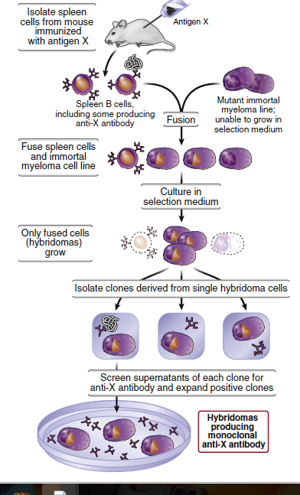

Most monoclonal antibodies are made by fusing cells from immunized mice with mouse
myelomas. Such mouse monoclonal antibodies cannot be injected repeatedly into human subjects, because the human immune system sees the mouse Ig as foreign and mounts an immune response against the injected antibodies. This problem has been partially overcome by genetic engineering approaches that retain the antigen-binding V regions of the mouse monoclonal antibody and replace the rest of the Ig with human Ig; such humanized antibodies are suitable for administration to people (although with prolonged
use, even some humanized monoclonal antibodies may elicit anti-Ig antibody responses in treated individuals). More recently, monoclonal antibodies have been generated by using recombinant DNA technology to clone the DNA encoding human antibodies of desired specificity. Another approach is to replace the Ig genes of mice with human antibody genes and then immunize these mice with an antigen to produce specific human antibodies. Monoclonal antibodies are now in widespread use as therapeutic agents for many diseases in humans.

Monoclonal antibody therapy
Monoclonal antibody therapy is a form of immunotherapy that uses monoclonal antibodies (mAb) to bind monospecifically to certain cells or proteins. This may then stimulate the patient's immune system to attack those cells. Alternatively, in radioimmunotherapy a radioactive dose localizes on a target cell line, delivering lethal chemical doses. More recently antibodies have been used to bind to molecules involved in T-cell regulation to remove inhibitory pathways that block T-cell responses, known as immune checkpoint therapy. It is possible to create a mAb specific to almost any extracellular/ cell surface target. Research and development is underway to create antibodies for diseases (such as rheumatoid arthritis, multiple sclerosis, Alzheimer's disease, Ebola and different types of cancers).
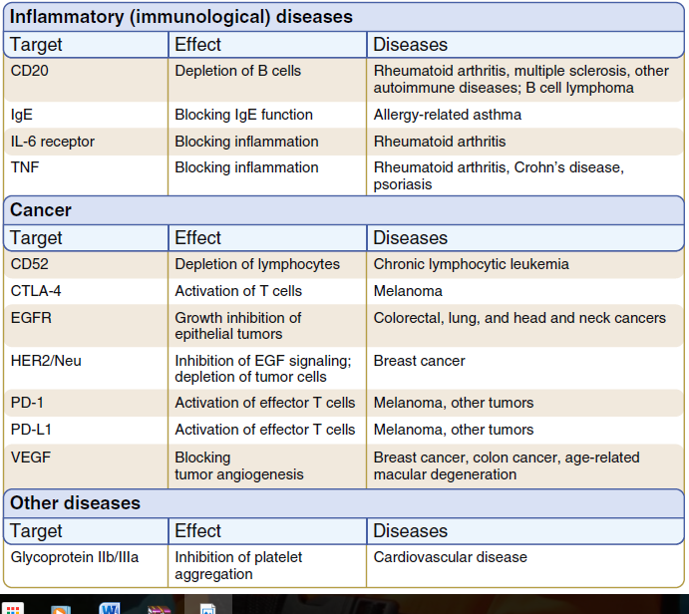

Immunotherapy ; is the "treatment of disease by inducing, enhancing, or suppressing an immune response Immunotherapies designed to elicit or amplify an immune response are classified as activation immunotherapies, while immunotherapies that reduce or suppress are classified as suppression immunotherapies. Immunomodulatory regimens often have fewer side effects than existing drugs, including less potential for creating resistance when treating microbial disease.

Applications of immunotherapy
- Protection and prevention (prophylaxis) against infectious disease e.g diphtheria, tetanus ,rabies and treatment for snake bite.
- Immunosuppression this include prevention of maternal isoimmunization Rho sensitization and immunosuppression during tissue transplantation.
- Cell-based immunotherapies are effective for some cancers. Immune effector cells such as lymphocytes, macrophages, dendritic cells, natural killer cells (NK Cell), cytotoxic T lymphocytes (CTL), etc., work together to defend the body against cancer by targeting abnormal antigens expressed on the surface of tumor cells.
- Allergen immunotherapy, Immunotherapy is used to treat allergies. While allergy treatments (such as antihistamines or corticosteroids) treat allergic symptoms, immunotherapy can reduce sensitivity to allergens, lessening its severity. Immunotherapy may produce long-term benefits. Immunotherapy is partly effective in some people and ineffective in others, but it offers allergy sufferers a chance to reduce or stop their symptoms. The therapy is indicated for people who are extremely allergic or who cannot avoid specific allergens. Immunotherapy is generally not indicated for food or medicinal allergies. This therapy is particularly useful for people with allergic rhinitis or asthma. The first dose contain tiny amounts of the allergen or antigen. Dosages increase over time, as the person becomes desensitized. This technique has been tested on infants to prevent peanut allergies.

Antibody replacement therapy (gamma globulin)
The administration of exogenous immunoglobulin (human immune globulin or Hlg) can be effective therapy for individuals with generalized antibody deficiencies (hypogammaglobulinemia or agammaglobulinemia). The immune globulin products are typically administered intravenously (intravenous immune globulin or IVIG). Hlg consists mostly of lgG with trace amounts of lgM and lgA. Because it is derived from pooled immune human sera, it can react against a broad range of epitopes. The benefit provided by Hlg lasts for approximately 1 month (the serum half-life of lgG is about 23 days); therefore Hlg injections must
be repeated at monthly intervals to maintain sufficient antibody levels for
protection. Since Hlg is an immunomodulating agent that can modulate
complement activation, alter antibody production , and suppress various
inflammatory mediators, Hlg can be beneficial in situations in which immune
deficiency is not the underlying problem. lt has been demonstrated to be beneficial in treatment of autoimmune idiopathic thrombocytopenic purpura, B cell chronic lymphocytic leukemia, and Kawasaki syndrome (a disease, usually affecting children, that involves inflammation of the blood vessels and other tissues such as heart muscles) . Antibody replacement therapy need not always involve broad-range Hlg. People with selective antibody deficiencies, groups at high risk for certain infections (the elderly or infants), or those exposed to certain
infectious diseases (e.g . , health care workers or laboratory personnel) may benefit from intramuscular injections of a broad-spectrum immune globulin or preparations of immune globulins containing specific antibodies. Preparations of immune globulins containing specific antibodies (e.g., against tetanus, hepatitis B, rabies, cytomegalovirus, and varicella zoster virus) are available for those at high risk or high exposure. With the advent of monoclonal antibody technology, large quantities of antibodies against specific epitopes are available for other therapeutic uses as well .

