Lab 3 Preparation of Bacterial antigens
Serology and Vaccines
Antigens which stimulate antibody production by the host in enterobacteriacae include:
  - K - polysaccharide capsular antigens

  - O - somatic polysaccharide antigen (associated with LPS)
  - H - flagellar antigen
Somatic antigen (O- Ag):
O antigens are the most external part of the cell wall lipopolysaccharide (LPS), also known as lipoglycans and endotoxin, and consist of repeating units of polysaccharide. Some O-specific polysaccharides contain unique sugars. O antigens are resistance to heat (100° C/2.5hr) and alcohol (96% Ethanol /4 hrs) and usually are detected by bacterial agglutination. It stimulates earliest antibodies to O antigens which are predominantly IgM.
Lipopolysaccharides (LPS) are large molecules consisting of a lipid and polysaccharide composed of O-antigen, outer core and inner core joined by a covalent bond; they are found in the outer membrane of Gram-negative bacteria, and elicit strong immune responses in animals.
It comprises three parts:
- O antigen (or O polysaccharide)
- Core oligosaccharide
- Lipid A
- O-antigen
A repetitive glycan polymer contained within an LPS is referred to as the O antigen, O polysaccharide, or O side-chain of the bacteria. The O antigen is attached to the core oligosaccharide, and comprises the outermost domain of the LPS molecule. The composition of the O chain varies from strain to strain. For example, there are over 160 different O antigen structures produced by different E. coli strains. The presence or absence of O chains determines whether the LPS is considered rough or smooth. Full-length O-chains would render the LPS smooth, whereas the absence or reduction of O-chains would make the LPS rough. Bacteria with rough LPS usually have more penetrable cell membranes to hydrophobic antibiotics, since a rough LPS is more hydrophobic. O antigen is exposed on the very outer surface of the bacterial cell, and, as a consequence, is a target for recognition by host antibodies. It is responsible for SPECIFICITY.
- Core
The Core domain always contains an oligosaccharide component that attaches directly to lipid A and commonly contains sugars . The LPS Cores of many bacteria also contain non-carbohydrate components, such as phosphate, amino acids, and ethanolamine substituents.It is responsible for ANTIGENICITY.
- Lipid A
The lipid A domain is responsible for much of the TOXICITY of Gram-negative bacteria. When bacterial cells are lysed by the immune system, fragments of membrane containing lipid A are released into the circulation, causing fever, diarrhea, and possible fatal endotoxic shock (also called septic shock). The Lipid A moiety is a very conserved component of the LPS.
Store Transformation: it is a phenomenon where pathogenic (Smooth) bacteria turns in Non-pathogenic (Rough) bacteria due to losing the ability of manufacturing Somatic-O-Antigen when it cultured on artificial media in the lab.
Preparation of somatic O- Ag:
Centrifugation
By Spreading
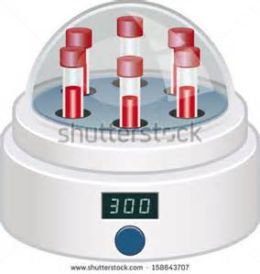
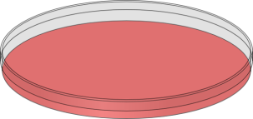
E.coli

3000rpm/30min
Water bath
100°C/2.5hr
Brain Heart Infusion A.
37°/24hr.
Brain Heart Infusion B.
37°/18hr.

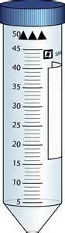

Thyoglycolat 37°/48hr
To detect sterility
Suspend the supernatant with 0.03 Formaldehyde
Wash several times with Normal Saline
Keep at 4°C until use

H (flagellar) antigens:
Flagellar proteins of motile genera and species it is used for (serotype) and it is absent in non-motile genera (Shigella and Klebsiella). Flagellar Ag is heat labile {Break down at 60°C but keep its immunogenicity and denaturate at 100°C) H flagellar antigen is used to specific antisera to identify organisms beyond “species” level, Example: Escherichia coli O157:H7. Flagelar antigen cn be detected by agglutinatin with H-antiserum. The immunoglobulin formed against H –Ag is IgG.
Centrifugation
Centrifugation
E.coli

With chlorophorm
To kill the bacteria
P.B.S
10 000 rpm/10min
To get rid of somatic O AG
Nutrient broth 37°C/24hrs
To enhance flagella formation
Nutrient agar
37°C/24hrs

Suspend with P.B.S and keep at 4°C

HOMEWORK:
In your opinion what is the benefit of preparing these above antigens from bacteria?

