Lab // 6
AVES
Phylum : Chordata
Sub phylum : Vertebrata
Super class : Tetrapoda
Class: Aves
Sub class: Neornithae
Super order: Neognathae
Order: Columbiformes
Genus: Pigeon

The body is usually spindle shaped, with four divisions: head, neck, trunk, and tail , forelimbs (wings) usually modified for flying; posterior pair adapted for perching, walking, and swimming; legs are covered with scales, the foot have three toes forwards and one backwards with claws at the end. Body covered with Feathers made of keratin. Birds have beaks, made of a bony core surrounded by a thin layer of keratin. The bird’s nostrils are at the junction between the beak and the head. The sense of smell is the least developed sense for most birds. The eyes are positioned further apart on the head, giving them a wider field of view, Pigeons have excellent eyesight and they can see all colors. The ears are located slightly behind the eyes, and they are covered with soft feathers Birds, hear a smaller frequency range than humans.
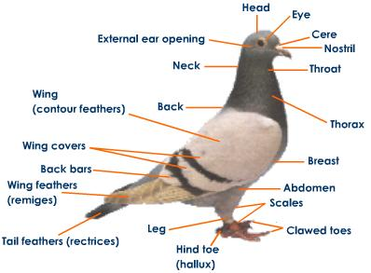
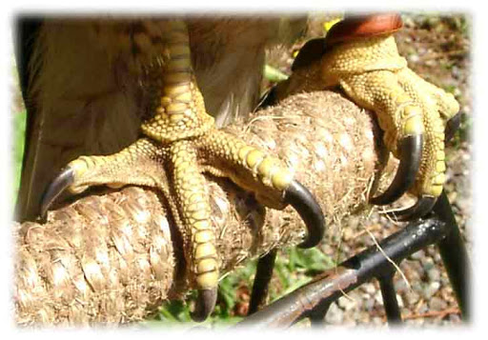

Digestive system
The mouth of birds distinctly different from mammals.
* They have no teeth and their jaws are covered by a beak which vary in shape, size, length and function according to the type of diet consumed.
*The tongue of birds is short, hard and practically lacks muscles and lateral lingual swellings.
** Digestion begins when the bird picks up food with its beak; the food is pushed down the esophagus with help from the tongue. Esophagus is a thin walled tube-like structure that runs from the mouth to the Stomach. Many species of birds have an enlarged area of the esophagus known as a **crop which serves as a temporary storage location for food. The **crop also allows food to be softened before it enters the stomach.** Pigeons produce "crop milk" that they feed to their young for the first two weeks after hatching. Food is slowly passed into the first part of the stomach; Birds have a two part stomach, a glandular portion known as the proventriculus and a muscular portion known as the gizzard. Hydrochloric acid, mucus and a digestive enzyme, pepsin, are secreted by specialized cells in the proventriculus and start the process of breaking down the structure of the food material. The food then passes to the second part of the stomach, the gizzard. The gizzard is a highly muscular organ which grinds the food up into small pieces to be more easily digested. The gizzard may contain small stones to help grind the food.

Once the food is broken down in the gizzard it passes through the pyloric sphincter into the small intestine. The first part of the small intestine is called the duodenum which receives bile from the liver and digestive enzymes from the pancreas. The rest of the small intestine is divided into two parts called the jejunum and the ileum. The small intestine is where food is digested and absorbed. Finally the food is passed through the large intestine which is relatively short and mainly acts as a connection between the small intestine and the cloaca where waste is excreted.
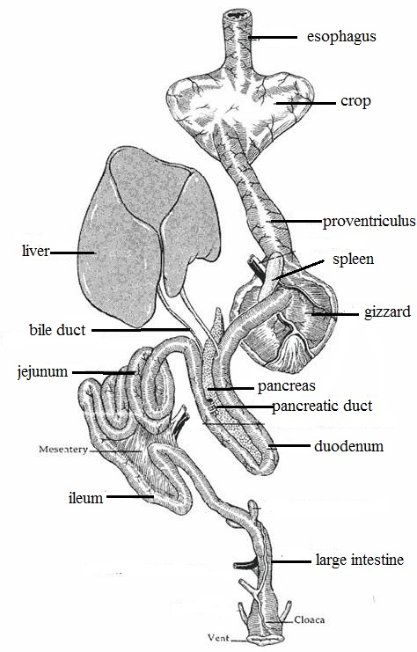

Respiratory system
Inspiration, beginning with the nostrils openings which are situated at the base of the beak. The openings are surrounded by soft sensitive membranous called cere. Air moves through the nostrils into the nasal cavity then to the larynx which is found at the anterior margin of trachea. From there it passes through the larynx and into the trachea. Air moves through the trachea to the syrinx, which is located at the point just before the trachea divides in two bronchi. Syrinx is the sound producing organ of pigeon called sound box. It is a wide cavity supported by tracheal rings. The two bronchi continued running for a short distance enters into the lungs.
Each bronchus made up of cartilaginous rings. Lungs are small, spongy organs; the gas exchange occurs in the walls of microscopic tubules, called 'air capillaries.
There are large, thin walled air sacs present around the lungs of pigeon. Their volume is several times more than the volume of lungs and they fill up much of the body cavity making the body light. There are nine air sacs which are of following types.
(a) Inter Clavicular sac (single)
(b) Cervical air sacs
(c) Anterior thoracic air sacs
(d) Posterior thoracic air sacs
(e) Abdominal air sacs
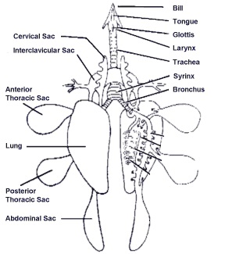
Excretory system
The two kidneys are reddish-brown with three lobes each and are found behind the lungs on each side of the vertebral column. A relatively straight, narrow tube called the ureter, leaves the medial border of each kidney and opens into the cloaca, the ureters do not join with the vas deferens and both open separately into the cloaca. Urinary bladder is absent. Urine is excreted in a semisolid state.

Reproductive system
Male have two functional bean-shaped testes located within the body, just above the kidneys. Each testis is attached to the kidney of its side by mesorchium. In a mature pigeon, the testes can vary in size and greatly enlarge during the breeding season. The left testis is often larger than the right. On the inside of each testes there is a small, flattened area that is called epididymis, where the deferent duct starts at this flattened area. The deferent duct continues from the epididymis as highly coiled tubes running lateral to the ureters. The Posterior end of each deferent duct enlarges to form seminal vesicle, and then opens into the cloaca.
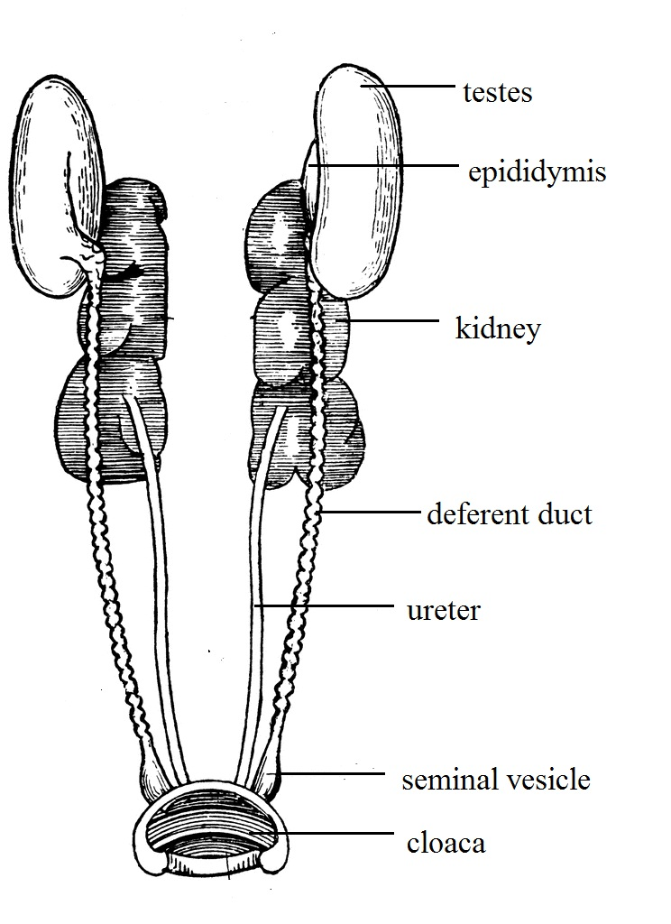

Female reproductive system consists of two ovaries and the oviduct, the left ovary and oviduct grow more rapidly to become functional while the right ovary usually does not develop., the left ovary is located in front of the kidneys and attached to anterior lobe of the left kidney by mesovarium. Ovary containing immature and mature follicles. The mature follicles consist of the egg "yolk" and the unfertilized ovum, matured yolk egg will released into the oviduct.
The oviduct is a long tube with many glands found in its walls. It is divided into five major portions each having different functions:
- *Infundibulum (or funnel): Located adjacent to the ovary and with long segments enclosing the ovary, the infundibulum collects the yolk after its release from the follicle as a funnel and directs it into the oviduct. Fertilization of the ovum by the male sperm occurs here.
- *Magnum: This is the longest and most coiled portion of the oviduct. It is very thick-walled and contains many tubular glands which secrete albumen.
- *Isthmus: Is a short portion of the oviduct. In this portion the inner and outer shell membranes which line the shell are formed.
- *Uterus or shell gland: The shell of the egg is secreted here by the shell gland.
5. *Vagina: It secretes the egg’s outer cuticle and possibly the shell pigment. The vagina is important in the laying of the egg, it is made of muscle that helps push the egg out of the hen's body.

