7- Calculation of the σy and σz Coefficients. Stability Methodology

The dispersion coefficients (σ) are determined from field measurements. The dispersion coefficients are dependent on:
1-The topography of the area of interest,
2-The atmospheric stability and
3-The distance and time from the start of the dispersion (Schnelle and Dey 1999).
The values in the scientific literature for the functions, σ_{y} and σ_{z} versus distance from the source and stability conditions have been calculated during field experiments from the period between 1950 and 1960 (Hanna et al. 1981). The area of the experiment was homogeneous, the emissions were performed close to the surface and the measurements were done at distances smaller than 1 km from the source. These field experiments resulted in 1961 in the Pasquill curves (Fig. 6.1). The semi continuous lines are due to the fact that, the experiments were performed at a distance of 1 km away and the continuation of the lines is valid in ideal conditions. Probably the actual curves deviate from these ideal lines since the conditions in the atmosphere are almost never ideal.
Analytical expressions for the functions σ_{y} and σ_{z} (dispersion coefficients for the directions x and y) have been presented in the scientific literature. One of the first mathematical expressions was given during 1967 by Smith who showed hourly measurements at distances up to 10 km from a source with height of 10⁸ meters. According to Smith’s measurements the following expressions for σ_{y} and σ_{z} are given:

σ_{y} = a χ ^{b} and σ_{z} = c χ ^{d}

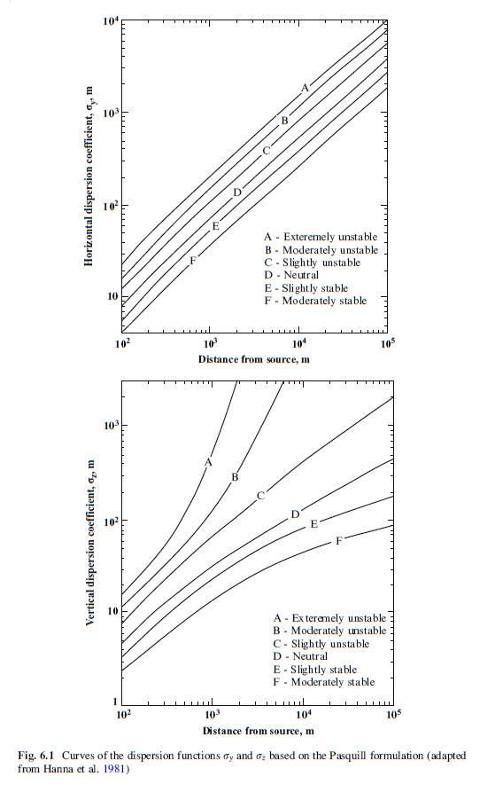

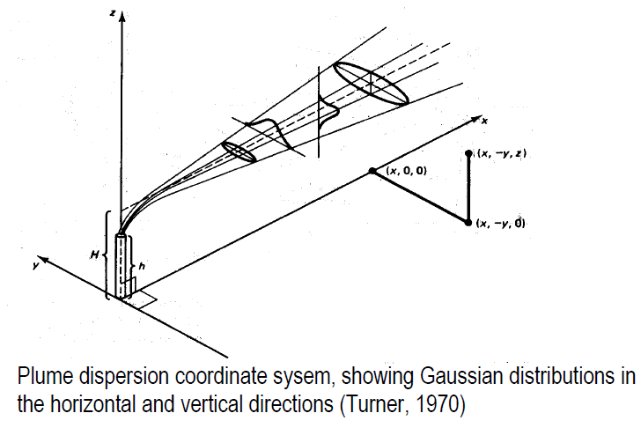
7-1 Plume Rise
When the emissions from a stack have a higher temperature than the temperature of the environment, then the plume is rising due to thermal motion. In addition, plume rise is also occurring if the emissions exit the stack with high velocity. Some plumes rise also due to different characteristics of the pollutants (density and composition). These gaseous species have positive upward transport (buoyant plume) if they are thinner than the air and a downward transport if they are heavier than the air. The rising of warm gaseous plumes can be described in the following stages (Fig. 6.3):
- Thermal stage, which is characterized by:
– Mixing due to initial turbulence,
– Moderate ascending and planar shape,
– Application of a linear thermal model and finally
– Description of the phenomenon by the Briggs methodology which assumes that the plume reaches its maximum height at this stage.

- Intermediate stage, which is characterized by:
– Dominance of the atmospheric turbulence,
– Breaking of the plume into small compartments and,
– A stepwise, increase of the plume diameter.

- Diffusion stage, which is characterized by:
– Dominance of the atmospheric turbulence diffusion
– Plume formation– even larger diffusion and
– Relatively slow development.

