**9: METEOROLOGICAL FACTORS AND PLUME-BEHAVIOUR**

Air movements influence the fate of air pollutants. So, any study of air pollution should include a study of the local weather patterns (meteorology). If the air is calm and pollutants cannot disperse, then the concentration of these pollutants’ pollutants will build up. On the other hand, when strong, turbulent winds blow, pollutants disperse quickly, resulting in lower pollutant concentrations Meteorological data helps:

* Identify the source of pollutants
* predict air pollution events such as inversions and high pollutant concentration days
* Simulate and predict air quality using computer models

**9-1 Wind Speed and Direction**

* When high pollutant concentrations occur at a monitoring station, wind data records can determine the general direction and area of the emissions.
* Wind carries air contaminants away from their source, causing them to disperse. The higher the wind speed, the more contaminants are dispersed and the lower their concentration.
* The stronger the wind, the more turbulent the air, and the better the mixing of the contaminants

**9-2 TEMPERATURE:**

* Measuring temperature supports air quality assessment, air quality modelling and forecasting activities.
* Temperature and sunlight (solar radiation) play an important role in the chemical reactions that occur in the atmosphere to form photochemical smog from other pollutants.
* Favorable conditions can lead to increased concentrations of smog.
* Warm air sits near the ground and the air can rise easily and carry away pollutants. In a temperature inversion, cold air is trapped near the ground by a layer of warm air. During a temperature inversion, smoke can't rise and carbon monoxide can reach unhealthy.

**9-2-1 TEMPERATURE INVERSION:**

* Temperature inversion, a reversal of the normal behaviour of temperature in the troposphere, in which a layer of cool air at the surface is overlain by a layer of warmer air.
* They occur most often when a warm, less dense air mass moves over a dense, cold air mass. This can happen for example when the air near the ground rapidly loses its heat on a clear night. In this situation, the ground becomes cooled quickly while the air above it retains the heat the ground was holding.

**9-3 HUMIDITY:**

* Like temperature and solar radiation, water vapor plays an important role in many thermal and photochemical reactions in the atmosphere.
* As water molecules are small and highly polar, they can bind strongly to many substances. If attached to particles suspended in the air, they can significantly increase the amount of light scattered by the particles HUMIDITY increase the amount of light scattered by the particles (measuring visibility). If the water molecules attach to corrosive gases, such as sulfur dioxide, the gas will dissolve in the water and form an acid solution that can damage health and property.
* Water vapor content of air is reported as a percentage of the saturation vapor pressure of water at a given temperature. This is the relative humidity.
* The amount of water vapour in the atmosphere is highly variable—it depends on geographic location.

**9- 4 RAINFALL:**

* Rain has a 'scavenging' effect when it washes particulate matter out of the atmosphere and dissolves gaseous pollutants.
* Removing particles improves visibility. Where there is frequent high rainfall, air quality is RAINFALL generally better.
* If the rain dissolves gaseous pollutants, such as sulfur dioxide, it can form acid rain resulting in potential damage to materials or vegetation.

**9-5 DISPERSION:**

* Turbulent velocity fluctuations.
* Diffusion due to concentration gradients – from plumes.
* Aerodynamic characteristics of pollution.
* Particles.
* Size
* Shape
* Weight

**9-6 TURBULENCE**:

* Two types:
* Atmospheric heating Causes natural convection currents --- discussed
* Thermal eddies
* Mechanical turbulence
* Results from shear wind effects
* Result from air movement over the earth’s surface, influenced by location of buildings and relative roughness of terrain.

**9-7 LAPSE RATE:**

* Important characteristic of atmosphere is ability to resist vertical motion: stability.
* Affects ability to disperse pollutants.
* When small volume of air is displaced upward

• Encounters lower pressure.

• Expands to lower temperature.

• Assume no heat transfers to surrounding atmosphere.

• Called adiabatic expansion.

**9-8 ATMOSPHERIC STABILITY:**

* Atmospheric stability determines whether or not air will rise and cause storms, sink and cause clear skies, or essentially do nothing.
* Stability is dependent upon the Dry and Saturated Adiabatic Lapse Rates and the Environmental Lapse Rate.

**9-8-1CONDITIONS**:

1. If an air parcel is warmer than its surrounding environment, then it will be less dense than its surroundings and will rise like a hot air balloon. This is Unstable Air and has the potential for creating storms.
2. If an air parcel is cooler than its surrounding environment, then it will be denser than its environment and will sink. This is Stable Air which generally leads to clear skies.
3. If an air parcel is the same temperature as its:
4. Environmental Lapse Rate: The rate at which the air temperature changes with height in the atmosphere surrounding a cloud or a rising parcel of air. The overall average rate is a decrease of about 6.5°C/km.
5. Where the lapse rate of temperature is negative (temperature increases with height), an inversion is said to exist.
6. The word adiabatic means that no outside heat is involved in the warming or cooling of the air parcels.
7. Dry air cools at about 10 C/km (the 'dry adiabatic lapse rate'), while moist air usually cools at less than 6 C/km ('moist adiabatic lapse rate’).
8. The lapse rate that occurs in a vertically moving air parcel in which no condensation is occurring. The temperature change is related to the expansional cooling` q (compressional warming) that occurs when the air moves upward (downward).

**Vertical Temperature Profiles:**

* Environmental lapse rate (ELR)
* Dry adiabatic lapse rate (DALR)

**If:**

* ELR **>** DALR =sub adiabatic condition, atmosphere is stable.
* ELR **>>** DALR=Inversion conditions. Very stable atmosphere.
* ELR **=** DALR=atmosphere is neutral.
* ELR**<** DALR = super adiabatic condition, atmosphere is unstable. Shapes of plumes

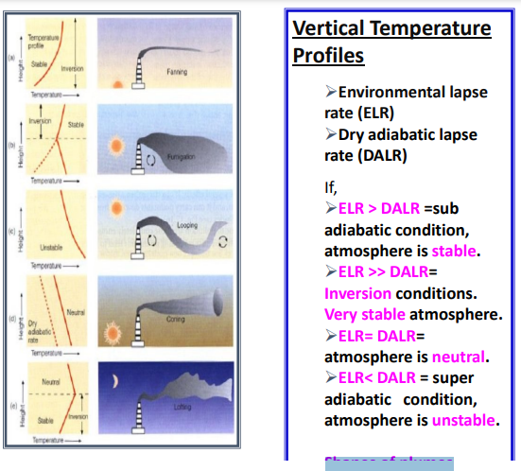

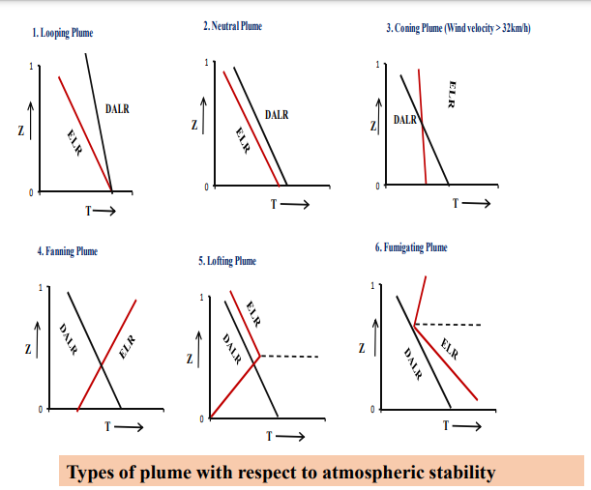

**9-9 Plume Rise**

As you observe smoke from a stack, you will notice that the smoke usually rises above the top of the stack. The distance that the plume rises above the stack is called *plume rise.* It is actually calculated as the distance to the imaginary centerline of the plume rather than to the upper or lower edge of the plume. Plume rise, Δh, depends on the stack’s physical characteristics. For example, the effluent characteristic of stack temperature in relation to the surrounding air temperature is more important than the stack characteristic of height. The difference in temperature between the stack gas (TS) and the ambient air (Ta) determine plume density and that density affects plume rise. Therefore, smoke from a short stack could climb just as high as smoke from a taller stack. Fig.1 a

Stack characteristics are used to determine momentum, and effluent characteristics are used to determine buoyancy. The stack provides the initial momentum of the effluent. It is determined by the speed of the effluent as it exits the stack. As momentum carries the effluent out of the stack, atmospheric conditions begin to affect the plume. Fig.1b

The condition of the atmosphere, including the winds and temperature profile along the path of the plume, will largely determine the plume’s rise. As the plume rises from the stack, the wind speed across the stack top begins to tilt the plume. Wind speed usually increases with distance above the earth’s surface. As the plume continues upward the stronger winds tilt the plume even farther. This process continues until the plume appears to be horizontal to the ground. The point where the plume to be appears to be horizontal may be a considerable distance downwind from the stack. The stronger the wind, the faster the plume will tilt over. Fig.1c

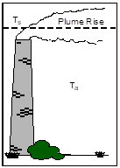  

Figure 1a Figure 1b Figure 1c

**9-10 Dispersion Modeling**

*Dispersion modeling is a tool used by environmental scientists to predict patterns of air pollution transport and dispersion*.

Wind speed and direction, atmospheric stability, plume rise and topography interact in complex ways to cause the transport and dispersion of air pollution. Pollutant dispersion modeling was created as a comprehensive means of viewing the results of these complex interactions, collecting data attributable to various elements, both natural and man-made, and estimating the amount of ground-level pollution at various distances from the source. *Modeling*, therefore, is a mathematical representation of pollutant dispersion and the factors that influence it. As an extension of these mathematic representations, scientists also use computer modeling to produce graphic representations of the transport and dispersion of air pollution.

In order to develop a precise model or method to illustrate the manner in which air pollution is transported and dispersed for a given locale, information about the pollutant source is needed. This information generally includes surrounding geographic features, features, quantity and types of pollutants emitted, effluent gas conditions, stack height, and influential meteorological factors. Using these types of data as input for a computer model, scientists can effectively predict how pollutants will be dispersed into the atmosphere. In addition, levels of pollutant concentration can be estimated for various distances and directions from the site of the smokestack.

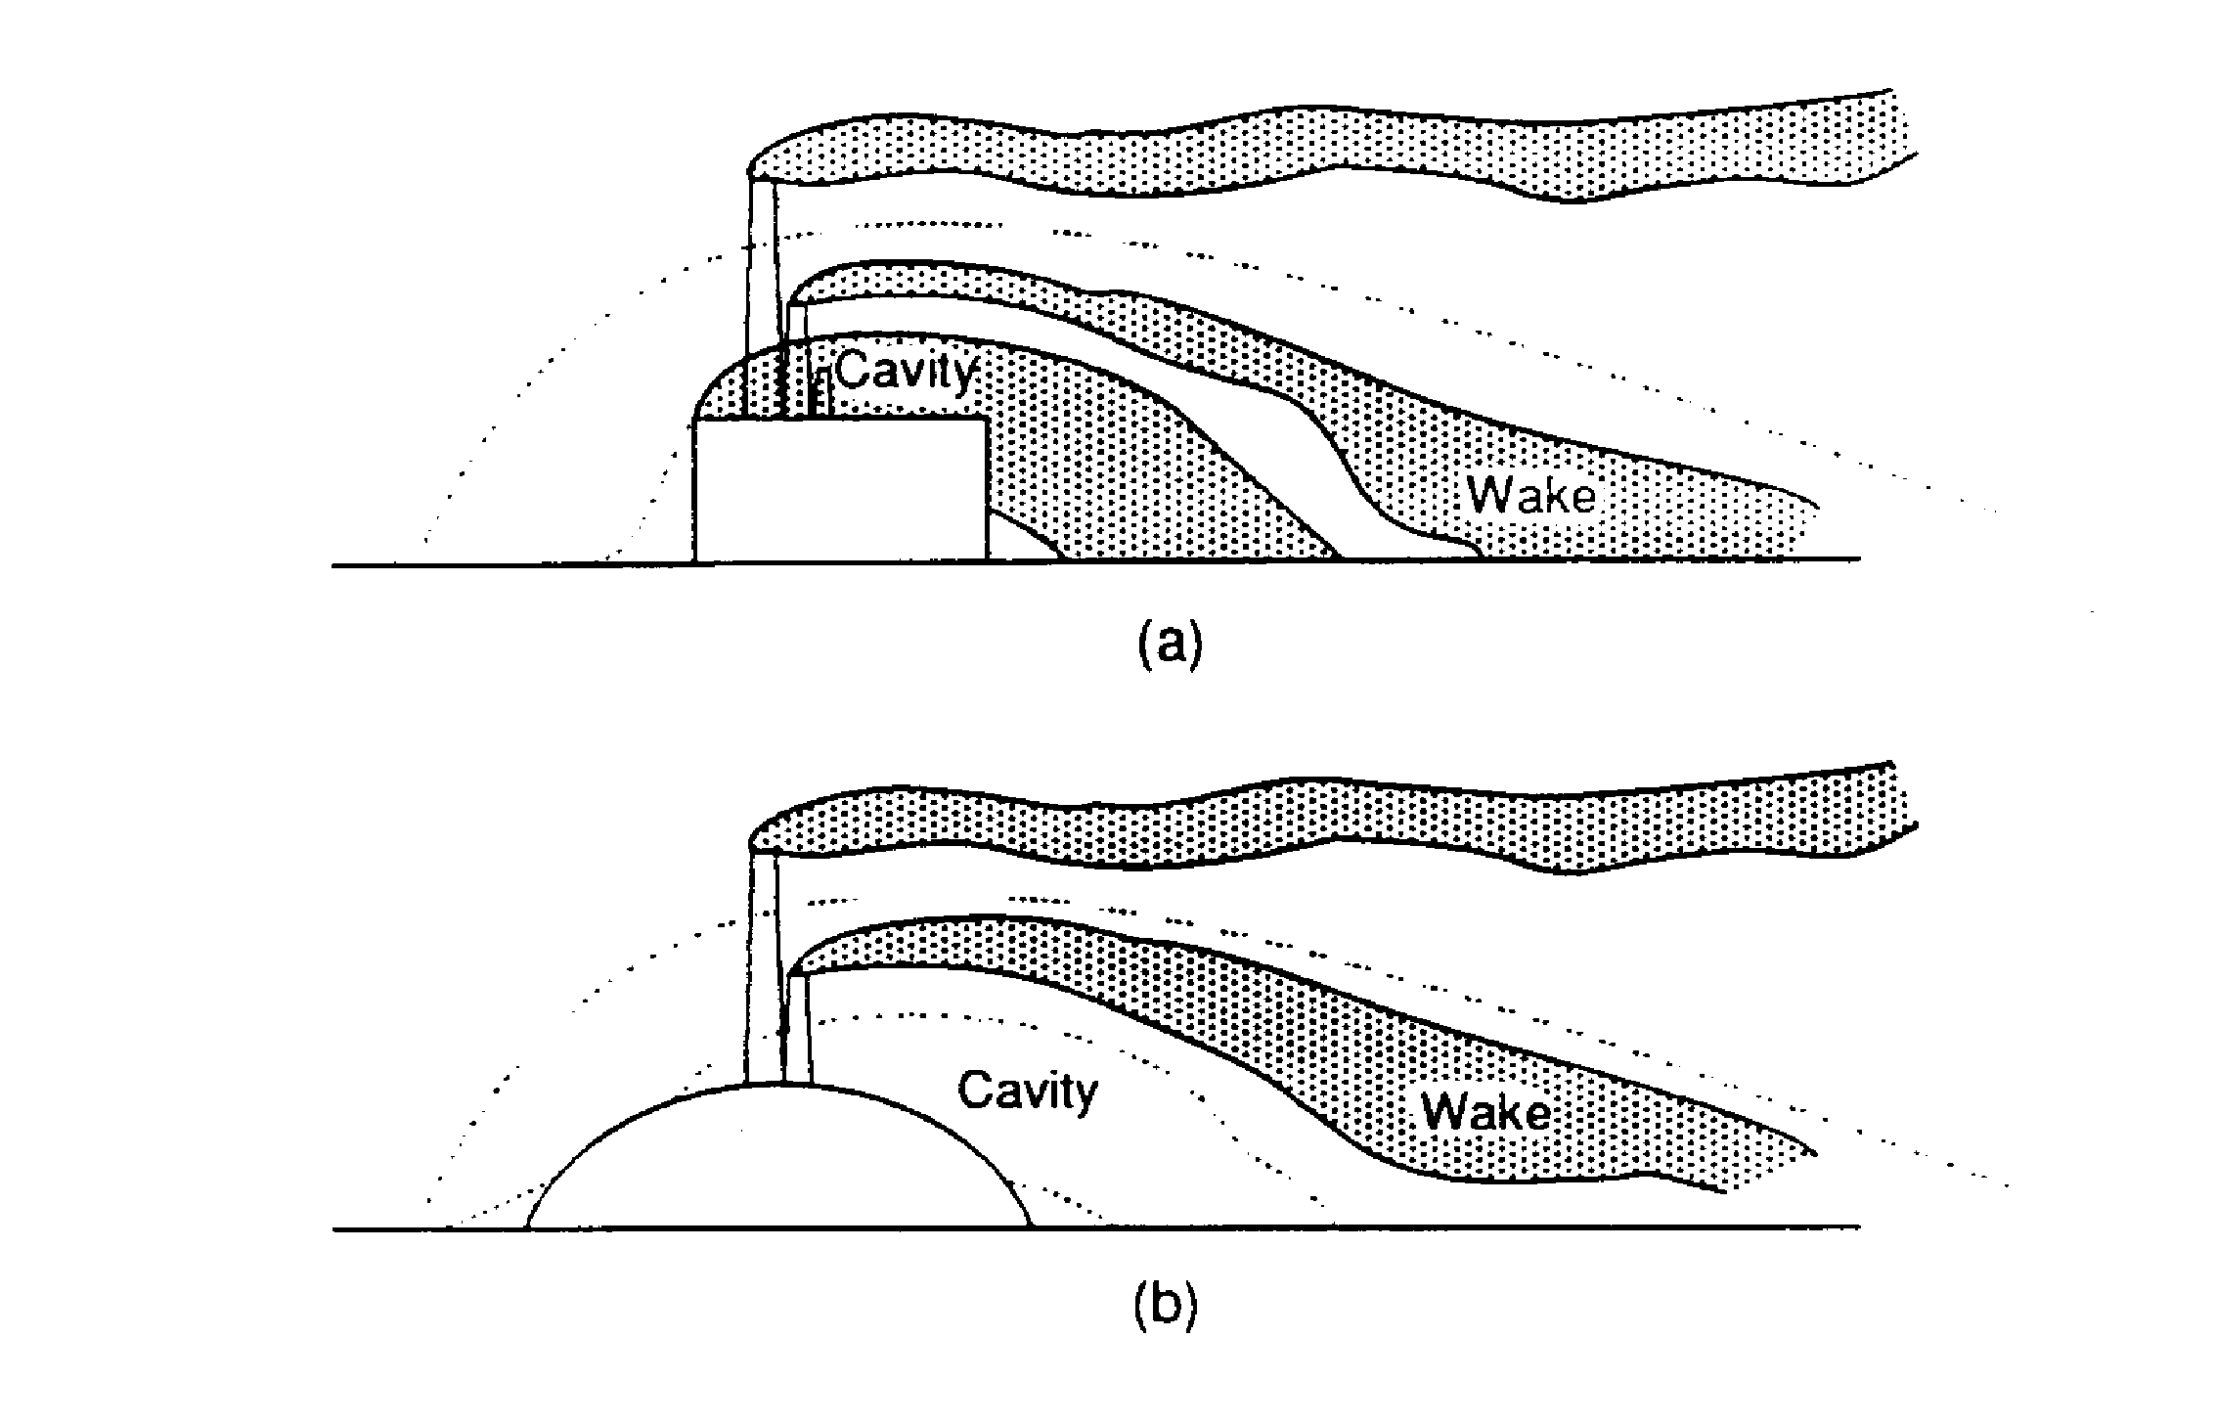

# Types of Pollutant Dispersion:

1. Distribution of pollutants injected within and outside the air cavity.

(b) The effect of streamlining an obstacle during the design phase of an effluent stack.

Fig. 3-10. Types of Pollutant Dispersion

Note:

*Air dispersion modeling is utilized extensively in the permitting process for new and existing industrial facilities. For New Source Review (NSR) requirements, dispersion modeling can determine whether the proposed source will exceed its part of an allowable air increment within the facilities Air Quality Management Area.*

**9-11 Theories of Atmospheric Diffusion**

Theories of Atmospheric Diffusion The mathematical description of the concentration profile of different chemical compounds in the atmosphere is one of the applications of atmospheric models. The problem which someone has to solve is to calculate the spatial and temporal concentration of air pollutants under specific emission conditions. Of course, in order to solve this problem, it is necessary to have a detailed description of the pollutant emissions, the land topography, the reactivity of the pollutants and the transport conditions in the atmosphere. The accurate determination of the factors which control the concentration of pollutants in the ambient air such as the emission sources, the pollutant transport (meteorological conditions) and the surface topography define how realistic is the solution of the problem.

In the literature, several categories of models have been used such as deterministic, statistical and stochastic for the solution of problems for pollutant dispersion in the atmosphere. Numerical and analytical solutions have been applied for deterministic models. Numerical solutions have been used widely but require extensive input data and computational time. Stochastic Gaussian models have been used also for air pollution control. There are two general approaches for the description of turbulent dispersion in the atmosphere, the Euler and Lagrange approaches. In the Euler approach the system is examined in fixed coordinates and is the most popular approach for the examination of mass and heat in the atmosphere. In the Lagrangian approach the concentration changes are described in relation to a non-fixed coordinate system (e.g., air). However, these two approaches can be related to each other as described in the current lecture.

**9-12 Euler Description**

The concentration of every chemical compound versus time has to satisfy the mass equilibrium inside the contained volume. This is the equation of continuity. The change of mass inside the air volume due to convection is balanced with mass transfer which is produced from chemical reactions, molecular diffusion and emissions. The mathematical description of this procedure for each chemical species it is given by the following equation for the concentration ci