IEC:6 SOIL MICROBIOLOGY DR.ASSEEL HABH

Phosphorus cycle
The phosphorus cycle is the biogeochemical cycle that describes the movement of phosphorus through the lithosphere, hydrosphere, and biosphere. Unlike many other biogeochemical cycles, the atmosphere does not play a significant role in the movement of phosphorus, because phosphorus and phosphorus-based compounds are usually solids at the typical ranges of temperature and pressure found on Earth. The production of phosphine gas occurs in only specialized, local conditions.
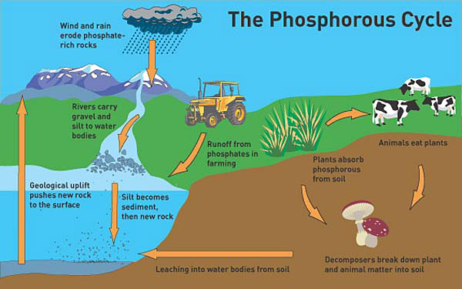
On the land, phosphorus gradually becomes less available to plants over thousands of years, because it is slowly lost in runoff. Low concentration of phosphorus in soils reduces plant growth, and slows soil microbial growth
Phosphorus is an essential nutrient for plants and animals. Phosphorus is a limiting nutrient for aquatic organisms. Phosphorus forms parts of important life-sustaining molecules that are very common in the biosphere. Phosphorus does enter the atmosphere in very small amounts when dust is dissolved in rainwater and seaspray, but remains mostly on land and in rock and soil minerals. Eighty percent of the mined phosphorus is used to make fertilizers. Phosphates from fertilizers, sewage and detergents can cause pollution in lakes and streams. Overenrichment of phosphate in both fresh and inshore marine waters can lead to massive algae blooms which, when they die and decay, leads to eutrophication of fresh waters only. An example of this is the Canadian Experimental Lakes Area. These freshwater algal blooms should not be confused with those in saltwater environments. Recent research suggests that the predominant pollutant responsible for algal blooms in salt water estuaries and coastal marine habitats is Nitrogen.

Phosphorus occurs most abundantly in nature as part of the orthophosphate ion (PO4)3−, consisting of a P atom and 4 oxygen atoms. On land most phosphorus is found in rocks and minerals. Phosphorus rich deposits have generally formed in the ocean or from guano, and over time, geologic processes bring ocean sediments to land. Weathering of rocks and minerals release phosphorus in a soluble form where it is taken up by plants, and it is transformed into organic compounds. The plants may then be consumed by herbivores and the phosphorus is either incorporated into their tissues or excreted. After death, the animal or plant decays, and phosphorus is returned to the soil where a large part of the phosphorus is transformed into insoluble compounds. Runoff may carry a small part of the phosphorus back to the ocean. Generally with time (thousands of years) soils become deficient in phosphorus leading to ecosystem retrogression.

The primary biological importance of phosphates is as a component of nucleotides, which serve as energy storage within cells (ATP) or when linked together, form the nucleic acids DNA and RNA. The double helix of our DNA is only possible because of the phosphate ester bridge that binds the helix. Besides making biomolecules, phosphorus is also found in bone and the enamel of mammalian teeth, whose strength is derived from calcium phosphate in the form of Hydroxylapatite. It is also found in the exoskeleton of insects, and phospholipids (found in all biological membranes). It also functions as a buffering agent in maintaining acid base homeostasis in the human body

Little of this released phosphorus is taken up by biota (organic form), whereas a larger proportion reacts with other soil minerals. This leads to precipitation into unavailable forms in the later stage of weathering and soil development. Available phosphorus is found in a biogeochemical cycle in the upper soil profile, while phosphorus found at lower depths is primarily involved in geochemical reactions with secondary minerals. Plant growth depends on the rapid root uptake of phosphorus released from dead organic matter in the biochemical cycle. Phosphorus is limited in supply for plant growth. Phosphates move quickly through plants and animals; however, the processes that move them through the soil or ocean are very slow, making the phosphorus cycle overall one of the slowest biogeochemical cycles.

