**Lab:4**

**Tissues**

**Tissue:** It is a group of cells similar in shape and function .

There are four main chief tissues in the body.

1. **Epithelial tissue**
2. **Connective tissue**
3. **Muscular tissue**
4. **Nervous tissue**

**Epithelial tissue**

Epithelium is divided into two types:

* + - * 1. **Simple epithelium:**

One cell layer thick

All cells rest on the basement membrane (basal surface) and all cells face the free surface.

Types of simple epithelium are: Squamous, Cuboidal, Columnar, Pseudostratified .

* + - * 1. **Stratified epithelium:**

1. More than one cell layer thick
2. Only the deepest layer of cells contacts the basement membrane and only the superficial-most cells have a free surface.
3. Types of stratified epithelium are: Squamous, Cuboidal, Columnar, Transitional.

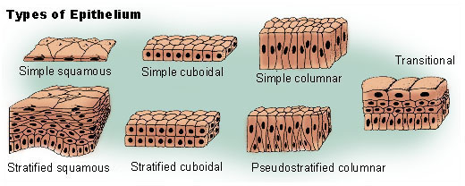

**Connective tissue**

The connective tissue have an important function include connecting, supporting and protection.

**Classification of connective tissue:**

**Proper connective tissue**

**1-Loose connective tissue: areolar**, **reticular** and **adepose.**

**2-Dense connective tissue: regular** and **Irregular**

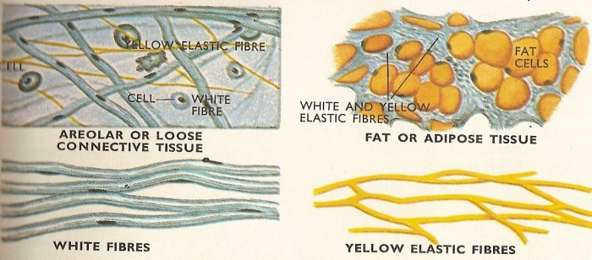

**Special Connective tissue**

**1-Cartilage:** There are three types of cartilage: **hyaline**, **fibro** and **elastic**.

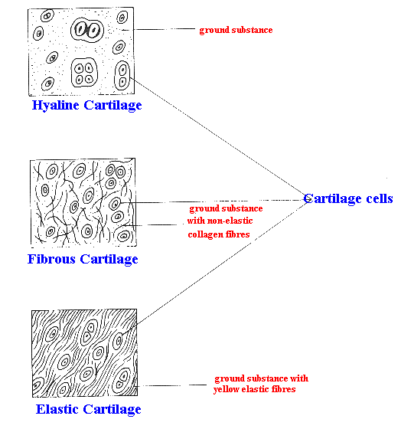

**2-Bone:** There are two types of bone**:compact** and **spongy**

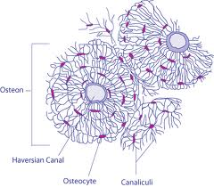

**3- Blood:** Consists of formed elements (cells) Are erythrocytes (RBCs) ,leukocytes (WBCs)& platelets suspended & carried in plasma (fluid part)



**Erythrocytes**

RBCs are flattened biconcave discs, Lack nuclei & mitochondria



**Leukocytes**

1. **Granular leukocytes**.

Include: eosinophils, basophils & neutrophils

**2.Agranular leukocytes**.

Include: lymphocytes & monocytes

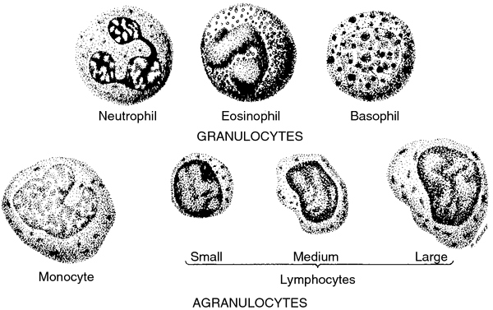

**Platelets (thrombocytes):** Are smallest of formed elements, lack nucleus

