Lab:5

Muscle tissue

Classification of Muscle tissues

    - Skeletal muscle
      - Striated and voluntary
      - Found mostly attached to the skeleton
3)Nuclei are peripherally located

    - Cardiac muscle
      - Striated and involuntary
      - Composes the majority of the heart wall (myocardium)
3) one central nucleus

    - Smooth muscle
      - Nonstriated and involuntary
      - Found mostly in the walls of hollow organs and vessels
3)one central nucleus

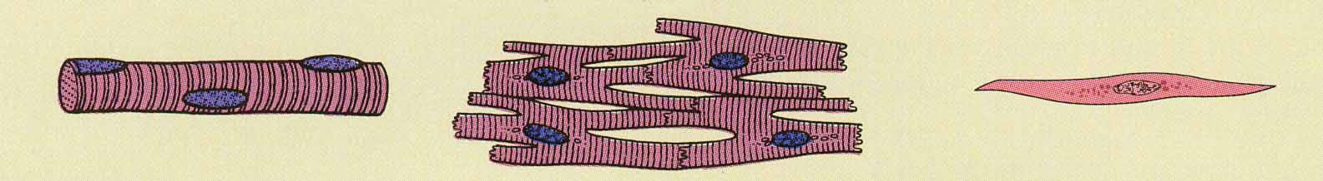
Skeletal muscle Cardiac muscle Smooth muscle

Nervous tissue
Is a tissue that are specialized for receiving different types of stimuli.
Neuron Consists of:
- Cell Body : contains nucleus, mitochondria,nissl bodies
- Dendrites: highly branched extensions of the cell body. Conduct impulses towards the cell body
- Axon: a single long process. Conducts impulses away from the cell body.

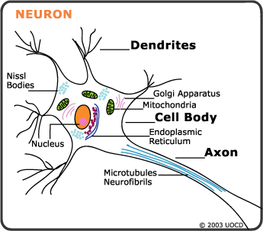
Structural of Neurons:
1. multipolar neurons: more than two processes one is the axon and the rest are denderites
2. bipolar neurons: have two processes one is axon and other one is denderites
3. pseudounipolar neurons : have a single process close to the perikaryon.
