Lab: 6

Biology: The science that deals with life.

Characteristics of life:
Living things show 4 Characteristics that the non living do not display.
1- Metabolic processes: The total of all chemical reaction within an organism. For example Nutrient up take, processing, and waste elimination.
2- Generative processes: Action that increase the size of an individual organism (growth), or increase the number of individual in population (reproduction).
3- Responsive processes: Those abilities to react to external and internal change in the environment, for example irritability individual adaptation , and evolution.
4- Control processes : Mechanisms that ensure that an organism will carry out all metabolic activities in the proper sequences (coordination) and the proper amount.

Scientific Name
- It Started with a system developed by Carlous Linnaeus.
- Linnaeus developed a two – part name system.
- Each known plant or animal is given with two parts.
First part: Genus name.
Last part: Species name.
- Linnaeus used Latin when he named plant & animal.
- The genus name is spelled is with a Capital letter.
- The species name is spelled is with a Small letter.
- When imprint both name are in italics.
- When written a scientific name under lined.
Ex. Fasciola hepatica

Classification

Classification : Means to put things into group.

*Classifying organisms makes it easier to study & learn about them.

* The groups are classified according to the similar & different from each other.
* life characteristics are used to divide all things into two groups non living & living things.
*living things are classified into five main groups. Each main group is called a Kingdom.
The 5 Kingdom are:
1-Monera Kingdom
2-Protista Kingdom
3- Fungi kingdom
4- Plant Kingdom
5- Animal Kingdom

Kingdom: Monera
- These organisms have cell walls.
- They do not have true nucleus & the nuclear material in the cells is not surrounded by a nuclear membrane.
- Chlorophyll may be present in the cells but there are no chloroplasts.
- The Monera kingdom is divided into two phylum:
  - Blue- Green Algae.(e.x: Nostoc , Oscillatoria )
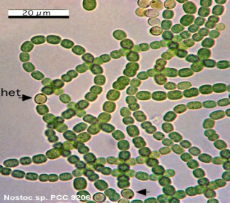

  - Bacteria.( Bacteria )

Bacteria
One- celled, most of them have no chlorophyll ,it have three basic shape ( Coccus, Spherical, Bacillus)
* Bacteria are found deep in Oceans & high in the atmosphere.
* Some bacteria cause disease in the plant & animal. And some bacteria are useful.
* Most bacteria need oxygen, warmth & food & water to grow.
* Bacteria that have chlorophyll can make their food by (photosynthesis) but other bacteria did not have chlorophyll so they obtain food by growth on living thing & called Parasites or by dead organic and called Saprophytes.

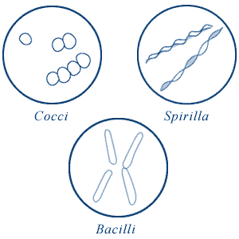

Kingdom: Protista
1- Most of the protista are unicellular .
2- Some of protista make their own food & others obtain their food from plants, animals, or dead organic matter.
3- They have a true nucleus. (Eukaryotic) .
4- The protista kingdom is divided into eight phylum. Three of these phylum are simple algae, four are different groups of Protozoa, one phylum consist of species of slim molds.
The phylum of Protista Kingdom:
- Euglenophyta → Euglena
- Chrysophyta (golden algae) → Diatoms
- Pyrophyta →Ceratium
- Sarcodina → Amoeba
- Ciliophora (Ciliates) → Paramecium
- Mastoigophora → Trichomonas , Trypansoma
- Sporozoa → Plasmodium
- Myxomycota (Slime Molds) → Physarum
Some examples about Protista:
Euglena:
- Are unicellular, live in water
- When present in large amount they may color the water green.
- Euglena have tail called a flagellum
- The shape of Euglena may change sometimes as it swims
- Euglena responds to light by swimming towards it because it has the stigma.
- Euglena has chloroplast and can make its own food.
- Euglena reproduces a sexually through cell division.
- Euglena lack cell wall and can move about.

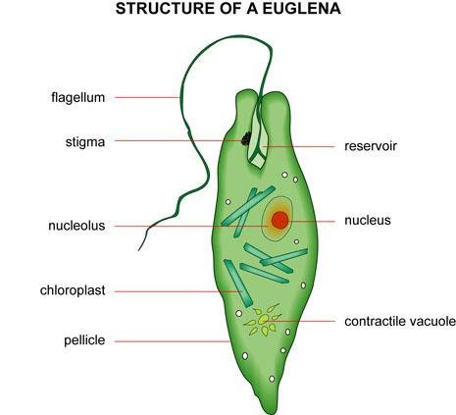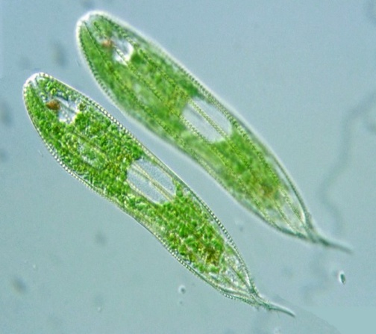

Paramecium:
- Paramecium is a Sporozoa with two nucleuses, large nucleus controls cell activities and small nucleus is involved in reproduction.
- Ciliated do not have cell wall, but they have cell membrane.
- Cilia of Paramecium are short, hair like parts on the out side of the cell.
- Cilia are useful for swimming & in obtaining food.