Lab:7
Kingdom: Animal
- Animals cannot make their own food, so they eat other organisms for food.
- Most animals can move about.
- Multicellular
- Animals with backbones are called vertebrates but the animals without backbones are called invertebrates.
- Animals reproduction can be a sexual or Asexual , ex: Hydra
It can reproductive with both ways.
- Animal Kingdom is classified into nine phylum, Vertebrates animal belong to one phylum & invertebrates belong to eight phylum.

The phylum of Animal Kingdom:
- Porifera (Sponges) →(ex. Sponge)
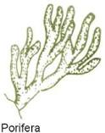
also named sponges:means animal that contains
holes,are sessile feeders(struck to the ground eating what comes near them).
Body symmetry: asymmetric
Ex: yellow Tube spongy.

- Cnidaria→(ex. Hydra)
Contains cnidocyte or Venomous cells that helps collect and
transmit sensory information .
body symmetry: radial
ex :Jelly fishes
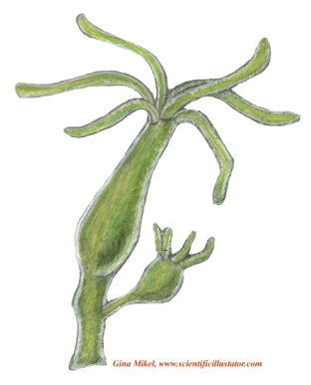
- Platy helminthes (flat worms) →(ex. Liver fluke)
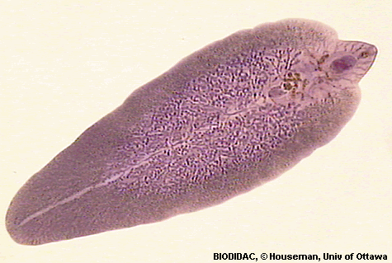
also named flat worms lack a coelom and other body cavities, can be found in
marine of fresh water.
Body symmetry: bilateral
Ex: tapeworms .

4- Nematoda (round worms) →(ex. Ascaris )
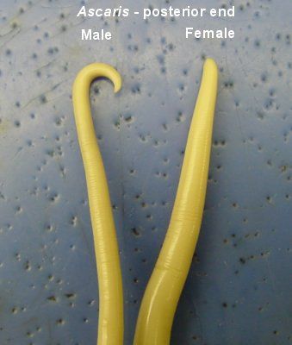
also named round worms, very long
and narrow.
Body symmetry: bilateral
Ex: Ascaris .
5-Annelida →(ex. Earth worm)
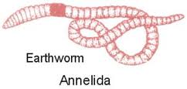
have long bodies that have
segments divided externally
by shallow rings.
Body symmetry: bilateral
Ex: earthworms
6- Mollusca →(ex. Octopus & Snail)
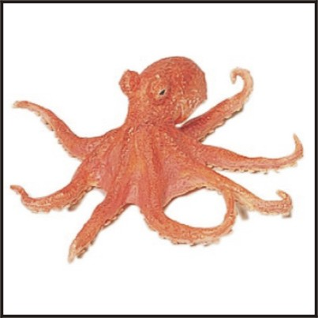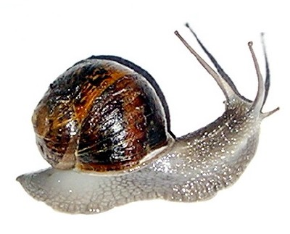
One of the largest phylum composed of many diverse organisms, all have a soft body, body structure composed of three parts.
Body symmetry: bilateral
Ex: snails , octopus
7-Arthropoda →(ex. Butterfly, Spider,Scorpion & Cockroach)

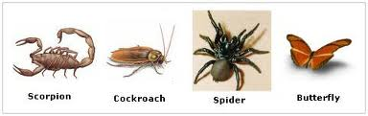
Have jointed appendages (body extensions that give them a wide range of controlled motion) , most successful because they are the most divers, living in a great range of habitats.
Body symmetry : bilateral.
8-Echinodermata →(ex. Sea cucumber , Sea urchin & Sea star)

means spiky skin, dwells at the bottom of
the ocean floor.
Body symmetry: radial
- Chordate → Vertebrate (ex. Fish, Frog & Birds)
Has internal skeletal rod , acomplete digestive
System, a ventral heart, a closed blood system and a tail
Body symmetry: bilateral.
