The Genetics of Cancer
In biology, a gene is a basic unit of heredity and a sequence of nucleotides in DNA or RNA that encodes the synthesis of a gene product, either RNA or protein. During gene expression, the DNA is first copied into RNA
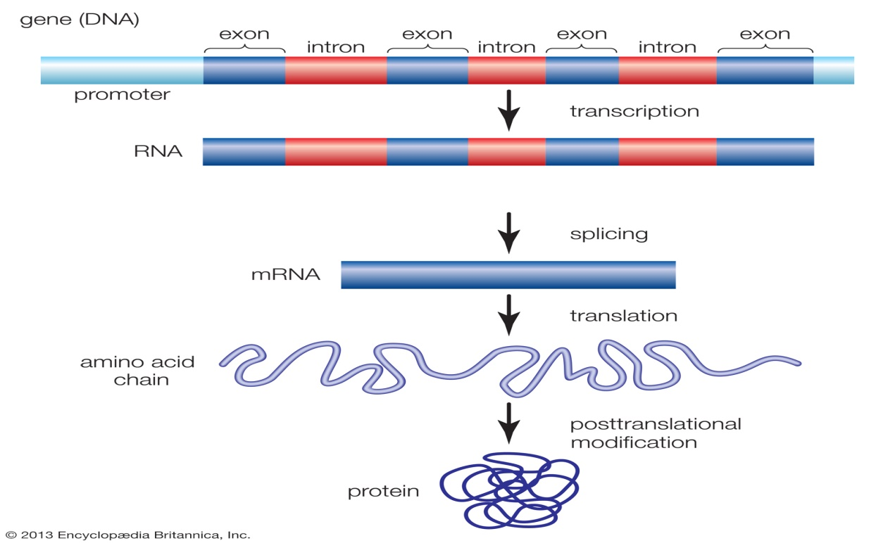
Genes are in the DNA of each cell in your body. They control how the cell functions, including:
- How quickly it grows
- How often it divides
- How long it lives
Researchers estimate that each cell contains 30,000 different genes. Within each cell, genes are located on chromosomes.

About chromosomes
Chromosomes are the thread-like structures in cells that contain genes. There are 46 chromosomes, arranged in 2 sets of 23.
You inherit one set from your mother and one from your father. One chromosome in each set determines whether you are female or male. The other 22 chromosome pairs determine other physical characteristics. These chromosome pairs are called autosomes.

How genes work
Genes control how your cells work by making proteins. The proteins have specific functions and act as messengers for the cell.
Each gene must have the correct instructions for making its protein. This allows the protein to perform the correct function for the cell.
All cancers begin when one or more genes in a cell mutate. A mutation is a change. It creates an abnormal protein. Or it may prevent a protein’s formation.
An abnormal protein provides different information than a normal protein. This can cause cells to multiply uncontrollably and become cancerous.

About genetic mutations
There are 2 basic types of genetic mutations:
Acquired mutations. These are the most common cause of cancer. They occur from damage to genes in a particular cell during a person’s life. For example, this could be a breast cell or a colon cell, which then goes on to divide many times and form a tumor. A tumor is an abnormal mass. Cancer that occurs because of acquired mutations is called sporadic cancer. Acquired mutations are not found in every cell in the body and they are not passed from parent to child.
Factors that cause these mutations include:
- Tobacco
- Ultraviolet (UV) radiation
- Viruses
- Age
Germline mutations. These are less common. A germ line mutation occurs in a sperm cell or egg cell. It passes directly from a parent to a child at the time of conception. As the embryo grows into a baby, the mutation from the initial sperm or egg cell is copied into every cell within the body. Because the mutation affects reproductive cells, it can pass from generation to generation.

Cancer caused by germ line mutations is called inherited cancer. It accounts for about 5% to 20% of all cancers.
Mutations and cancer
Mutations happen often. A mutation may be beneficial, harmful, or neutral. This depends where in the gene the change occurs. Typically, the body corrects most mutations.
A single mutation will likely not cause cancer. Usually, cancer occurs from multiple mutations over a lifetime. That is why cancer occurs more often in older people. They have had more opportunities for mutations to build up.
Types of genes linked to cancer
Many of the genes that contribute to cancer development fall into broad categories:
Tumor suppressor genes. These are protective genes. Normally, they limit cell growth by:
- Monitoring how quickly cells divide into new cells
- Repairing mismatched DNA
- Controlling when a cell dies
When a tumor suppressor gene mutates, cells grow uncontrollably. And they may eventually form a tumor.
Examples of tumor suppressor genes include BRCA1, BRCA2, and p53 or TP53.
Germ line mutations in BRCA1 or BRCA2 genes increase a woman’s risk of developing hereditary breast or ovarian cancers and a man’s risk of developing hereditary prostate or breast cancers. They also increase the risk of pancreatic cancer and melanoma in women and men.
The most commonly mutated gene in people with cancer is p53 or TP53. More than 50% of cancers involve a missing or damaged p53 gene. Most p53 gene mutations are acquired. Germline p53 mutations are rare, but patients who carry them are at a higher risk of developing many different types of cancer.
Oncogenes. These turn a healthy cell into a cancerous cell. Mutations in these genes are not known to be inherited.
Two common oncogenes are:
- HER2, a specialized protein that controls cancer growth and spread. It is found in some cancer cells. For example, breast and ovarian cancer cells.
- The RAS family of genes, which makes proteins involved in cell communication pathways, cell growth, and cell death.
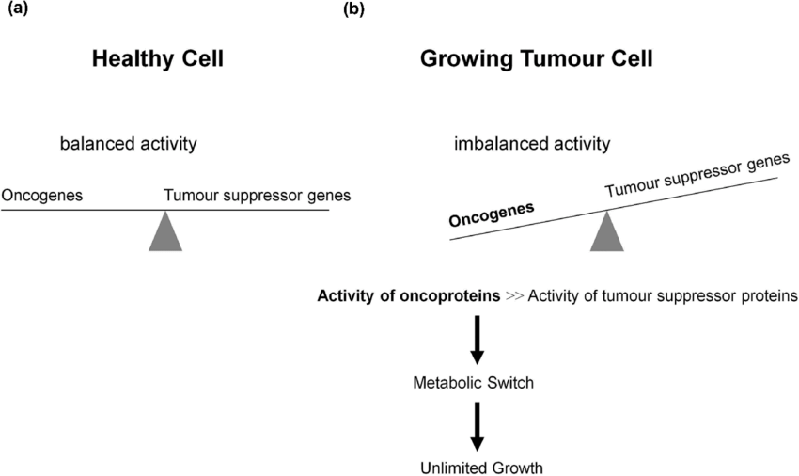

Relationship between Proto-Oncogenes and Tumour
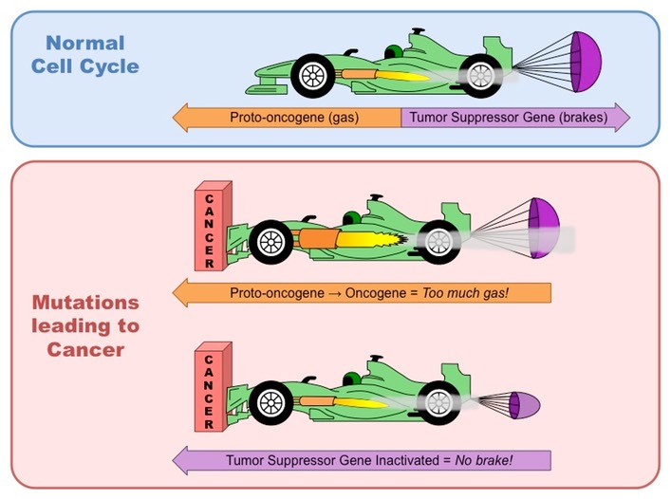
DNA repair genes. These fix mistakes made when DNA is copied. Many of them function as tumor suppressor genes. BRCA1, BRCA2, and p53 are all DNA repair genes.
If a person has an error in a DNA repair gene, mistakes remain uncorrected. Then, the mistakes become mutations. These mutations may eventually lead to cancer, particularly mutations in tumor suppressor genes or oncogenes.
Mutations in DNA repair genes may be inherited or acquired. Lynch syndrome is an example of the inherited kind. BRCA1, BRCA2, and p53 mutations and their associated syndromes are also inherited.
cancer cells can commonly avoid immune detection as they are not foreign bodies but abnormally functioning body cells
This makes them difficult to treat – common strategies involve surgical removal and chemotherapy
However there are a number of differences between normal and cancerous tissues which may provide the basis for the development of future therapies
Normal Cells versus Cancer Cells
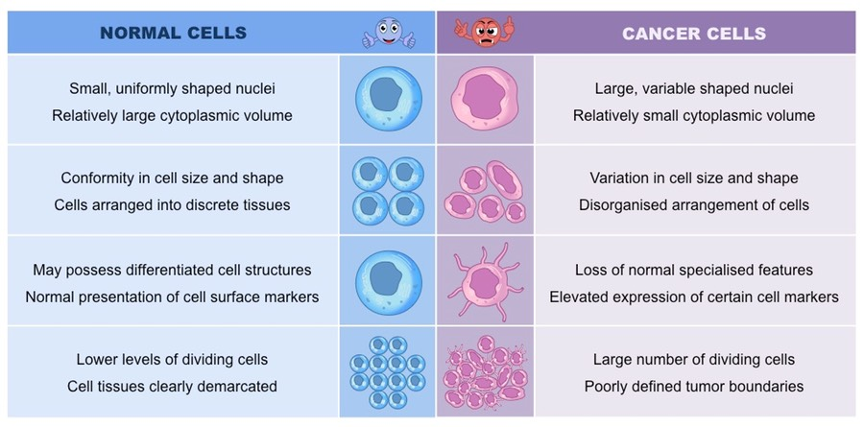

Metastasis
Tumour cells may either remain in their original location (benign) or spread and invade neighbouring tissue (malignant)
Metastasis is the spread of cancer from one location (primary tumour) to another, forming a secondary tumour
Secondary tumours are made up of the same type of cell as the primary tumour – this affects the type of treatment required
- E.g. If breast cancer spread to the liver, the patient has secondary breast cancer of the liver (treat with breast cancer drugs)

Formation of Secondary Tumours via Metastasis

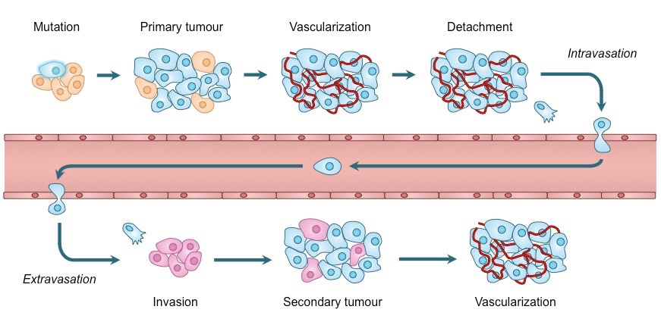

Challenges in understanding cancer genetics
Researchers have learned a lot about how cancer genes work. But many cancers are not linked with a specific gene. Cancer likely involves multiple gene mutations. Moreover, some evidence suggests that genes interact with their environment. This further complicates our understanding of the role genes play in cancer.
Researchers continue to study how genetic changes affect cancer development. This knowledge has led to improvements in cancer care, including early detection, risk reduction, the use of targeted therapy, and survival.
Further studying cancer genetics may help doctors find better ways to:
- Predict a person’s risk of cancer
- Diagnose cancer
- Treat cancer

