**THE EXTRACTION OF SEMIVOLATILE ORGANICS FROM LIQUIDS**

**PRINCIPLES OF EXTRACTION**

The three widely used techniques for extraction of semivolatile organics from liquids:

1- Liquid–liquid extraction (LLE)

2- Solid-phase extraction (SPE)

3- Solid-phase microextraction (SPME)

Other techniques may be useful in selected circumstances, but these three techniques have become the extraction methods of choice for research and commercial analytical laboratories. A fourth, recently introduced technique, stir bar sorptive extraction (SBSE), is also used.

To understand any extraction technique it is first necessary to discuss some underlying principles that govern all extraction procedures. The chemical properties of the analyte are important to an extraction, as are the properties of the liquid medium in which it is dissolved and the gaseous liquid, supercritical fluid, or solid extractant used to effect a separation. Of all the relevant solute properties, five chemical properties are fundamental to understanding extraction theory:

1- Vapor pressure

2- Solubility

3- Molecular weight

4- Hydrophobicity

5- Acid dissociation

These essential properties determine the **transport** of chemicals in the human body, the transport of chemicals in the air–water–soil environmental compartments, and the transport between immiscible phases during analytical extraction.

Extraction or separation of dissolved chemical component X from liquid phase A is accomplished by bringing the liquid solution of X into contact with a second phase, B, given that phases A and B are immiscible. Phase B may be a solid, liquid, gas, or supercritical fluid. A distribution of the component between the immiscible phases occurs. After the analyte is distributed between the two phases, the extracted analyte is released and/or recovered from phase B for subsequent extraction procedures or for instrumental analysis.

**Volatilization**

Volatilization of a chemical from the surface of a liquid is a partitioning process by which the chemical distributes itself between the liquid phase and the gas above it. Organic chemicals said to be volatile exhibit the greatest tendency to cross the liquid–gas interface. When compounds volatilize, the concentration of the organic analyte in the solution is reduced. Semivolatile and nonvolatile (or involatile) describe chemicals having, respectively, less of a tendency to escape the liquid they are dissolved in and pass into the atmosphere above the liquid, certain sample preparation techniques are clearly more appropriate for volatile compounds than for semivolatile and nonvolatile compounds.

**SOLID-PHASE EXTRACTION**

The historical development of solid-phase extraction (SPE) has been traced by various authors. After a long latency period (from biblical times to 1977) when the theoretical ‘‘science’’ of SPE was known but not frequently practiced, technological breakthroughs in sorbents and devices fueled the growth of SPE use that continues today. The modern era of SPE, which resulted in today’s exponential growth in applications of this technique began in 1977 when the Waters Corporation introduced commercially available, prepackaged disposable cartridges/columns containing bonded silica sorbents. The term solid-phase extraction was coined in 1982 by employees of the J.T. Baker Chemical Company.

The most commonly cited benefits of SPE that led to early advances relative to LLE are reduced:

1- **Analysis** **time** **2- cost** 3- **labor** 4- **organic solvent**

Because SPE is **faster** and requires less manipulation; reduced organic solvent consumption and disposal which results in reduced analyst **exposure** to organic solvents; and reduced potential for formation of emulsion. The potential for automation of SPE increased productivity because multiple simultaneous extractions can be accomplished. SPE provides **higher concentration factors** (i.e., **KD**) than LLE and can be used to **store** analytes in a **sorbed state** or as a vehicle for chemical derivatization SPE is a multistaged separation technique providing greater opportunity for **selective isolation** than LLE such as fractionation of the sample into different compounds or groups of compounds. The use of SPE for all of these objectives is being exploited by today’s SPE researchers.

Solid-phase extraction refers to the nonequilibrium, exhaustive removal of chemical constituents from a flowing liquid sample via retention on a contained solid sorbent and subsequent recovery of selected constituents by elution from the sorbent. The introduction of sorbents exhibiting a very strong affinity for accumulating semivolatile organic compounds from water was the primary advance in the 1970s that propelled the technique into widespread use. The affinity, which was strong enough to be analytically useful from sorbents that were inexpensive enough to be economically feasible, was useful in both pharmaceutical and environmental applications.

Mathematically, a strong affinity equates to a large KD value in equation because the concentration in the sorbent extracting phase, [X]B, is large relative to the sample extracted. For this reason, SPE is sometimes referred to as **digital chromatography**, indicating the all-or-nothing extremes in the sorptive nature of these sorbents, caused by the strong attraction for the analyte by the sorbent. SPE drives **liquid chromatographic mechanisms** to their extreme, such that KD approaches infinity, representing total accumulation of the analyte during retention, and KD approaches zero during subsequent elution or release of the analyte

Some analysts mistakenly refer to SPE sorbents as ‘‘**filters**’’ and the SPE process as ‘‘**filtration**’’ because of the porous character of many of the sorbents used for SPE. The molecules of the analyte that exist in true homogeneous solution in the sample are not filtered; they become associated with the solid phase through sorption. However, sorbent particles do act as **depth filters** toward particulate matter that is not in true homogeneous solution in the sample. Particulate matter can become lodged in the interstitial spaces between the sorbent particles or in the intraparticulate void volume, or pore space, within sorbent particles. The filtering of particulate matter is generally detrimental to the analysis and can lead to plugging of the extraction sorbent or channeling the flow through the sorbent.

Fritz summarizes that the severity of a plugging problem in SPE depends on

(1) The concentration type and size of the particulates in the sample

(2) The pore size of the sorbent

(3) The surface area of the sorbent bed

While particulate matter can cause plugging and channeling of the sorbent in SPE as described above, analysts performing SPE extraction and other analytical procedures must also be concerned with the potential for the analyte’s association with particulate and colloidal matter contamination in the sample. Complex equilibria govern **partitioning** of organic analytes among the solution phase, colloidal material, and suspended particulate matter. Depending on the chemical nature of the analyte and the contamination, some of the analyte molecules can become sorbed to the contaminating particulate and/or colloidal matter in the sample. Analytes can adhere to biological particulates such as **cellular debris** or bind **to colloidal proteins**. Similarly, analytes can adhere to environmental particulates or associate with colloidal **humic substances**. If the sample is **not filtered** particulates can partially or entirely elute from the sorbent, leading to both a dissolved and particulate result when the sample is analyzed. In addition to concern about the potential for suspended solids in the water sample **plugging the SPE** sorbent and analytes of interest adsorbing onto particulates **loss of the analyte may occur** if small particulates pass through the pores of the sorbent bed. To avoid these problems and ensure consistent results, sample particulate matter should be removed by **filtration prior to SPE analysis**. If measuring the degree to which the analyte is bound to contaminants in the solution or, conversely, the degree to which the analyte is unassociated, or in true solution is important, the sample should be filtered prior to analysis by SPE or LLE. **Glass-fiber filters**, which have no organic binders, should be inert toward the analyte of interest while trapping particulate matter Particles with a diameter of 1 mm or greater tend to settle out of solution by gravity. Nominal **filter sizes** of 0.7, 0.45, or 0.22 mm are commonly reported in literature in conjunction with preparation of a sample for SPE. An appropriate level of filtration should be determined for the particular sample matrix being analyzed and used consistently prior to SPE analysis. The material retained on the filter may be analyzed separately to determine the level of bound analyte. The analyst must carefully assess whether rinsing the filter with water or an organic solvent and recombining the rinsings with the filtered sample meet the objectives sought and are appropriate for the given analysis.

**Sorbents in SPE**

Appropriate SPE sorbent selection is critical to obtaining efficient SPE recovery of semivolatile organics from liquids. Henry notes that an SPE sorbent ‘‘**must be able to sorb rapidly and reproducibly**, defined quantities of sample components of interest.’’ Fritz states that ‘‘successful SPE has two major requirements:

1- High, **reproducible** percentage of the analytical solutes must be taken up by the solid extractant.

2- The solutes must then be easily and **completely eluted** from the solid particles.’’

The sorption process must be **reversible**. In addition to reversible sorption, SPE sorbents should be **porous with large surface areas**, be free of leachable impurities exhibit stability toward the sample matrix and the elution solvents, and have good surface contact with the sample solution.

Obviously, **knowledge of the chemistry** and **character of commonly used SPE** sorbents is important to achieving successful extractions. Liska describes developments from the late 1960s until the early 1980s as the ‘‘age of searching’’ for a universal SPE sorbent that culminated in the introduction of polymeric materials and **bonded silicas**. These sorbents have proven useful for a wide variety of applications. However, the realization that no single optimal sorbent for all purposes exists prompts current efforts to optimize a sorbent for a particular application, that is, for a specific analyte in a specific matrix. Poole et al. categorize the SPE sorbents available today as either **general purpose**, **class specific**, or **compound specific**. This discussion covers **polar**, **polymeric**, **bonded silica**, and **graphitized carbon sorbents** of general applicability as well as **functionalized polymeric resins**, **ion-exchange sorbents**, **controlled-access sorbents**, **immunoaffinity sorbents**, and **molecularly imprinted polymers** designed for more specific purposes.

**Polar Sorbents**

The earliest applications of chromatography, a term coined by Tswett in used polar sorbents to separate analytes dissolved in nonpolar solvents. Using **light petroleum** as the nonpolar **mobile phase**, Tswett separated a colored extract from leaves using column chromatography on a polar calcium carbonate column. The alternate system, in which the sorbent is nonpolar while a polar solvent is used, was not used in chromatography until the late 1940s to early 1950s. Howard and Martin introduced the term **reversed-phase** to describe separation of fatty acids using solid-supported **liquid paraffin** or **n-octane** as **nonpolar** **stationary phases** that were eluted with **polar aqueous solvents**. At that time, these systems appeared to be ‘‘**reversed**’’ to the ‘‘normal’’ arrangement of **polar stationary** phases used with **less polar eluents**. Although **reversed-phase** applications outnumber **normal-phase** chromatographic applications today, the nomenclature still applies.

The most common polar sorbents used for **normal-phase SPE** are **silica** (SiO2)x, **alumina** (Al2O3), **magnesium silicate** (MgSiO3 or **Florisil**), and the bonded silica sorbents in which silica is reacted with highly polar functional groups to produce aminopropyl [(SiO2)x-(CH2)3NH2]-, cyanopropyl [(SiO2)x-(CH2)3CN]-, and diol [(SiO2)x-(CH2)3OCH2CH(OH)CH2(OH)]- **modified silica** sorbents (Figure below). Polar SPE sorbents are often used to remove **matrix interferences** from organic extracts of plant and animal tissue. The **hydrophilic matrix** components are **retained** by the **polar sorbent** while the analyte of interest is eluted from the sorbent. The interactions between solute and sorbent are controlled by **strong polar forces** including **hydrogen bonding**, **dipole–dipole** interactions, **π– π interactions**, and **induced dipole–dipole** interactions.

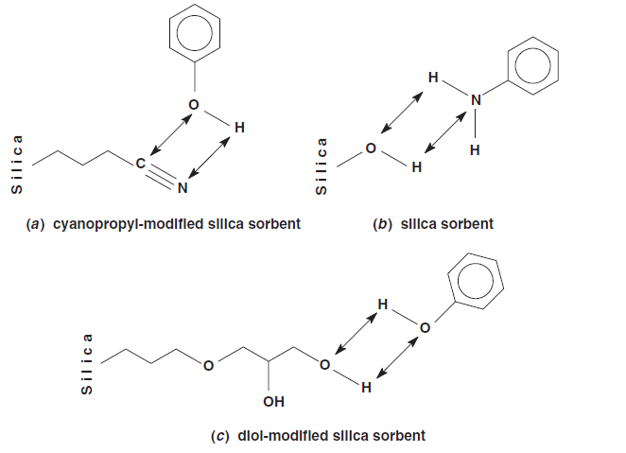

Fig. (1) Interactions between analytes and polar sorbents via dipolar attraction or hydrogen bonding.

**Apolar Polymeric Resins**

Synthetic **styrene–divinylbenzene** and other polymers, particularly the trademarked **XAD resins** developed by Rohm & Haas, were used for SPE in the late 1960s and early 1970s. However, the **particle size** of the XAD resins is **too large** for efficient SPE applications, and therefore the resins require additional grinding and sizing. Also, intensive purification procedures are needed for XAD resins.

In the latter half of the 1990s, porous, highly cross-linked **polystyrene-divinylbenzene** (PS-DVB) resins with smaller, **spherical particle sizes** more **suitable** for SPE uses became available (Figure 2). The new generation of apolar polymeric resins is produced in more purified form, reducing the level of impurities extracted from the sorbent. Polymeric resins are discussed in more detail by Huck and Bonn, Fritz, Thurman and Mills, and

Pesek and Matyska. The enhanced performance of PS-DVB resins is due to their highly **hydrophobic character** and **greater surface area** as compared to the **bonded silica** sorbents. The **strong sorption properties** of PS-DVB resins may arise from the aromatic, poly-meric structure that can interact with aromatic analytes via **π– π** interactions. However, because PS-DVB sorbents are highly **hydrophobic**, they are **less selective**. Also, PS-DVB sorbents exhibit low retention of polar analytes.

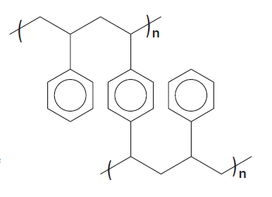

Fig.(2) Cross-linked styrene–divinylbenzene copolymer.

Polymeric organic sorbents can reportedly be used at virtually any pH,2 to 12 or 0 to 14, increasing the potential to analyze simultaneously multiresidue samples containing acidic, basic, and neutral compounds. Polymeric sorbents contain no silanol groups and thereby avoid the problems caused by residual silanol groups when bonded silica sorbents are used.

**Bonded Silica Sorbents**

The first class of sorbents used for modern-era SPE was **bonded-phase silicas**. In the early 1970s, bonded silica sorbents found popularity as a stationary phase for HPLC. HPLC was not commonly used until the early 1970s, nor SPE until the late 1970s, until the application of silanized, or bonded silica sorbents, was realized. May et al. [89] and Little and Fallick are credited with the first reports of applying bonded phases to accumulate organic compounds from water. The first article about SPE on commercially available bonded-phase silica (an octadecyl, C18, phase) was published by Subden et al. and described the cleanup of histamines from wines.

Chemically bonded silica sorbents are currently the most commonly used solid phase for SPE. Bonded stationary phases are prepared by ‘‘grafting’’ **organic nonpolar**, **polar**, or **ionic ligands** (**denoted R**) to a silica particle via covalent reaction with the silanol groups on its surface. The importance of this advancement to chromatography in general and particularly to solid phase extraction was the ability to produce **highly hydrophobic phases** that were more attractive to organic solutes in aqueous solution than any other sorbents available at the time. Reversed-phase bonded silica sorbents having **alkyl groups** covalently bonded to the silica gel backbone interact primarily with analytes via **van der Waals** forces (Figure 3).

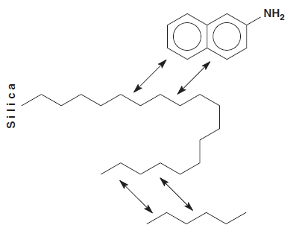

Fig.(3) Interactions between analytes and nonpolar bonded silica sorbents via van de Waals forces.

**Graphitized Carbon Sorbents**

Graphitized carbon sorbents are earning a reputation for the successful extraction of **very polar**, **extremely water soluble** organic compounds from aqueous samples. The retention behavior of the graphitized carbon sorbents is different than that of the apolar polymeric resins or the hydrophobic bonded silica sorbents. Two types of graphitized carbon sorbents, graphitized carbon blacks (GCBs) and porous graphitic carbons (PGCs), are commercially available for SPE applications.

GCBs do **not have micropores** and are composed of a nearly **homogeneous surface array** of graphitelike carbon atoms. **Polar adsorption sites** on GCBs arise from surface oxygen complexes that are few in number but interact strongly with polar compounds. Therefore, GCBs behave both as a **nonspecific sorbent** via **van der Waals** interactions and as an **anion-exchange sorbent** via **electrostatic interactions**. GCBs have the potential for simultaneous extraction of **neutral, basic, and acidic compounds**. In some cases no pH adjustment of the sample is necessary. Desorption can be difficult because GCB is very retentive.

**Functionalized Polymeric Resins**

Adding **polar functional groups** to cross-linked, **apolar polymeric resins** by covalent chemical modification has developed particularly for generation of SPE sorbents suitable for recovery of **polar compounds**. **Hydrophilic functional** groups such as **acetyl-benzoyl, o-carboxybenzoyl, 2-carboxy-3/4- nitrobenzoyl, 2,4-dicarboxybenzoyl, hydroxymethyl, sulfonate, trimethylammonium, and tetrakis(p-carboxyphenyl)porphyrin** have been chemically solid-phase extraction introduced into the structural backbone of PS-DVB copolymers. Generation of a macroporous copolymer consisting of two monomer components, divinylbenzene (lipophilic) and N-vinylpyrrolidone (hydrophilic), produced a hydrophilically–lipophilically balanced SPE sorbent. Chemically modifying apolar polymeric sorbents in this way improves wettability, surface contact between the aqueous sample and the sorbent surface, and mass transfer by making the surface of the sorbent less hydrophobic i.e., more hydrophilic.

**Ion-Exchange Sorbents**

SPE sorbents for ion exchange are available based on either **apolar polymeric resins** or **bonded silica sorbents**. Ion-exchange sorbents contain **ionized functional groups** such as **quaternary amines** or **sulfonic acids**, or **ionizable functional groups** such as **primary/ secondary amines** or **carboxylic acids**. The charged functional group on the sorbent associates with the oppositely charged counter ion through an **electrostatic**, or **ionic**, bond (Figure 4). The functional group on the sorbent can be positively or negatively charged. When the sorbent contains a positively charged functional group and the exchangeable counter ion on the analyte in the liquid sample matrix is negatively charged, the accumulation process is called anion exchange. Conversely, if the functional group on the sorbent surface is negatively charged and the exchangeable counter ion on the analyte in the liquid sample matrix is positively charged, the accumulation process is called cation exchange.

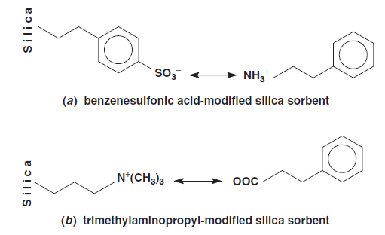

Fig.(4) Interactions between analytes and ion-exchange sorbents: (a) strong cationexchange

sorbent and (b) strong anion-exchange sorbent.

**Controlled-Access Sorbents**

Controlled-access sorbents are intended to be either ‘‘**inclusive**’’ or ‘‘**exclusive**’’ of large molecules and **macromolecules**. **Wide-pore**, or **large-pore**, sorbents are designed intentionally to allow accessibility of macromolecules to the **internal pore structure** of the sorbent such that they will be retained. Conventional SPE sorbents commonly have pores of **60A˚**, whereas widepore SPE sorbents have pores of **275 to 300A˚**. Conversely, restricted access materials or **restricted access media** (RAM) retain **small molecules** while excluding macromolecules such as biological proteins in their presence. Small molecules are retained by **sorption processes** in the pores of the sorbent while the large molecules are **excluded** and elute at the interstitial volume of the sorbent. This separation leads to **size-selective** disposal of interfering macromolecular matrix constituents. Unlike conventional steric exclusion sorbents, RAM sorbents exhibit **bifunctional or dual-zone** character, in that the inner and outer surfaces are different. The outer surface is designed to exclude macromolecules physically and is rendered chemically hydrophilic to discourage retention of biomolecules. Small molecules penetrate to an inner surface, where they are retained by any of the various other sorptive surface chemistries already discussed.

**Immunoaffinity or Immunosorbents**

The driving force behind development of more selective sorbents is minimizing the problem of coextracting matrix interferences that are usually present in much greater concentration than the trace levels of the analyte of interest. **More selective** sorbents also permit extraction of larger sample volumes, thereby reducing the **level of detection** of the analyte of interest. A recent approach to producing **highly selective sorbents** for SPE is based on **molecular recognition technology** and utilizes **antibodies immobilized** by covalent reaction onto solid supports such as silica (Figure 5). Preparation of immunoaffinity sorbents for SPE was reviewed by Stevenson and Stevenson et al. Using immunosorbents, efficient cleanup is achieved from **complex biological and environmental samples**. Antibodies can cross-react with closely related analytes within a chemical family. This **disadvantage** has been used to **advantage** in SPE. Therefore, **immunosorbents** have been designed for a **single analyte**, a single analyte and its metabolites, or a class of structurally related analytes. The approach is therefore useful for chemical class-specific screening of compounds, such as **triazines, phenylureas, or polyaromatic hydrocarbons**. The specificity of the antibody is used for extraction by chemical class. Following SPE, analytical chromatographic techniques such as HPLC and GC separate structurally similar analytes for quantification.

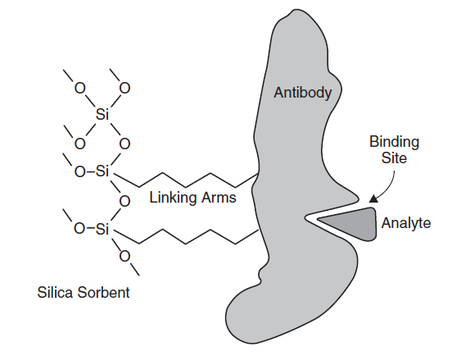

Fig.(5) Diagrammatic representation of an immunoaffinity SPE binding an analyte

**Molecularly Imprinted Polymeric Sorbents**

Another approach to selective SPE based on molecular recognition is the development of molecularly imprinted polymers (MIPs), which are said to be an attempt to synthesize antibody mimics. Produced by chemical synthesis, **MIPs** are **less expensive** and **more easily** and **reproducibly** prepared than **immunosorbents** that are prepared from biologically derived antibodies SPE sorbents that are **very selective** for a **specific analyte** are produced by preparing (MIPs) in which the target analyte is present as a **molecular template** when the polymer is formed. Sellergren is credited with first reporting of the use of MIP sorbents for SPE. Subsequently, **MIP-SPE** has been applied to several **biological and environmental samples** MIP sorbents are prepared by combining the **template molecule** with a **monomer** and a cross-linking agent that causes a rigid polymer to form around the template (Figure 6). When the template is removed, the polymer has **cavities** or imprints designed to retain the **analyte selectively**. Retention of the analyte on these sorbents is due to **shape recognition**, but other physicochemical properties, including **hydrogen bonding**, **ionic interactions**, and **hydrophobic interactions**, are **important to retention** as well. MIP-SPE sorbents are stable in both **aqueous and organic** solvents and are **very selective** for the analyte of interest. Increased selectivity relative to other sorbents produces increased sensitivity because larger sample volumes can be extracted. Also, increased selectivity results in **efficient sample cleanup** of the analyte in the presence of complex biological or environmental matrix interferences. However, desorption is usually more difficult if any sorbent has increased affinity for the analyte.

One problem noted in MIP-SPE is **incomplete removal of the template molecule** from the polymer, resulting in leaching of the analyte during subsequent trace analyses. Stringent cleaning of the sorbent and analytical confirmation of the **lack of interfering** compound can reduce this problem. Alternatively, another approach has been to use a structural analog of the target analyte as the template used to create the MIP sorbent. This approach is successful if the structural analog creates an imprint that is selective for the target analyte and if the structural analog and the target analyte can be separated chromatographically for quantitation after extraction.

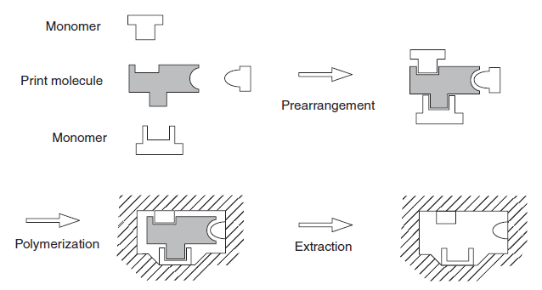

Fig.(6) Schematic depiction of the preparation of molecular imprints

**Mixed-Mode Sorbents and Multiple-Mode Approaches**

Each of the types of SPE sorbents discussed retains analytes through a primary mechanism, such as by **van der Waals** interactions, **polar dipole–dipole forces**, **hydrogen bonding**, or **electrostatic forces**. However, sorbents often exhibit retention by a **secondary mechanism** as well. Bonded silica ionexchange sorbents primarily exhibit electrostatic interactions, but the analyte also experiences nonpolar interaction with the bonded ligand. Nonpolar bonded silicas primarily retain analytes by hydrophobic interactions but exhibit a dual-retention mechanism, due to the silica backbone and the presence of unreacted surface silanol groups.

Recognition that a dual- retention mechanism is not always detrimental to an analysis has led to the production of mixed-mode sorbents by design. The development of mixed-mode sorbents and multiple-mode approaches to capitalize on multiple retention mechanisms has evolved as a logical extension of the observation of **secondary interactions**.

A mixed-mode sorbent is designed chemically to have **multiple retentive sites** on an individual particle. These sites exploit different retention mechanisms by chemically incorporating different ligands on the same sorbent. For example, sorbents have been manufactured that contain **hydrophobic alkyl chains and cation-exchange sites** on the same sorbent particle. Mixed-mode sorbents exploit interaction with different functional groups on a single analyte or different functional groups on multiple analytes. Mixed-mode SPE sorbents are particularly useful for the extraction of analytes from bodily fluids.

**EXTRACTION OF SEMIVOLATILE ORGANIC**

**COMPOUNDS FROM SOLID MATRICES**

There are many techniques for the extraction of semivolatile organics from solid matrices. The commonly used and commercially available techniques, which include 1- Soxhlet extraction

2- Automated Soxhlet extraction

3- Ultrasonic extraction

4- Supercritical fluid extraction (SFE)

5- Accelerated solvent extraction (ASE)

6- Microwave-assisted extraction (MAE)

The underlying principles, instrumentation, operational procedures, and selected applications of these techniques are described. In a given application probably all the methods mentioned above will work, so it often boils down to identifying the most suitable one. Consequently, an effort is made to compare these methodologies.

**Extraction Mechanism**

Extraction of organics from solids is a process in which solutes desorb from the sample matrix and then dissolve into the solvent. Extraction efficiency is influenced by three interrelated factors:

1- Solubility

2- Mass transfer

3- Matrix effects

The solubility of an analyte depends largely on the type of the solvent, and for a selected solvent, its solubility is affected by temperature and pressure. Mass transfer refers to analyte transport from the interior of the matrix to the solvent. It involves solvent penetration into the matrix and removal of solutes from the adsorbed sites. Mass transfer is dependent on the: 1- Diffusion coefficient

2- Particle size

3- Structure of the matrix

Factors that facilitate mass transfer are:

1- Temperature and pressure

2- Low solvent viscosity

3- Small particle size

4- Agitation

It is a more important issue than solubility when the analyte concentration in the extraction solvent is below its equilibrium solubility (i.e., when the analyte is readily soluble in the solvent). Matrix effects are the least understood of the three factors. A highly soluble compound can be ‘‘unextractable’’ because it is locked in the matrix pores, or is strongly bound to its surface. For example, analytes in aged soil bind more strongly than in a clean soil when spiked with the same analyte. Desorption is more difficult and may take longer.

Some extraction techniques, such as SFE, are found to be matrix dependent.

Different extraction parameters are employed for different groups of analytes in different matrices. Solvent selection depends largely on:

1- Nature of the analytes

2- The matrix.

The matrix effects are often unpredictable. There is no single solvent that works universally for all analytes and all matrices. Sometimes, a mixture of water-miscible solvents (such as acetone) with nonmiscible ones (such as hexane or methylene chloride) are used. The water-miscible solvents can penetrate the layer of moisture on the surface of the solid particles, facilitating the extraction of hydrophilic organics. The hydrophobic solvents then extract organic compounds of like polarity. For instance, hexane is efficient in the extraction of nonpolar analytes and methylene chloride extracts the polar ones. As temperature and pressure play important roles in extraction kinetics extraction techniques can be classified based on these parameters. **Classical methods** include

1- Soxhlet extraction

2- Automated Soxhlet extraction

3- Ultrasonic extraction

They are operated under atmospheric pressure, with heating or ultrasonic irradiation. These methods consume relatively **large volumes of organic solvents**, and the extraction may take a **long time**. The other group consists of:

1- Supercritical fluid extraction (SFE)

2- Accelerated solvent extraction (ASE)

3- Microwave-assisted extraction MAE

Which are performed under elevated pressure and/or temperature. The extraction is faster, more efficient and sample throughput is high. With relatively **less consumption of organic solvents**, these methods are **more environmentally friendly**. Moreover, the **costs of solvent** purchase and waste disposal are reduced. Despite the high initial equipment cost, these methods may be more **economical in the long run**, especially for the routine analysis of a large number of samples.

**Preextraction Procedures**

Most extraction methods perform best on dry samples with small particle size. If possible, samples may be **air-dried and ground** to a fine powder before extraction. However, this procedure is not recommended if the sample contains volatile analytes and/or worker exposure is a concern. Instead the sample can be dried by mixing with **anhydrous sodium sulfate** or palletized diatomaceous earth. In certain applications such as in MAE, water can be used as a part of the solvent mixture. Instead of drying, water is added into the sample to maintain a certain moisture level.

**Postextraction Procedures**

Some extraction techniques generate large volumes of solvent extract. The extract needs to be **concentrated** to meet the **detection limit** of the analytical method. Moreover, in most cases, extracts of soil, sludge, and waste samples require some degree of **cleanup** prior to analysis. The purpose of cleanup is to remove interfering compounds and high-boiling materials that may cause error in quantification, equipment contamination, and deterioration of chromatographic resolution.

**Soxhlet Extraction**

A schematic diagram of a typical Soxhlet apparatus is shown in Figure below. The system has three components. The top part is a solvent **vapor reflux condenser**. In the middle are a thimble holder with a siphon device and a side tube. The thimble holder connects to a round-bottomed flask at the bottom. The sample is loaded into a porous cellulous sample thimble and placed into the thimble holder. Solvent vapor passes through the side tube and goes to the reflux condenser, where it condenses and drips back to the thimble chamber. When the analyte-laden solvent reaches the top of the thimble holder, it is drained back into the bottom flask through the siphon device. This cycle repeats many times for a predetermined time period. Since the extracted analytes have higher boiling points than the extraction solvent, they accumulate in the flask while the solvent recirculates. Consequently, the sample is always extracted with fresh solvents in each cycle.



**Fig 1 Schematic diagram of a Soxhlet apparatus**

Because the sample is extracted with cooled, condensed solvents, Soxhlet is **slow** and can take between **6 to 48 hours**. The extract volume is relatively **large**, so a solvent evaporation step is usually needed to **concentrate** the analytes prior to extract cleanup and analysis. The sample size is usually **10 g** or more. **Multiple samples** can be extracted on separate Soxhlet units, and the extraction can be run unattended. Soxhlet is a rugged, well-established technique that is often used as the benchmark for comparing other methods. Few parameters can affect the extraction. The main drawbacks are the long extraction time and relatively large solvent consumption.

**Automated Soxhlet Extraction**

In 1994, automated Soxhlet extraction (**Soxtec**, commercially) was **approved by EPA** as a standard method. A shematic diagram of Soxtec is shown in Figure 2. The extraction is carried out in three stages:

1- Boiling

2- Rinsing

3- Solvent recovery

In the first stage, a thimble containing the sample **is immersed** in the boiling solvent for about **60 minutes**. Extraction here is **faster** than Soxhlet, because the **contact** between the solvent and the sample is more **vigorous**, and the **mass transfer** in a **high-temperature** boiling solvent is more **rapid**. In the second stage, the sample thimble is **lifted** above the boiling solvent. The condensed solvent drips into the sample, extracts the organics, and falls back into the solvent reservoir. This rinse–extract process is similar to Soxhlet and is usually set for **60 minutes**. The third stage is a concentration step for **10 to 20 minutes**.

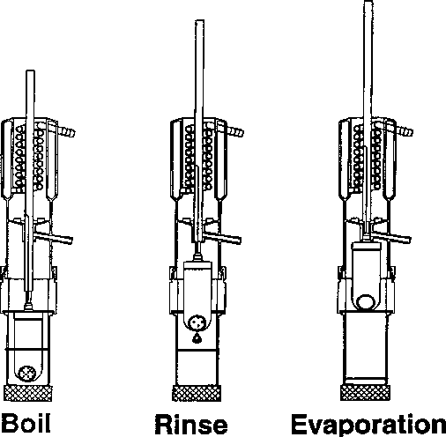

**Fig 3 shematic diagram of Soxtec**

**Comparison between Soxtec and Soxhlet**

Soxhlet can be applied universally to almost any sample. It is not uncommon to use Soxhlet as the benchmark method for **validating** other extraction techniques. Soxtec **reduces the extraction time to 2 to 3 hours** as compared to **6 to 48 hours in Soxhlet**. It also decreases solvent use from **250 to 500 mL** per extraction to **40 to 50 mL** per extraction. Two to six samples can be extracted simultaneously with a single Soxtec apparatus.

Recent studies comparing Soxtec with Soxhlet show comparable or even better results for Soxtec. Brown et al. compared the efficiency of the standard Soxhlet method against three different protocols using the Soxtec extractor, organic mutagens were extracted from municipal sewage sludge using MeOH and CH2Cl2 as solvents Both the Soxtec (with 5 minutes of boiling time and 55 minutes of rinsing time), and Soxhlet procedures yielded reproducible mutagenic responses within the variability of the bioassay. The data indicate that the Soxtec extraction, which was **faster** and required **less solvent**, provided adequate extraction of organic mutagens from sewage sludge Foster and Gonzales reported a collaborative study by 11 laboratories of Soxtec and Soxhlet methods for the determination of total fat in meat and meat products. Each lab analyzed six samples: canned meat ground beef, frankfurters, fresh pork sausage, hard salami, and beef patties with added soy. In general, results for the Soxtec system showed improved performance. The method was first adopted by AOAC International for the extraction of fat from meat. Membrado et al. tested Soxtec against Soxhlet extraction for the extraction of coal and coal-derived products Optimization of Soxtec operating conditions reduced the total extraction time to 10% of what was needed by Soxhlet extraction. The **recovery and precision** by the two methods were comparable.

**Ultrasonic extraction**

Ultrasonic extraction, also known as sonication, uses **ultrasonic vibration** to ensure **intimate contact** between the sample and the solvent. Sonication is relatively **fast**, but the extraction efficiency is **not as high** as some of the other techniques. Also, it has been reported that ultrasonic irradiation may lead to the **decomposition** of some organophospho- --rus compounds.

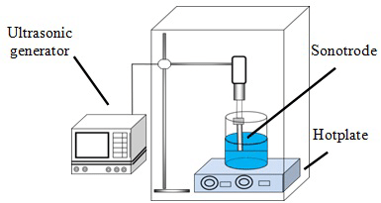

Fig 4 Schematic diagram of an ultrasonic extraction device

The selected solvent system and the operating conditions must demonstrate adequate performance for the target analytes in reference samples before it is implemented for real samples. This is particularly important for low-concentration [parts per billion (ppb) levels] samples. Figure 4 shows a schematic diagram of a sonication device. The sample is usually dried with anhydrous sodium sulfate so that it is free flowing. For trace analysis, the sample size is typically 30g. Then a certain volume (typically, 100 mL) of selected solvents are mixed with the sample. The most common solvent system is acetone–hexane v/v) or acetone–methylene chloride (1:1 v/v). For nonpolar analytes such as polychlorinated biphenyls (PCBs), hexane can also be used.

**Supercritical fluid extraction**

Supercritical fluid extraction (SFE) utilizes the **unique properties** of supercritical fluids to **facilitate** the extraction of organics from solid samples. Analytical scale SFE can be configured to operate on- or off-line. In the online configuration, SFE is coupled directly to an analytical instrument such as a gas chromatograph, SFC, or high-performance liquid chromatograph. This offers the potential for automation, but the extract is limited to analysis by the dedicated instrument. Off-line SFE, as its name implies, is a stand-alone extraction method independent of the analytical technique to be used. Off-line SFE is more flexible and easier to perform than the online methods. It allows the analyst to focus on the extraction per se, and the extract is available for analysis by different methods.

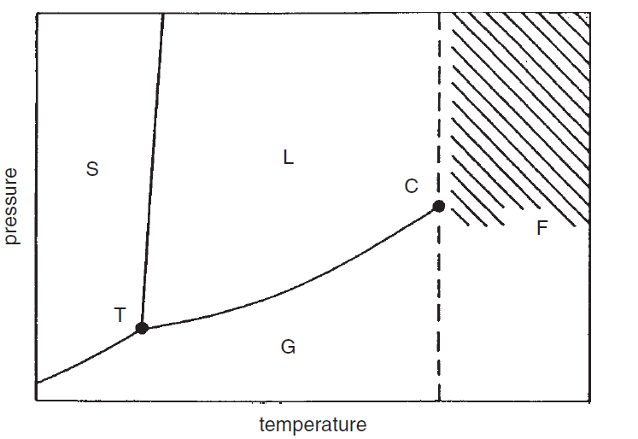

**Fig 5 Phase diagram of a pure substance**

A supercritical fluid is a substance above its critical temperature and pressure. Figure 5 shows a phase diagram of a pure substance, where curve T–C is the interface between gas and liquid. Each point on the line corresponds to a certain temperature and the pressure needed to liquefy the gas at this temperature. Point C is the critical point. Beyond the critical temperature a gas does not liquefy under increasing pressure. Instead, it is compressed into a supercritical fluid. The **densities** of supercritical fluids are close to that of a **liquid**, whereas their **viscosities** are **gas** like. The **diffusion coefficients** are in between. Due to these unique properties, supercritical fluids have good **solvating power** (like liquid), **high diffusivity** (better than liquid), low viscosity, and minimal **surface tension** (like gas). With **rapid mass transfer** in the supercritical phase and with better ability **to penetrate** the **pores in a matrix**, extraction is **fast** in SFE, along with high extraction efficiency. The solubility of a supercritical fluid is influenced by its temperature, pressure, and density. Solubility correlates better to density than to pressure.

Carbon dioxide (CO2) has a low supercritical temperature (31°C) and pressure (73 atm). It is **nontoxic** and **nonflammable** and is available at **high purity**. Therefore, CO2 has become the solvent of choice for most SFE applications. Being nonpolar and without permanent dipole moment supercritical CO2 is a good solvent for the extraction of nonpolar and moderately polar compounds. However, its solvating power for polar solutes is rather poor. Moreover, when the solutes bind strongly to the matrix, the solvent strength of CO2 is often inadequate to break the solute–matrix bond. This is true even if it is capable of dissolving the solutes. Supercritical solvents such as N2O and CHClF2 are more efficient in extracting **polar** compounds but their routine use is uncommon due to **environmental concerns**. The extraction efficiency of polar compounds by CO2 can be improved by the **addition** of small quantities (1 to 10%) of polar organic solvents, referred to as modifiers. This is a common practice in SFE.

**Advantages/Disadvantages and Applications of SFE**

SFE is **fast** (10 to 60 minutes) and uses **minimum amount of solvents** (5 to 10 mL) per sample. CO2 is **nontoxic, nonflammable, and environmentally friendly**. Selective extraction of different groups of analytes can be achieved by tuning the strength of the supercritical fluids with different modifiers and by altering operating conditions. In addition, the extract from SFE does not need additional filtration, as the extraction cell has frits. On the down side, analytical-scale SFE has **limited sample size** (<10 g) and the instrument is rather **expensive**.

**Accelerated solvent extraction**

Accelerated solvent extraction (ASE) is also known as **pressurized fluid extraction** (PFE) or pressurized liquid extraction (PLE). It uses conventional solvents at elevated temperatures (**100 to 180°C**) and pressures (**1500 to 2000 psi**) to enhance the extraction of organic analytes from solids. ASE was introduced by Dionex Corp. (Sunnyvale, CA) in 1995. It evolved as a consequence of many years of research on SFE. SFE is matrix dependent and often requires the addition of organic modifiers. ASE was developed to overcome these limitations. It was **expected** that conventional solvents would be less efficient than supercritical fluids, which have **higher diffusion coefficients and lower viscosity**. However, the results turned out to be quite the **opposite**. In many cases, extraction was **faster** and more **complete** with organic solvents at elevated temperature and pressure than with SFE. Extensive research has been done on the extraction of a variety of samples with ASE. ASE was approved by EPA as a standard method in 1996.

The elevated pressure and temperature used in ASE affects the **solvent**, the **sample**, and their **interactions**. The solvent boiling point is increased under high pressure, so the extraction can be conducted at **higher temperatures**. The high pressure also allows the solvent to **penetrate deeper** into the sample matrix, thus facilitating the extraction of analytes **trapped** in matrix pores. At elevated temperatures, analyte **solubility increases and the mass transfer is faster**. The high temperature also **weakens the solute–matrix bond** due to van **der Waals forces, hydrogen bonding, and dipole attractions**. In addition the high temperature **reduces the solvent viscosity and surface tension**, which enhances solvent penetration into the matrix. All these factors lead to faster extraction and better analyte **recovery**.

**Microwave-assisted extraction**

The microwave-assisted extraction (MAE) is different from microwave-assisted acid digestion. The former uses organic solvents to extract organic compounds from solids, while the latter uses acids to dissolve the sample for elemental analysis with the organic contents being destroyed. The name magnetron (microwave generator) was first used in 1921 by A W. Hall. In 1946, Percy Spencer discovered the function of microwave as a heating source. Domestic microwave ovens became available in 1967. In 1975, microwave was first applied to acid digestion for metal analysis by Abu-Samra et al. Since then much work has been done on microwave-assisted acid digestion, and it has gained widespread acceptance and approval by regulatory agencies as a standard method. Microwave-assisted organic extraction was first carried out in 1986 by Ganzler et al. for the extraction of fats and antinutrients from food and pesticides from soil. In 1992, Pare patented a process called MAP (microwave-assisted process) for the extraction of essential oils from biological materials. This technique was later extended to analytical as well as large-scale applications. In the year 2000, MAE was approved by the EPA as a standard method for the extraction of semivoaltile and nonvolatile compounds from solid samples.

**Micelle-mediated separation and cloud-point extraction**

In 1976, Watanabe and co-workers introduced Cloud point extraction (CPE) as a promising new separation and extraction technique, as an alternative to organic solvents. Although CPE was initially introduced for the preconcentration of metals, in the form of their hydrophobic complexes, it was extensively exploited as a primary isolation step for the purification of proteins. From this point on, scientists all over the world developed its potential, adding more applications. Thus, in a couple of decades, numerous studies were published covering its theoretical background and especially proposing extraction and preconcentration schemes for the determination of organic and inorganic analytes.

A synopsis of the potential of CPE was presented in 1982, while another attempt to review the literature comprehensively appeared in 1985. Since then, several changes to the classical approach have been proposed, while automation has also been introduced. In a phrase, along with ionic liquids, micellar formations are the solvents of the modern era, taking extraction from the macro-environment of bulk organic solvents to the privileged selectivity of micellar micro-world. This article endeavors to give a comprehensive outline of the latest fundamental and procedural applications of CPE in analysis, and to highlight some current trends and required developments.

**MME: theory and concept**

**What is a micelle?**

Surface-active agents are amphiphilic molecules with distinct hydrophobic and hydrophilic moieties; a polar or ionic group connected to a long hydrocarbon tail (linear, branched or containing aromatic rings). In aquatic solutions, low concentrations of **surfactant molecules** are present, mainly as **monomers** although **dimers** and **trimmers** may also be detected. When their concentration increases above a certain **threshold**, called the **critical micellar concentration (cmc)**, surfactant monomers, spontaneously accumulate to form colloidal-sized clusters known as **micelles** (Fig. 1(a)). Depending on the specific surfactant and solution conditions, micelles can adopt a variety of shapes, ranging from roughly spherical to ellipsoidal (Fig. 7(b)).

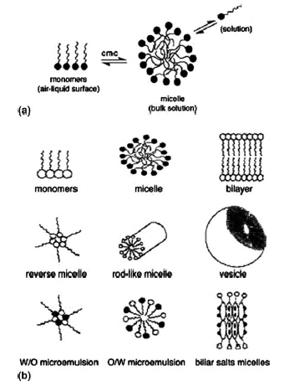

Figure 7. (a) Schematic representation of the formation of a micelle from its monomers beyond its critical micellar concentration (cmc) (b) Forms of surfactant aggregates.

**How does MME work?**

Regardless of their shape or size, surfactant aggregates orientate their hydrocarbon tail towards the center of the formation, creating a non-polar core. Hydrophobic and covalent compounds initially present in the aqueous solution are favorably partitioned in the non-polar microenvironment. The whole process resembles traditional liquid–liquid extraction (LLE), the only difference being that the ‘‘organic’’ phase is generated within the aqueous phase, converting a previously homogeneous solution to heterogeneous one by simply gathering its previously scattered hydrophobic suspensions. When the solution conditions, such as temperature and pressure, are appropriately altered, phase separation occurs for the aqueous micellar solution. In other words, surfactant monomers aggregate and separate from water while scattering visible light (Fig. 8). This turbid, surfactant-rich phase is loaded with the hydrophobic burden of the initial solution while the aqueous supernatant withholds a concentration of surfactant, close to the cmc. Although the exact mechanism via which this phenomenon occurs is yet to be defined, several studies have shown that such phase separations result from the competition between entropy (which favors miscibility of micelles in water) and enthalpy (which favors separation), so the clouding and phase-separation procedure is reversible. Re-establishment of the initial solution conditions drives the micelles to merge with the aqueous phase, re-producing a homogeneous system.

|  |  |
| --- | --- |
| **Extraction into micelles: important features**  To date, liquid–liquid phase separation of non-ionic or zwitterionic surfactant micelles (i.e., CPE) are employed, while the use of charged surfactant species is still scant. Advantageous features that promoted applications of MME include:  1- The **capacity to concentrate** a plethora of analytes with almost **quantitative recoveries**.  2- The preconcentration factors obtained are comparable or superior to other schemes, and they can also be modified on demand by varying the amount of surfactant.  3- Commercial surfactants are environmentally friendly and cost effective, and the amounts used for effective extraction schemes are minimal compared to the amounts of organic solvents used in conventional extraction**;** oven. An important gain of this procedure is that the resulting surfactant phase is reduced to a minimum, approximating its initial volume, which rarely exceeds 100µL per 10 mL of sample volume. Moreover, oven drying can be applied simultaneously to a multitude of samples, making CPE appealing for large-scale analysis. | Description: C:\Users\JAD\AppData\Local\Microsoft\Windows\Temporary Internet Files\Content.Word\New Picture (57).bmp  Figure 8 Visual representation of cloud formation upon heating beyond the cloud-point temperature (cpt). |

There are, of course, several limitations inherent in MME, which primarily stem from the manipulation of the surfactant-rich phase obtained. As it is viscous, it cannot be injected directly to conventional analytical instruments, so it has to be diluted with an aqueous or organic solvent to reduce its viscosity, thus impairing the anticipated theoretical preconcentration factors. Moreover, surfactant-bearing chromophores interfere with UV detection by overlapping with the analyte signal. This problem can be solved by diluting the surfactant-rich phase with an organic solvent prior to injection into the chromatographic column, increasing the portion of organic solvent in LC mobile phases or even using fluorescence detection. If these methods fail, then clean-up procedures can be employed.

More recently, aliphatic (mostly ionic) surfactants that do not absorb in the UV region have also been used. These surfactants eliminate the need to employ wash-up steps and pose no threat to quantitation. There have also been proposals to use zwitterionic surfactants or hydrogenated forms of non-ionic surfactants, although the slurry-like nature of the surfactant-rich phase obtained and the difficulty of manipulating the surfactant-rich phase are often mentioned.

**Parameters that optimize MME**

In order to achieve such a wide range of applications, several parameters have to be taken into account to optimize MME. For organic species, the parameters susceptible to optimization stem from the properties of the surfactant medium that is applied. However, for inorganic species, where the quantitative formation of a hydrophobic complex is an essential prerequisite for efficient MME, the properties of the surfactant system have to be optimized more carefully, taking into account the variables of complex formation. Apart from the selection of the appropriate chelating agent, common parameters for both organic and inorganic species, which have to be examined to make CPE successful, are: pH; ionic strength; surfactant type and concentration, temperature and equilibrium and centrifugation time.

**Solution pH**

For organic molecules, pH is perhaps the most critical factor regulating the partitioning of the target analyte in the micellar phase. Especially for ionizable species, such as phenols and amines, maximum extraction efficiency is achieved at pH values where the uncharged form of the target analyte prevails. In recently developed CPE, schemes based on ionic surfactants were used effectively to extract charged analytes. However, for inorganic species, little differentiation was observed in the extraction efficiency of the complexes formed at different pH values, since these complexes are bulky, uncharged and covalent. Only in the case of pH-dependent reactions does the pH seem to control extraction efficiency e.g., Cr (III),, which is known to form inert aqua-complexes, becomes reactive and useful for efficient MME in alkaline pH). In any other case, the role of pH is the same as in traditional pH-selective fractional precipitation, where the separation of several metal ions was made feasible by repeatedly adjusting the pH.

**Effect of surfactant concentration**

It is important to discuss the effect of surfactant concentration on CPE. There is a narrow range within which easy phase separation, maximum extraction efficiency and analytical signal are accomplished. Increasingly, outside this optimal range, the analytical signal is observed to deteriorate due to the increase in the final volume of the surfactant that causes the preconcentration factor (phase–volume ratio) to decrease. However, if surfactant concentration is decreased from that recommended, accuracy and reproducibility would probably suffer because the resultant surfactant-rich phase would not be sufficient to make reproducible measurements of extraction and separation.

**Incubation temperature and duration**

In the same way as other parameters, temperature and duration of the MME procedure seem to play roles, especially when dealing with inert inorganic species. It has been proved that, when dealing with such inert metals or metal complexes, like those of chromium and mercury, it is necessary to apply elevated temperatures (>80C) and prolonged incubation times in order to achieve satisfactory extraction. This observation comes as affirmation of the belief that the whole procedure is controlled by the requirement that the reaction should be complete for complex formation to be efficient, since clouding and phase separation occur even at room temperatures. As a universal observation, temperature seems to play an additional role in enhancing preconcentration efficiency and enhancement factors, as it is reported that applying elevated temperatures leads to dehydration of the micelle, increasing the phase–volume ratio and thus, the signal enhancement by a factor as great as 3. An important point, with regard to incubation time, is that, for metals, their reaction with chelating agents and their transportation inside the micelle are kinetically controlled (although thermodynamically favored, simulating the shift of equilibrium towards precipitation). It is therefore essential to maintain the reaction time above a minimum threshold for quantitative extraction. In most studies, a reaction time of up to 10 min is reckoned to be optimal [30]. This reaction time coincides with the incubation time reported for the optimal extraction of organic species into micellar formations.

**Effect of ionic strength and centrifugation**

Ionic strength and centrifugation time have also been of concern, although they have proved to have a negligible effect on the performance of CPE. Increasing ionic strength enhances phase separation through sorting out phenomena that also apply to conventional extraction schemes, yielding higher recoveries without by any means deteriorating the analytical performance. In that aspect, it is feasible to apply this factor directly to difficult matrixes, such as environmental waters and biological fluids. In general, centrifugation time hardly ever affects micelle formation but accelerates phase separation in the same sense as in conventional separations of a precipitate from its original aqueous environment. Centrifugation times around 5–10 min are usually efficient for most MME procedures.

**Selection of the chelating agent**

Selection of the chelating agent is the regulating factor for all metal-MME schemes. Since Watanabes pioneering application of CPE in metal extraction, several chelating agents have been utilized in order to produce sufficiently hydrophobic complexes to be isolated in the surfactant-rich phase of a micellar solution. Based on their reactivity and formation constants with the target metal species, some of the most widely applicable reagents are carbamates, pyridylazo, quinoline and naphthol derivatives. These molecules are universal chelators that form hydrophobic compounds with the majority of metal ions and they can be applied when an element-specific detector is available. Other reagents, such as O,O-diethyldithiophosphate, have been utilized for more specific applications. In any case, a ligand is selected with the requirement that the derived complex is sufficiently hydrophobic, possesses a high partition coefficient and is formed quickly and quantitatively with the least possible excess. Complexation parameters, such as the thermodynamics [formation constant (Kf)], as well as the kinetics of complex formation and transfer into the micellar phase govern the whole procedure, while the contributions of cloud point and micellization parameters are less pronounced. The distribution behavior of metal chelates in the surfactant medium varies, depending on the nature of the complex and the prevailing conditions, in contrast with organic solvents, where the distribution constants are almost independent of the nature of the metallic ions. It is essential to comprehend that even obsolete reactions and separation techniques can be reinstated and improved through CPE. For example, classical separation by fractional precipitation can be performed in terms of CPE to enable separation and preconcentration in a single step by simple pH adjustment. From that perspective, even the growing need to design speciative schemes can be satisfied, as shown below in the section dealing with speciation analysis.

**Applications of MME**

MME in the analysis of organic compounds The solubilization of non-polar organic molecules in the hydrophobic micellar core is an inherent property of all surfactant systems, widely exploited for the design of new preconcentration procedures. The efficiency of these procedures relies on the magnitude of analyte solubilization into the micelle (non-polar core and polar micelle–water interface), analyte polarity and solution composition. Therefore, any experimental approach should focus on the combination that ensures maximum extraction recovery. Recent studies on analyte partitioning in surfactant aggregates have shown that there is a sharp dependence between the octanol–water partition coefficient of a given organic compound and its partition into the surfactant-rich phase. Theoretically, extremely hydrophobic analytes show very favorable distribution constants between the micellar and the aqueous phases, resembling those observed with organic solvents. It is therefore estimated that maximum preconcentration factors that can be achieved coincide numerically with the phase ratio. In practice, the hydrated nature of the surfactant-rich phase leads to a smaller partition coefficient than those reported for organic solvents. With regard to surfactant structure, it has been recognized that solubilization of organic solutes increases by increasing the length of the hydrophobic tail and decreasing the size of polar head (i.e., the number of EO units). It is therefore conceivable that solubilization of organic analytes into the surfactant micelles is amended by minimizing the non-hydrophobic contributions.

**Analytes of environmental interest.**

The analytical utility of CPE procedures in the analysis and isolation of organic molecules has been widely accepted. Several review articles have therefore been published to summarize the latest developments and provide the basis for future research, covering both environmental and biological fields. To quantitate the analytes in most applications, LC methods are coupled with UV, fluorescence or electrochemical detectors. Polychlorinated dibenzo-p-dioxins have been efficiently extracted from fresh, brackish and sea water with polyoxyethylene 10 lauryl ether (POLE) achieving good recoveries especially with highly saline samples. PAHs were also determined in water samples with POLE and Tergitol 15 S-7 as extractants producing efficient recoveries. Genapol X-80 micelles have proved to be an effective media for the preconcentration of phenolic compounds and herbicides from sea water and wastewater samples. Similarly, the preconcentration of phenol as its 4- minoantypyrene complex has been reported followed by spectrophotometric quantitation in Triton X-114 micelle In an extended application, Saitoh et al. [10] evaluated the possibility of isolating a wide range of organic analytes, including PAHs, alkylbenzenes, alkylphenols, chlorobenzenes, chlorophenols, phthalic esters, pesticides and steroid hormones with octyl-b-D-thioglucoside (OTG) followed by LC–UV detection. The method produced satisfactory recoveries applying uniform experimental conditions, thus proving to be valid for the preconcentration of a large number of analytes. In a different approach, Revia and Makharadze reported that it was feasible for non-ionic surfactant Triton X-100 to entrap fulvic and humic substances. In essence, the partitioning of the HA and FA onto the surfactant-rich phase was possible at acidic conditions (pH < 2) and elevated temperatures (90C). At low pH values, the electrostatic charge of the HA and FA is reduced due to protonation of the carboxylate groups while heating; this alters the water structure and hydrophobic interactions of HA and FA, enhancing their hydrophobic properties. The addition of CTAB to a solution of HA and FA has proved to enhance significantly their partition coefficients into non-ionic surfactants through the formation of a bulky ion-pair, thus allowing quantitative recovery of the analytes. The method affords detection limits as low as 5 lg/L, which renders it suitable for the determination of HA and FA in most natural waters.

**Analytes of biological interest**

The CPE technique has also been utilized effectively for isolating organic molecules of biological interest. Historically, the first application of MME in the biochemical area was made by Bordier, who reported the separation of hydrophobic membrane proteins into a Triton-series surfactant. Since then, many useful biological CPE schemes have been devised. Numerous analytes, including proteins, enzymes, receptors and biomaterials, have been purified by the CPE technique, and several standard biological/biochemical methods have incorporated this technique into recommended protocols [24]. To date, the majority of applications deal with the separation of hydrophobic from hydrophilic proteins. This enables the degree of hydrophobicity of biomaterial fractions to be gauged before and after biomolecular modifications. The method has also been extended to the isolation and the preconcentration of biochemical analytes of plant and animal origin. Fang et al. [25] reported the concentration of both hydrophobic and hydrophilic ginsenosides from Chinese herbal medicine in the micelles of Triton X-100 in the presence of high salt content. Paleologos et al. [8] applied the method to the preconcentration of biogenic amines from fish-tissue samples as their benzoyl derivatives in the micelles of Triton X-114 followed by separation with micellar LC and UV detection. Sirimanne et al. [26] were able to determine PAHs and PCDDs in human serum with HPLC after concentration in Triton X-100 micelles. Likewise, Rukhadze at al. [27] reported the determination of antiepileptic drugs in biological fluids based on the separation of free and protein-bound fractions of the drugs with Triton X-114 directly from blood plasma and saliva samples. All of the above studies, along with their precedents, utilizing micelles for the preconcentration and subsequent determination of vitamins, hormones, enzymes, receptors and other biologically active compounds, have contributed towards elucidating several important aspects of CPE relevant to the concentration and the isolation of organic molecules.

**Implementation of MME in the analysis and speciation of inorganic ions**

The use of MME in metal analysis is the second most frequently reported application. Usually, the experimental procedure is as follows:

- the metal reacts with a suitable ligand to form a hydrophobic complex. - clouding is generated by increasing temperature above the cloud point, or by adding salt. - the micelles formed entrap the metal complexes inside their hydrophobic core; and, - the surfactant-rich phase is subsequently separated from the bulk aqueous one by centrifugation. Fig. 9 shows the experimental procedure for MME in metal analysis.

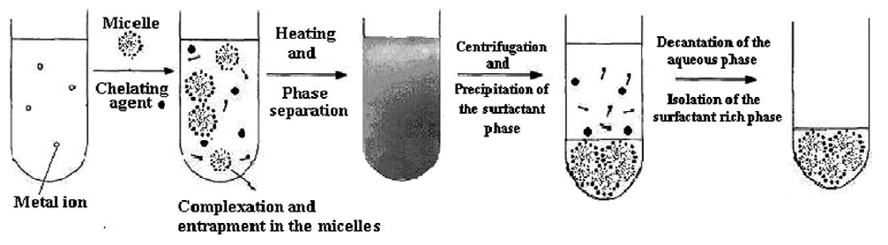

Figure 9. Micelle-mediated extraction (MME) of metal ions from water samples.